**TITLE: Safe Haven**

**Game Idea:**

Our game will be a first person shooter. You can only move left and right. Enemies will start spawning in the level and starts walking towards the player. Player have to prevent the enemies to reach them.

**Game Mechanics**

Left click to shoot, press r to reload. After killing all the enemies, the player will automatically move to the next wave. If the player clears all 10 waves in the game, they win. But if the player loses all their lives before they reach the final wave, the player loses the game.

**Features**

* Upgrade Menu (To upgrade weapon damage, increase movement speed, increase reload speed, increase ammo capacity, heal base health points)
* 10 waves of enemies to defeat

**Art Style**

* Theme: Sci-fi

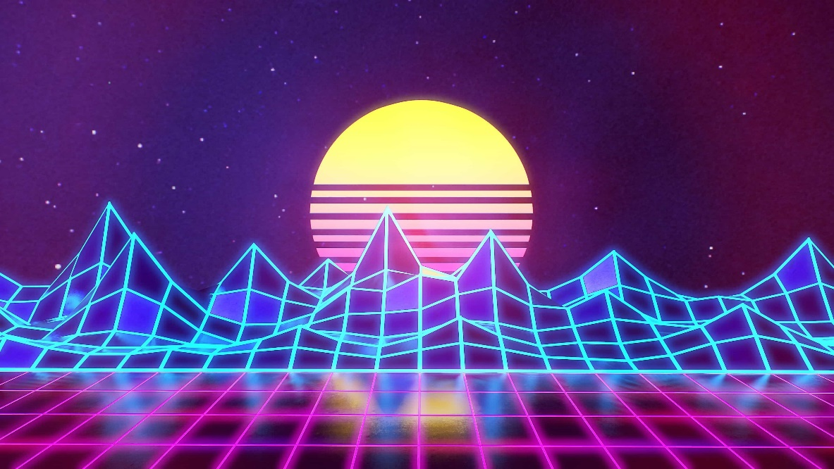

**Version Control**

* Git Hub

**Project Timeline**

* Lucas
* Wynn
* Vanness

**Sound Effects**

* Gunshot sound - <https://www.freewebtools.com/Gunshot-Sound-Effect-Single-Shot-download/>
* Reload sound - <https://www.youtube.com/watch?v=xmxof0mQI_Y>
* Ambience - <https://www.youtube.com/watch?v=XVbvE0PJyss>
* Robot 1 movement - <https://www.youtube.com/watch?v=0K7jGB_xKqY>
* Robot 2 movement - <https://www.youtube.com/watch?v=Dwf22lZEBK8>
* Robot 1 punch sound - <https://www.youtube.com/watch?v=NKcxfl2Is1s>
* Robot 2 punch sound - <https://www.youtube.com/watch?v=-AKVtiYZ83Y>

**Assets**

* Robot 1 - <https://assetstore.unity.com/packages/3d/characters/robots/futuristic-robot-mk-01-47458>
* Robot 2 - <https://assetstore.unity.com/packages/3d/characters/robots/robot-1-65726>
* Gun –
* Buildings - <https://sketchfab.com/3d-models/skyline-cutout-city-large-b00abd35578e4f628f4bcd3625ce5951#download>
* Buildings - <https://sketchfab.com/3d-models/scifi-building-1-0ae51cf0fd21473a98a26207cbc932df>
* Barricade - <https://sketchfab.com/3d-models/barricade-low-polly-42bf74c4d5e140aebf08accbf9646a20>

**Gantt Chart**

|  |  |  |  |  |  |  |  |  |  |  |  |  |
| --- | --- | --- | --- | --- | --- | --- | --- | --- | --- | --- | --- | --- |
| **Tasks** | **7-Nov** | | **8-Nov** | **9-Nov** | **10-Nov** | | **11-Nov** | **12-Nov** | | **13-Nov** | **14-Nov** | |
| GDD |  | |  |  |  | |  |  | |  |  | |
| Player Movement |  | |  |  |  | |  |  | |  |  | |
| Add UI |  | |  |  |  | |  |  | |  |  | |
| Add Sound Effects |  | |  |  |  | |  |  | |  |  | |
| Add Scenes |  | |  |  |  | |  |  | |  |  | |
| Weapon Orientation |  | |  |  |  | |  |  | |  |  | |
| Add Upgrade shop |  | |  |  |  | |  |  | |  |  | |
| **Tasks** | | **15-Nov** | | | | **16-Nov** | | | **17-Nov** | | |
| Add Enemies (Model, Animation) | |  | | | |  | | |  | | |
| Import Assets | |  | | | |  | | |  | | |
| Create Test Cases | |  | | | |  | | |  | | |

**Unity Profiler Screenshot**

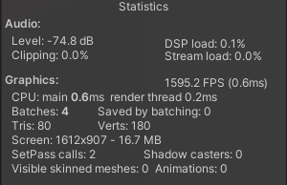 **Start (FPS)**

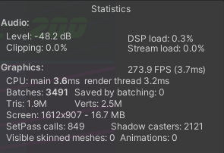

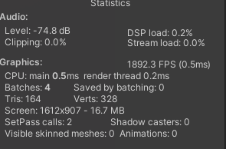**End (FPS)**

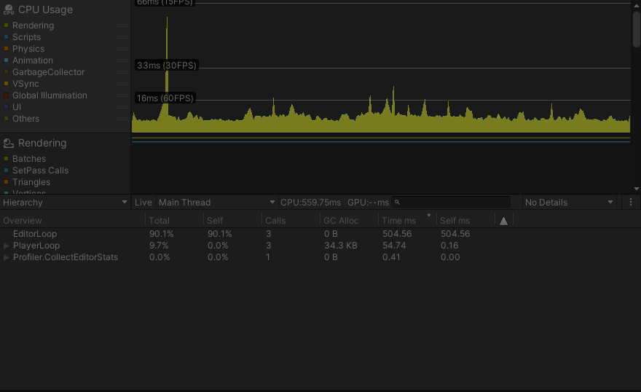

**Start (CPU)**

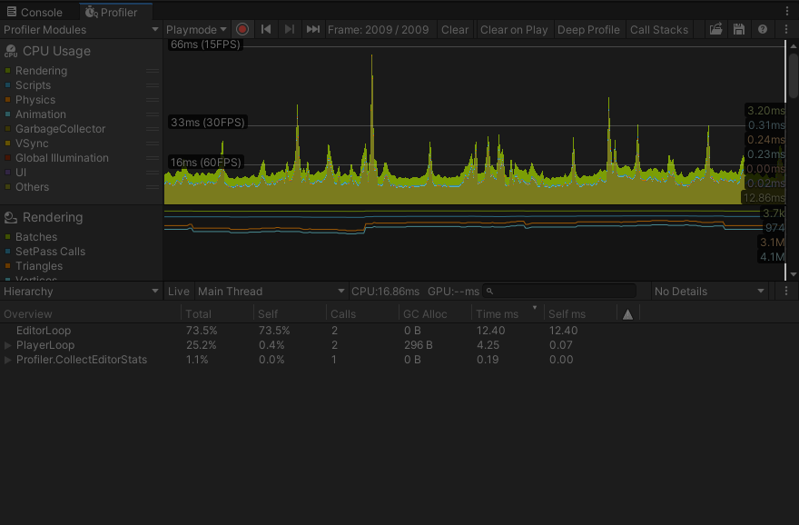

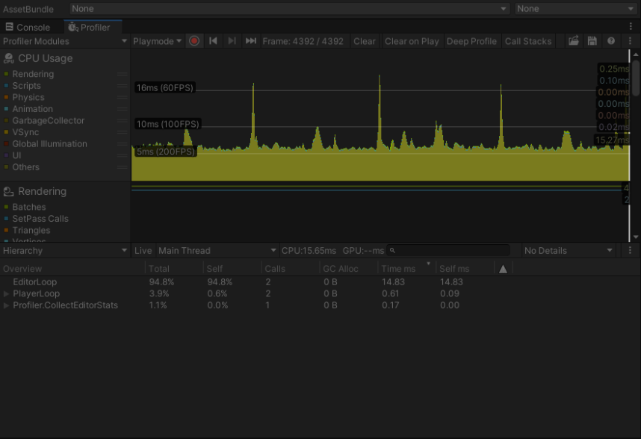

**End (CPU)**

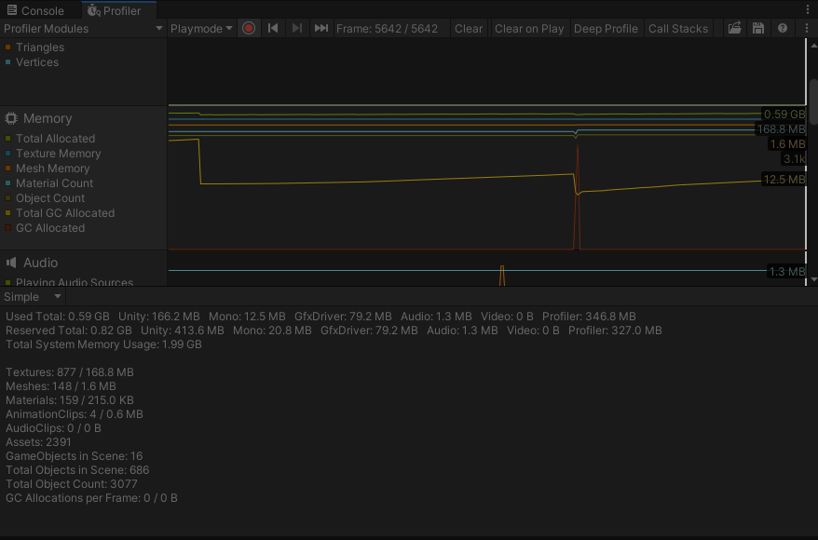

**Start (Memory)**

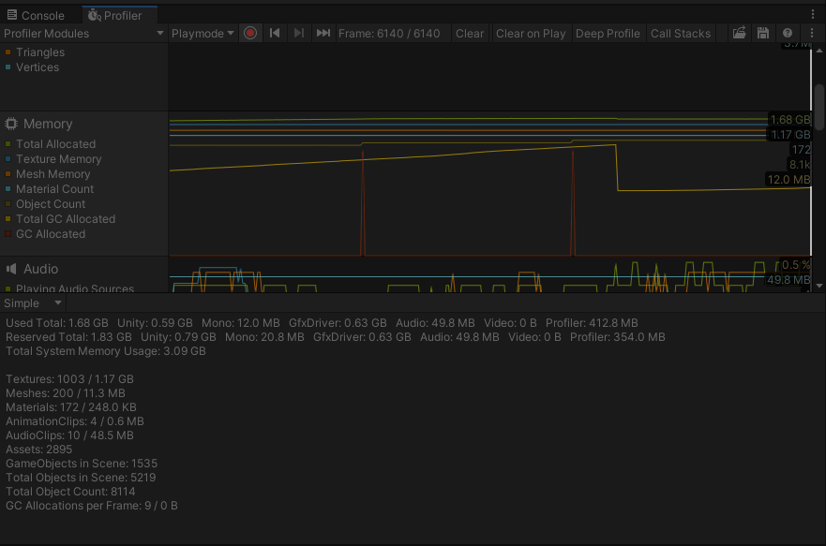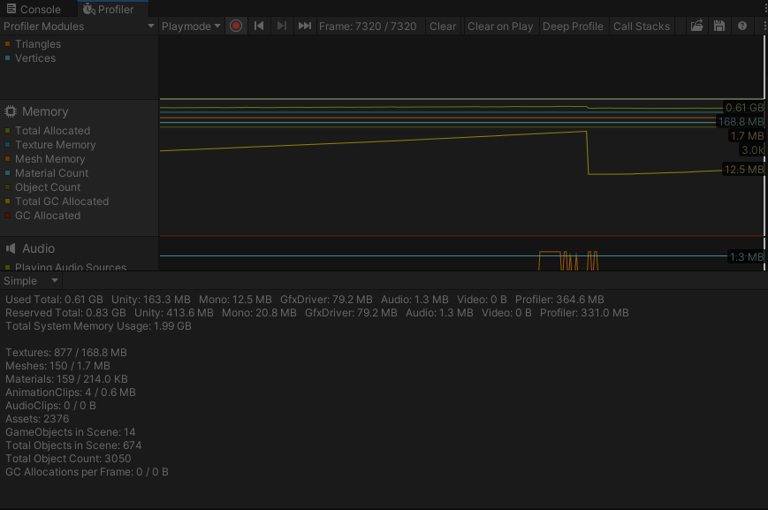

**End (Memory)**

**Code optimization method**

* Refactoring method

**References**

Texture - <https://opengameart.org/content/4096-scifi-hex-tiles-pbr-texture>

Particles Effect - <https://assetstore.unity.com/packages/vfx/particles/hit-impact-effects-free-218385>