**CSE2022 Computer Programming Week2**

Problems are based on the lecture <http://blog.naver.com/atelierjpro/220668883943>.

Use Monte-Carlo simulation and draw using Excel.

For each problem,

* Attach result image in your lab report file(MS .doc file).
* Submit your codes to your Github and leave links in your lab report.

Warning: if you don’t follow instructions on lab report, your score will be discounted.

Problem 1. Draw a circle. (3 points)

Problem 2. Draw a dumbbell shape. (3 points)

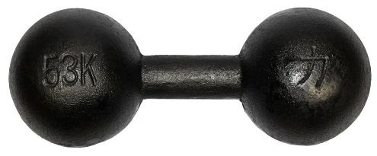

Problem 3. Draw an ellipsoid. (4 points)