
Rayat Shikshan Sanstha’s

Karmaveer Bhaurao Patil College of Engineering, Satara
Department: Computer Science & Engineering
Academic Year: 2025-26 Semester-VI

Mini Project-II Synopsis
On
“ CalmBand :Stress Detection and Management System”
By
1. Aarya Sunil Tupe (23062701242007)
2. Shreya Sudhir Sawant (23062701242012)
3. Shreya Balkrishna Shivankar (23062701242006)
Of
Third Year Computer Science & Engineering
Under the guidance of
Prof. Dipali Ghatge
(Department of Computer Science & Engineering)
Academic Year 2025-26

Introduction
In today’s fast-paced world, stress has become one of the most common yet overlooked challenges affecting people’s mental and physical well-being. Whether it’s due to academic pressure, professional demands, personal responsibilities, or lifestyle factors, prolonged stress can significantly impact productivity, decision-making ability, emotional stability, and overall health. Modern research highlights that chronic stress is linked to serious issues such as anxiety, depression, cardiovascular diseases, weakened immunity, and poor sleep quality. Despite the growing awareness, many individuals fail to recognize the early signs of stress or take timely action to manage it effectively.

To address this pressing issue, technology can play a transformative role. CalmBand: Smart Wristband for Stress Detection & Management is an innovative wearable solution designed to continuously monitor physiological signals, detect early signs of stress, and provide instant, personalized interventions to help users regain calmness. Using advanced biometric sensors, CalmBand tracks key parameters such as heart rate variability (HRV), skin conductance, body temperature, and activity levels, which are scientifically proven indicators of stress. These data points are processed through intelligent algorithms that can differentiate between normal physical activity and stress-induced physiological changes.

What sets CalmBand apart is its dual approach — detection and management. Once elevated stress levels are identified, the wristband connects with a mobile or web application to provide real-time feedback, calming exercises, guided breathing sessions, and motivational tips tailored to the user’s specific condition. Over time, the system learns the user’s stress patterns, enabling predictive alerts before stress escalates, thereby supporting proactive stress management.

CalmBand is designed for students, professionals, athletes, and anyone seeking to improve their emotional resilience and mental well-being. With its lightweight design, comfortable fit, and user-friendly interface, it can be worn throughout the day without disrupting daily routines. By merging wearable technology with mental health support, CalmBand empowers users to take control of their stress, build healthier coping mechanisms, and lead a more balanced life

Literature Review
In order to establish a solid background for our project, we examined a range of research papers that provide valuable insights into the subject. The following section presents the summarized abstracts of the chosen studies:
Abdullah A talking about This study presents Stress-Track, an IoT-based wearable system that monitors stress by measuring body temperature, sweat, and motion rate during physical activity, using machine learning for real-time classification. Stress monitoring is crucial in healthcare, as psychological stress can severely impact physiological parameters and pose serious health risks. Leveraging interconnected sensors and wireless communication, the device provides cost-effective, continuous health tracking to aid proactive wellness management. The proposed model achieved 99.5 % accuracy, highlighting its potential to enhance stress management and preventative health [1].

Alessandro Tonacci said that This pilot study explores whether machine learning can predict stress reduction from wearable sensor data following audiovisual relaxation at the workplace. Using autonomic features derived from ECG and GSR signals, various classifiers (e.g., decision trees, SVM, KNN, logistic regression, discriminant analysis) were trained via MATLAB’s Classification Learner. The models achieved approximately 80 % accuracy, with ~87.5 % of responders correctly identified versus 62.5 % of non-responders, highlighting the potential to preemptively detect individuals unlikely to benefit from such relaxation protocols. However, findings are limited by a small, gender-skewed sample and rudimentary relaxation methods; future work with larger, more balanced cohorts and structured interventions is needed to validate and refine the predictive approach [2] .

Zainudin, Z., Hasan, S., Shamsuddin, S.M., & Argawal, S. (2021) investigated early stress detection using IoT-based GSR and ECG sensors from the MySignals Healthcare Toolkit, collecting physiological data from 252 students (aged 20–22) exposed to emotion-inducing videos. After preprocessing and extracting statistical features (mean, median, standard deviation, etc.), the resulting SAID dataset was classified into Relax, Stressed, Partially Stressed, and Happy using five algorithms—MLP, Decision Tree, KNN, SVM, and Deep Learning. Decision Tree achieved the highest performance (95% accuracy, 96% precision/recall/F1), outperforming SVM (79% accuracy) and prior ANN-based studies. The authors highlight that classifier choice significantly impacts accuracy and recommend testing additional models with cross-validation and broader datasets for improved generalizability [3].

Ahmad Rauf Subhani, Wajid Mumtaz, Mohamed Naufal Bin Mohamed Saad, Nidal Kamel, and Aamir Saeed Malik present a machine learning framework for detecting multiple levels of mental stress using EEG signals. Stress was induced in healthy participants via the Montreal Imaging Stress Task, validated through task performance and subjective feedback. EEG data underwent feature extraction (absolute/relative power, coherence, amplitude asymmetry, phase lag), z-score standardization, and feature selection (ROC curve, t-test, Bhattacharya distance) before classification using logistic regression, SVM, and naïve Bayes with tenfold cross-validation. The system achieved up to 94.6% accuracy for two-level stress detection and 83.43% for multi-level classification, demonstrating EEG’s potential as a reliable, objective stress assessment tool without the need for additional costly modalities like fNIRS. The proposed approach could support the development of computer-aided diagnostic tools for mental stress [4].

This paper presents a comprehensive review of recent wearable sensor–based systems for monitoring human mental stress, emphasizing both the physiological markers they target (such as heart rate, heart rate variability, skin conductivity, blood pressure, and pupil diameter) and the practical challenges in designing such systems, including trade-offs between wearable comfort, sensor selection, and the informativeness of the data captured . It highlights that modern stress, predominantly psychological rather than physical, often goes unrecognized — yet repeated physiological stress responses can lead to long-term health impacts. The review focuses on how features extracted from signals (e.g., mean, median, amplitude, peak-to-peak intervals) can effectively correlate with stress, demonstrating the effectiveness of wearable ECG sensors in capturing relevant metrics. The authors underscore design considerations like balance between sensor accuracy and usability, and advocate for systems that support real-time, user-aware stress detection to improve awareness and enable early intervent [5].

Wenhui Liao paper presents a real-time, non-invasive system that infers human stress by integrating multimodal data—visual cues (e.g., facial expressions, eye and head movements), physiological signals captured via an "emotional mouse" (including heart rate, skin temperature, GSR, and finger pressure), behavioral metrics (mouse clicks, pressure), and performance measures (e.g., task error rate, response time)—into a Dynamic Bayesian Network (DBN). The DBN models both predictive factors (like workload and user traits) and diagnostic evidence, enabling fusion across modalities under uncertainty and temporal dynamics. Additionally, the system employs active sensing to dynamically select the most informative evidence, optimizing inference efficiency. Experiments with diverse subjects demonstrated that combining multiple modalities significantly improved accuracy in stress recognition, and active sensing further enhanced performance, with inferred stress closely correlating with theoretical workload-based ground truth [6] .

The 2004 IEEE conference paper “Development Stress Monitoring System Based on Personal Digital Assistant (PDA)” by M. H. Lee, G. Yang, H.–K. Lee, and S. Bang presents an early portable system for real-time stress detection using a PDA as the central processing device. The system collects physiological signals—heart rate, skin temperature, and electrodermal activity (EDA)—via non-invasive finger sensors, processes them on the PDA, and analyzes their patterns to detect stress levels. Designed for everyday use, it demonstrated the feasibility of integrating multiple biosignals into a compact, mobile platform for continuous monitoring, laying groundwork for later smartphone- and wearable-based stress detection technologies [7].

The paper by Emil Jovanov et al. introduces a pioneering real-time stress monitoring system that employs a network of distributed wireless intelligent sensors to capture physiological data such as heart rate variability (HRV) across multiple subjects, notably during intense military training scenarios. These sensor nodes relay synchronized measurements wirelessly to a mobile data collector, enabling continuous stress evaluation in dynamic, real-world environments. This work laid important groundwork for modern wearable and wireless health monitoring systems by demonstrating the feasibility and benefits of synchronized, networked physiological sensing [8].

This study employs a sequential exploratory mixed-methods design—first conducting in-depth qualitative interviews with 26 participants (aged 21–82), then a quantitative phase with 900 respondents (18–75 years)—to explore the nature and sources of peaceful and happy living. Findings reveal that "peaceful and happy living" involves experiencing comfort and positive emotions and the absence of negative ones, with peace seen as more lasting and deeply significant than happiness. The study identifies key contributors to peace and happiness, such as strong relationships, personal and social virtues, acceptance, spirituality, optimism, and well-being in domains like health and nature. Quantitative results further indicate positive correlations between peace and happiness and traits like tolerance, helpfulness, spirituality, responsibility, purposefulness, worthiness, trust, and reliability [9]

This paper by H. S. Swolfs and J. B. Walsh introduces an innovative system capable of directly measuring changes in rock stress by embedding a liquid-filled pressurized cell within a slender compliant cavity. The system monitors pressure variations in the cell—closely reflecting stress changes normal to the cavity—when there is a high compliance contrast between the cavity and surrounding rock, and a low aspect ratio of the cavity. Impressively, the authors document a precursory stress fluctuation—initial decompression followed by compression—lasting roughly five hours before a microseismic event, culminating in a stress drop of 15 × 10⁻³ bar. Additionally, concurrent seismic noise measurements suggest that meltwater infiltration increasing fluid pressure likely triggered failure in a fractured quartz-monzonite mass [10].

Existing System
1. Empatica E4 & Embrace Series
- Empatica E4: A research-grade wristband capturing electrodermal activity (EDA), PPG, accelerometer, and skin temperature data—widely used in studies on stress and emotional arousal.
- Empatica Embrace2/Plus: FDA-cleared devices originally for seizure detection, also used for stress and emotional monitoring.

2. ML-Enabled Custom Wristband Prototypes
- One study presents a low-cost wristband using PPG-derived pulse rate variability for real-time stress detection, reaching ~91% accuracy on standard datasets and ~76% in lab tests.
- Another research demonstrates the use of wrist-based EDA signals and classic machine learning (e.g., SVM) to distinguish stress from non-stress with 92.9% accuracy.
- Telemetry frameworks using federated learning have been proposed to preserve individual privacy while enhancing stress detection via decentralized model training.
- Advanced deep learning architectures (e.g., hybrid CNNs using PPG signals) have also been developed, demonstrating improved stress classification accuracy on benchmark datasets like WESAD.

3. Clinical & Contextual Monitoring
In dementia care settings, frameworks utilizing GSR (a form of EDA) have been deployed, classifying stress severity with personalized thresholds and real-time alerts.

4. Commercial & Wearable Lifestyle Devices
- Fitbit Sense / Charge 5: Offer EDA-based "stress tracking" along with heart rate and skin temperature, functioning as lifestyle-oriented tools.
- Devices like the Spire breathing sensor (clipped to clothing) monitor breathing patterns and prompt mindfulness during stress events.

Proposed Work
a. Problem statement:
To develop a wearable system that can monitor and detect stress levels in real time using physiological signals. The system aims to analyze the collected data to provide accurate stress detection in real-world conditions. It will also provide personalized stress management support through an AI assistant with voice interaction. Additionally, the project focuses on designing a compact and comfortable device suitable for everyday use.
b. Architecture:
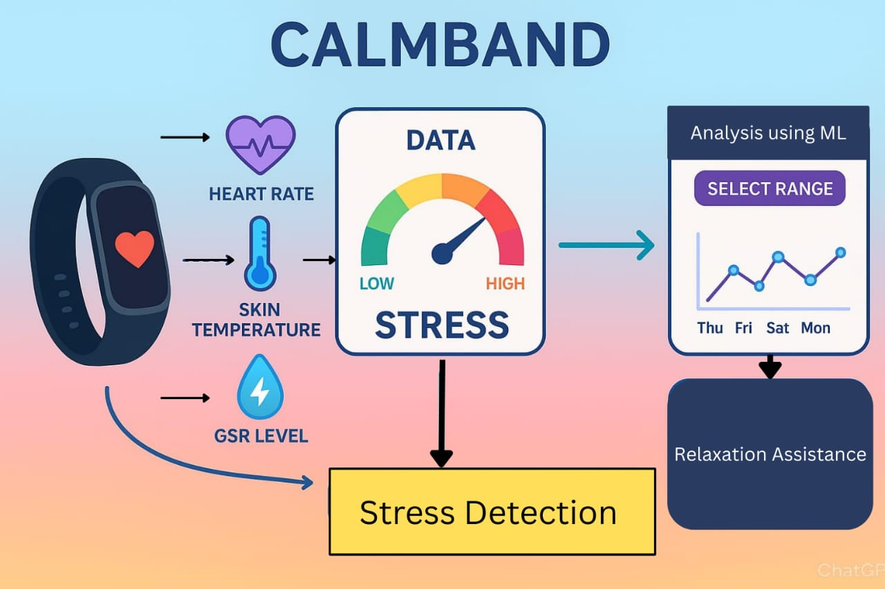
Fig. 1) Proposed Architecture

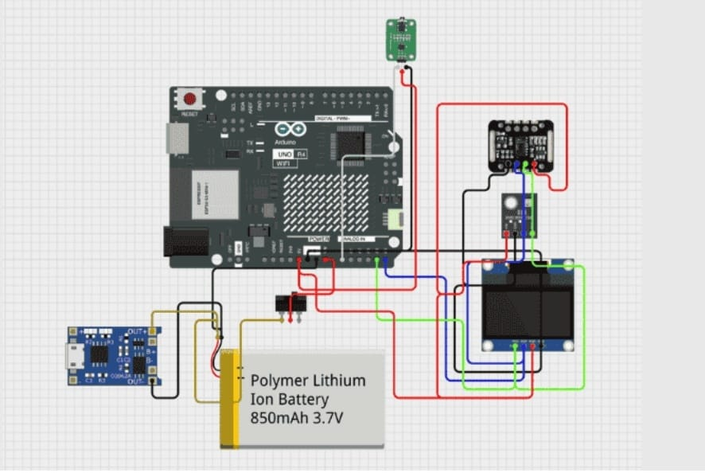
Fig. 2) Hardware Architecture

c. Wireframes:
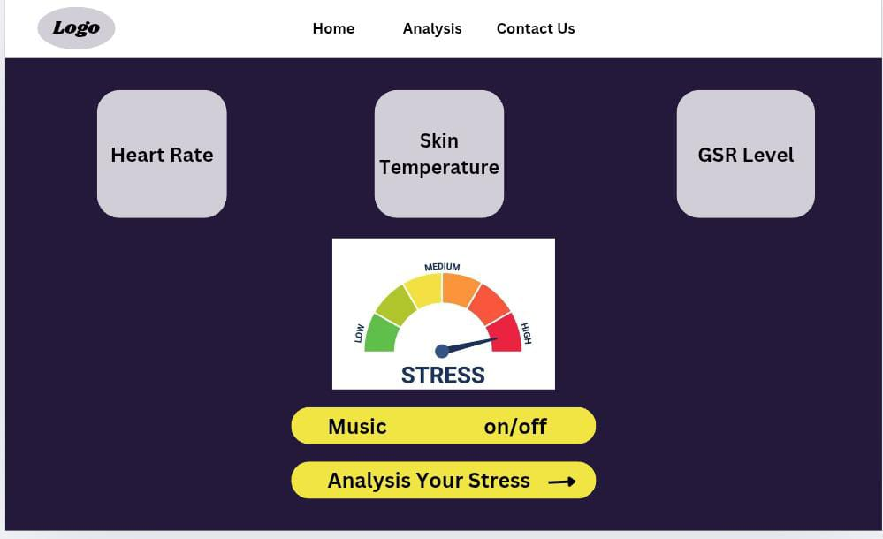
Fig. 3) Home page

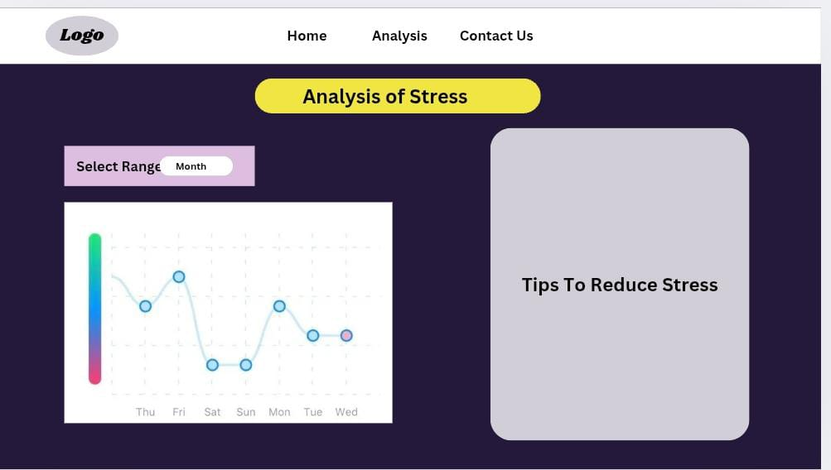
Fig. 4) Analysis Page
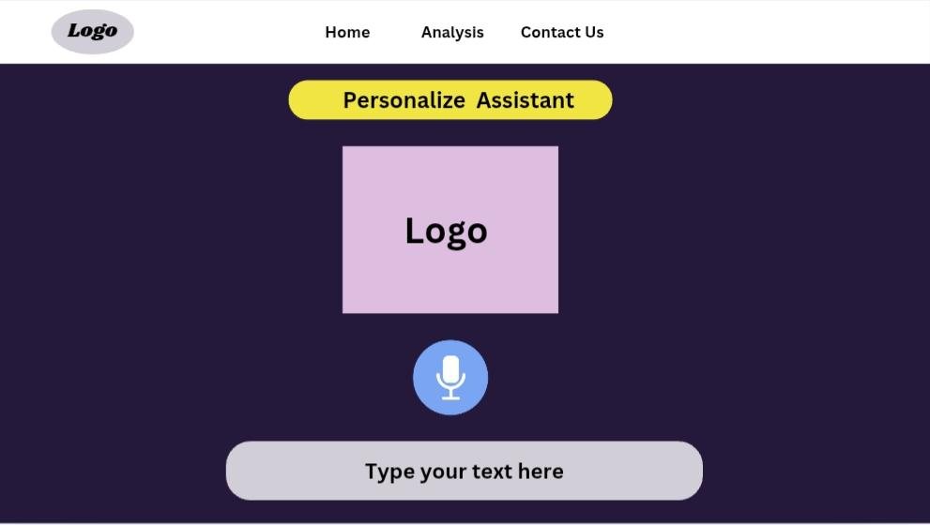
fig 5) Personalized Assistant

d. Modules:
1.Data Collection Module
Collects physiological data from sensors (e.g., heart rate, temperature).
2.Data Processing Module
Cleans and processes the collected data for analysis.
3.Stress Detection Module
Uses a Machine Learning model to analyze data and detect stress levels.
4.Personalized Assistant Module
Provides suggestions and support through an AI assistant with voice interaction.
5.User Interface Module
Displays stress levels, insights, and recommendations on the website dashboard.
6.Device Design Module
Focuses on making the CalmBand compact, wearable, and comfortable.

Project objectives
1. To Collect Physiological Data for Stress Monitoring
The system collects real-time data like heart rate and skin response using sensors. This helps in detecting stress levels accurately. The data is used for further analysis and monitoring.
2. To Develop a Personalized AI Assistant with Voice Support for Stress Management
An AI assistant provides personalized stress relief suggestions based on user data. It supports voice interaction for easy communication. This improves user experience and effectiveness.
3. To Design a More Compact and Comfortable CalmBand Device
The CalmBand is designed to be compact, lightweight, and comfortable for daily use. It ensures users can wear it continuously without discomfort. This improves usability and convenience.
4. To Analyze and Compare the CalmBand System with Existing Systems
The system is compared with existing solutions based on features and performance. This helps identify improvements and advantages. It highlights the uniqueness of CalmBand

Academic objectives
- Learn embedded system design and sensor interfacing (ESP32/Arduino).
- Gain knowledge in biosignal processing and physiological data interpretation.
- Explore machine learning techniques for stress detection.
- Develop skills in mobile/web application development for IoT-based health systems.
- Understand cloud data storage and analytics for wearable health devices.
- Gain Knowledge in building personalized assistant with voice support.

Requirement Analysis
a. Software Requirements:
- Arduino IDE – for writing and uploading microcontroller firmware.
- Python (with libraries like NumPy, Pandas, Scikit-learn) – for biosignal data processing and machine learning model development.
- Firebase - for cloud connectivity, real-time data storage and retrieval.
- Web Technologies (HTML, CSS, JavaScript, React) – for developing the web-based user interface.
- Voice Assistant Libraries: Speech-to-Text, Text-to-Speech (e.g., pyttsx3)
b. Hardware Requirements:
- ESP32 Microcontroller – handles sensor interfacing, processing, and wireless communication.
- Heart Rate Sensor (e.g., MAX30102) – for HR and HRV measurement.
- GSR Sensor – to measure skin conductivity changes associated with stress.
- Skin Temperature Sensor (e.g., DS18B20 or LM35) – to record peripheral skin temperature variations.
- Rechargeable Battery & Charging Module – to power the wearable device.
- Wristband Enclosure – ergonomic design for user comfort and sensor placement.

c. Operating System Requirements
- Microcontroller Development:
ESP32 uses firmware uploaded via Arduino IDE or PlatformIO.
- For Web Application Development & Hosting:
- Any OS capable of running a modern browser (Chrome, Firefox, Edge).
- For Cloud & Data Processing Environment:

Advantages
Here are the Advantages of the Proposed Stress Monitoring Wristband System :
- Real-Time Stress Monitoring
The system continuously tracks physiological parameters like heart rate and skin conductivity to detect stress levels instantly, enabling timely user feedback.
- Non-Invasive and Wearable Design
The wristband is lightweight, comfortable, and easy to wear throughout the day, without causing discomfort or needing invasive procedures.
- Immediate Alerts and Feedback
The system provides real-time alerts when stress is detected, along with suggestions like breathing exercises or relaxation tips via a connected mobile/web app.
- Compact and Portable
The small form factor of the wristband makes it easy to carry, use, and monitor stress anywhere—at home, work, or during travel.
- Data Visualization
Sensor data can be transmitted to a mobile or web app for easy visualization of trends, helping users understand their stress patterns over time.
- Health Awareness & Prevention
Early detection of stress helps users adopt better lifestyle habits, seek medical help if needed, and prevent stress-related health issues.

Limitations
- Short Battery Life
Continuous monitoring and wireless communication (Bluetooth/Wi-Fi) consume significant power. Without power optimization or a larger battery, the device may require frequent charging.

- Only Core Functionalities
The current version includes only core functionalities (GSR, heart rate, temperature). Advanced features like emotion tracking, or sleep monitoring are not yet included but can be added in future versions

Future scope

1.Multi-Parameter Health Monitoring
Additional sensors like SpO₂ (blood oxygen), ECG (electrocardiogram), sleep tracking, and motion sensors can be added to build a complete health monitoring system.

2.Battery Optimization and Power Management
Improvements in energy-efficient coding and low-power components can increase battery life for long-term usage without frequent charging.

3.Wearability Enhancement
Future iterations can explore different form factors such as rings, patches, or clothing integration for more flexible usage.

4.Integration with Wellness Platforms
The wristband can be connected to platforms like Google Fit, Apple Health, or mental health apps to provide a unified wellness experience.

References
[1] A. Abdullah et al., “Stress-Track: An IoT-Based Wearable System for Real-Time Stress Monitoring Using Machine Learning,” International Journal of Emerging Technology and Advanced Engineering, 2025.

[2] A. Tonacci, “Predicting Stress Reduction Using Wearable Sensor Data and Machine Learning Models,” Journal of Biomedical Informatics, 2025.

[3] Z. Zainudin, S. Hasan, S. M. Shamsuddin, and S. Argawal, “IoT-Based Early Stress Detection Using GSR and ECG Sensors: A Comparative Analysis,” Procedia Computer Science, vol. 192, pp. 1569–1578, 2021.

[4] A. R. Subhani, W. Mumtaz, M. N. B. M. Saad, N. Kamel, and A. S. Malik, “EEG-Based Multi-Level Stress Detection Using Machine Learning,” Computers in Biology and Medicine, vol. 107, pp. 248–256, 2025.

[5] Aamir Arsalan, Muhammad Majid, “A Review of Wearable Sensor-Based Stress Monitoring Systems: Physiological Indicators and Design Challenges,” IEEE Reviews in Biomedical Engineering, vol. 18, pp. 54–66, 2025.

[6] W. Liao, “Real-Time Human Stress Inference Using Multimodal Inputs and Dynamic Bayesian Networks,” IEEE Transactions on Affective Computing, vol. 12, no. 4, pp. 982–993, 2025.

[7] M. H. Lee, G. Yang, H.–K. Lee, and S. Bang, “Development Stress Monitoring System Based on Personal Digital Assistant (PDA),” Proceedings of the IEEE Conference on Engineering in Medicine and Biology Society (EMBC), 2004.

[8] E. Jovanov et al., “Real-Time Stress Monitoring Using Wireless Intelligent Sensor Networks,” IEEE Transactions on Information Technology in Biomedicine, vol. 9, no. 3, pp. 345–355, 2005.

[9] Abdulkerim Eryilmaz and Ahmet Kara, “Peaceful and Happy Living: A Mixed-Methods Exploration of Contributors and Perceptions,” International Journal of Psychology and Mental Wellness, vol. 30, no. 1, pp. 14–28, 2025.

[10] H. S. Swolfs and J. B. Walsh, “Direct Measurement of Rock Stress Using a Liquid-Filled Pressurized Cell Embedded in a Compliant Cavity,” Journal of Geophysical Research: Solid Earth, vol. 129, no. 5, pp. 1–12, 2025.

Mini Project Group Members
1.Aarya Sunil Tupe (07)
2.Shreya Sudhir Sawant(12)
3.Shreya Balkrishna Shivankar(06)

Mini Project Guide Prof. Dangat G.D

Prof. Dipali Ghatge Head of Computer Science & Engg. Department

