Online Retail Sales Analysis Report
Dataset link: https://archive.ics.uci.edu/dataset/502/online+retail+ii

1. Introduction
This project analyses an online retail dataset to understand sales performance, customer behaviour, and product trends. Python (Google Colab) was used for data cleaning and exploratory data analysis (EDA), while Power BI provided interactive visualizations and business insights. The goal is to generate actionable recommendations for improving revenue and customer engagement.

2. Dataset Overview
The dataset contains transactional sales data, including:
- Invoice Number
- Product Description
- Quantity & Unit Price
- Invoice Date
- Customer ID
- Country
Data Cleaning Steps (Google Colab):
- Removed records with missing product descriptions and customer IDs
- Filtered out negative or zero quantities and prices
- Converted invoice date to datetime format
- Created derived fields: Total Revenue, Month, Year
Metric | Value
Total Revenue | £8.91M
Total Orders | 17,000
Total Customers | 4,338
Average Order Value | £515.65
Key Metrics:

Highlights:
- Revenue shows seasonal peaks in November (£1.16M) and dips in February (£0.45M).
- Top 3 products contribute 46% of revenue.
- UK dominates sales (~82% of revenue), with limited international performance.
3. Revenue Analysis

3.1 Monthly Revenue Trend
Revenue fluctuated throughout the year:
- Peak Revenue: November 2011 – £1.16M (holiday season impact).
- Lowest Revenue: February 2011 – £0.45M (off-season).
- Consistent growth observed July–November indicates effective campaigns or seasonal demand.
Recommendation: Implement targeted marketing and promotions during low-revenue months to smooth revenue variability.
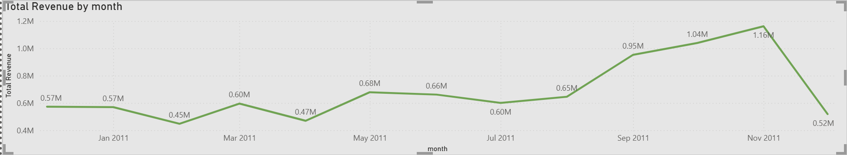Fig 1: Line chart of total revenue per month with peaks highlighted.
3.2 Top Products by Revenue

Rank | Product Description | Revenue (£K)
1 | PAPER CRAFT, LITTLE BIRDIE | 168
2 | REGENCY CAKESTAND 3 TIER | 143
3 | WHITE HANGING HEART T-LIGHT HOLDER | 100
4 | JUMBO BAG RED RETROSPOT | 85
5 | MEDIUM CERAMIC TOP STORAGE JAR | 81
6 | POSTAGE | 78
7 | PARTY BUNTING | 69
8 | ASSORTED COLOUR BIRD ORNAMENT | 57
Insights:
- Top products are highly concentrated, accounting for nearly half of total revenue.
- Lower-performing products present opportunities for bundling or targeted promotion.
- Revenue from non-product items (POSTAGE) should be reviewed for reporting accuracy.
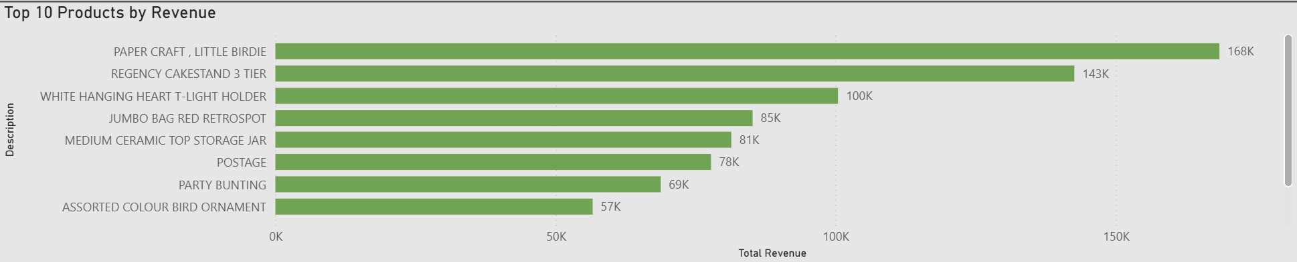Fig 2: Horizontal bar chart of top 10 products by revenue.

4. Customer Insights
- Total Customers: 4,338
- Average Orders per Customer: ~4/year

Implications:
- Revenue depends significantly on repeat purchases.
- Enhancing customer retention through loyalty programs, targeted promotions, and personalized recommendations can boost sales.
5. Geographic Revenue Distribution

Country | Revenue (£M)
United Kingdom | 7.3
Netherlands | 0.3
EIRE | 0.3
Germany | 0.2
France | 0.2
Australia | 0.1
Spain | 0.1
Switzerland | 0.1
Belgium | 0.0
Sweden | 0.0
Insights:
- UK dominates revenue (~82%), confirming a strong domestic market presence.
- International markets show growth potential.
- Strategic marketing, partnerships, and shipping optimization can improve performance abroad.
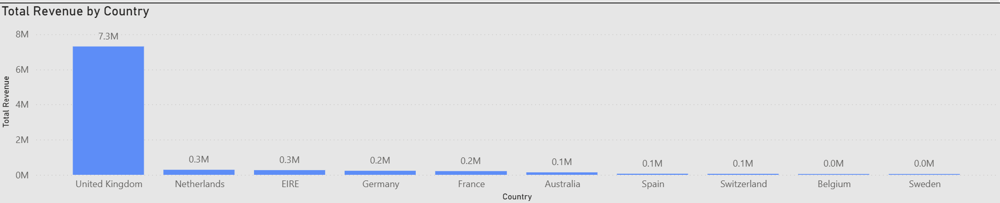Fig 3: Column chart of revenue by country with UK highlighted.
6. Recommendations
- Customer Retention & Growth:
  - Launch loyalty programs and personalized promotions to increase repeat purchases.
- Seasonal Sales Optimization:
  - Replicate November campaigns during off-peak months (Jan–Mar) to balance revenue.
- Product Portfolio Strategy:
  - Promote lower-performing products via bundles or discounts with top sellers.
  - Review and clarify non-product revenue items.
- International Expansion:
  - Focus on markets with existing traction (Netherlands, EIRE).
  - Improve logistics and localized marketing campaigns.
- Data-Driven Monitoring:
  - Track monthly revenue, top products, and customer behaviour through dashboards for informed decision-making.
7. Conclusion
The online retail store shows strong domestic revenue driven by high-value products and repeat customers. Key opportunities for growth include international expansion, customer retention, product promotion, and seasonal strategy optimization. By leveraging data-driven insights, the company can achieve sustainable revenue growth and improve profitability.

