**COGNIZANT**

**Week- Hands on**

**Assignments**

**GIT**

**Name: *Lathika K***

**Super Set ID: *6384458***

**E-mail:727822tuit125@skct.edu.in**

**GIT**

**GITLAB-https://gitlab.com/lathikalathika1122/gitdemo.git**

**Question-1(Git lab configuration using Git bash)**

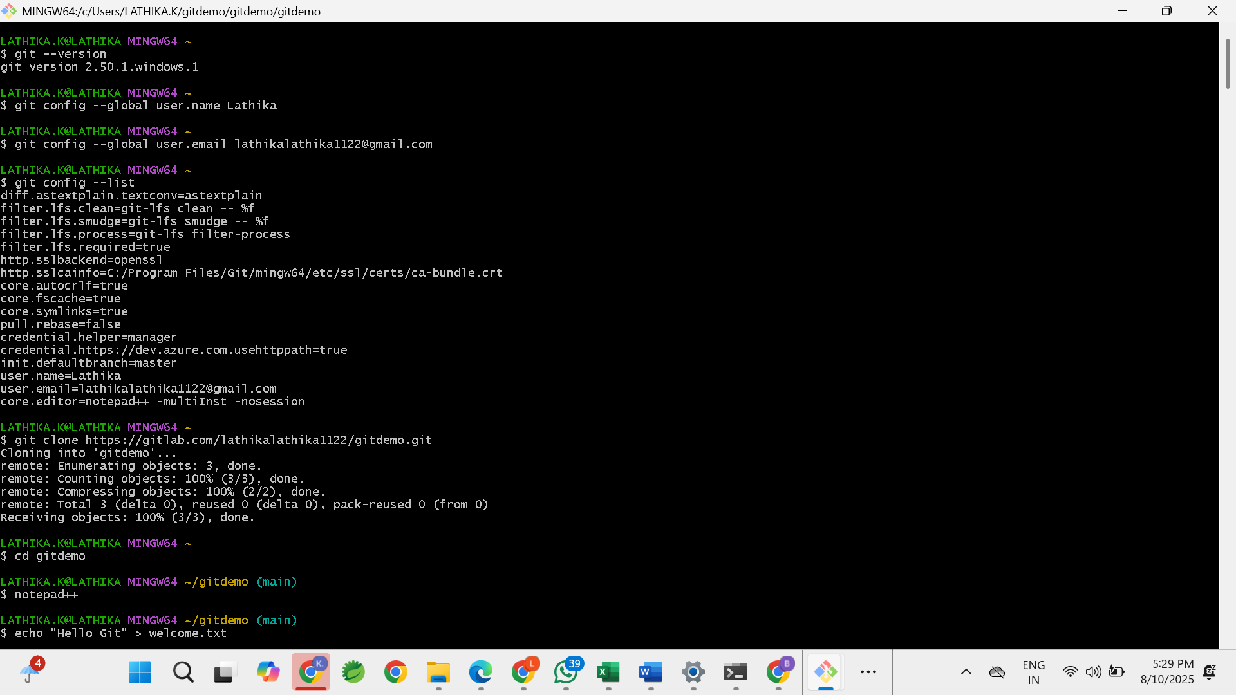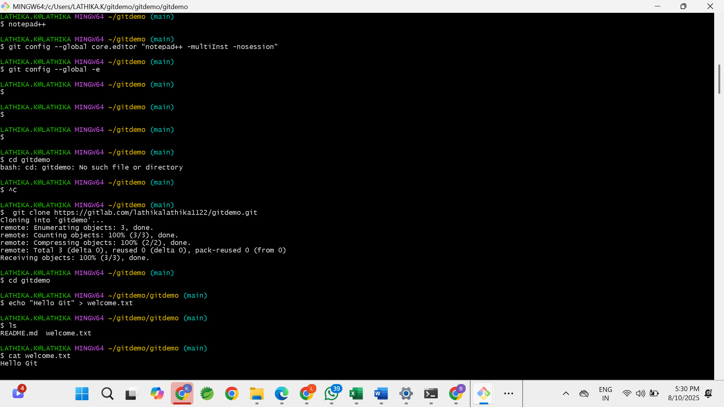

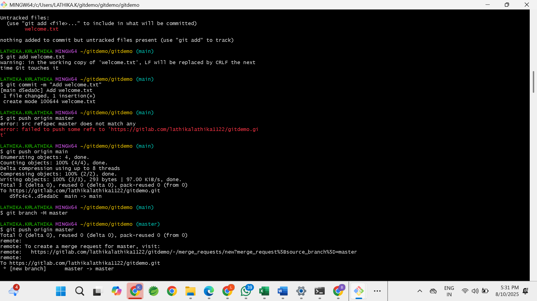

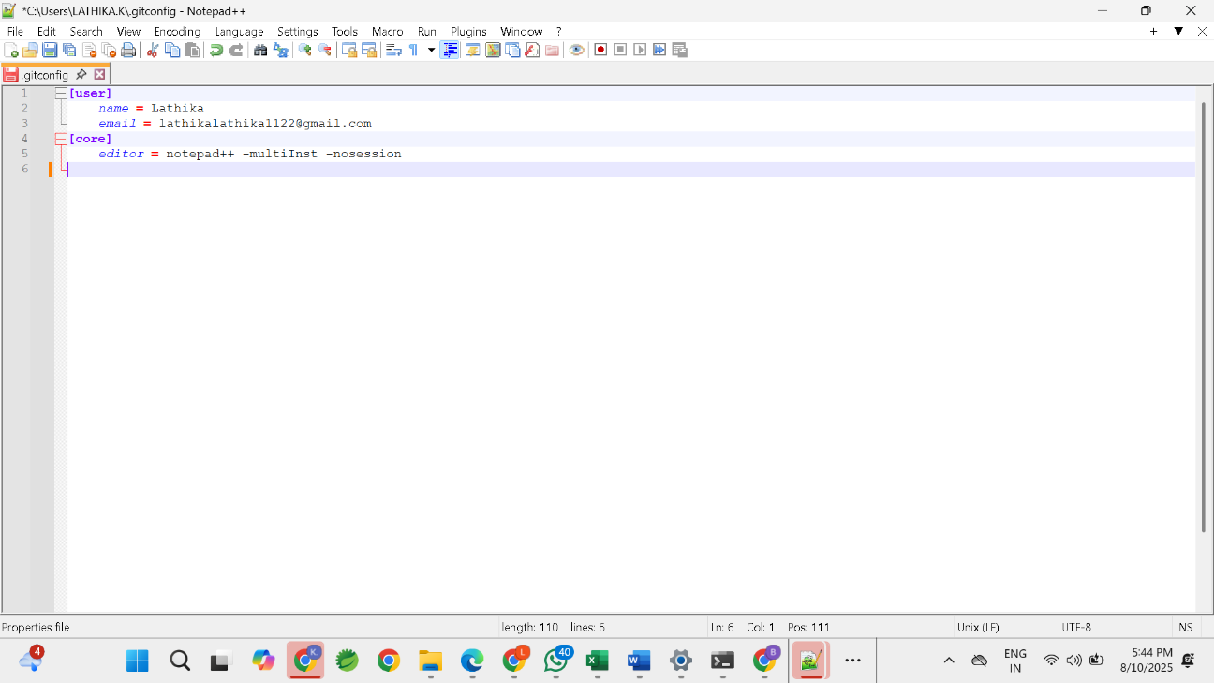

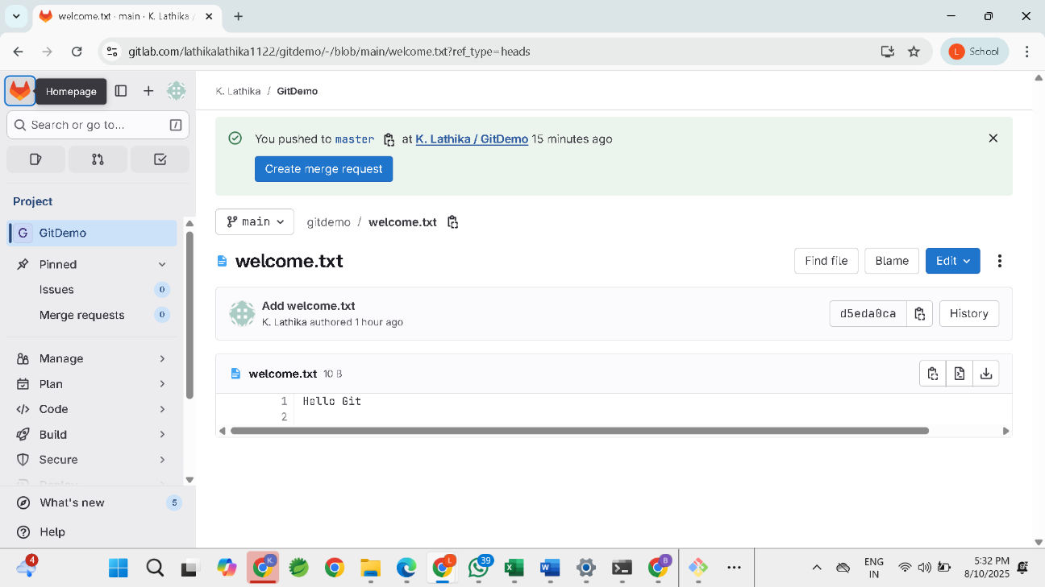

**Question-2(Create a “.log” file and a log folder in the working directory of Git)**

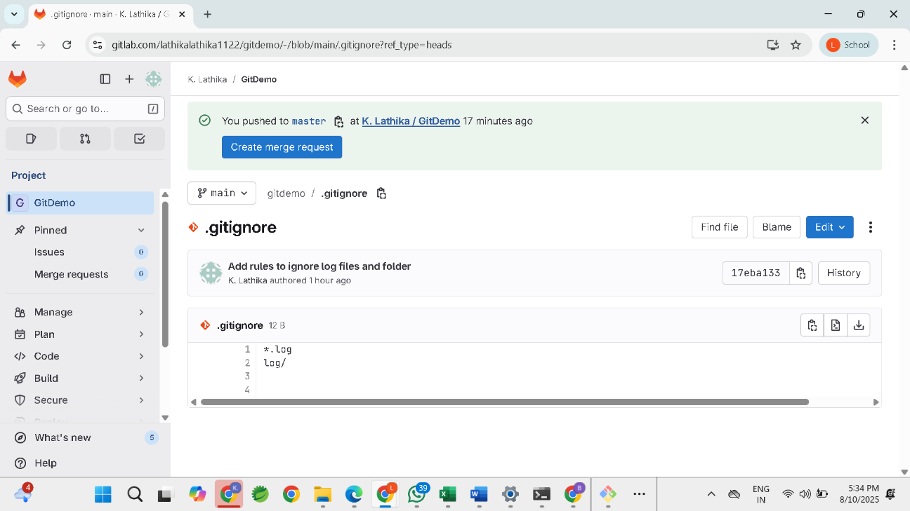

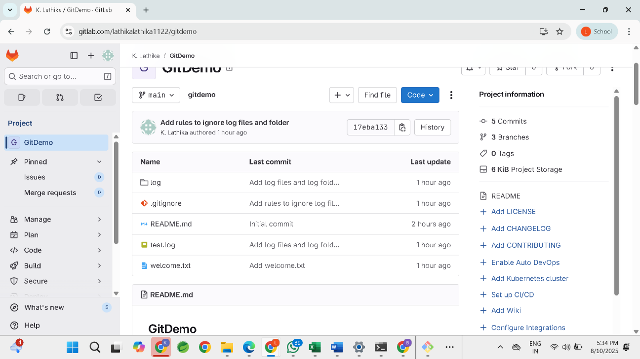

**Question-3(Git Branching and Merging)**

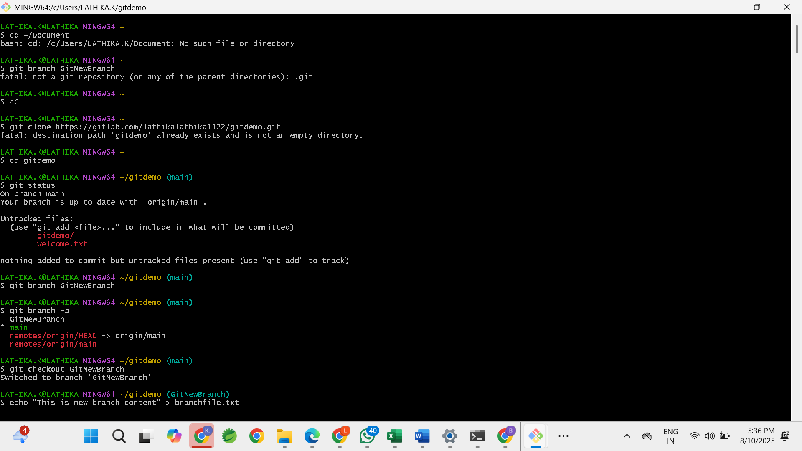

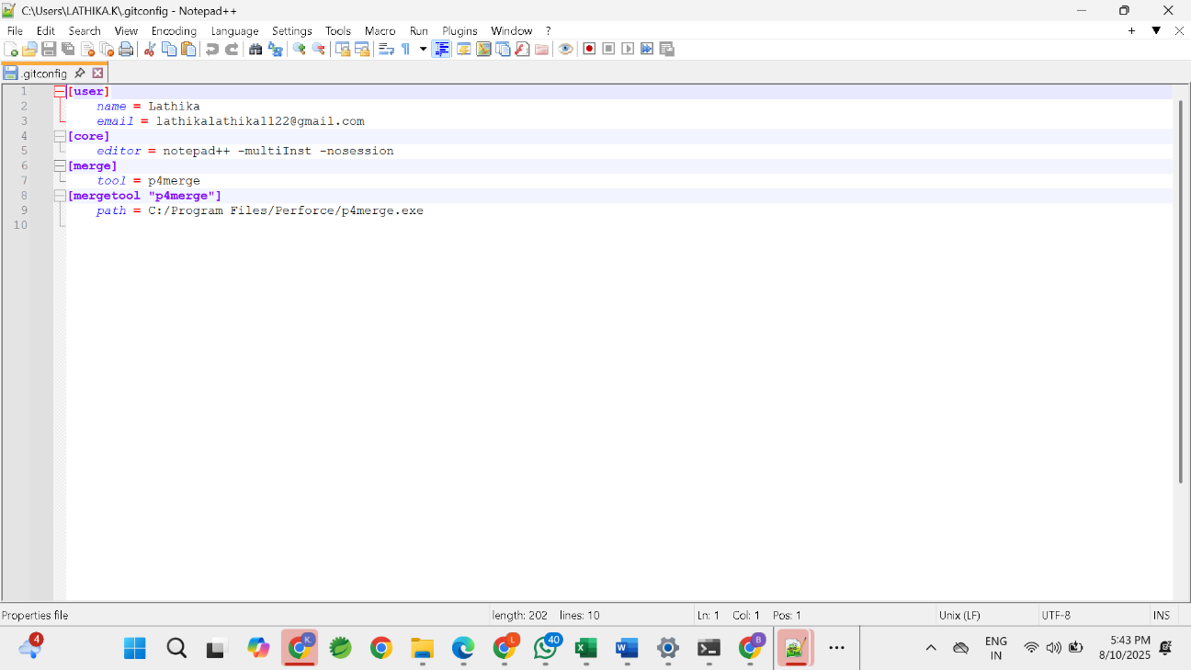

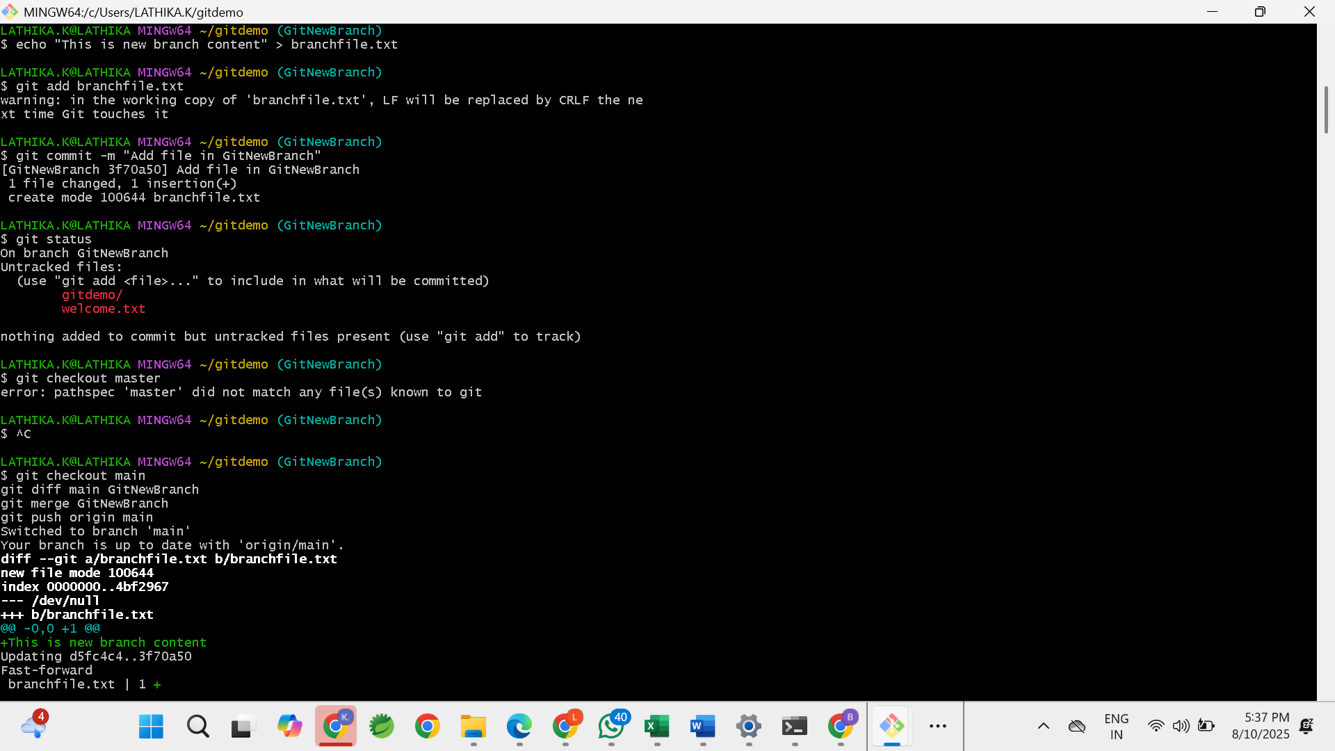

**Question-4(Implement conflict resolution when multiple users are updating the trunk (or master))**

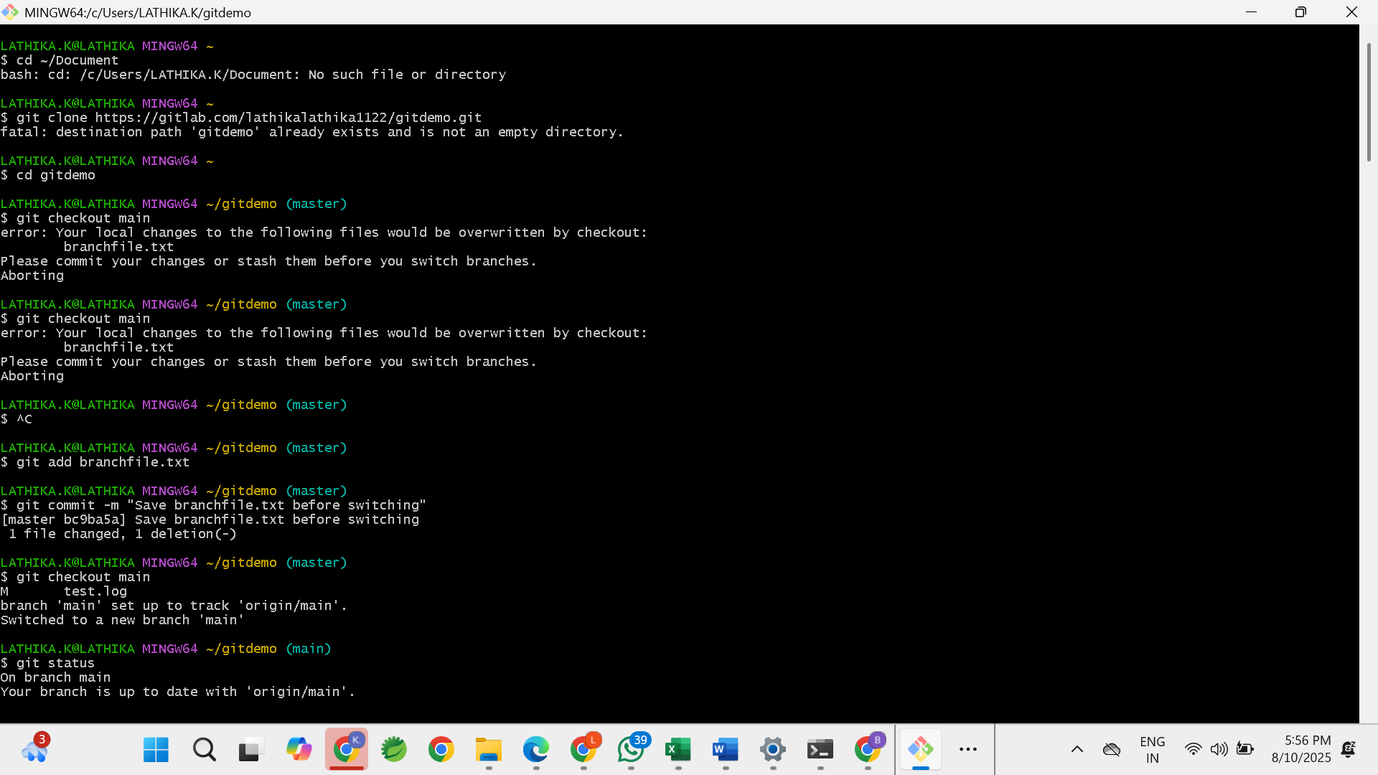

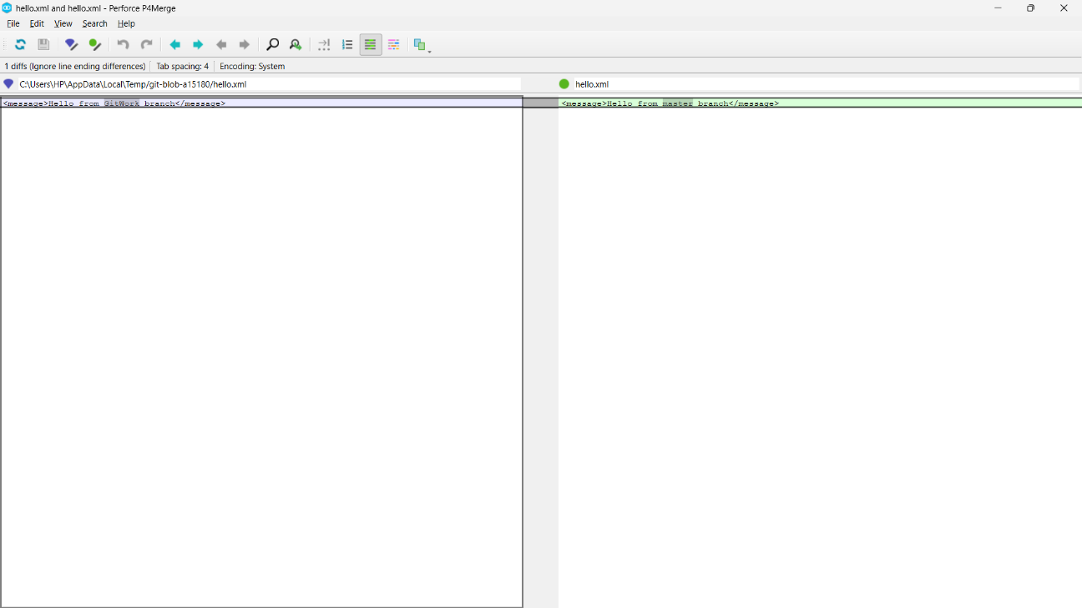

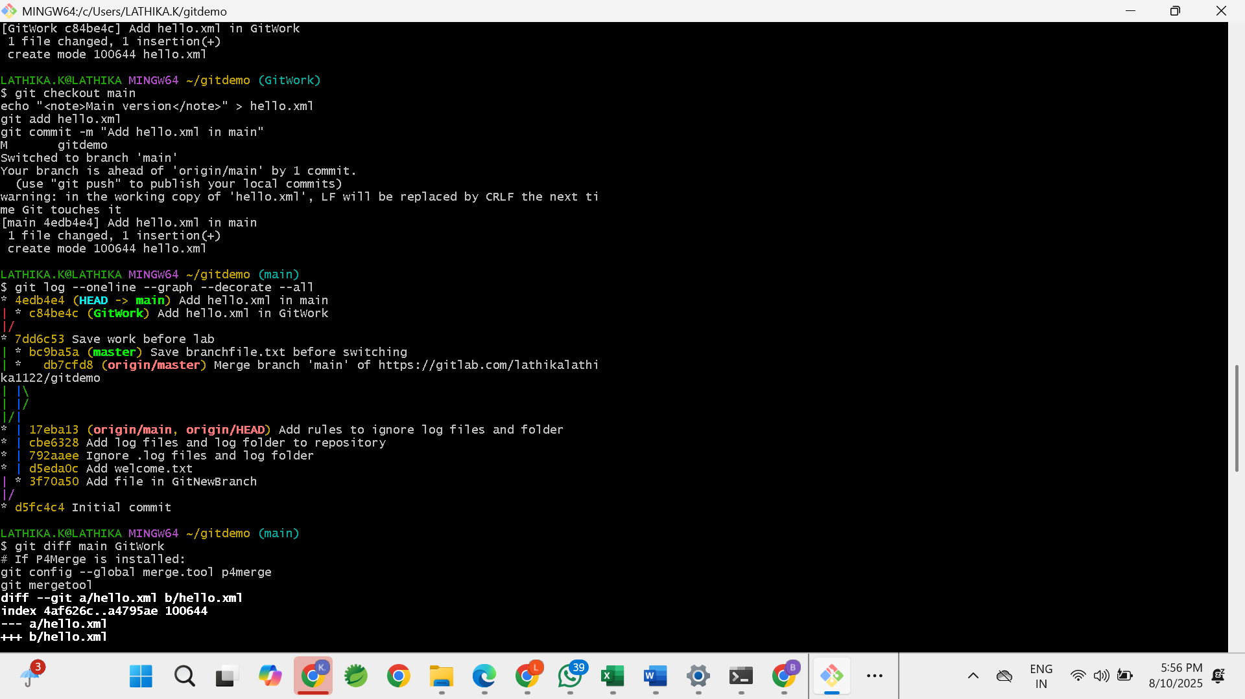

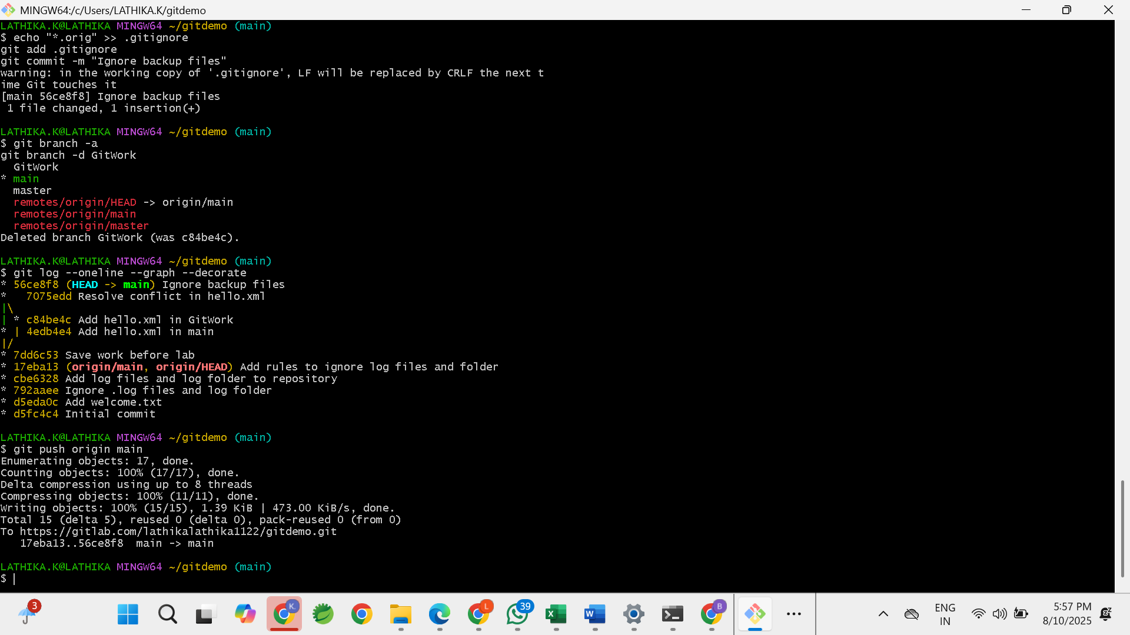

**Question-5(Execute steps involving clean up and push back to remote Git)**

