SMBD Configuration Guide

# Introduction

The guide provides information about how to install, configure and troubleshooting.

# Environment

This is the configuration on Windows server2016.

OS: Windows Server2016

Network card

|  |  |  |  |  |
| --- | --- | --- | --- | --- |
| Network Card Name | | RDMA | | Non-RDMA |
| Chelsio | Mellanox |
| Driver | | [ChelsioUwire_6.14.2.0_WIN_006.0.54.exe](https://service.chelsio.com/downloads/Microsoft/Drivers/ChelsioUwire_6.14.2.0_WIN_006.0.54/ChelsioUwire_6.14.2.0_WIN_006.0.54.exe) | [MLNX_VPI_WinOF-5_35_All_win2016_x64.exe](http://www.mellanox.com/downloads/WinOF/FUR/MLNX_VPI_WinOF-5_35_All_win2016_x64.exe) |  |
| IP | Driver | 192.168.30.1 | 192.168.40.1 | 192.168.1.111 |
| SUT | 192.168.30.101 | 192.168.40.101 | 192.168.1.112 |
| Subnet | | 255.255.255.0  (Driver & SUT) | 255.255.255.0  (Driver & SUT) |  |
| Supplement | |  | [Configuration](https://docs.mellanox.com/display/WINOFv550/OpenSM+-+Subnet+Manager) |  |

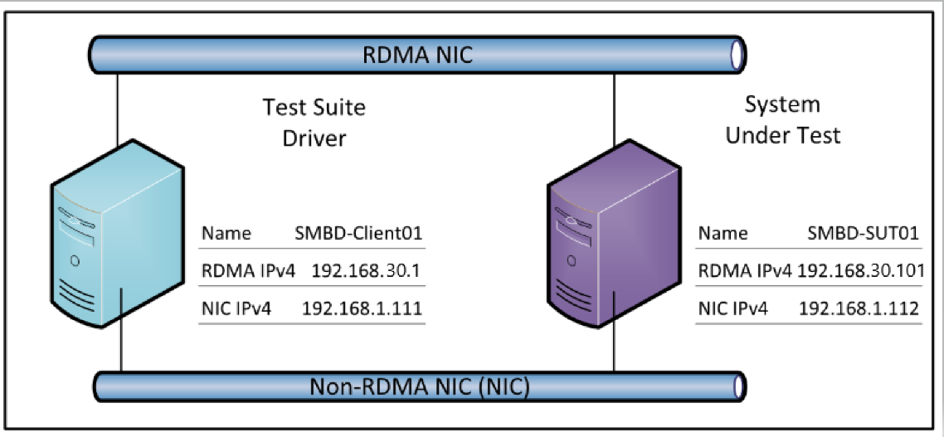

# Configuration

This section describes the configuration for the test environment that are used to run this test suite.

* Follow the instructions for installation: [MS-SMBD Server Test Suite User Guide](https://github.com/microsoft/WindowsProtocolTestSuites/blob/staging/TestSuites/MS-SMBD/docs/MS-SMBD_ServerUserGuide.md#_Toc395696796)
* After installing the RDMA network card driver, Mellanox network card needs to be configured, please refer to [Mellanox OFED for Windows - WinOF / WinOF-2](https://cn.mellanox.com/page/products_dyn?product_family=32&mtag=windows_sw_drivers&ssn=b860gd6jki3t42ulau0bv732n7)
* Check network adapter, the state must be enabled.

# Troubleshooting

This section describes how to troubleshoot common issues in running test cases.

**Unalbe to connect Driver:**

**Message**:

New-PSSession : [SMBD-Driver] Connecting to remote server SMBD-Driver failed with the following error message : Access is denied. For more information, see the about_Remote_Troubleshooting Help topic.

**Solution**:

To add all computers to the list of trusted hosts, use the following command, which places a value of * (all) in the ComputerName

PowerShell

Enable-PSRemoting

Set-Item wsman:localhost\client\trustedhosts -Value *

More information is available: [About Remote Troubleshooting](https://docs.microsoft.com/en-us/powershell/module/microsoft.powershell.core/about/about_remote_troubleshooting?view=powershell-6).

**Test case cannot be detected**

**Message:**

No test runs are available for this build. Run tests and get rich reports by using an appropriate built-in task such as the Visual Studio Test task. Alternately, run tests using a runner of your choice such as JUnit, xUnit, mocha, jest, pytest, rspec, etc. and use the Publish Test Results task to get rich reports.

**Solution**:

Please check the version of the **ProtocolTestFramework(PTF)** .

**Mellanox network card cannot pass test case**

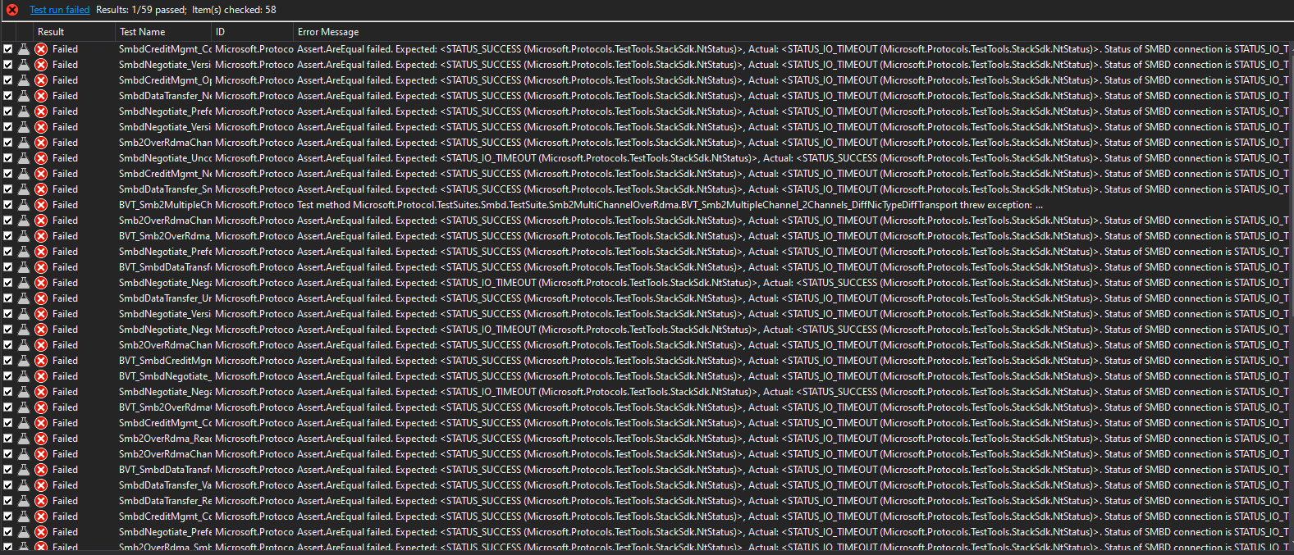

**Solution**:

Please check the status of **OpenSM** services.

Please check the driver of Mellanox, too new drives can lead to errors.