**Steps to install DSF driver for RDPEUSB:**

1. DSF msi location:

WindowsProtocolTestSuitesHelper\TestSuites\RDP\Client\Setup\Tools\DSF

1. Copy #1 directory to c:\Temp\Tools
2. DSF Installation scripts folder: WindowsProtocolTestSuitesHelper\TestSuites\RDP\Client\Setup\VSTORMLITEFiles\PostScript
3. Copy #3 directory to c:\Temp
4. Launch native PowerShell command and run below

*cd C:\Temp*

*.\Enable-TestSignning.ps1*

*.\Install-DSF.ps1*

It will show a ‘Windows Security’ dialog for 5 times like below, you need to click ‘Install this driver software anyway’.

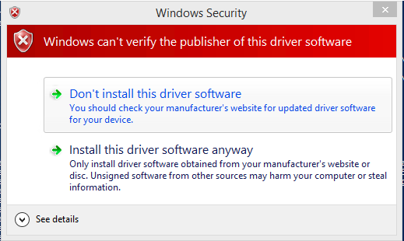

Once done, it will show like below,

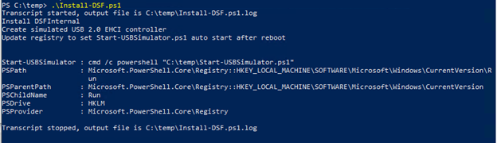

1. Run below powershell script:

*.\Start-USBSimulator.ps1*

When the script done, you will see below output and a simulator application,



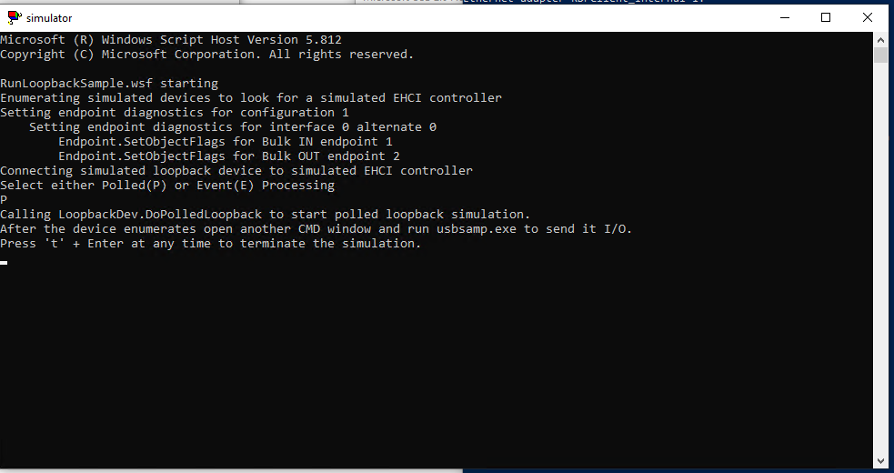

At present, for Win10 OS build 17763, it can install the DSF driver to work fine, and for Windows 8.1 Enterprise OS build 9600, windows Server 2019 OS build 19041, run the script might crash OS and cannot install the DSF driver successfully.

**Note:**

1. Even MSFTTestRoot.cer is expired, but you still can install DSF on Win10 OS build 17763 without issue.
2. Even we can install DSF on Win10 OS build 17763, but Win 7 is the latest supported OS for DSF: [Supported Platforms for DSF (Windows Driver Kit) | Microsoft Docs](https://docs.microsoft.com/zh-cn/previous-versions/windows/hardware/dsf/ff542516(v=vs.85)), if we want to use DSF on latest OS, we should port it to KMDF driver [emulated USB devices (UDE)](https://msdn.microsoft.com/en-us/library/windows/hardware/mt595925(v=vs.85).aspx).

And if you want to check if your DSF driver is good or not, you can check below red line ‘1’,’2’,’3’,’4’, and you can run case like red line ‘5’.

