Temasek Polytechnic

School of Informatics and IT

**Diploma in Information Technology (IT)**

Software Design Specifications (DS)

**Project Particulars**

|  |  |
| --- | --- |
| **Tutor** | Zaw |
| **Class** | P01 |
| **Project Title** | Hotel Management System |

**Project Team’s Particulars**

|  |  |
| --- | --- |
| **Matric Number** | **Student Name** |
| **1706416C** | **Vincent Tang Jian Wei** |
| **1701380F** | **Ong Zhixuan** |
| **1704749I** | **Ikhwan Haziq Bin Sinwan** |
| **1707184F** | **Aloysius Wee Zi Xiang** |

Revision History

|  |  |  |  |
| --- | --- | --- | --- |
| **Date** | **Version** | **Description** | **Author** |
| 30/12/2018 | 1.0 | Draft | All |
| 04/01/2019 | 1.1 | Final | All |

**Table of Contents**

1. DISTRIBUTION OF WORKLOAD.. 2

2. ARCHITECTURE DESIGN.. 3

3. USER INTERFACE (UI) DESIGN.. 3

4. PROGRAM DESIGN.. 7

5. DATABASE DESIGN.. 10

# **1. DISTRIBUTION OF WORKLOAD**

|  |  |
| --- | --- |
| **Design** | **Members** |
| Architecture Design | Aloysius Wee |
| User Interface Design | Vincent Tang |
| Program Design | Ikhwan Haziq |
| Database Design | Ong Zhi Xuan |

# 

# **2. ARCHITECTURE DESIGN**

We’ll be using 3-tier architecture design, the first layer is where user/ client will be using. Followed by the web application which the web interface will be interact with, and finally the database which all information from customer details, booking preferences to staff management will be stored here.

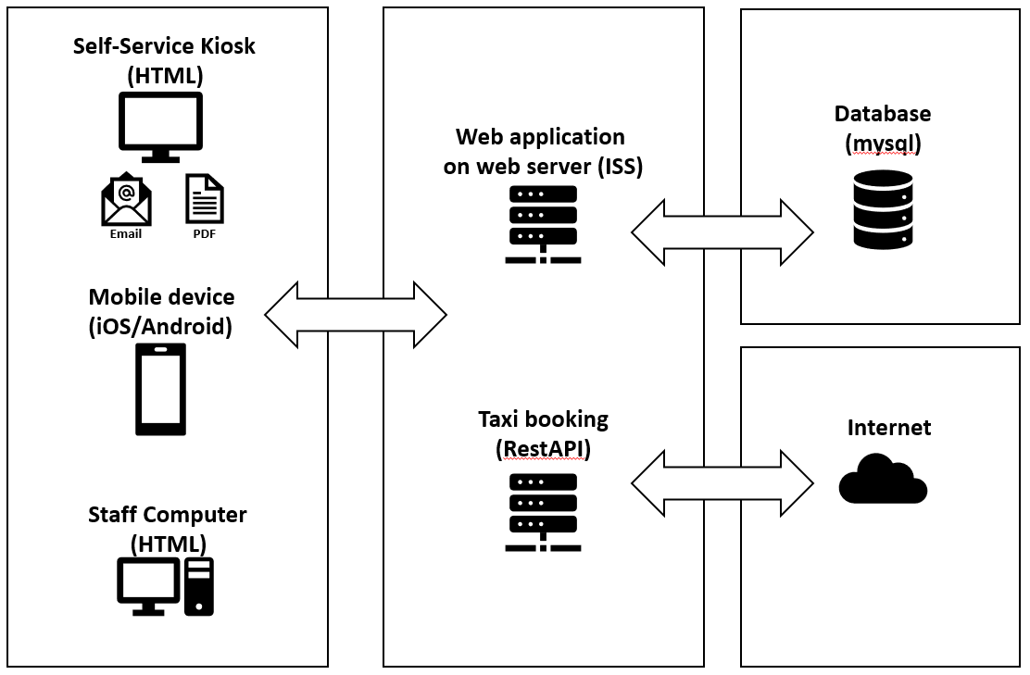

# **3. USER INTERFACE (UI) DESIGN**

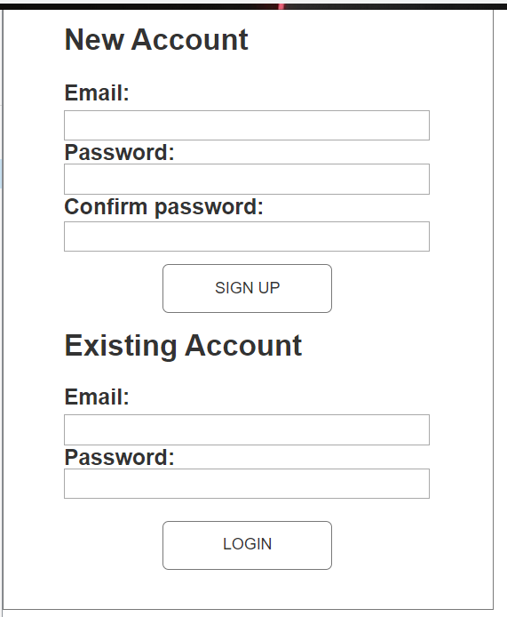

This is the home page, this is what the customer first sees when the load up the application for the first time. There is two option here, first option is for new customers where they sign up to use the application. Second option is for existing customer where they already have an account but logged out previously. As the application needs a user account before the customer can access the hotel’s features, most features like booking a room, room services will be locked until the login with a valid account.

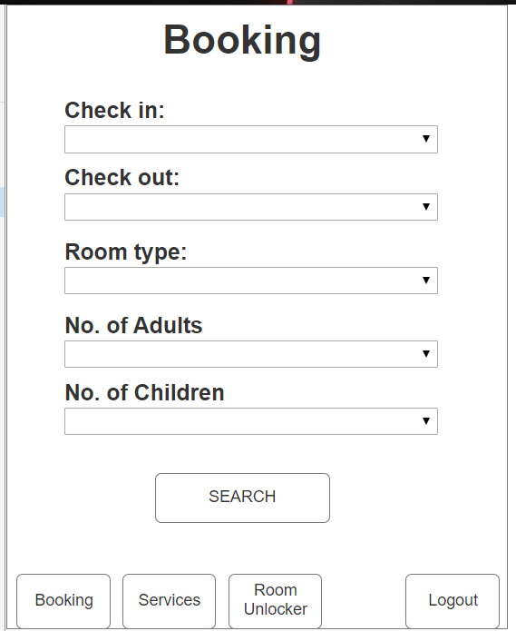

This is the booking page that appears when after user logins into the mobile application. For the both the check in and check out selection, a calendar pop out will be used to select the dates. The reason for this is that the user would not have to manually enter the date that they are checking in and out, making it less troublesome and more convenient for the users.

As for the room type, a drop down list will be used instead as room type have only two options compared to dates, for example, standard and premium.

The selection for number of adults and number of children will also be using a drop down list using the range of 0-3 for both. The reasoning behind this is that we do not expect that many people using a single room by itself as each room will only have two beds at most, along two floor mattress if needed.

The search button will be visible at all times, but only interactable when all the above option are filled out. The reason why the button is called search instead of select is because the application is searching for rooms that are available during the selected time frame.

The bottom buttons are for navigation purposes, the first three buttons each bring the customer to the respective pages. For the logout button is there for when the customer feels like they need to log out or switch to another account, it will bring them to the home page.

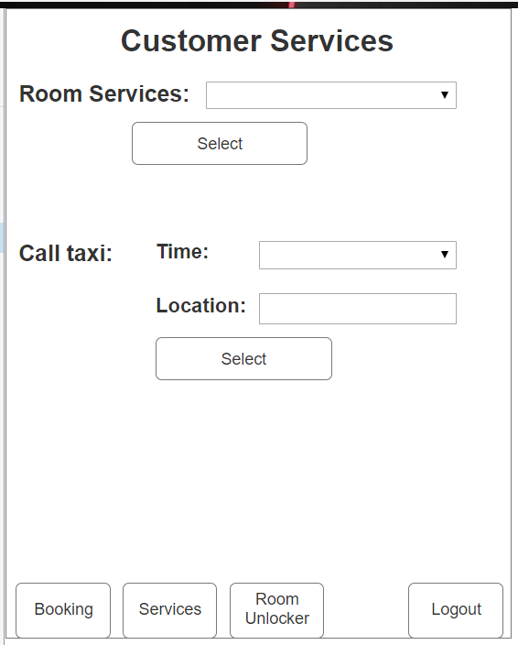

This is the services page that mobile application users will see after they have selected and confirmed a room of their choosing. As the application recognise which room the customer have booked, all of the services will be linked to that particular room. Room services options are chosen using a drop down list. The call taxi function works by first select a time that the customer want the taxi to arrive follow by the location where the taxi is arriving. Fees will be automatically added to the customer’s bill when the check their bill.

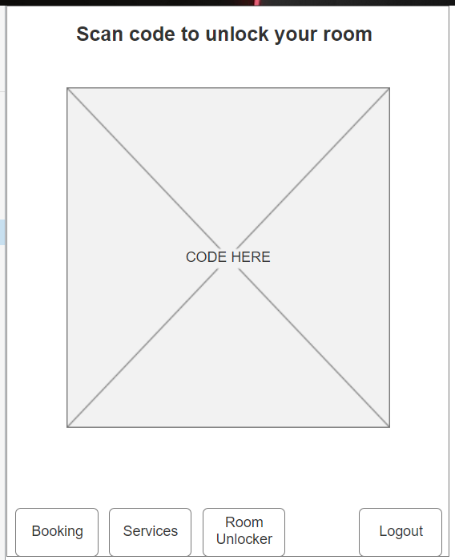

The is the room unlocker page, the special feature of this application. Customer simply need to scan this code with the room’s scanner. The code is in big enough that the scanner is able to scan it properly. As with the services page, this code is unique to each customer and will only unlock the rooms that they have booked, it will not work with any other rooms.

# **4 . PROGRAM DESIGN**

**Sequence Diagram for [Hotel Management System]**

Use case Name: Hotel Check In and Check Out.

Actors:

• User: Not registered in the system.

• Hotel administrator: In charge of updating the application system, availability of hotel rooms and confirmation of users booking by sending emails and text message.

Triggers:

• The user indicates that he or she wants to make online booking through the application, users are able to check in and out of their hotel rooms by using the application and able to use all the additional features that were provided in the application.

Preconditions:

• The users can make an online booking of hotel rooms if the room is available and the users can check in and out of the hotel rooms by using the application once the room is ready and to check out on the day and time they have selected..

Normal Flows:

1. Register user’s information.

2. User will choose which types of room that are available in that hotel.

3. User will select date for their stay in that hotel..

4. View availability of rooms.

5. User select and confirm booking.

6. User can check in into the hotel through the application on the day of checking in.

7. User can check out of from their room by using the application.

Alternative flow:

4a. Rooms fully booked, user must choose other dates of booking.

5a. User will receive a confirmation reservation email or text message from the hotel.

# 

# **5. DATABASE DESIGN**

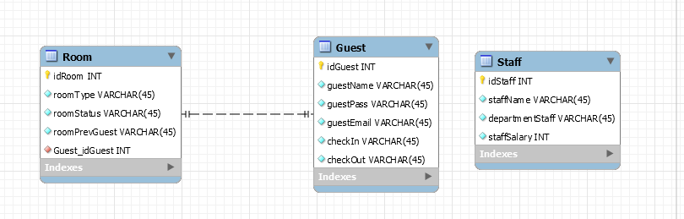

For the room table, there would have a room ID assigned to each element in the table the room ID would correspond to the room number of the hotel. The room type would dictate which type of room the room would be (basic room,luxury suite). Room status shows the availability of the room. Previous room guest would show the previous occupant of the room for easy for reference in case there is a need to contact said guest.

For the guest table , it will contain the guest’s contact information and account information. It will also list the check in and check out status of the guest.

For the staff table it will store the staff’s name and the department they are in. It will also keep track of the salary they get.

The limitations of this database would be the capacity, as more guest’s data are being stored the more storage space it would take. Eventually it will lead to the database being overworked and will slow down the system. As per the requirement of needing to keep logs for up to 5 years, an estimated storage size of 5GB worth of storage space would be needed in order to keep track of the data logs.

The room table would be using the guest table as a foreign key as the room will be tied the the guest that is currently staying in that room.