Temasek Polytechnic

School of Informatics and IT

**Diploma in Information Technology (IT)**

Project Plan

**Project Particulars**

|  |  |
| --- | --- |
| **Tutor** | Ms Serena Tai |
| **Class** | P01 |
| **Project Title** | Hotel Management System |

**Project Team’s Particulars**

|  |  |
| --- | --- |
| **Matric Number** | **Student Name** |
| **1706416C** | **Vincent Tang Jian Wei** |
| **1701380F** | **Ong Zhixuan** |
| **1704749I** | **Ikhwan Haziq Bin Sinwan** |
| **1707184F** | **Aloysius Wee** |

Revision History

|  |  |  |  |
| --- | --- | --- | --- |
| **Date** | **Version** | **Description** | **Author** |
| 14 Nov 2018 | 0.1 | Draft | <All group members> |
| 17 Nov 2018 | 1.0 | Final | <All group members> |

Table of Contents

1. Introduction

1.1. Objectives and scope of the project

1.2. Assumptions and constraints

1.3. Definitions and acronyms

2. Roles and responsibilities

3. Estimates and project schedule

3.1. Work breakdown structure

3.2. Project schedule

3.3. Budget summary

4. Risk management plan

Project Plan

1 Introduction

1.1 Objectives and scope of the project

Objective: Create a hotel management system for a hotel. System must improve the guest’s experience. System should come with a mobile application for guest’s to download and will make the guest’s experience at the hotel more convenient. System will also come with an NFC system that can be integrated into the door’s acting as a lock. System will also be able to book for taxi services through the mobile application.

Scope: A mobile app , NFC lock system- A lock system for the doors in the hotel that will response to the NFC signal that will be emitted from the guest’s mobile devices. Check in and check out will be handled by the mobile app.

1.2 Assumptions and constraints

Assumptions: Hotel is located in a competitive but lucrative district.

Competing hotels currently has a more complex management system while client’s hotel still does not feature any management systems. Check in and check out is handled by logs and guests are given keys to the hotels.

Client has requested for us to overhaul the whole management system and has given the team the freedom to change any current method if necessary.

The team has their own working system and necessary programs installed on it.

Future maintenance after completion of the system will be handled by the hotel but the team is required to leave behind an operating system to handle

Constraints: $400k budget, 9 weeks time limit, unable to meet on some days where some members of the group are busy, some members might need to focus more on their other subjects submission, some members having a part time job

Constraints:

1.3 Definitions and acronyms

|  |  |
| --- | --- |
| Acronyms | Definition |
| SDLC | Software Development Life Cycle |
| TOR | Terms of reference… |

2 Roles and responsibilities

**Project**

|  |  |
| --- | --- |
| **Project Objectives/Deliverables** | **Members** |
| Terms of Reference (TOR) | Done by all |
| Project Plan |
| Software Requirement Specifications (SRS) |
| Software Design Specifications (SDS) |
| Software Coding |
| Software Testing |
| Deployment |

**Project Plan**

|  |  |
| --- | --- |
| **Project Plan** | **Members** |
| Section 1 | Zhi Xuan |
| · Section 1.1 |
| · Section 1.2 |
| · Section 1.3 |
| Section 2 | All |
| Section 3 | Aloysius & Haziq |
| · Section 3.1 |
| · Section 3.2 |
| · Section 3.3 |
| Section 4 | Vincent |

3 Estimates and project schedule

3.1 Work breakdown structure

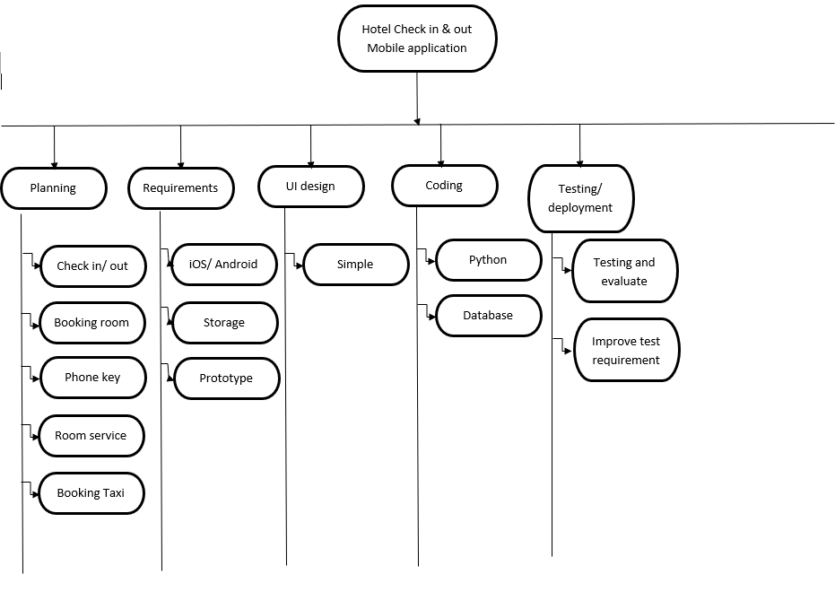

3.2 Project Schedule

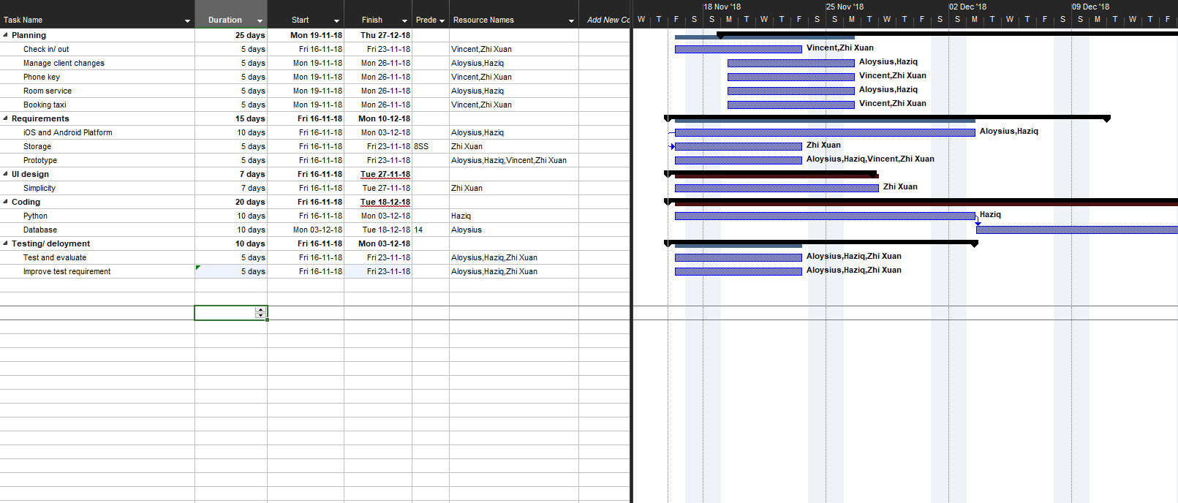

3.3 Budget Summary

|  |  |  |
| --- | --- | --- |
| **Category** | **Description** | **Amount (S$)** |
| Manpower | Graphics Designers | 18,000 |
|  | Developers | 6,000 |
|  | Testers | 3,500 |
| Hardware | Self check in/out kiosk x5 | 2,500 |
|  | Database server | 4,000 |
|  | Enterprise desktop | 1,500 |
|  | Mobile phone (iOS, Android) | 5,000 |
| Software | Kiosk system software | 400 |
|  | Windows server 2008 | 1,000 |
|  | Microsoft Project | 1,159 |
|  | Android studio | 0 |
|  | Visual studio | 951 |
|  | Swift (iOS) | 0 |
| Total | | 47,572 |

4 Risk Management Plan

|  |  |  |  |  |
| --- | --- | --- | --- | --- |
| **Type of Risk** | **Severity of Impact**  ***(Degree of Damage***  ***if it happens)*** | **Likelihood of Occurrence**  ***(Chance of it happening)*** | **Risk Exposure**  ***(Impact x Likelihood)*** | **Recommendation** |
| a) Developer resign | High (3) | High (3) | 9 | Avoidance, ensure that the working environment is excellent and benefits will be given to employee who stays longer |
| i) Cloud data wipe due to error on their site | HIgh (3) | Medium (2) | 6 | Contingency, have a server with local backup of the data in the hotel |
| h) Underestimate the total cost of this project | High (3) | Medium (2) | 6 | Avoidance,  Plan out everything as best as possible and not to rush the project |
| f) Power outage, server loss of power | High (3) | Medium (2) | 6 | Contingency, Install an additional source of power like uninterruptible power supply |
| c) Bug with displaying of available rooms | Medium (2) | Medium (2) | 4 | Avoidance, software maintenance after developing the application |
| g) Competition from other similar application | Medium (2) | Medium (2) | 4 | Acceptance, hire marketing experts to promote the application and software developer to create more unique features to stand out from the rest |
| d) Bug with the payment system | High (3) | Low (1) | 3 | Avoidance, software maintenance after developing the application |
| e)Software developer hired not knowledgeable in their field | High (3) | Low (1) | 3 | Avoidance, increase the hiring requirement |