Temasek Polytechnic

School of Informatics and IT

**Diploma in Information Technology (IT)**

Software Requirement Specifications (SRS)

**Project Particulars**

|  |  |
| --- | --- |
| **Tutor** | Zaw |
| **Class** | P01 |
| **Project Title** | Hotel Management System |

**Project Team’s Particulars**

|  |  |
| --- | --- |
| **Matric Number** | **Student Name** |
| **1706416C** | **Vincent Tang Jian Wei** |
| **1701380F** | **Ong Zhixuan** |
| **1704749I** | **Ikhwan Haziq Bin Sinwan** |
| **1707184F** | **Aloysius Wee Zi Xiang** |

Revision History

|  |  |  |  |
| --- | --- | --- | --- |
| **Date** | **Version** | **Description** | **Author** |
| 28/12/2018 | 1.0 | Draft | All |
| 02/01/2019 | 1.1 | Final | All |

**Table of Contents**

1. DISTRIBUTION OF WORKLOAD.. 3

2. OVERVIEW OF REQUIREMENTS. 3

2.1 System Functions. 4

2.2 User Characteristics. 4

2.3 General Constraints. 5

2.4 Functional Requirements. 5

2.5 Data Requirements. 10

2.6 User Interface Requirements. 10

2.7 Assumptions. 15

3 REFERENCES. 16

# 

# 

# 

# 

# **1. DISTRIBUTION OF WORKLOAD**

|  |  |
| --- | --- |
| **Requirement Gathering** | **Members** |
| 2.4(reporting module), 2.5, 2.6 | **Vincent Tang Jian Wei** |
| 2.3, 2.4(convenience module) | **Ong Zhixuan** |
| 2.4(housekeeping and staff management module), 2.5, 2.7 | **Ikhwan Haziq Bin Sinwan** |
| 2.4(booking module), 2.1, 2.2 | **Aloysius Wee Zi Xiang** |

# 

# **2. OVERVIEW OF REQUIREMENTS**

1. **Web application for self check in/ check out kiosk**
2. **Mobile application for guest convenience to access their rooms**
3. **Mobile application for room services**
4. **Web application for housekeeping and staff management module**
5. **Web application for reporting module**
6. **Database for storing user information and records**
7. **Third party integration to mobile application for taxi/ private hire booking**

**2.1 System Functions**

The first main function is, the system is a web interface for check in and check out running on self service kiosk, guest will be able to check in/ check out, make payments, edit room type all by themselves through the self service kiosk located at the lobby of the hotel.

Second main function is staff management module and reporting module, this system will allows for efficient tracking of staff management such as duty roster for the staff, clocking the amount of hours that the staff have worked.

The third main function is the mobile application for guest to access their room and getting room services after they have made payment for their services. Guest could easily download the hotel application for both iOS and Android devices. After downloading the application, it would require their login credential to use the services, the services from the application includes request for amenities like towels and toiletries to services like housekeeping and luggage assistance 24/7 during their stay in the hotel. This application also provide live chat with the hotel staff for other service that are not listed on the application.

**2.2 User Characteristics**

User of this system should be able to check in/ check out of their rooms with the date/ time that they’ve book in advance or book on the spot. This system also allows guest to edit their check out date/ time however, subjected that there’s slot available. This system have two access level, guest and staff. Guest will have the access guest function and staff will have access to both guest and staff management functions. The guest should be able to do such function:

* Make a room booking
  + Check in/ check out date
  + Room type
  + Confirmation

The staff should have the following management functions:

* Edit guest booking
  + Change room type
  + Get guest information
  + Calculate changes for room type

## **2.3 General Constraints**

As we are making use of the NFC system as a form of verification for access, we are dependent on the NFC system. Guests with NFC supported phones will be able to use it to gain entry to their hotel room. Regardless guests would be issued a NFC enabled card upon checking in to the hotel.

As for the taxi service that the system provides, the pricing and availability of the system would be dependent on the supporting taxi companies.

There would also be a constraint on the database as there is a requirement to log every guest’s information and a sudden mass influx of of guests would put a strain on the system .

## **2.4 Functional Requirements**

|  |  |
| --- | --- |
| **Booking module (Check-in)** | |
| **Main flow** | |
| Tap on self service kiosk | Kiosk screen should show home page |
| Guest to tap on check-in icon | Booking page will be displayed |
| Guest to choose their check-in and check-out date | Page will display chosen date and display amount for payment |
| Guest to proceed to made payment | Payment page will be displayed |
| Payment was successful | Kiosk will print out receipt with serial number for mobile application usage |
| **Alternate flow (No room available)** | |
| Guest to choose their check-in and check-out date | Page display that no room available for that date. Pop-out message display to choose different room or date. |
| **Alternate flow (Payment unsuccessful)** | |
| Guest to proceed to made payment | Card did not go through. Pop-out message display for guest to proceed to manual payment. |

|  |  |
| --- | --- |
| **Booking module (Check-out if booking made through third party)** | |
| **Main flow** | |
| Guest to tap on self service kiosk | Kiosk screen should show home page |
| Tap on check-out icon | Page will display pop out message, request guest to scan the QR code or to key in their room information. |
| (Kiosk will display for guest to hold on for 5 mins or less) | Kiosk will send to housekeeping for them to check the room |
| Check-out successful | Kiosk will display thank you for your stay |
| **Alternate flow (Payment for missing/ damaged item)** | |
| (Kiosk display that request guest to pay for missing/ damaged item) | Kiosk will display which item and total payment to be made. |
| Guest proceed to made payment through kiosk | Kiosk will issue a receipt for the item. |

|  |  |
| --- | --- |
| **Housekeeping and staff management module (Clean the guest room)** | |
| **Main flow** | |
| Guest wants to clean the room, opens the app and selects housekeeping | Page displays housekeeping and state your request. |
| Selecting to room option | Page will ask for room number of guest |
| Notification is sent to guest when the room is done cleaning. | App will send a notification to the guest’s phone |
| **Alternate flow (Guest flight is delayed/Baggage Claim delays)** | |
| Guest do not want their room to be clean by housekeeping. | Page will display options to of “Do not Disturb” or “Clean my Room”. |
| Guest can state the time they want the housekeeping to clean their room. | Page will display timing options. |

|  |  |
| --- | --- |
| **Housekeeping and staff management module (Staff can check information through the application).** | |
| **Main flow** | |
| The housekeeping staff can check which room is available to clean. | Page will display availability of room can clean. |
| The staff working schedule will update in that application. | Page will display the staff roster in the application which can be open by staff only. |
| The staff able to see from the app if the guest request for any room service. | Page will display list of what guest requesting. |
| **Alternate flow (Payment for room service)** | |
| Guest proceed to made payment through the application and bill to the room or pay by cash. | Guest will issued a receipt for every item at the end of payment. |

|  |  |
| --- | --- |
| **Convenience module (Booking a Taxi from the Hotel)** | |
| **Main flow** | |
| Guest to call for taxi through app | Application screen should display from hotel or to hotel |
| Select the From Hotel option | Page will display destination , estimated cost. |
| Confirm booking and payment method. | Page will display payment methods ( Cash, Credit/Debit Card) |
| Booking successful | Page will display estimated time of arrival for taxi |
| Notification is sent to guest when taxi has arrived | App will send a notification to the guest’s phone |
| **Alternate flow (Guest did not board the taxi after 5 minutes.)** | |
| Notification would be made to the main desk. | Main desk would be alerted. |
| Main desk would call up the hotel room | Phone in the hotel room would ring informing the guest that the taxi has arrived. |

|  |  |
| --- | --- |
| **Convenience Module(Booking from airport to hotel)** | |
| **Main flow** | |
| Guest upon arrival opens the app and selects to hotel. | Page displays from hotel and to hotel options. |
| Selecting to hotel option | Page will ask for location of guest |
| Confirm booking | Page will display options to pay by cash or by credit/debit card. |
| Booking successful | Page displays estimated time of arrival of the taxi to guest’s location. |
| Notification is sent to guest when taxi arrives. | App will send a notification to the guest’s phone |
| **Alternate flow (Guest flight is delayed/Baggage Claim delays)** | |
| Guest will notify taxi driver of delay | Screen will pop up an option for guest to choose the a new time for the taxi to come |
| Taxi driver will arrive on the new stated time. | -NIL |

|  |  |
| --- | --- |
| **Reporting Module(Viewing all room status)** | |
| Allow management user to list all the room status in the hotel which are vacant, occupied or schedule for cleaning. | |
| **Main flow** | |
| 1. | Management user login into the system |
| 2. | System accepted username and password |
| 3. | Management user clicks on generate report for room status |
| 4. | System asked if a preview is needed |
| 5. | Management user selects no |
| 6. | System generate report of the list of room and their current status |
| **Alternate flow** | |
| 1a.1 | Management user is unable to login |
| 1a.2 | Management user need to re enter password correctly |

|  |  |
| --- | --- |
| **Reporting Module(Previewing staff’s duties report)** | |
| Allow management user to preview the list of duties the staff have been allocated to. | |
| **Main flow** | |
| 1. | Management user login into the system |
| 2. | System accepted username and password |
| 3. | Management user clicks on generate report for staff’s duties |
| 4. | System asked if a preview is needed |
| 5. | Management user selects yes |
| 6. | System generate report preview for staff’s duties |
| **Alternate flow** | |
| 1a.1 | Management user is unable to login |
| 1a.2 | Management user need to re enter password correctly |

## **2.5 Data Requirements**

Staff

|  |  |
| --- | --- |
| Name | Name of staff member |
| Department | Where staff is working at |
| Salary | How much is the salary |

Guest

|  |  |
| --- | --- |
| Email | Guest’s email |
| password | password |
| name | Guest’s name |
| Check in | Guest’s check in date |
| Check out | Guest’s check out date |

Room

|  |  |
| --- | --- |
| Room number | Rooms’ number |
| type | What type of room it is, premium or standard |
| status | vacant, occupied or schedule for cleaning |
| Previous guest | List of previous guest’s details that used the room |

## **2.6 User Interface Requirements**

Staff’s view

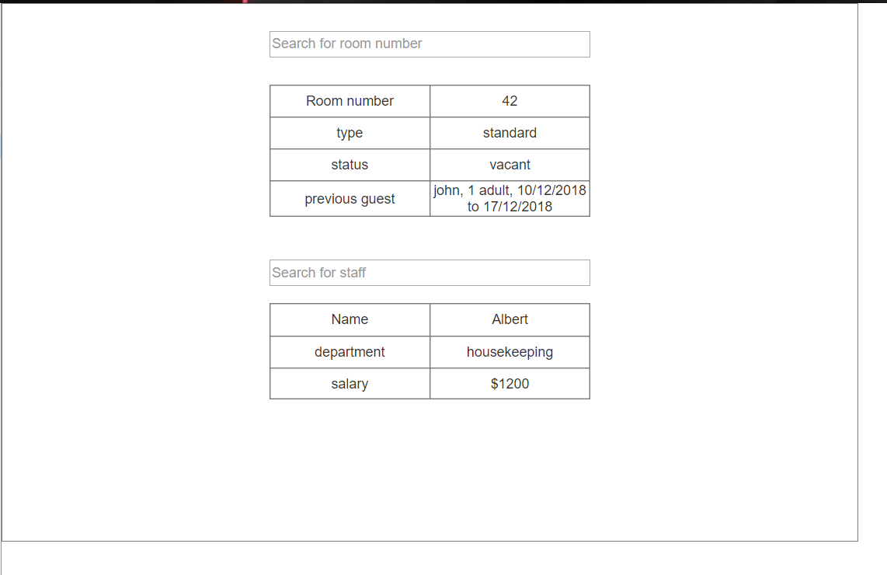

Guest’s view

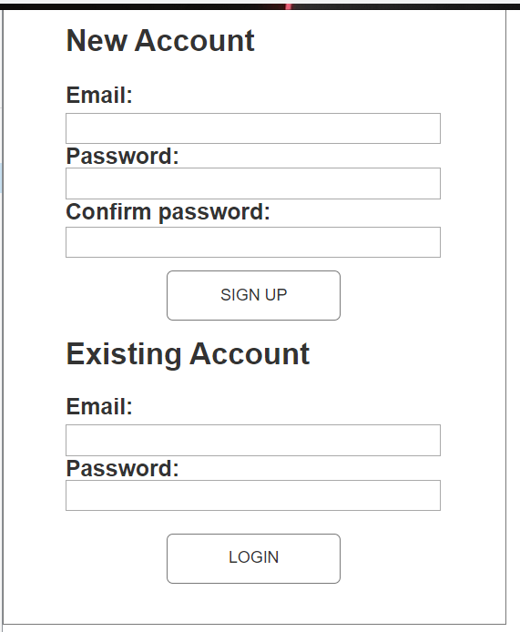

First page when user loads up the application

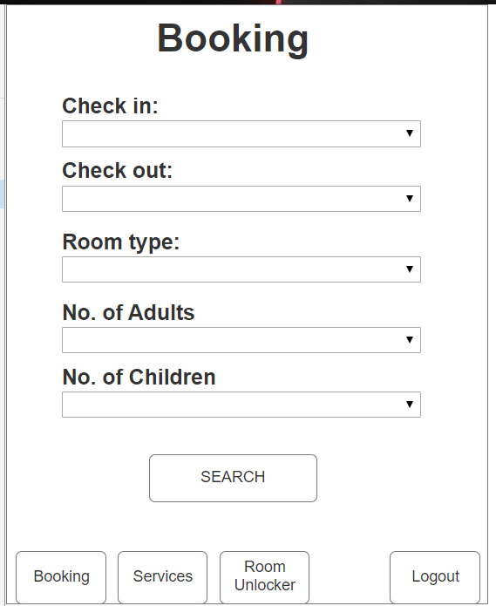

Both check in and check out will be select using a calendar. Room type is selected using a drop down menu.

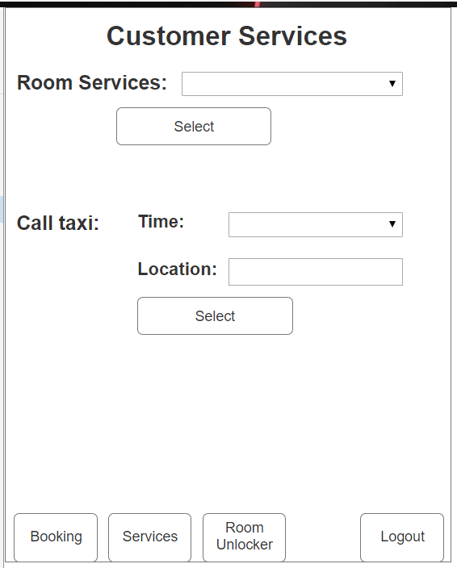

Selects which room services to call using a dropdown menu. Select time for taxi to arrive to the hotel entrance. A unique code to scan is given to each customer to unlock their room.

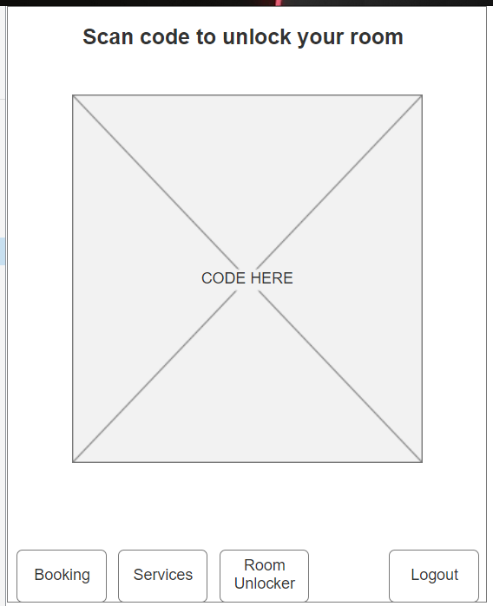

The code to be scanned for unlocking room without using the key.

## **2.7 Assumptions**

## 

The assumptions were made by our group regarding our application which will make the users feel easier and straightforward to use the application. We have choose to design a room booking in the application and the users can check in and check out without going to the hotel front counter. They users can select their preferable room type and they will receive a confirmation regarding their booking. For the staff, we decided to have the following management functions which is edit guest booking like change the guest room type, get all of the guest information when they make a booking and also calculate changes for room type. This application will be useful as we assume that everywhere now are using technology, so by designing this application will make the users and staff in that particular hotel feel more convenient.

We assumed that the current computer is Pentium 4 running on the Windows XP Support Package 2 operating system. It has a 1GB ram and a 160GB hard disk. It is connected to the internet via a broadband connection. Due to the limited budget the system would not need to be integrated into existing systems.

# **3 REFERENCES**

http://tynerblain.com/blog/2007/04/09/sample-use-case-example/