Checkpoint 4

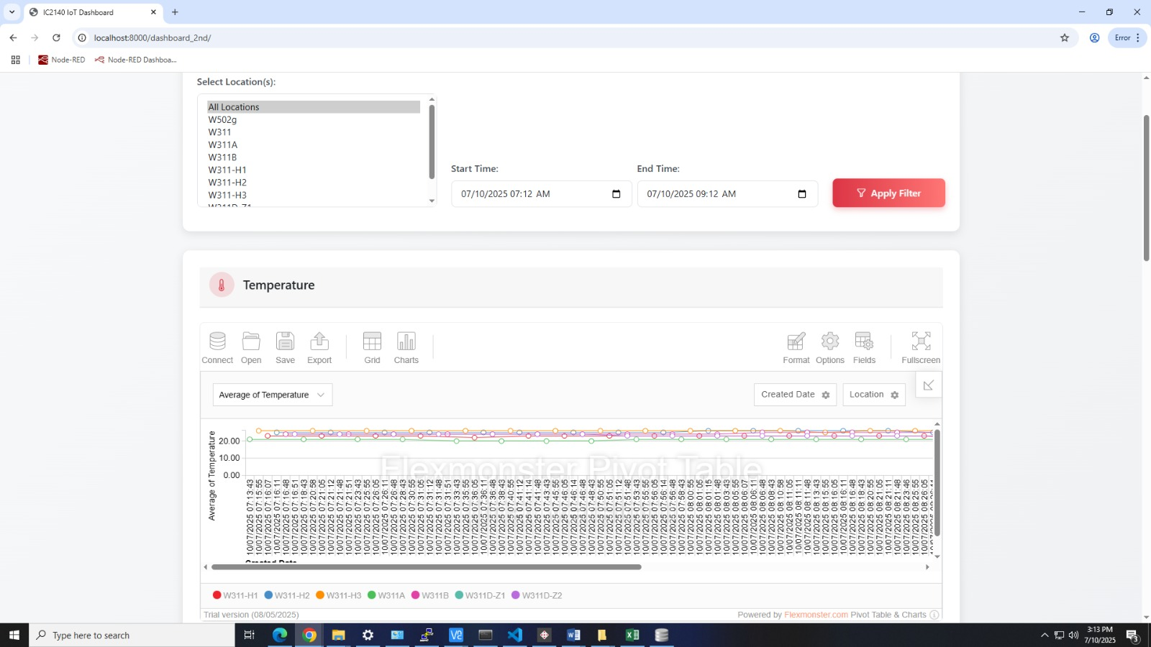

Feature Description

The main function of the IC2140 IoT Dashboard is to simultaneously display temperature, light intensity, humidity, and sound level data on dashboards in separate modules. The user can select specific locations from the “Select Location(s)” list, such as W502g, W311A, etc. The user can choose one location or hold control to choose multiple locations. Then, the user can set a time range through “Start Time” and “End Time” which can be specified to minutes. After clicking the “Apply Filter” button, instant data refresh can be triggered, and the data will be displayed. It is worth noting that locations are differentiated using distinct colors for quick visual comparison.

Design Methodology

The project is a Django-based IoT sensor dashboard, which consists of three main parts: the model layer, the view layer, and the front-end page. This structure follows the Model - View - Template (MVT) architectural pattern of Django.

The models.py file in the sensor app defines the application’s data model, namely a sensor model. The sensor model includes fields such as temp (temperature), hum (humidity), light (light intensity), snd (sound level), node_id, loc (location), and date_created to store sensor data.

The views.py file in the dashboard_2nd app contains the view functions that handle HTTP requests and return appropriate responses. The index function renders the main dashboard page (dashboard_2nd/index.html). It serves as the entry point for users to access the dashboard. The temp_data function retrieves all sensor data from the database and serializes it into JSON format. It then returns the JSON data as a response, which can be used by the front-end to display sensor information. The summary function calculates summary statistics (average, maximum, and minimum temperature) for all sensor data. It then prepares a context with the sensor data and summary statistics and passes it to the dashboard_2nd/summary.html template for rendering.

The index.html file is the main page of the IoT sensor dashboard, creating an interactive and visually appealing user interface. The page features a header with the dashboard title, a filter section allowing users to select locations and time ranges, and multiple dashboard cards for displaying different types of sensor data (temperature, humidity, light, and sound).
CSS styling, Bootstrap, and custom CSS are employed for styling. The custom CSS defines color variables and other styles, and adds hover effects to dashboard cards to improve the user experience. JavaScript functions include the processData function, which filters the sensor data according to the selected locations and time range. The loadCharts function initializes four Flexmonster charts (for temperature, humidity, light, and sound) using the filtered data. The updateCharts function updates the charts when the user changes the location selection or applies a time filter. The getFeed function polls the server every 10 seconds to obtain the latest sensor data and updates the charts accordingly.

In summary, this IoT sensor dashboard design combines Django's backend capabilities with front-end technologies to offer users a real-time, interactive monitoring system for sensor data.

Analysis of the IOT data and performance result

The data are collected using the MQTT protocol to subscribe to messages from the iot/sensor-A topic on the ia.ic.polyu.edu.hk server. These messages are sensor data, representing environmental information collected by IoT devices. The received MQTT messages are first decoded into strings using msg.payload.decode("utf-8") and then parsed into Python dictionaries iotData using json.loads(). This indicates that the messages are sent in JSON format and contain key-value pairs such as node_id, loc, temp, hum, light, and snd, which represent the node ID, location, temperature, humidity, light, and sound data, respectively. After parsing, the data is used to create an instance p of the sensor model, and p.save() is called to save the data to the database. This shows that the code has the function of persisting IoT sensor data, which is convenient for subsequent data analysis and historical queries. The data can be retrieved by calling the temp_data function in views.py after importing the sensor. By comparing data across different locations (e.g., W311A vs. W502g), the dashboard reveals spatial variations in sensor readings, helping to pinpoint areas with abnormal conditions.

Sensor data accuracy is fundamental when measuring performance. Assuming the sensors are highly precise, the dashboard is highly accurate since the data is directly subscribed. Moreover, with the getFeed function polling the server every 10 seconds to obtain the latest sensor data and updating the charts accordingly, the dashboard can be further ensured to be accurate. Despite the accuracy, limitations also exist. For instance, when the database is too large, Flexmonster takes time to analyze the data and even shows an error message, which affects the user experience. Additionally, location identifiers like W311-H1 require external documentation, affecting usability.
Checkpoint 5

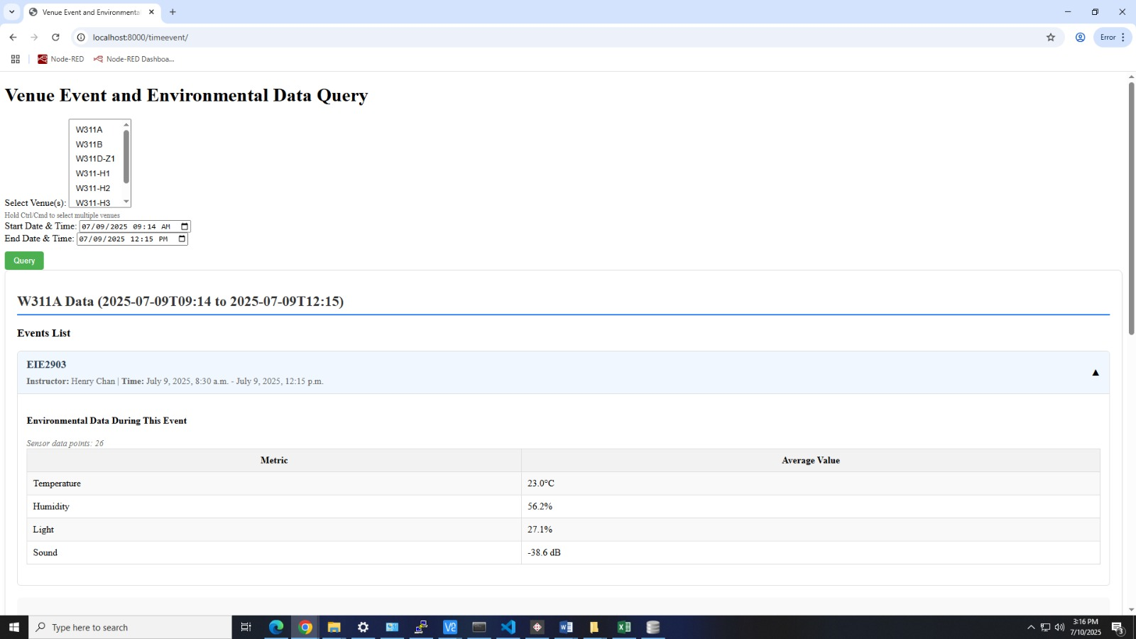

Feature Description

The web page is designed for Venue Event and Environmental Data Query. The user can pick specific venues from the dropdown list (like W311A, W311B, etc.) and hold “Ctrl” to choose multiple venues if needed. Then, the user can set a start and end date/time to define the period they want to query data for. After clicking the “Query” button, it will retrieve two main types of info for the selected venue(s) and time. They are event details which list events (e.g., “EIE2903”) with basic information like instructor and event time, and environmental data showing average values of sensors (temperature, humidity, light, sound) during the event, based on collected data points (here, 26 sensor points for the example). If more than one event is selected in a venue across a certain period, the user can see basic info about different events as well as the overall average values of environmental data. Moreover, the user can click on a specific event to unfold it so that the environmental data of this event is displayed. Additionally, the number of data (sensor data sample) calculated to get the average is shown.

Design Methodology

The design methodology of checkpoint 5 shares similarities with that of checkpoint 4. The Venue, Event, and EnvironmentalData models are defined in the models.py file. The information about the venues and events was input manually in the admin page. Relationships between models are established using foreign keys. For example, an Event is related to a Venue through a foreign key, which means each event occurs at a specific venue. The unique=True parameter in the name field of the Venue model ensures that each venue has a unique name, maintaining data integrity.

The time_event_data view in the views.py file contains the main logic. When receiving a POST request, it validates user inputs, ensuring at least one venue is selected and both start/end datetime values are provided. If validation fails, appropriate error messages are returned. For valid inputs, it converts datetimes to timezone-aware objects and processes each selected venue by: identifying overlapping events using ‘Q’ objects to capture partial or exact matches within the timeframe, aggregating average sensor readings (temperature, humidity, light, sound) across the entire timeframe for the venue, and calculating the same metrics individually for each qualifying event within its specific duration. Sensor data counts are recorded at both venue and event levels. Errors during datetime conversion or database operations are also caught, and appropriate error messages are displayed to the user. Finally, the function renders an HTML template with the original venue list, processed analytics data, user-submitted datetimes, and any applicable error messages.

The index.html file is the template for the web page. It uses HTML, CSS, and JavaScript to create an interactive user interface. The page features a form with a multi-select venue dropdown and start/end datetime pickers that retain user input. Any Django error messages appear prominently in a red alert box. Results are grouped by venue, each section labeled with the venue name and selected time range. Events are shown in collapsible panels with headers displaying event name, instructor, and time range. Expanding a panel reveals detailed environmental metrics, sensor data counts, and a toggle icon that rotates during interaction. An "Overall Environmental Data" section summarizes aggregated sensor readings for the period.
User experience is enhanced with smooth panel animations, hover effects, clear "no data" messages, and well-formatted tables with values rounded to one decimal. JavaScript manages panel toggling and icon rotation. The design uses a color scheme, distinct section borders, subtle shadows, and a responsive layout for all devices.

Analysis of the IOT data and performance result

The application aggregates IoT sensor data stored in the SensorData model. It calculates the average values of temperature, humidity, light, and sound for the entire selected time range and each individual event. This aggregation provides a high-level overview of the environmental conditions during events and the overall period. The average values are presented in HTML tables, making it easy for users to view and compare environmental metrics. If no sensor data is available, appropriate messages are displayed.

The use of Django’s ORM (Object-Relational Mapping) and database queries helps to optimize the data retrieval process. For example, the filter and aggregate methods are used to query and calculate data efficiently. However, as the amount of data in the database grows, the performance may be affected, especially when querying a large number of events and sensor data.

Self-Reflection LONG Yuhan 24105998d

During this project, I contributed to the design and implementation of web applications in checkpoints 4 and 5. For Checkpoint 4, I helped develop the IC2140 IoT Dashboard using Django’s MVT architecture. My work included defining the sensor data model, implementing backend logic to handle data retrieval and summary statistics, and designing the interactive front-end dashboard. I integrated real-time data updates using JavaScript polling and Flexmonster charts and ensured the user interface was both visually appealing and user-friendly with Bootstrap and custom CSS.

For Checkpoint 5, I extended the system to support querying venue, event, and environmental data. I designed models for Venue, Event, and EnvironmentalData, and implemented logic to validate user input, aggregate sensor data, and handle errors gracefully. I also developed an interactive HTML template with collapsible event panels, clear data tables, and responsive design. Throughout, I focused on usability, data clarity, and robust error handling.

In developing the HTML templates and some backend logics for checkpoints 4 and 5, GenAI could be a helpful tool. During my work, GenAI was used to debug my code and enhance the user interface aesthetically. By showing the error message, it helped me locate the error syntax and made modifications. Also, GenAI was of assistance in designing the collapsible panels of events in checkpoint 5. It is worth noting that the overlapping logic using ‘Q’ objects was hinted by GenAI, given the code below: events=Event.objects.filter(venue=venue).filter(Q(start_datetime__lt=end_datetime, end_datetime__gt=start_datetime) |Q(start_datetime__exact=start_datetime) |Q(end_datetime__exact=end_datetime) ).order_by('start_datetime'), which shows data as long as the periods intersect.

Reflecting the whole experience, I deepened my understanding of web development, especially with Django and modern front-end techniques. I learned how to structure data models for real-world IoT applications and how to efficiently process and aggregate large datasets. Implementing real-time updates and interactive visualizations challenged me to balance performance with user experience. Moreover, my programming skills have greatly improved since a lot of programming was used.

I encountered problems in both front-end and back-end applications. I solved the problems by a brainstorming, asking the teacher for help, communicating with others, and consulting GenAI. One important realization from this project is the significance of teamwork. Collaborating with my teammates allowed us to combine our strengths, share ideas, and solve problems more efficiently. For instance, I consulted my teammate who was in charge of checkpoint 3 when importing the data. Through regular communication and cooperation, we were able to divide tasks according to each member’s expertise and support each other when challenges arose. I found that effective teamwork not only improved the quality and efficiency of our work but also made the project experience more enjoyable and rewarding. This experience has reinforced my belief that strong collaboration is essential for the success of any complex project.

Throughout this project, I also significantly improved my skills in using Generative AI (GenAI) tools. By interacting with GenAI, I learned how to craft effective prompts, refine my questions, and integrate AI-generated content into my project deliverables.

Overall, this project improved my technical skills in Django, Python, responsive design, GenAI tools, and teamwork. I am proud of the solutions I implemented and look forward to applying these skills in future projects.

