ClassB Group 6 Report
Checkpoint 1
Feature Description
The core function of Checkpoint 1 in the "Smart Campus in W311" project is to enable the Raspberry Pi sensor node to operate autonomously. Specifically, the node should automatically boot up, connect to Wi-Fi, and immediately start streaming environmental data via MQTT without any manual intervention. Once configured, the node can be installed in its final location and will automatically recover from power cuts, continuously publishing temperature, humidity, light, and sound readings to the MQTT broker after booting.
Design Methodology
To achieve autonomous operation, the key configuration involves using the crontab tool to schedule the execution of the data acquisition script on system reboot. The specific steps are as follows:
Execute the command crontab –e to edit the crontab configuration.
Select the nano editor when prompted.
Append the line @reboot sleep 60 && python3 /home/pi/Desktop/TEAM_AB_IOT.py to the configuration. This line ensures the system waits 60 seconds (sufficient for the WLAN interface to obtain an IP address) after reboot, then runs the Python script TEAM_AB_IOT.py.
Save the configuration. After rebooting the Raspberry Pi, the script will run automatically every time the device is powered on.
Analysis of the IoT Data and Performance Result
The implementation of Checkpoint 1 transforms the Raspberry Pi from a manual-operated device into a fully autonomous sensor node. The 60-second delay in the crontab configuration effectively addresses the issue of Wi-Fi connection latency, ensuring the node can successfully connect to the network before starting data transmission.
In terms of performance, the node achieves the expected autonomy: after power is applied, it completes booting, connects to Wi-Fi, and starts publishing data without human involvement. This reliability is critical for real-world deployment, as the node can now be placed in its target location and recover independently from power interruptions, laying the foundation for subsequent data collection and analysis.
Checkpoint2:
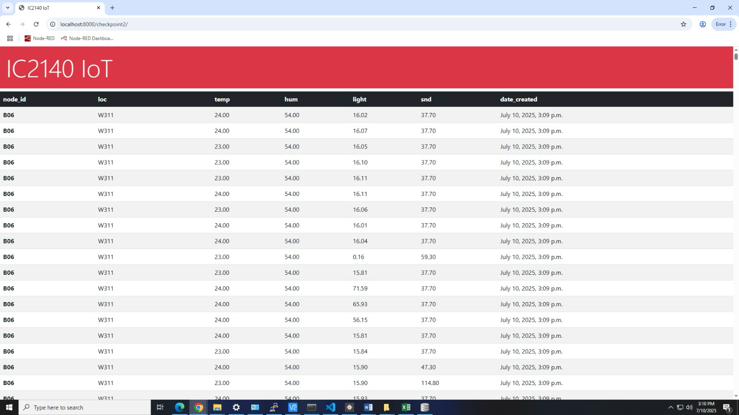
Checkpoint2:
Feature Description
Checkpoint 2 shifts the focus from hardware and basic connectivity to data processing and accessibility. Its main function is to convert MQTT message streams into persistent, queryable information that non-technical users can access with a single click. This involves storing structured sensor data and providing a user-friendly interface to view the data.
Design Methodology
The implementation involves three key components:
Data Ingestion: A small web server process is established to maintain a persistent connection to the campus MQTT broker. When JSON payloads arrive, the server extracts six required fields (node_id, loc, temp, hum, light, snd) and inserts them into an SQL table, along with a server-side timestamp.
Data Storage: The SQL table is carefully defined to ensure data integrity, with fields corresponding to the extracted sensor data and timestamps.
Data Retrieval: A REST endpoint /list is implemented to execute a SELECT... ORDER BY ts DESC query, retrieve the first 200 records, and serialize them into an HTML template for display.
To enhance reliability, additional measures are taken:
Exponential backoff logic to prevent infinite looping when the proxy is closed.
try/except blocks around each INSERT operation, with failed inserts written to a disk queue if the database is temporarily unavailable.
Basic input validation (e.g., temperature and humidity range checks, string length limits for node_id) to prevent malformed packets from corrupting the table.
Analysis of the IoT Data and Performance Result
The data stored in the SQL table includes rich environmental information, with sample records showing node_id , loc (e.g., W311), and readings such as temperature , humidity,light, and sound.
These protective measures (backoff, error handling, validation) ensure the system operates stably in real-world conditions, distinguishing it from a mere academic demonstration and making it suitable for deployment by facility managers. The /list endpoint enables non-technical users to easily access the latest data, bridging the gap between raw sensor streams and actionable information.
Checkpoint3:
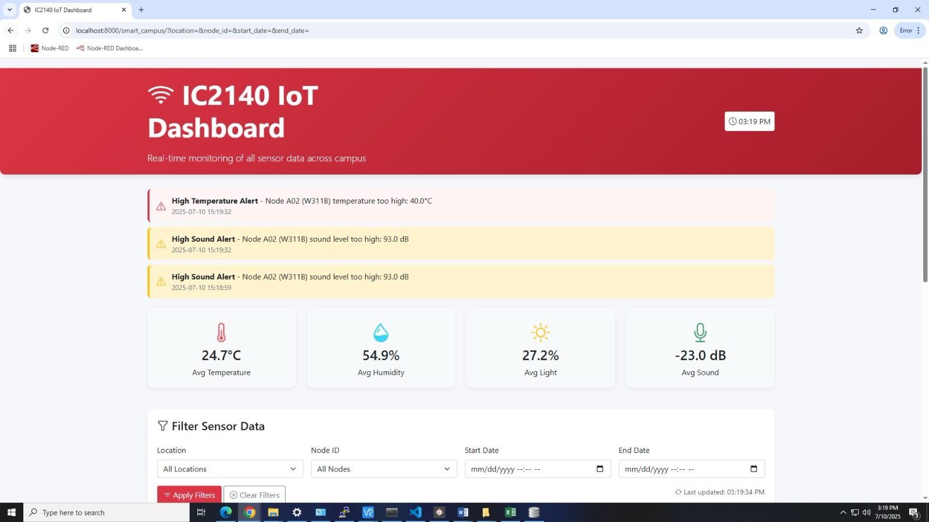
Feature Description
Checkpoint 3 expands the system to handle large-scale data collection and provide flexible data filtering for users. The core function is to create a unified web application that collects data from all sensors across the campus, allowing users to filter data by location, date/time, and node ID, and display results in an organized format.
Design Methodology
Data Ingestion Scaling: The backend subscription filter is expanded from the narrow camp/W311b/# to a wildcard camp/#, enabling the system to receive, validate, and store thousands of messages per hour from all campus locations (classrooms, hallways, laboratories).
Database Optimization: Composite indexes on (loc, ts) and (node_id, ts) are added to avoid primary key conflicts and support efficient filtering.
Front-End Enhancement: A user-friendly interface with foldable sidebars is designed to allow users to select one or multiple locations (e.g., W311a, W311b) and specify date ranges via calendar widgets. User selections generate a query string (e.g., /app/select?location=W311b&start=2023-11-01&end=2023-11-07), which Flask converts into SQL WHERE clauses. The matched data is returned as JSON and displayed in a table.
Analysis of the IoT Data and Performance Result
The expanded system successfully transforms isolated sensor nodes into a unified information system. By integrating data from all nodes, issues of data consistency and scalability are addressed, and the use of standardized fields (node_id, loc, etc.) simplifies future database integration and comparison.
The filterable interface adds tangible value: associating temperature, humidity, and other metrics with specific nodes, rooms, and times converts raw data into actionable insights for energy efficiency, comfort monitoring, and preventive maintenance. For example, a lecturer can select "W311b" and a time range of "08:00–18:00" to view environmental changes during class hours, demonstrating the system’s practical utility.
Checkpoint 4
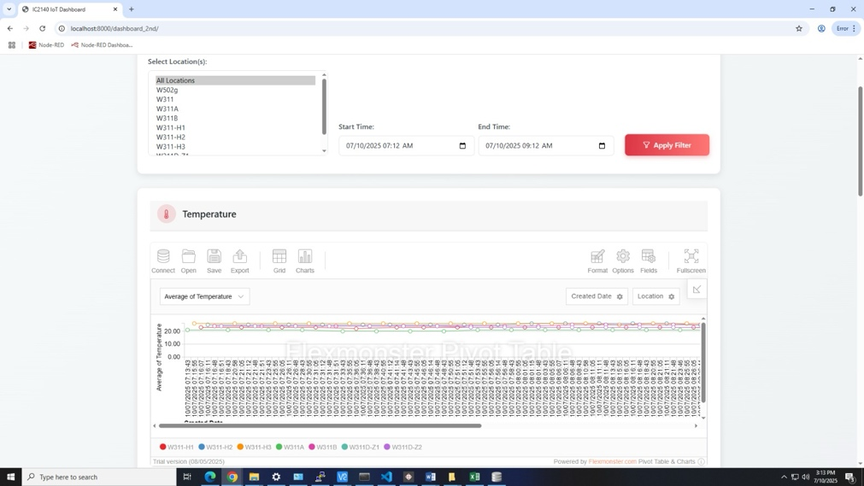

Feature Description
The main function of the IC2140 IoT Dashboard is to simultaneously display temperature, light intensity, humidity, and sound level data on dashboards in separate modules. The user can select specific locations from the “Select Location(s)” list, such as W502g, W311A, etc. The user can choose one location or hold control to choose multiple locations. Then, the user can set a time range through “Start Time” and “End Time” which can be specified to minutes. After clicking the “Apply Filter” button, instant data refresh can be triggered, and the data will be displayed. It is worth noting that locations are differentiated using distinct colors for quick visual comparison.
Design Methodology
The project is a Django-based IoT sensor dashboard, which consists of three main parts: the model layer, the view layer, and the front-end page. This structure follows the Model - View - Template (MVT) architectural pattern of Django.
The models.py file in the sensor app defines the application’s data model, namely a sensor model. The sensor model includes fields such as temp (temperature), hum (humidity), light (light intensity), snd (sound level), node_id, loc (location), and date_created to store sensor data.
The views.py file in the dashboard_2nd app contains the view functions that handle HTTP requests and return appropriate responses. The index function renders the main dashboard page (dashboard_2nd/index.html). It serves as the entry point for users to access the dashboard. The temp_data function retrieves all sensor data from the database and serializes it into JSON format. It then returns the JSON data as a response, which can be used by the front-end to display sensor information. The summary function calculates summary statistics (average, maximum, and minimum temperature) for all sensor data. It then prepares a context with the sensor data and summary statistics and passes it to the dashboard_2nd/summary.html template for rendering.
The index.html file is the main page of the IoT sensor dashboard, creating an interactive and visually appealing user interface. The page features a header with the dashboard title, a filter section allowing users to select locations and time ranges, and multiple dashboard cards for displaying different types of sensor data (temperature, humidity, light, and sound).
CSS styling, Bootstrap, and custom CSS are employed for styling. The custom CSS defines color variables and other styles, and adds hover effects to dashboard cards to improve the user experience. JavaScript functions include the processData function, which filters the sensor data according to the selected locations and time range. The loadCharts function initializes four Flexmonster charts (for temperature, humidity, light, and sound) using the filtered data. The updateCharts function updates the charts when the user changes the location selection or applies a time filter. The getFeed function polls the server every 10 seconds to obtain the latest sensor data and updates the charts accordingly.
In summary, this IoT sensor dashboard design combines Django's backend capabilities with front-end technologies to offer users a real-time, interactive monitoring system for sensor data.
Analysis of the IOT data and performance result
The data are collected using the MQTT protocol to subscribe to messages from the iot/sensor-A topic on the ia.ic.polyu.edu.hk server. These messages are sensor data, representing environmental information collected by IoT devices. The received MQTT messages are first decoded into strings using msg.payload.decode("utf-8") and then parsed into Python dictionaries iotData using json.loads(). This indicates that the messages are sent in JSON format and contain key-value pairs such as node_id, loc, temp, hum, light, and snd, which represent the node ID, location, temperature, humidity, light, and sound data, respectively. After parsing, the data is used to create an instance p of the sensor model, and p.save() is called to save the data to the database. This shows that the code has the function of persisting IoT sensor data, which is convenient for subsequent data analysis and historical queries. The data can be retrieved by calling the temp_data function in views.py after importing the sensor. By comparing data across different locations (e.g., W311A vs. W502g), the dashboard reveals spatial variations in sensor readings, helping to pinpoint areas with abnormal conditions.
Sensor data accuracy is fundamental when measuring performance. Assuming the sensors are highly precise, the dashboard is highly accurate since the data is directly subscribed. Moreover, with the getFeed function polling the server every 10 seconds to obtain the latest sensor data and updating the charts accordingly, the dashboard can be further ensured to be accurate. Despite the accuracy, limitations also exist. For instance, when the database is too large, Flexmonster takes time to analyze the data and even shows an error message, which affects the user experience. Additionally, location identifiers like W311-H1 require external documentation, affecting usability.
Checkpoint 5
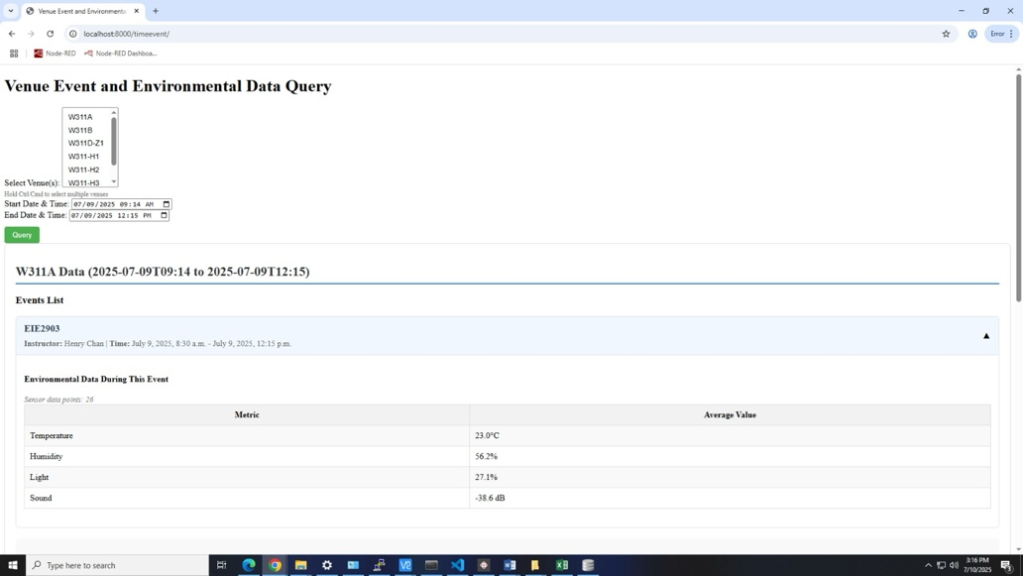
Feature Description
The web page is designed for Venue Event and Environmental Data Query. The user can pick specific venues from the dropdown list (like W311A, W311B, etc.) and hold “Ctrl” to choose multiple venues if needed. Then, the user can set a start and end date/time to define the period they want to query data for. After clicking the “Query” button, it will retrieve two main types of info for the selected venue(s) and time. They are event details which list events (e.g., “EIE2903”) with basic information like instructor and event time, and environmental data showing average values of sensors (temperature, humidity, light, sound) during the event, based on collected data points (here, 26 sensor points for the example). If more than one event is selected in a venue across a certain period, the user can see basic info about different events as well as the overall average values of environmental data. Moreover, the user can click on a specific event to unfold it so that the environmental data of this event is displayed. Additionally, the number of data (sensor data sample) calculated to get the average is shown.
Design Methodology
The design methodology of checkpoint 5 shares similarities with that of checkpoint 4. The Venue, Event, and EnvironmentalData models are defined in the models.py file. The information about the venues and events was input manually in the admin page. Relationships between models are established using foreign keys. For example, an Event is related to a Venue through a foreign key, which means each event occurs at a specific venue. The unique=True parameter in the name field of the Venue model ensures that each venue has a unique name, maintaining data integrity.

The time_event_data view in the views.py file contains the main logic. When receiving a POST request, it validates user inputs, ensuring at least one venue is selected and both start/end datetime values are provided. If validation fails, appropriate error messages are returned. For valid inputs, it converts datetimes to timezone-aware objects and processes each selected venue by: identifying overlapping events using ‘Q’ objects to capture partial or exact matches within the timeframe, aggregating average sensor readings (temperature, humidity, light, sound) across the entire timeframe for the venue, and calculating the same metrics individually for each qualifying event within its specific duration. Sensor data counts are recorded at both venue and event levels. Errors during datetime conversion or database operations are also caught, and appropriate error messages are displayed to the user. Finally, the function renders an HTML template with the original venue list, processed analytics data, user-submitted datetimes, and any applicable error messages.
The index.html file is the template for the web page. It uses HTML, CSS, and JavaScript to create an interactive user interface. The page features a form with a multi-select venue dropdown and start/end datetime pickers that retain user input. Any Django error messages appear prominently in a red alert box. Results are grouped by venue, each section labeled with the venue name and selected time range. Events are shown in collapsible panels with headers displaying event name, instructor, and time range. Expanding a panel reveals detailed environmental metrics, sensor data counts, and a toggle icon that rotates during interaction. An "Overall Environmental Data" section summarizes aggregated sensor readings for the period.
User experience is enhanced with smooth panel animations, hover effects, clear "no data" messages, and well-formatted tables with values rounded to one decimal. JavaScript manages panel toggling and icon rotation. The design uses a color scheme, distinct section borders, subtle shadows, and a responsive layout for all devices.
Analysis of the IOT data and performance result
The application aggregates IoT sensor data stored in the SensorData model. It calculates the average values of temperature, humidity, light, and sound for the entire selected time range and each individual event. This aggregation provides a high-level overview of the environmental conditions during events and the overall period. The average values are presented in HTML tables, making it easy for users to view and compare environmental metrics. If no sensor data is available, appropriate messages are displayed.
The use of Django’s ORM (Object-Relational Mapping) and database queries helps to optimize the data retrieval process. For example, the filter and aggregate methods are used to query and calculate data efficiently. However, as the amount of data in the database grows, the performance may be affected, especially when querying a large number of events and sensor data.
Checkpoint6:
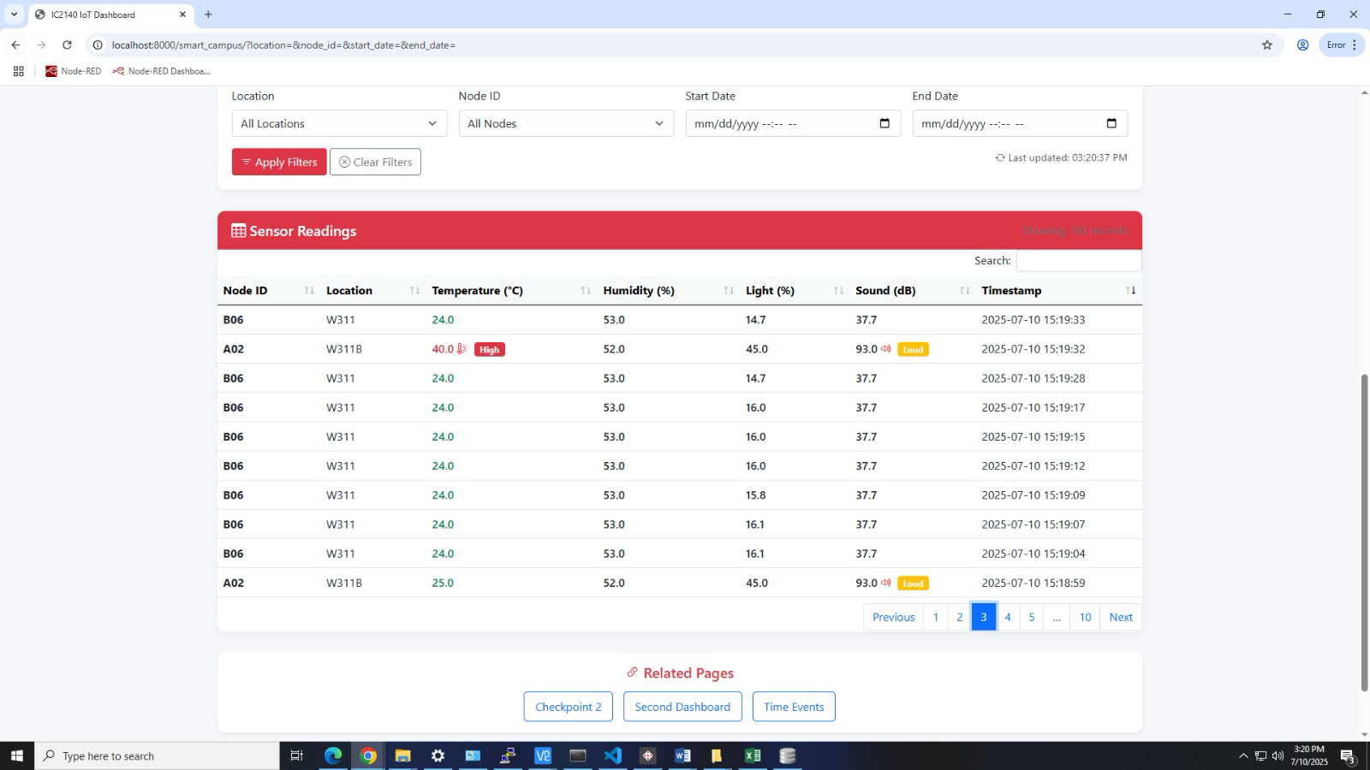
Feature Description
Checkpoint 6 focuses on transforming passive data collection into active monitoring by identifying patterns in sensor data and generating automatic alerts for anomalies. A key use case is detecting potential intrusions: if sound and light levels in a workshop exceed predefined thresholds during nighttime, the system triggers alerts via multiple channels.
Design Methodology
Rule Engine Integration: A rule engine is embedded into the Flask backend. The backend scheduler runs every 60 seconds, extracts the latest measurements from each node, and evaluates SQL-like conditions stored in a dedicated table (e.g., "hours between 00:00 and 06:00, snd_dBA>45" for nighttime intrusion detection). Rules can be added/modified via the web interface without changing Python code.
Alert Handling: When a rule is triggered (condition evaluates to TRUE), the engine writes a record to an alerts table and passes the alert to an output scheduler.
Alert Distribution: Alerts are displayed via the web dashboard (red badges in the navigation bar, toast notifications) to ensure immediate visibility for users.
Analysis of the IoT Data and Performance Result
During a three-day test, the system generated multiple alerts, validating its ability to convert passive telemetry into an active tool for safety and efficiency. Sample alerts include "High Temperature Alert - Node A02 (W311B) temperature too high: 40.0°C" and "High Sound Alert - Node A02 (W311B) sound level too high: 93.0 dB".
Future iterations plan to introduce adaptive thresholds (based on historical averages), visual analysis of "alarm minutes" by room, and integration with campus Telegram bots for personalized alerts. This closes the loop between data and action, making the system a practical tool for facility management.
M5StickCPlus2
Feature Description
The M5StickCPlus2 is designed to measure the temperature and humidity and collect data of acceleration and angular velocity through the built-in IMU. And we setup WIFI () function connects to the specified WiFi network (SSID: "icw502g", password: "8c122ase"). Upon successful connection, it displays a confirmation message and retrieves the device's IP address and MAC address and if the connection fails, the program will restart the device after 30 seconds. For the display screen, we set up data display function. The display method of Temperature and humidity is color changing according to temp: red when exceeding alarm threshold(24), yellow when exceeding warning threshold(22), green otherwise. And accelerometer data will be red when moving. Current time and battery level with graphical display. Alarm function: If the temperature exceeds the alarm threshold (24℃), the buzzer will sound an alarm. The LED light will flash to indicate the status of the device.
Design methodology
About modular design, this code divide function into multiple modules, each handling specific tasks: Wi-Fi connection module (setup WIFI), sensor data acquisition modules (dht.read, M5.Imu.update), data display modules (M5.Lcd.print, showTime, drawBattery), and MQTT communication module (client.publish). This ensures a clear code structure that is easy to maintain and extend.
About status monitoring and feedback, real-time monitoring of equipment status is achieved by detecting motion (detectMovement) and temperature (whether exceeding warning or alarm thresholds). Intuitive feedback is provided through LCD screen displays, buzzer alarms, and LED light flashes based on detection results. For how to handle data which measure by us, data formatting and transmission is helpful. Use ArduinoJson library to format the collected data into JSON format for easy data transmission and parsing. Publish the data to the server through MQTT protocol to realize data interaction between the device and the server.
About how to realize time synchronization and error handling. Utilize NTP servers ("pool.ntp.org") to obtain accurate time and display the current date and time on the LCD screen. When WiFi connection fails, the program automatically restarts the device after 30 seconds to allow reconnection attempts. Display error messages on the LCD screen when sensor data collection fails (e.g., temperature or humidity values reaching 255).
Analysis of the IOT data and performance result
In IOT systems, various types of data play crucial roles. Temperature and humidity data collected through the DHT11 sensor are essential environmental parameters, widely used for environmental monitoring, intelligent control, and other applications. Accelerometer and angular velocity data from the IMU enable the detection of device motion status. For example, when a device moves, these data can trigger alarms or record motion trajectories. Additionally, device status data, including IP address, battery level, and other operational parameters, is vital for users to understand the device's operational status and network connectivity.
Regarding performance metrics, the code employs a delay function(delay(2000))to collect data every 2 seconds. This low-frequency approach helps conserve power but may miss rapidly changing data points. Data transmission stability is ensured through the MQTT protocol, which is lightweight, consumes low bandwidth, and is highly reliable, making it suitable for IOT devices. Device power consumption is influenced by feedback mechanisms such as LED flashing and buzzer alerts, as well as WiFi connections and data transmission. Adjusting data collection and transmission frequencies based on device usage scenarios and battery capacity can help extend the device's lifespan. The M5StickCPlus2 displays real-time data on its LCD screen, allowing users to intuitively monitor device status and environmental parameters. Although the LCD offers clear visual clarity, its performance may be limited by screen resolution and color rendering capabilities. For time synchronization accuracy, the system leverages NTP servers, achieving high precision that meets the requirements of most IOT applications.

ESP8266 Program

Feature Overview
The WeMos-D1 microcontroller plays a central role in our IoT system. It connects to Wi-Fi, receives sensor data via MQTT, processes the data to detect environmental changes, and displays key information using an LED matrix. Additionally, it uses RGB LEDs to indicate system status and provides a button-based interface for switching between different operation modes. This integration allows the ESP8266 to act as both a data receiver and a real-time visual alert platform.

System Design and Operation
The system is initialized through the setup() function, where hardware pins, the LED matrix, serial communication, and network settings are configured. The LED matrix is used to display messages in scrolling format, with customized brightness and alignment. Wi-Fi connection is established using hardcoded SSID and password. If the ESP8266 fails to connect within 30 seconds, the system restarts automatically to ensure reliability.
Once connected, the ESP8266 subscribes to a specified MQTT topic (iot/sensor22) hosted on the PolyU server. It receives environmental sensor data — specifically, light intensity and sound level — in JSON format. Upon message arrival, the callback() function is triggered, parsing the incoming payload and storing the sensor values for further processing.
A pushbutton connected to GPIO is used to switch between three system modes. Each button press cycles through a mode, and the RGB LEDs change color accordingly to reflect the current state. The button input is debounced using a software library to ensure accurate detection.

Display and Alert Mechanism
The system operates in three modes:
- Data Monitoring Mode: The main functionality of the ESP8266 is active in this mode. The latest light and sound readings are evaluated against predefined thresholds. If either value exceeds the threshold, the red LED blinks rapidly to signal an alert. If both values are within acceptable range, the system lights up yellow by combining red and green. The sensor data is shown as scrolling text on the LED matrix, enhancing readability over time. Scrolling is timed precisely using millisecond counters to ensure smooth movement of text.
- Device ID Display Mode: This mode simply displays the device identifier (B22) on the LED matrix for easy reference and testing. It turns off unnecessary indicators and keeps the system in a clean output state.
- Sleeping Mode: In this low-activity mode, the display shows a "ZZ" message to indicate that the system is in sleep or inactive state. The matrix brightness is reduced, and all LEDs are turned off.
This structure ensures the system is both functional and user-friendly. The separation of modes also helps in debugging, monitoring, and demonstration.

MQTT Integration and Communication
Reliable communication is a key part of the system. The ESP8266 uses the PubSubClient library to manage MQTT connections. If the connection to the server is lost, the reconnect() function ensures automatic recovery, preventing long-term data loss or display freeze. Every message received is acknowledged with a brief blue LED flash, providing a subtle visual indicator of successful MQTT communication.
JSON parsing is handled using the ArduinoJson library. Only the necessary fields (light and snd) are extracted from each payload, minimizing memory usage and processing time. This efficient approach allows the microcontroller to handle incoming data smoothly while continuing to manage other tasks such as display and alerts.

Summary
This ESP8266-based system integrates network communication, real-time environmental monitoring, and user interaction in a compact and efficient design. By combining MQTT data handling, visual display, and responsive alerting, it supports the core objectives of our IoT project — simplicity, reliability, and visibility. The modular software design also allows for easy future updates, such as adding temperature or humidity sensors, or implementing remote control features.
Reflection:(liyuzhao) 24106781D
Looking back at the first four checkpoints of the "Smart Campus in W311" journey, I realized how each stage quietly reshaped my way of thinking about IoT projects. Checkpoint 1, the simple crontab "@ reboot" line, reminds me that reliability is the primary requirement: before the device can withstand a power outage without human assistance, it is just a laboratory toy. Turning to checkpoint 2, when I saw the raw MQTT frames flowing into a structured data table and being re displayed as a real-time HTML list, I finally understood the way data is stored and displayed; Persistence turns fleeting numbers into company assets, forcing me to focus on architecture design, timestamps, and input validation. Then, checkpoint 3 made me face the scale and background. Receiving messages from each node on the floor prompted me to optimize the index, rethink UI filters, and most importantly, I realized that the same temperature value, once labeled with rooms, dates, and course schedules, means something completely different. When we reached the sixth checkpoint (rule-based analysis and multi-channel alerts), the project had evolved from a monitoring tool to a working system. Writing a rule engine, handling false positives, and rate limiting emails made me realize that 'sensor software' ultimately serves people with real workflows, habits, and fatigue thresholds. In short, these four checkpoints form a carefully considered teaching ladder: autonomy, persistence, scalability, and action. Climbing up this ladder not only broadened my technical toolbox (Python, SQL, Flask, SMTP), but also broadened my way of thinking and gave me more confidence in my abilities. For me, this is the most valuable lesson in the entire exercise.
Self-Reflection LONG Yuhan 24105998d
During this project, I contributed to the design and implementation of web applications in checkpoints 4 and 5. For Checkpoint 4, I helped develop the IC2140 IoT Dashboard using Django’s MVT architecture. My work included defining the sensor data model, implementing backend logic to handle data retrieval and summary statistics, and designing the interactive front-end dashboard. I integrated real-time data updates using JavaScript polling and Flexmonster charts and ensured the user interface was both visually appealing and user-friendly with Bootstrap and custom CSS.
For Checkpoint 5, I extended the system to support querying venue, event, and environmental data. I designed models for Venue, Event, and EnvironmentalData, and implemented logic to validate user input, aggregate sensor data, and handle errors gracefully. I also developed an interactive HTML template with collapsible event panels, clear data tables, and responsive design. Throughout, I focused on usability, data clarity, and robust error handling.
In developing the HTML templates and some backend logics for checkpoints 4 and 5, GenAI could be a helpful tool. During my work, GenAI was used to debug my code and enhance the user interface aesthetically. By showing the error message, it helped me locate the error syntax and made modifications. Also, GenAI was of assistance in designing the collapsible panels of events in checkpoint 5. It is worth noting that the overlapping logic using ‘Q’ objects was hinted by GenAI, given the code below: events=Event.objects.filter(venue=venue).filter(Q(start_datetime__lt=end_datetime, end_datetime__gt=start_datetime) |Q(start_datetime__exact=start_datetime) |Q(end_datetime__exact=end_datetime) ).order_by('start_datetime'), which shows data as long as the periods intersect.
Reflecting the whole experience, I deepened my understanding of web development, especially with Django and modern front-end techniques. I learned how to structure data models for real-world IoT applications and how to efficiently process and aggregate large datasets. Implementing real-time updates and interactive visualizations challenged me to balance performance with user experience. Moreover, my programming skills have greatly improved since a lot of programming was used.
I encountered problems in both front-end and back-end applications. I solved the problems by a brainstorming, asking the teacher for help, communicating with others, and consulting GenAI. One important realization from this project is the significance of teamwork. Collaborating with my teammates allowed us to combine our strengths, share ideas, and solve problems more efficiently. For instance, I consulted my teammate who was in charge of checkpoint 3 when importing the data. Through regular communication and cooperation, we were able to divide tasks according to each member’s expertise and support each other when challenges arose. I found that effective teamwork not only improved the quality and efficiency of our work but also made the project experience more enjoyable and rewarding. This experience has reinforced my belief that strong collaboration is essential for the success of any complex project.
Throughout this project, I also significantly improved my skills in using Generative AI (GenAI) tools. By interacting with GenAI, I learned how to craft effective prompts, refine my questions, and integrate AI-generated content into my project deliverables.
Overall, this project improved my technical skills in Django, Python, responsive design, GenAI tools, and teamwork. I am proud of the solutions I implemented and look forward to applying these skills in future projects.
Self-reflection Liu Yuhang 24105038D
In this M5StickCPlus2 project, I design some functions. Connecting to a designated WiFi network using preset credentials and attempting reconnection or device reboot upon connection failure; communicating with a MQTT server via the PubSubClient library to publish collected data in JSON format to specified topics; collecting temperature and humidity data through a DHT11 sensor while utilizing the M5StickCPlus2's built-in IMU for acceleration and gyroscope measurements; displaying real-time temperature, humidity, acceleration, gyroscope data, and current time on the LCD screen, with LED lights and buzzer providing status feedback and alarm functions. The code integrates multiple functionalities into a single device, creating a versatile IoT solution. Real-time data display via the LCD enhances user interactivity and provides instant feedback. It includes mechanisms to handle WiFi connection failures and sensor errors, ensuring stable operation under suboptimal conditions. The code demonstrates clear structure and modular functionality, facilitating maintenance and expansion. However, there are areas for improvement: The current data collection frequency (every 2 seconds) may be too low for real-time monitoring applications. Increasing the frequency could provide more accurate and timely data, though it might increase power consumption. Devices could adopt advanced power management techniques, such as entering sleep mode during data collection intervals to extend battery life. While the code handles WiFi connection errors, it lacks detailed handling for MQTT communication failures – adding retry or fallback mechanisms could enhance reliability. The current code uses unencrypted MQTT connections; implementing TLS/SSL encryption would strengthen data security, particularly for sensitive applications. For large-scale deployments, the code could be optimized to manage multiple devices more efficiently, such as through dynamic topic naming or more sophisticated device management approaches. Overall, this code demonstrates a comprehensive approach to building multifunctional IOT devices that effectively integrate sensor data collection, real-time display, and remote communication. However, by optimizing performance, power efficiency, and security, the device could become more robust and adaptable to a wider range of application scenarios.
I learned a lot from this TM1118 because it made me review the internet of things knowledge from TM1117.During this project, I faced challenges in both front-end and back-end development. To solve these problems, I used brainstorming, sought help from my teacher, communicated with others, and consulted GenAI tools. This experience highlighted the importance of teamwork. By collaborating with my teammates, we combined our strengths, shared ideas, and tackled challenges more efficiently. For example, I consulted a teammate responsible for checkpoint 3 when importing data. Regular communication allowed us to divide tasks based on expertise and support each other when needed. Teamwork not only improved our work quality and efficiency but also made the project more enjoyable and rewarding. I also significantly improved my skills in using GenAI tools, learning to craft effective prompts and integrate AI-generated content into our project deliverables. Overall, this project enhanced my technical skills in Django, Python, responsive design, and GenAI tools. I am proud of the solutions we implemented and look forward to applying these skills in future projects.
Personal Reflection Wu Jizhou 24106194D
During this project, my main responsibility was to develop the core program for the ESP8266 module, which acted as the local intelligence of our IoT system. I worked on establishing WiFi and MQTT connections, parsing JSON payloads from the server, and implementing the logic for alarm detection and display using an LED matrix. The device was also capable of switching between different display and alert modes based on input from a hardware button.
Through this experience, I gained a much deeper understanding of how embedded systems interact with network services. Writing the setup_wifi() and reconnect() functions made me appreciate the importance of ensuring reliable connectivity, especially in environments where uptime matters. I learned how to handle asynchronous MQTT data reception and how to safely deserialize JSON strings using ArduinoJson, a library I had never used before. One technical highlight was designing a smooth scrolling mechanism for the LED matrix to display sensor values in real time. I also implemented threshold-based alert logic for both light and sound data, with corresponding LED indicators to visually show the status.
While implementing these features, I encountered several challenges. Debugging MQTT connection issues required careful examination of WiFi states, MAC addresses, and broker configurations. It was also a challenge to synchronize real-time display with button-triggered mode changes while keeping the system responsive. I overcame these by testing individual modules extensively and restructuring the code to separate concerns between data handling, user input, and display logic.
This hands-on experience not only improved my programming skills in C++ and embedded development but also enhanced my understanding of how different parts of an IoT system communicate. I also learned how to better integrate hardware and software by coordinating with teammates responsible for the server and visualization parts. It was rewarding to see our ESP8266 device functioning smoothly as a reliable sensor endpoint within a broader system.
Beyond technical skills, this project also made me appreciate the importance of simplicity and robustness in design. Since the ESP8266 is a resource-constrained device, I had to make trade-offs in terms of memory usage and responsiveness. Every feature I added needed to be tested carefully to avoid unexpected behavior.
Overall, this project gave me valuable insight into embedded IoT development. It pushed me to work more independently, make design decisions, and consider real-world reliability. I now feel more confident about taking on similar roles in future projects and look forward to exploring more advanced topics in edge computing and smart sensing systems.

