**Forecasts from meanf method**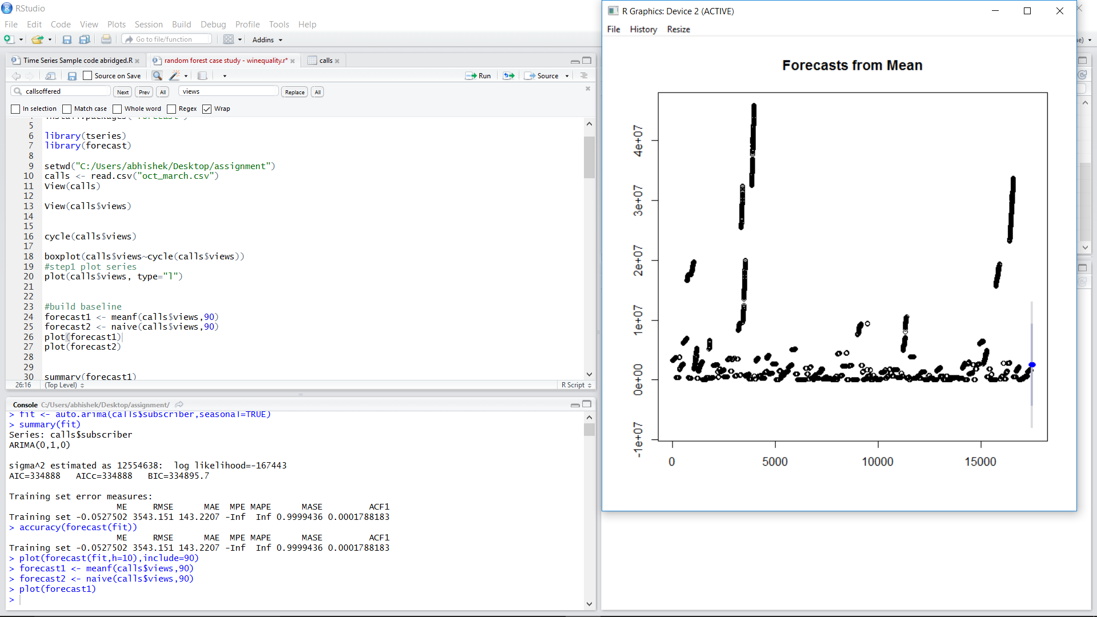

**Forecasts from HoltWinters Technique (Prediction of values).**

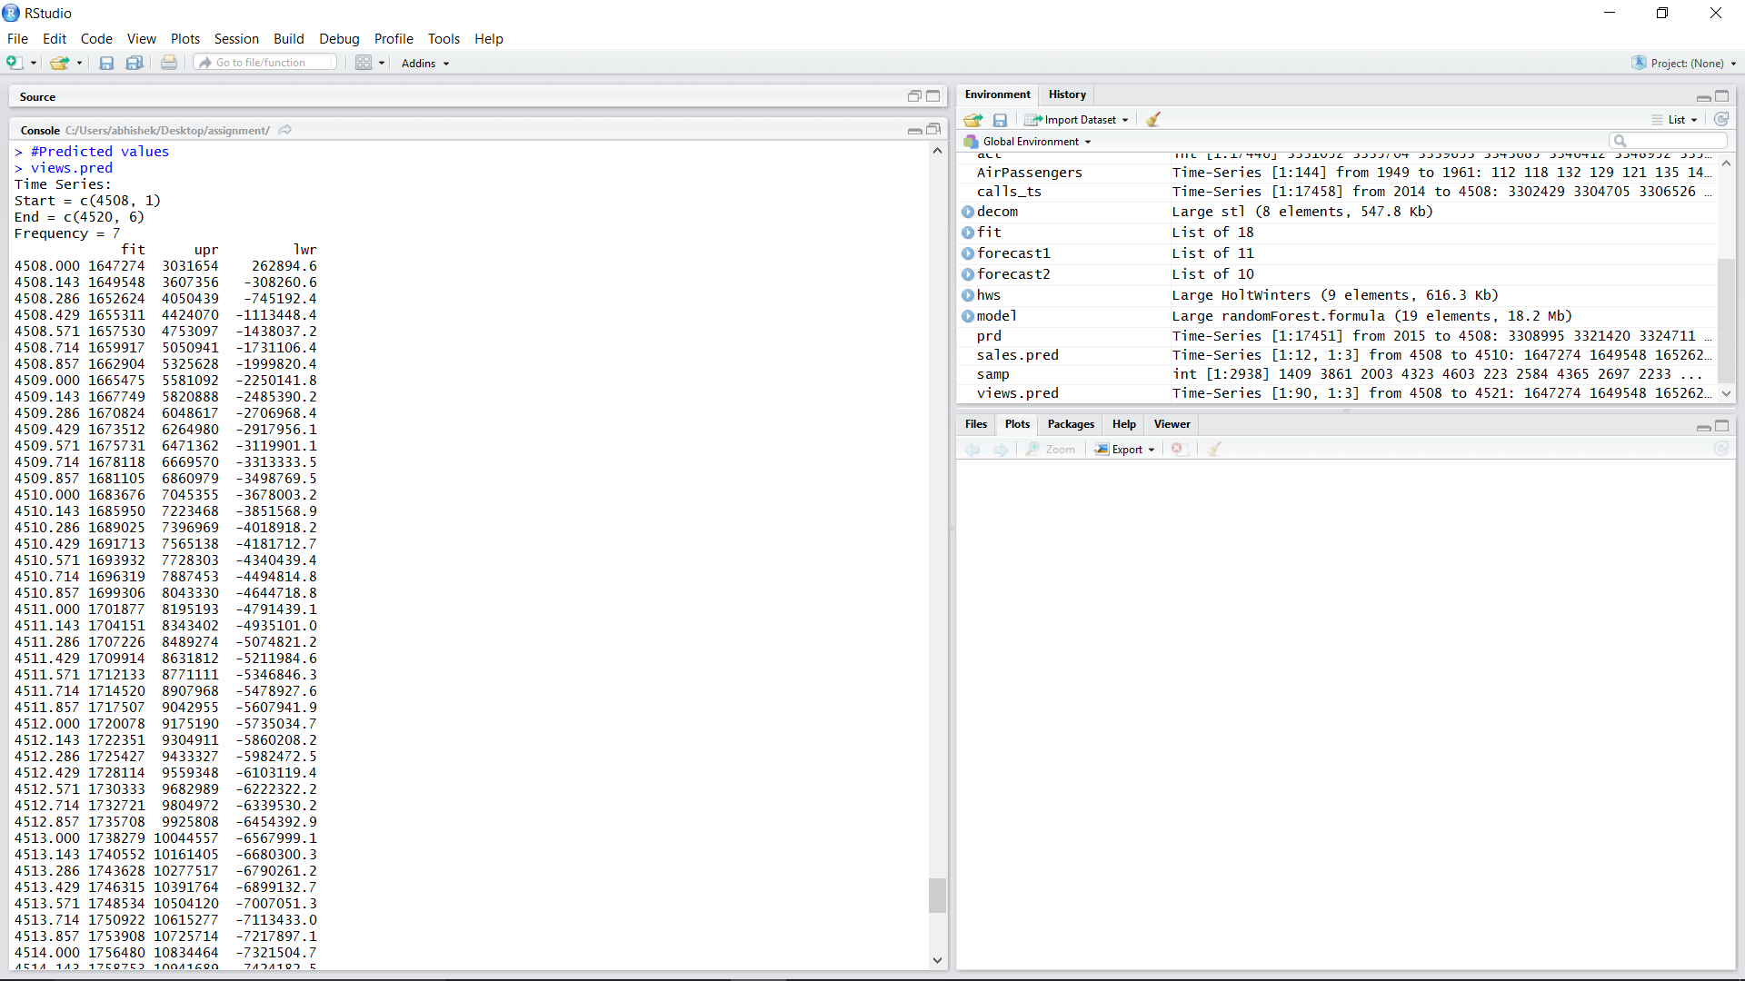

**Forecasts from Naïve method**

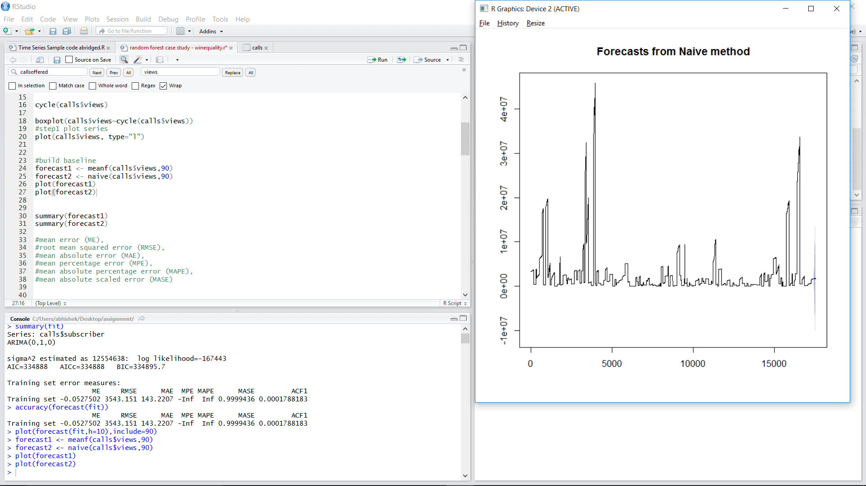

**Forecasts from ARIMA MODEL** 