BÀI TẬP THIẾT KẾ CƠ SỞ DỮ LIỆU

Bài 1:

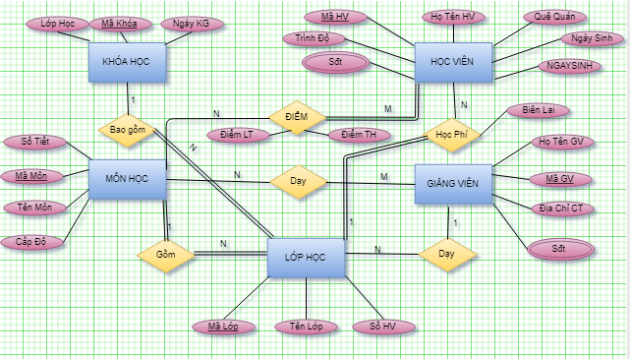

Bài 2

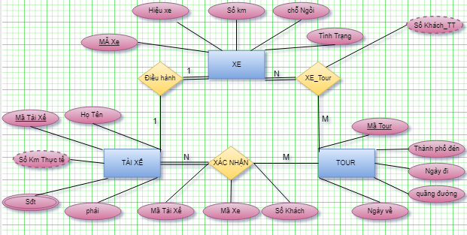

Bài 3

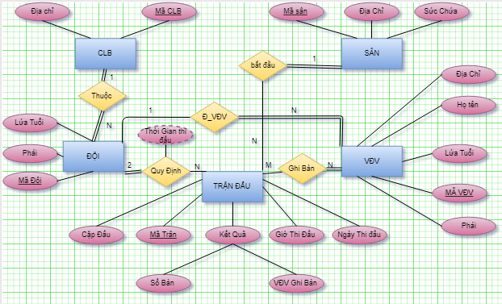

Bài 4

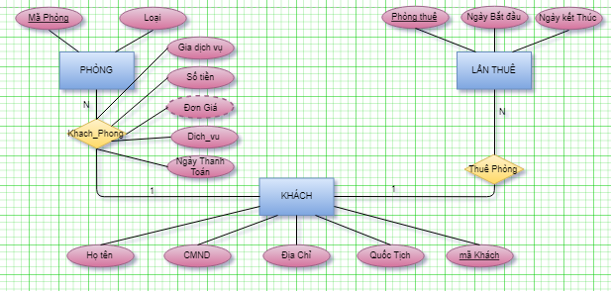

Bài 5

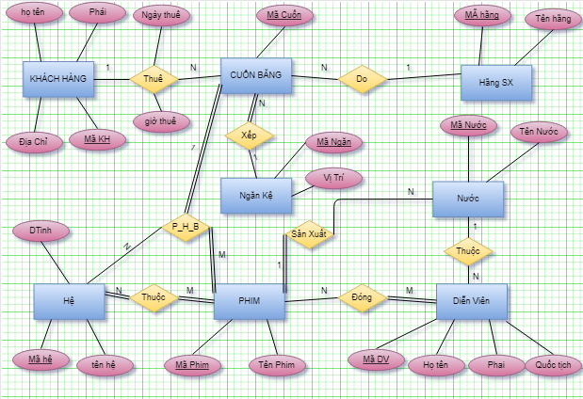

**BÀI TẬP CHUYỂN ERD SANG QUAN HỆ**

AIRPORT(Airport_code , City, State, Name)  
 FLIGHT_LEG(Airport_code, Leg_no, Number, Scheduled_dep_time, Scheduled_arr_time )  
 CAN_LAND(Airport_code, Type_name)  
 AIRPLANE_TYPE(Type_name, Max_seats, Company)  
 FLIGHT(Number, Airline, Weekdays)  
 FARE(Number, Restriction, Amount, Code)  
 AIRPLANE(Airplane_id, Total_no_of_seats, Type_name)  
 LEG_INSTANCE(Airport_code, Airplane_id,No_of_avail_seats,Leg_no, Number,Date Arr_time,Dep_time)  
 SEAT(Seat_no, Date, Leg_no, Number, Customer_name, Cphone )

CAN_LAND( Airport_code,Type_name)

BÀI 2,

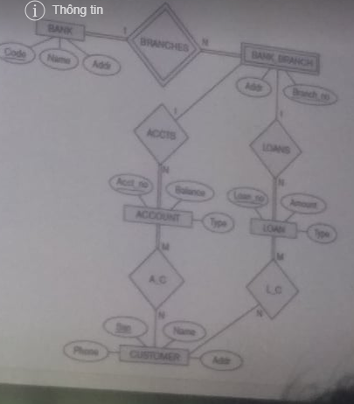

BANK(Code,Name,Addr)

ACCOUNT(Acct_no,Balance,Type,Branch_no,Code)

CUSTOMER(Ssn,Name,Addr,Phone)

LOAN(Loan_no,Amount,Type,Branch_no,Code)

BANK_BRANCH(Addr,Branch_no,Code)

A_C(Acc_no,Ssn)

L_C(Ssn,Loan_no)

BÀI 3.

BacSi(MaBacSi,Hoten)

BS_ChuyenMon(MaBacSi,ChuyenMon)

BenhNhan(MaBenhNhan,HoTen,GioiTinh,Ngay,thang,nam,Mabacsi)

ThanNhan(Hoten_TN,Diachi,SoDthoai,Mabehnhan,HotenTN)

DIEUTRI(Ngay,ThoiGian,ketqua,MaBacsi,Ketqua,MabenhNhan)