**INTRODUCTION**

Zoho Books is a popular cloud-based accounting software designed for small and medium-sized businesses. It provides a comprehensive platform for managing various financial aspects, including invoicing, expense tracking, inventory management, and more. With its user-friendly interface and robust features, Zoho Books simplifies accounting processes and enables businesses to efficiently handle their financial operations.

Purpose :

The term "travel tax" can refer to different things in various contexts. In some cases, it may refer to a tax imposed by governments on travelers departing from a specific country, while in other cases, it might pertain to taxes related to the travel industry or specific travel services. The purpose of a travel tax can vary depending on the region and the specific regulations in place.

Typically, the purpose of travel taxes includes the following:

* **Revenue Generation**: Travel taxes can be a significant source of revenue for governments. These funds can be allocated to various projects, such as the development of infrastructure, tourism promotion, and other initiatives that benefit the local or national economy.
* **Infrastructure Improvement**: Travel taxes might be used to improve transportation facilities, such as airports, roads, and public transportation systems, to accommodate the growing number of tourists and ensure a smooth travel experience for both visitors and locals.
* **Regulation and Control**: Travel taxes can also serve regulatory purposes, helping governments regulate and monitor the flow of tourists in and out of the country.

Problem Definition & Design Thinking;

EmpathyMap:

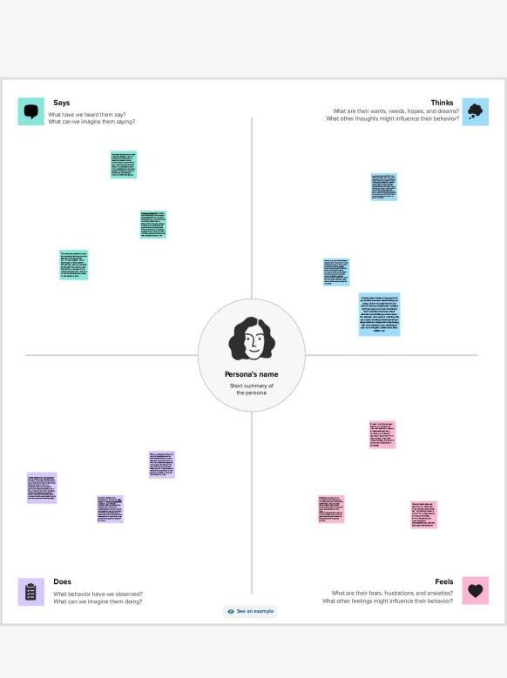

Ideation Brainstorming Map;

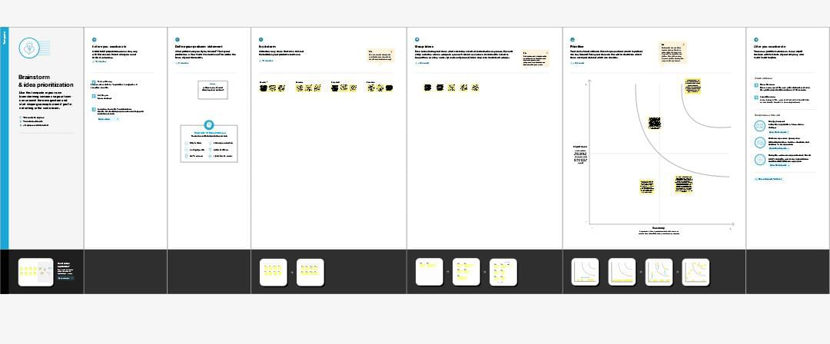

Result:

Travel tax problems can impose financial burdens on businesses in the travel and tourism industry, leading to reduced profitability, potential layoffs, and decreased investment in infrastructure and services. Persistent travel tax problems can contribute to an overall economic slowdown, particularly in regions heavily reliant on tourism. This can have a cascading effect, impacting various industries and leading to job losses and a decrease in overall economic activity. If travel taxes are excessively high or poorly managed, it can discourage tourists from visiting a particular destination, leading to a decline in tourism revenue for the local economy.

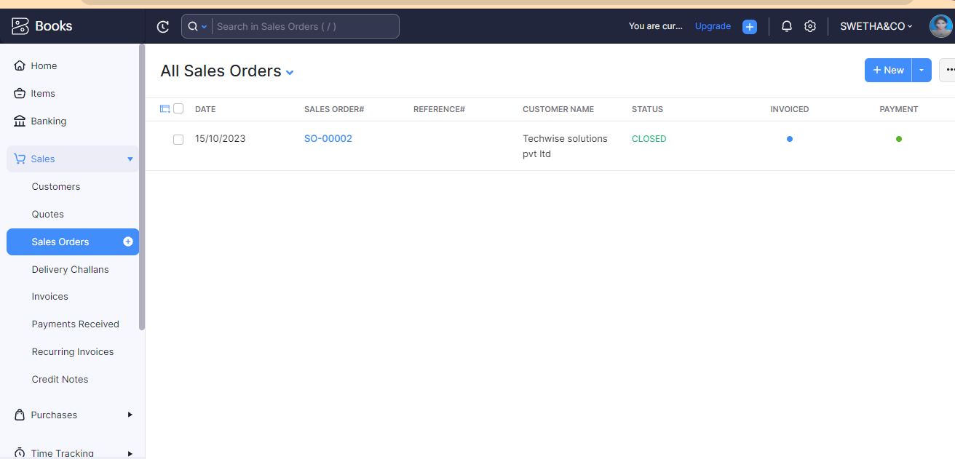

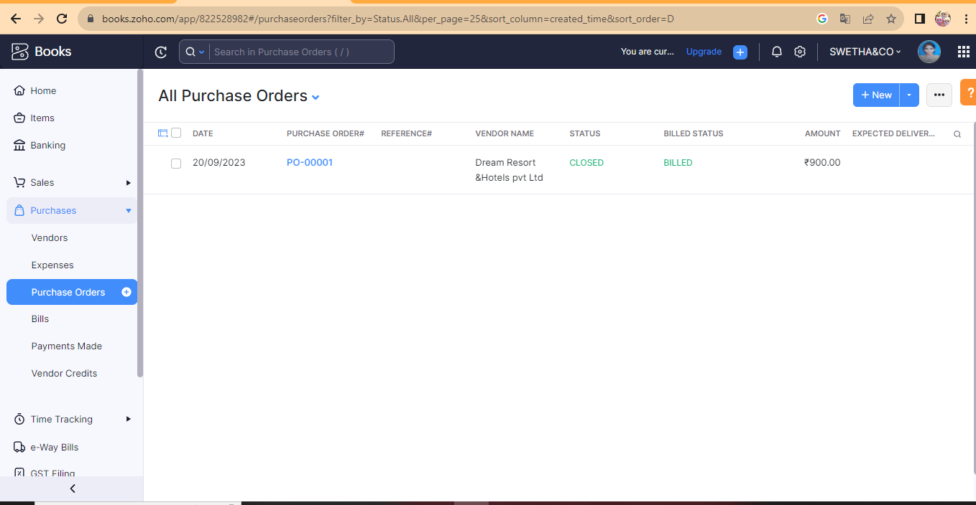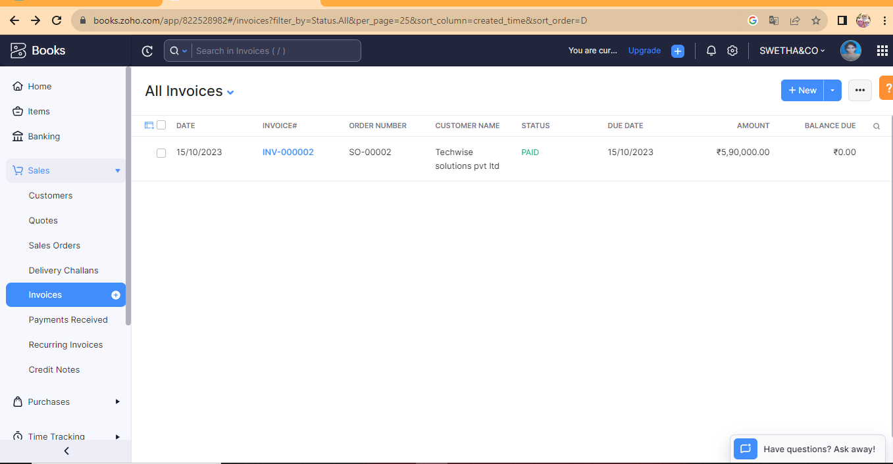

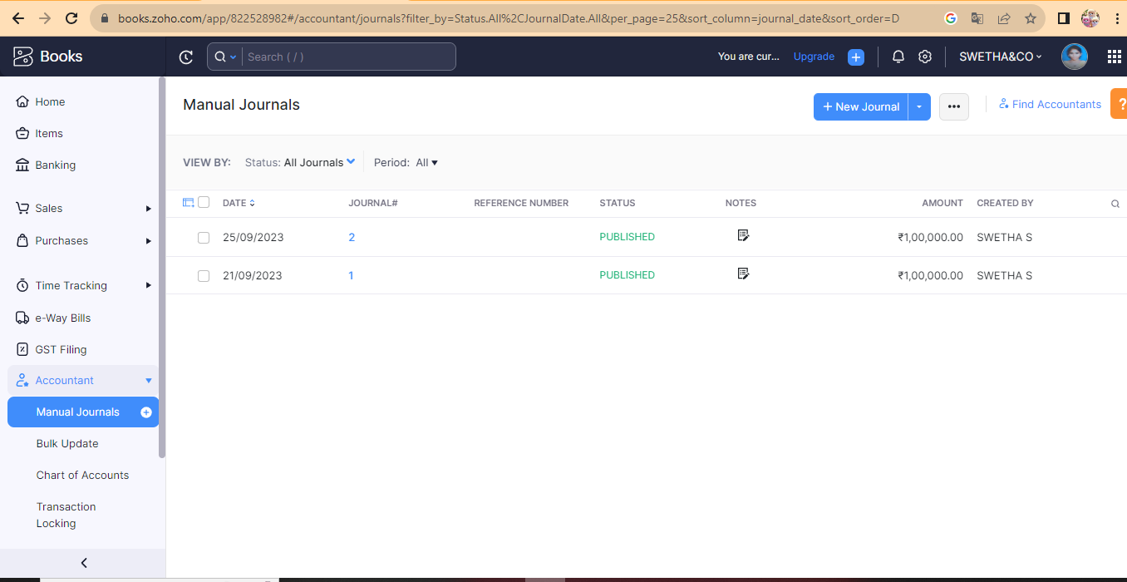

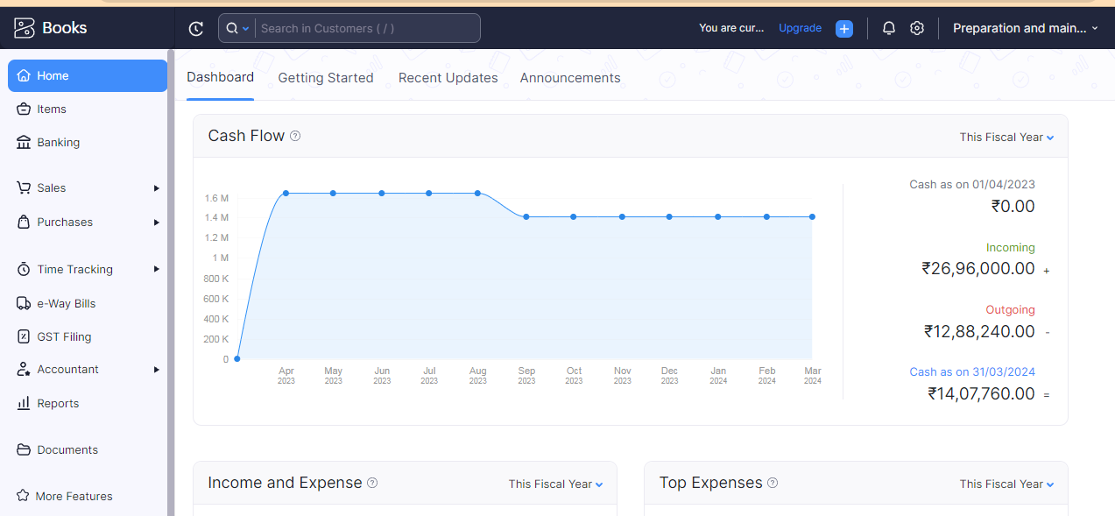

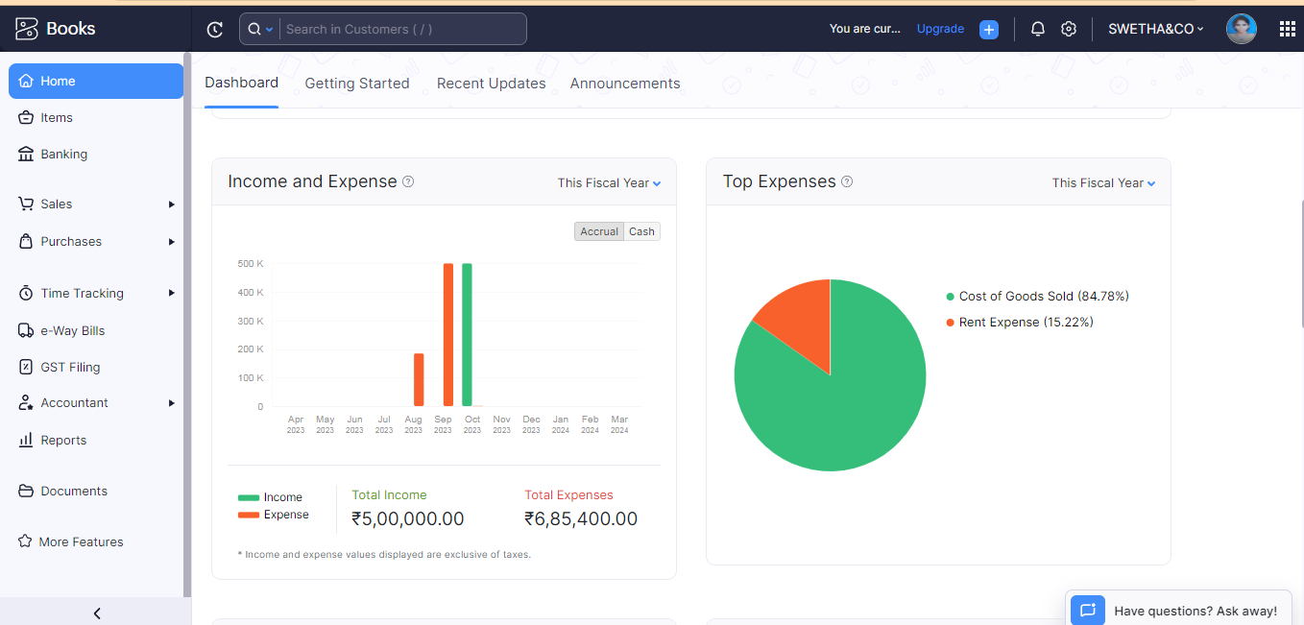

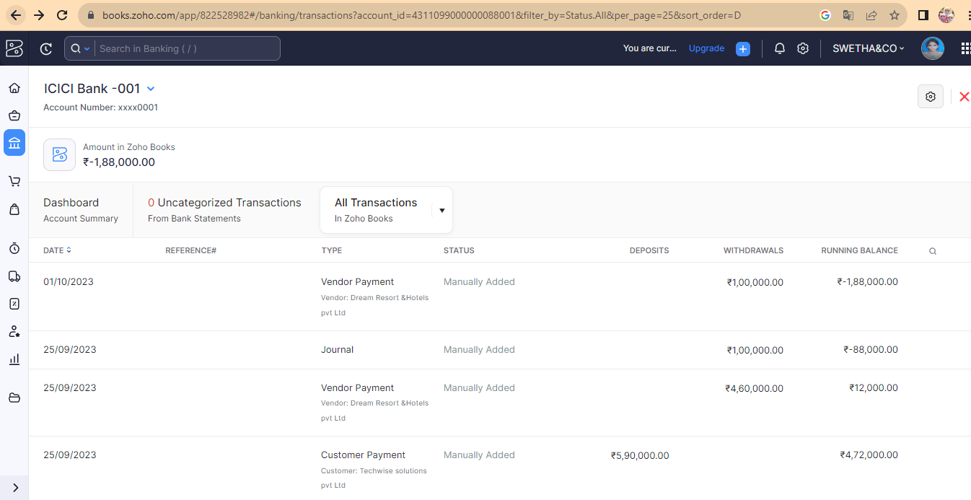

ADVANTAGES & DISADVANTAGES;

Advantage:

* Travel and tour taxes can generate significant revenue for governments, which can then be used for various public services and infrastructure development. This revenue can be used to improve transportation systems, maintain tourist attractions, and enhance the overall tourist experience.
* The revenue generated from travel taxes can be allocated to promoting and developing the tourism industry, attracting more visitors, and improving the overall tourism infrastructure. This can include advertising campaigns, the development of tourist facilities, and the preservation of cultural and natural heritage sites.
* Travel taxes can be utilized to fund environmental protection and conservation efforts, especially in ecologically sensitive tourist destinations. This can include initiatives such as waste management, conservation of natural habitats, and the promotion of sustainable tourism practices.
* Taxes on tourism can be used to support local communities in popular tourist destinations. This can be achieved through the development of local businesses, infrastructure, and community services, ultimately improving the living standards of residents in these areas.
* The funds collected through travel and tour taxes can be used to upgrade and maintain tourism-related infrastructure and facilities, such as roads, airports, public transportation, and tourist accommodations. This can lead to an enhanced travel experience for tourists and improve the overall image of a tourist destination.

It's important to note that while travel and tour taxes can have these advantages, they should be implemented thoughtfully to avoid overburdening tourists and negatively impacting the tourism industry. Governments and policymakers should consider the balance between generating revenue and maintaining the attractiveness and affordability of the destination for tourists.

Disadvantages;

Zoho Books is an accounting software designed for small and medium-sized businesses, including those in the travel industry. However, it does not specifically handle travel taxes or tour-related functions, as its primary focus is on general accounting and bookkeeping tasks. Nevertheless, I can provide some insights into the potential disadvantages of travel taxes for businesses in the travel industry:

* **Increased Cost for Customers**: Travel taxes can lead to increased costs for travelers, including higher ticket prices for transportation, accommodation, and various tourist activities. This can potentially deter some customers from making travel plans or reduce their spending during their trip.
* **Competitiveness and Attractiveness**: High travel taxes can make a destination less competitive compared to others that have lower tax burdens. This can affect the overall attractiveness of a location, especially for budget-conscious travelers who may opt for more affordable options.
* **Administrative Burden**: Managing and complying with travel tax regulations can create an additional administrative burden for businesses. This can involve extra paperwork, the need for specialized expertise, and additional time and resources dedicated to tax compliance and reporting.
* **Risk of Economic Slowdown**: Excessive travel taxes can potentially lead to a slowdown in the tourism sector, impacting the overall economy of a region or country. A decline in tourism can affect various related industries, including hospitality, transportation, and local businesses that rely on tourist spending.
* **Tourist Perception and Satisfaction**: High travel taxes may lead to negative perceptions among tourists regarding the value for money in a particular destination. This can impact overall satisfaction levels, potentially leading to reduced repeat visits and negative word-of-mouth, which can harm the long-term reputation of a tourist destination.To mitigate these disadvantages, it's crucial for governments and businesses to strike a balance between generating revenue through taxes and maintaining the attractiveness and affordability of their destinations. Efficient management of taxes and a focus on improving the overall tourist experience can help alleviate some of these potential drawbacks.

APPLICATIONS;

Zoho Books is an accounting software that primarily focuses on managing general accounting and bookkeeping tasks for businesses. While it may not be specifically tailored for the travel and tourism industry, it can still be utilized effectively by travel agencies, tour operators, and other businesses within this sector. Some of the key applications of Zoho Books for travel-related businesses include:

* **Expense Tracking:** Zoho Books can help track expenses related to various aspects of travel operations, such as accommodation, transportation, and other logistical expenses. This can provide a clear overview of the costs associated with different tours or travel packages.
* **Invoicing and Billing:** The software enables the creation and customization of invoices, making it suitable for travel agencies and tour operators to bill their clients for the services provided. It can handle different currencies, which is beneficial for businesses dealing with international clients.
* **Payment Processing:** With integrated payment gateways, Zoho Books facilitates the smooth processing of payments from customers. This feature is particularly useful for businesses in the travel industry that often deal with online bookings and payments.
* **Inventory Management:** While not specific to the travel industry, the inventory management feature can be useful for tracking and managing travel-related assets such as equipment, vehicles, or any other inventory that may be used during tours or travel services.
* **Tax Compliance:** Zoho Books assists businesses in managing their tax-related responsibilities, including the calculation and tracking of taxes. While it may not be specifically tailored for travel taxes, it can still help with general tax management, which is crucial for businesses in the travel industry.

While Zoho Books may not offer industry-specific features for the travel and tourism sector, its general accounting and financial management capabilities can still be effectively applied to businesses within this industry. However, businesses with more specific needs related to travel and tourism may find it beneficial to explore other specialized software solutions that cater directly to their industry requirements.

CONCLUSION;

Zoho Books, while not specifically designed for the travel and tourism industry, can still be a valuable tool for managing various financial aspects of businesses in this sector. Although it may not have specialized features for handling travel taxes and tour operations, its general accounting capabilities can be adapted to meet the needs of travel agencies, tour operators, and other related businesses.

Zoho Books can effectively handle tasks such as expense tracking, invoicing, financial reporting, payment processing, and tax compliance, providing businesses with the necessary tools to manage their financial operations.

The software allows for customization and integration with various third-party applications, enabling businesses to tailor it to their specific requirements within the travel and tourism industry.

Zoho Books offers different pricing plans, making it a cost-effective solution for businesses looking for an accounting software that can handle their financial tasks without incurring significant expenses.

While Zoho Books may not have industry-specific features for managing travel taxes and tour operations, its adaptability and core accounting functionalities make it a suitable option for businesses seeking a general accounting solution. For more specific and comprehensive needs related to the travel and tourism industry, businesses may benefit from exploring dedicated software solutions designed explicitly for this sector.

FUTURE SCOPE:

Considering the dynamic nature of the travel and tourism industry, there are potential areas where Zoho Books or similar accounting software could expand its functionalities to better serve businesses in this sector. Some future scopes for Zoho Books in relation to the travel and tourism industry might include.

Future versions of Zoho Books could potentially integrate with travel management systems, allowing businesses to seamlessly manage bookings, reservations, and itineraries alongside their financial data.

To cater specifically to the travel industry, Zoho Books could incorporate features that automate the calculation and management of various travel-related taxes, making it easier for businesses to ensure compliance with relevant tax regulations.

Enhanced reporting capabilities tailored to the unique metrics and KPIs of the travel and tourism industry could provide businesses with valuable insights into their performance, customer behavior, and market trends.

Integration with popular tour booking platforms and travel marketplaces could streamline the process of managing bookings, cancellations, and refunds, providing a more holistic solution for businesses operating in the travel and tourism industry.

By incorporating these and other industry-specific features, Zoho Books can further solidify its position as a comprehensive accounting solution for businesses in the travel and tourism sector, catering to their evolving needs and helping them streamline their financial operations more effectively.

APPENDIX

Source Code

Attach the code for the solution built.