**Ho Chi Minh City University of Technology**

**FACULTY OF COMPUTER SCIENCE & ENGINEERING**



Laboratory Report

OPERATING SYSTEM

Laboratory Report 4 -

Scheduling & Contiguous Memory Allocation

Course: Operating Systems

Student:

Hoàng Cao Quốc Thắng -2050020

Ho Chi Minh City, 15/11/2021

**3 Exercises**

1. **Write two programs for CPU scheduling using FIFO and Round Robin. Measure the total turnaround time for all processes.**

First is FIFO

This is my work ( Full code is in the folder lab4_2050020/problem1):

FIFO.c

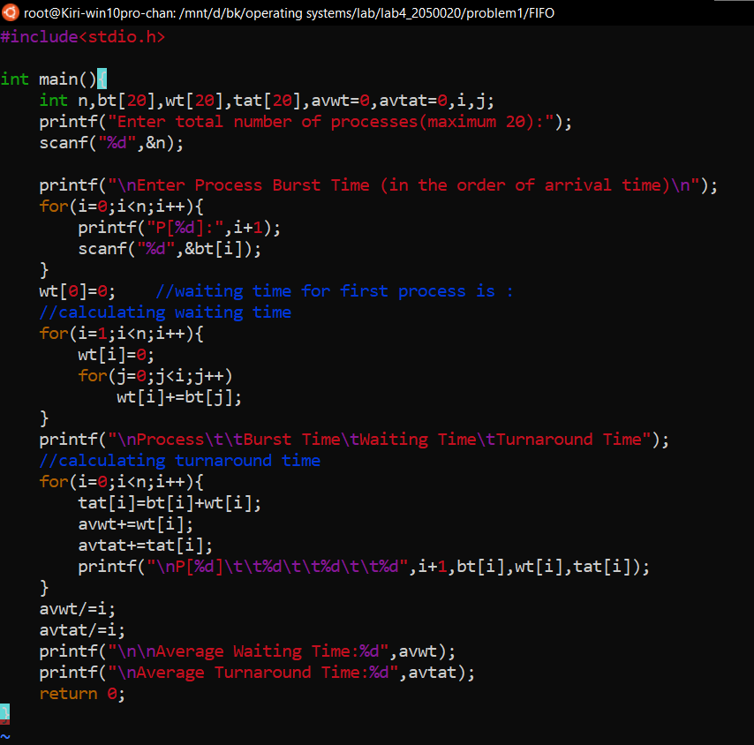

**And this is the output:**

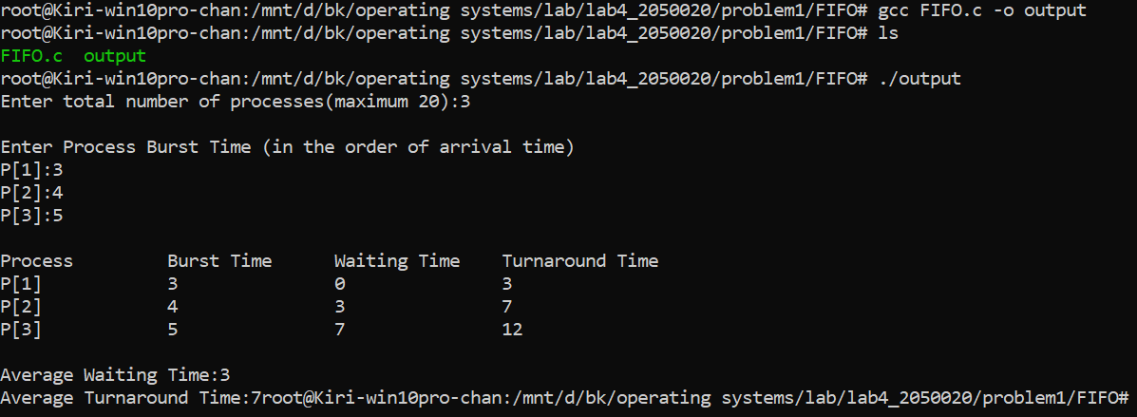

Secondly, this is the Round Robin algorithm: (round_robin.c)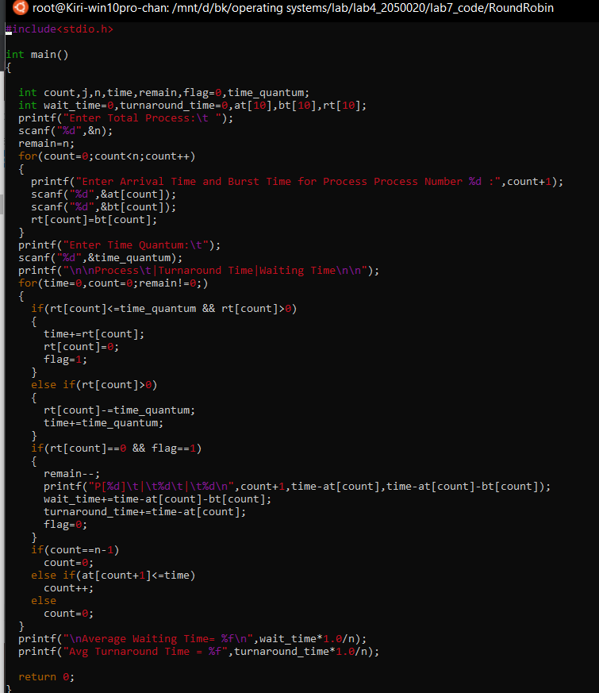

And the result:

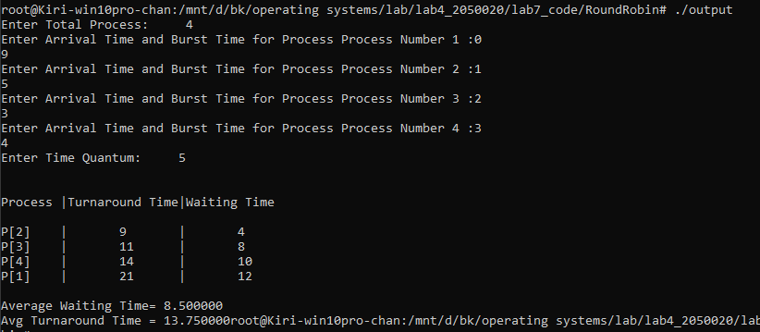

1. **Write two programs for the Contiguous Memory Allocation using algorithm Bestfit and Worst-fit by completing the TODO part in the sample code.**

In this problem, I alter file mem.c:

- Finishing the TO DO part in

void * best_fit_allocator(unsigned int size)

- Adding 1 more function:

void * worst_fit_allocator(unsigned int size)

This is my work ( Full code is in the folder lab4_2050020/problem2):

queue.c:

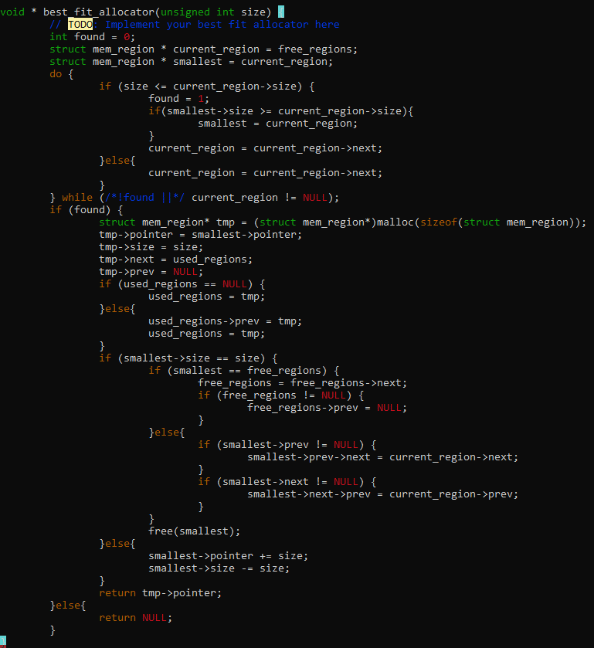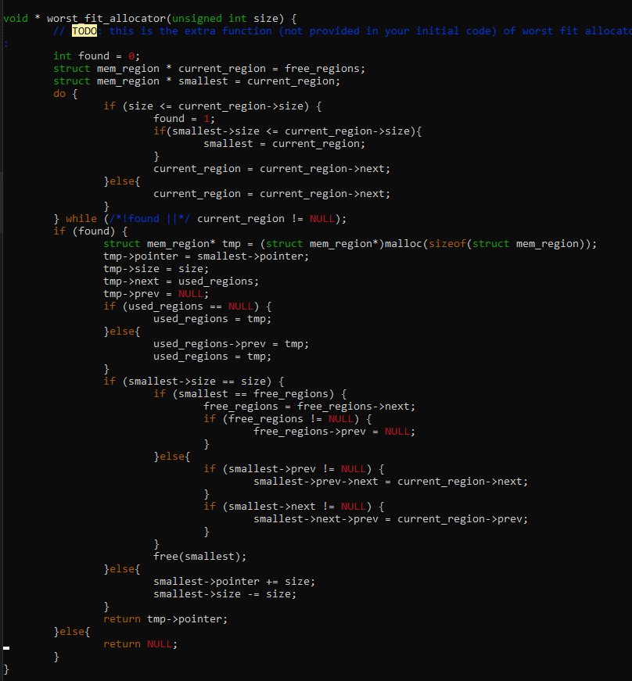

Therefore: the result of each stragergies:

Best-fit:

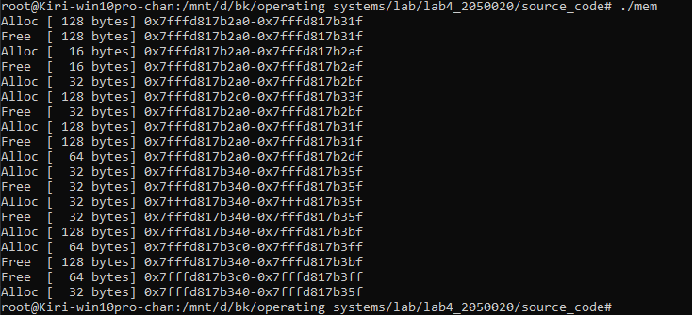

Worst-fit:

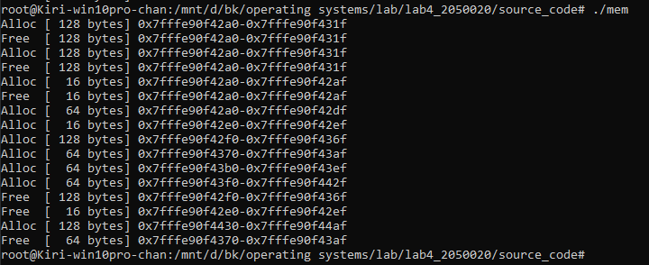

~This is the end of the report~