# Source:

<https://www.youtube.com/watch?v=kjN7mV5POXc>

<https://github.com/elastic/go-elasticsearch/blob/main/_examples/main.go#L127>

<https://www.elastic.co/guide/en/elasticsearch/reference/current/query-dsl-multi-match-query.html>

<https://www.elastic.co/guide/en/elastic-stack-get-started/current/get-started-docker.html>

<https://www.freecodecamp.org/news/go-elasticsearch/> hits

<https://outcrawl.com/go-elastic-search-service>

# What is Elasticsearch?

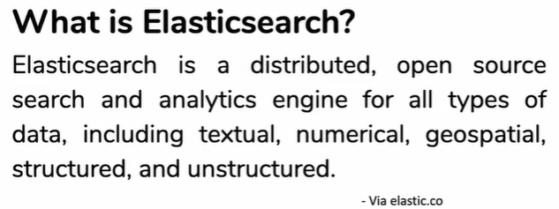

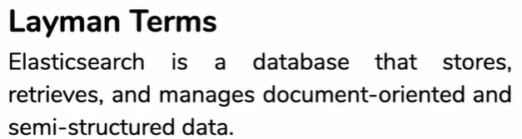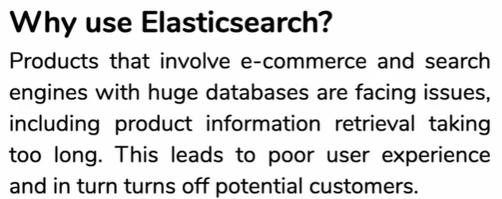

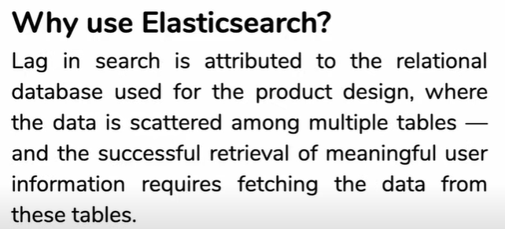

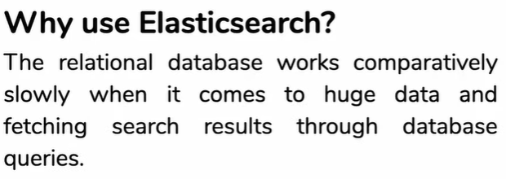

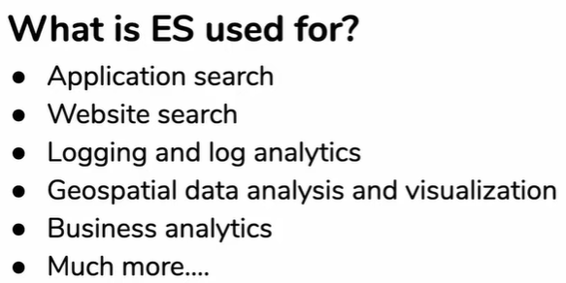

# How des elasticsearch work

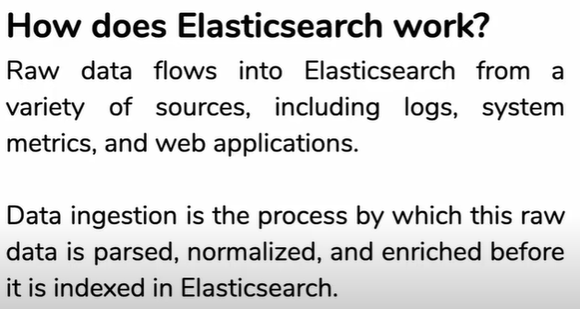

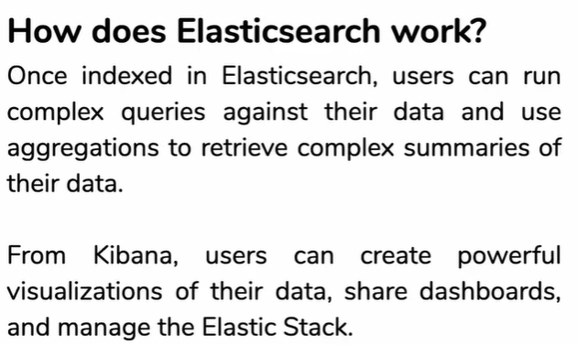kibana

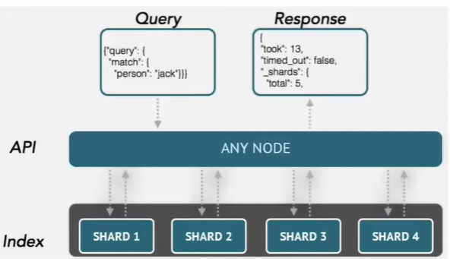

# Basic concepts of Elasticsearch

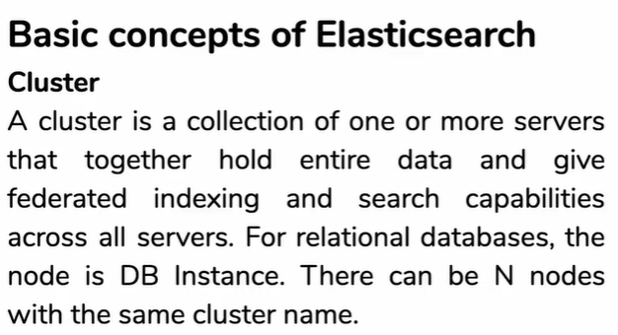cluster

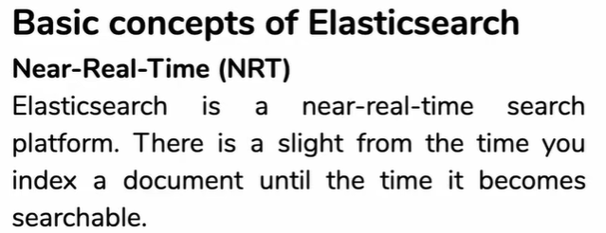

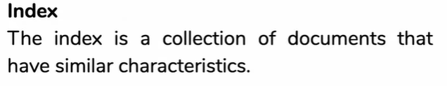

b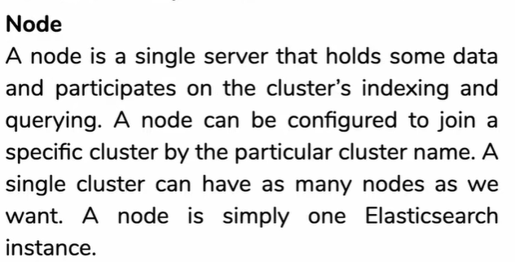

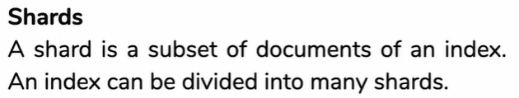shards

# Docker Elastic search

* Elasticsearch docker

https://hub.docker.com/_/elasticsearch

* kibana:

<https://hub.docker.com/_/kibana>

* kibana connect to elasticsearch

https://stackoverflow.com/questions/40341346/kibana-on-docker-cannot-connect-to-elasticsearch

<https://www.elastic.co/guide/en/kibana/current/docker.html>

* docker-compose kibana vs elasticsearch

<https://viblo.asia/p/tich-hop-elasticsearch-va-kibana-vao-docker-compose-Az45bymqlxY>

# elasticsearch REST APIs

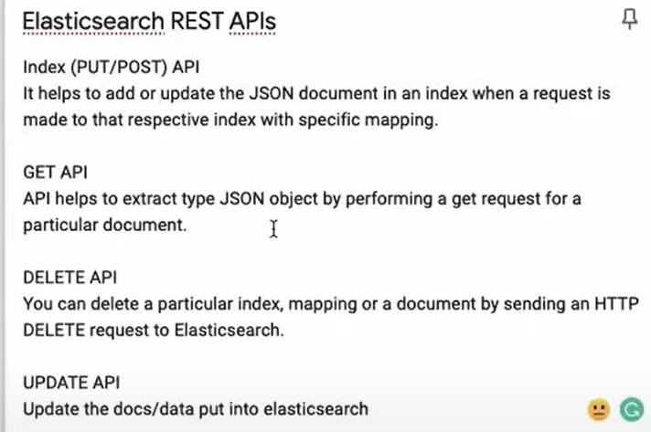

# Logstash:

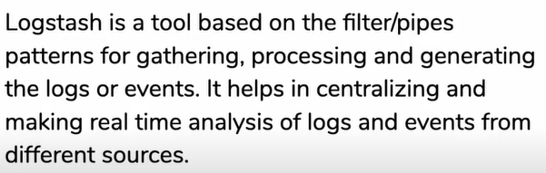

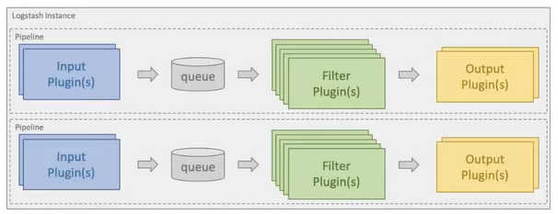

* General features logstash

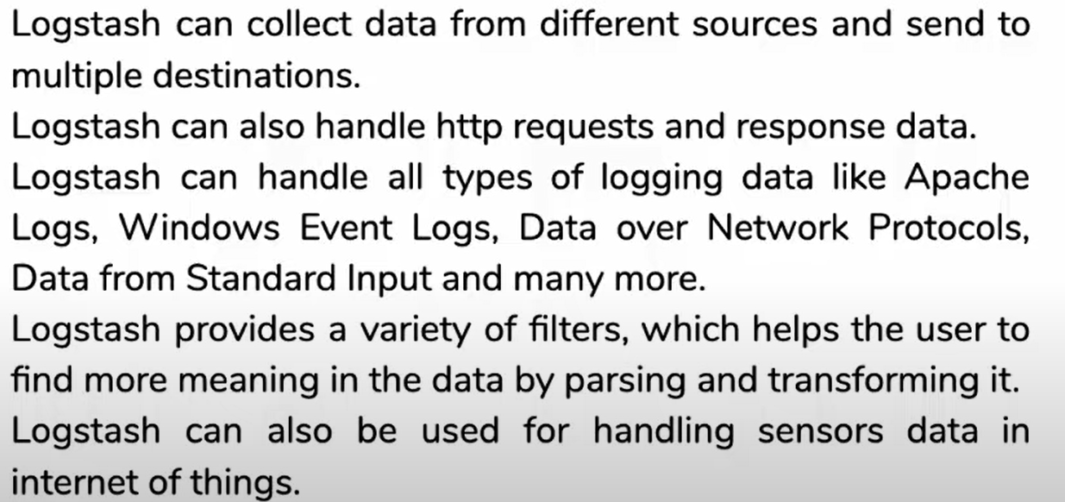

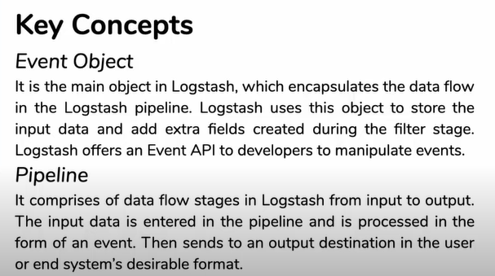

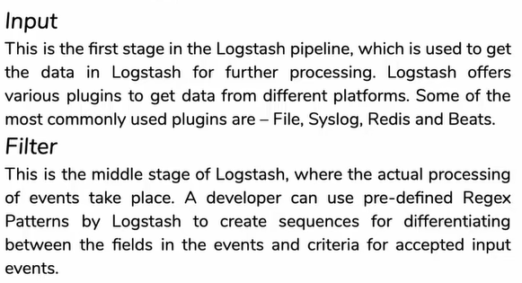

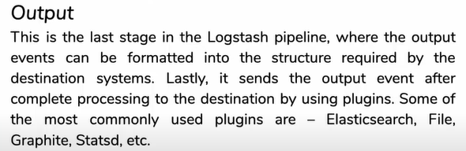

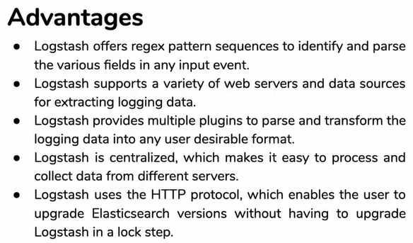

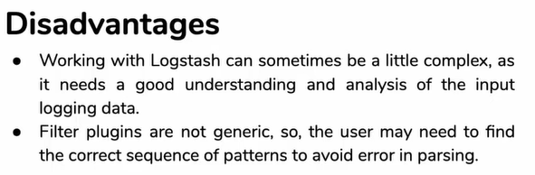

# Transactions:

https://www.elastic.co/guide/en/apm/get-started/current/transaction-spans.html

* Spans contain information about the execution of a specific code path. They measure from the start to the end of an activity, and they can have a parent/child relationship with other spans.

<https://www.elastic.co/guide/en/apm/get-started/current/transactions.html>

* Transactions are a special kind of span that have additional attributers associated with them.
* Elastic agents:

https://www.elastic.co/guide/en/fleet/current/elastic-agent-installation-configuration.html

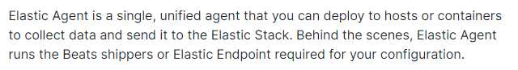

* Transactions

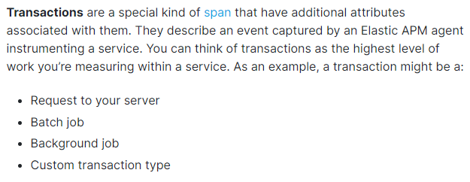

<https://www.elastic.co/guide/en/apm/get-started/current/transactions.html>