# What is RabbitMQ:

<https://www.youtube.com/watch?v=pAXp6o-zWS4>

<https://www.youtube.com/watch?v=L0yJxCKrkIY>

go file: <https://github.com/rabbitmq/rabbitmq-tutorials>

<https://dev.to/koddr/working-with-rabbitmq-in-golang-by-examples-2dcn> : RabbitMQ_Fiber

<https://github.com/koddr/tutorial-go-fiber-rabbitmq> : RabbitMQ_Fiber

<https://nizu.tech/go-blog-1> : RabbitMQ_gin

<https://topdev.vn/blog/doi-chut-ve-rabbitmq/> : RabbitMQ gin vietname

<https://www.rabbitmq.com/tutorials/tutorial-four-go.html> : RabbitMQ

<https://www.rabbitmq.com/queues.html> english

* 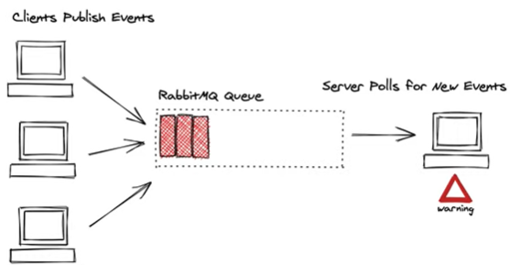
* Increased reliability and fault tolerance
* Dead letter queues
* Decouples services
* No point-to-point heandaches
* 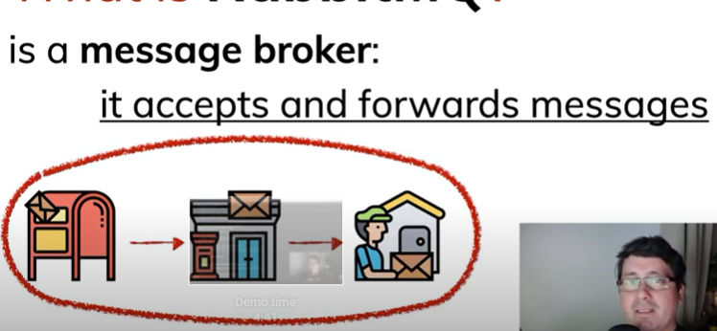
* One by one
* 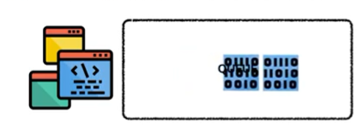
* 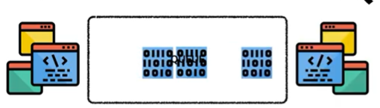
* 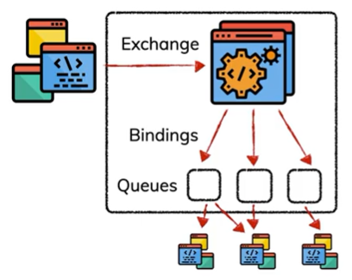

# Dive in

* 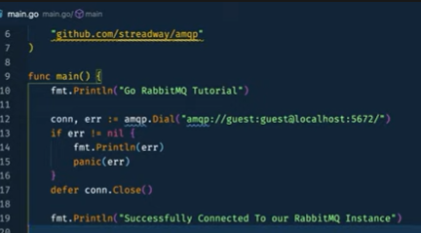connect RabbitMQ
* 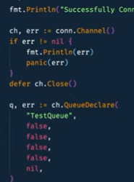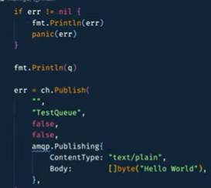
* 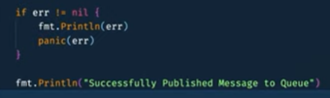
* 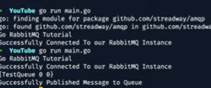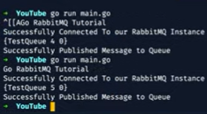
* 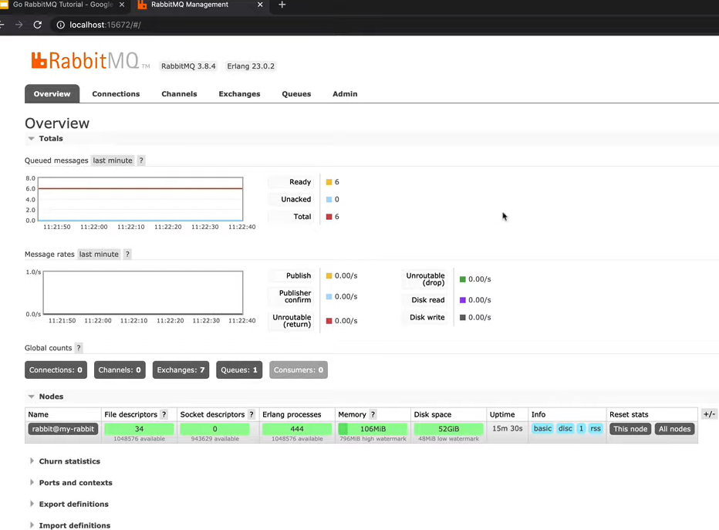
* In main.go
* 
 