# Proof-of-work:

https://www.investopedia.com/terms/p/proof-work.asp

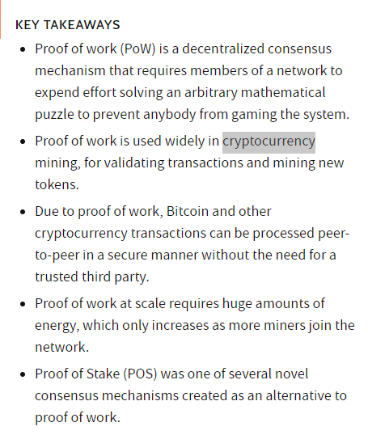

<https://academy.binance.com/vi/articles/what-is-blockchain-technology-a-comprehensive-guide-for-beginners>