# Câu hỏi phỏng vấn

* Làm việc với ai

# learn for work:

* 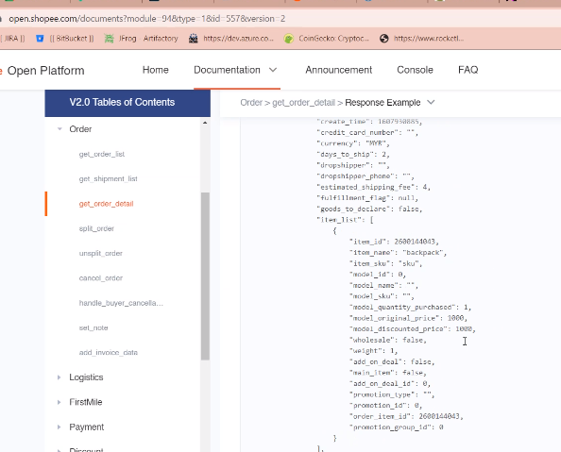
* 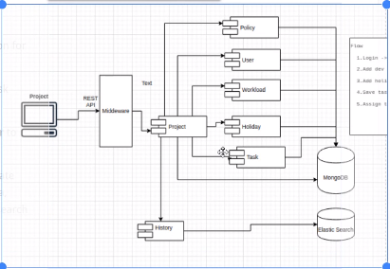

# Learn show data

* 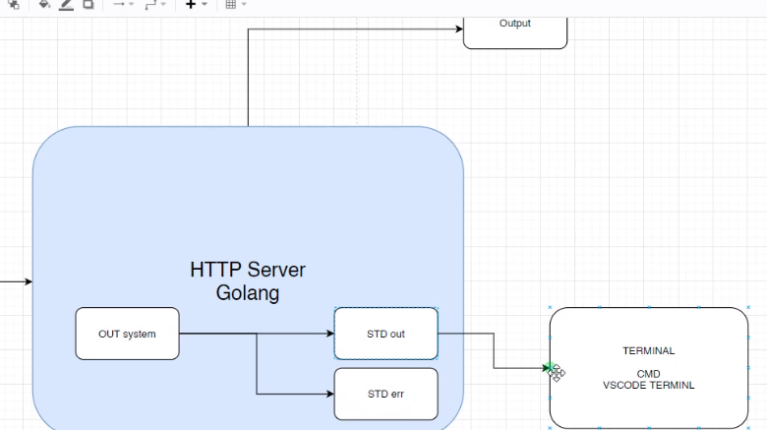
* 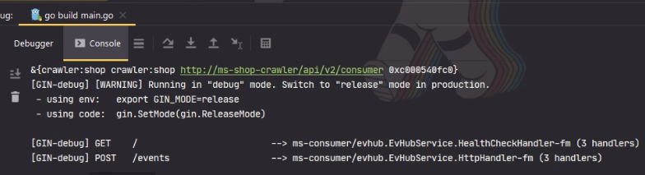
* <https://github.com/Sirupsen/logrus>
* Goland
* Docker compose
* Adapter
  + Folder cmd:
    - Go standard project structure
    - Project-layou
* 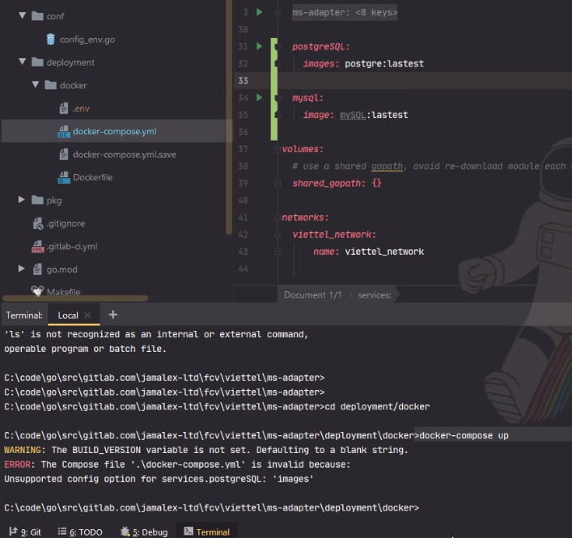
* Authentication vs authorization

# Logrus:

* <https://stackoverflow.com/questions/48971780/how-to-change-the-format-of-log-output-in-logrus>

logger := &logrus.Logger{

Out: os.Stderr,

Level: logrus.DebugLevel,

Formatter: &prefixed.TextFormatter{

DisableColors: true,

TimestampFormat : "2006-01-02 15:04:05",

FullTimestamp:true,

ForceFormatting: true,

},

}

# Git

* 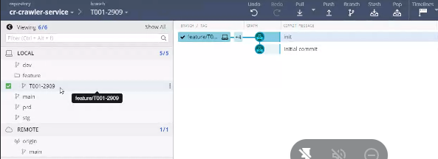

# Poker

* <https://www.scrumpoker-online.org/en/room/887659/scrum-poker>
* 13 point là 2 tuần, hơn 1 sprint
* Trello:
  + <https://trello.com/b/2XaFcjq5/dlu-intern-01>

# Golange-standards/project-layout

* Go awaesome
* <https://github.com/avelino/awesome-go>
* Handlers: controller
* 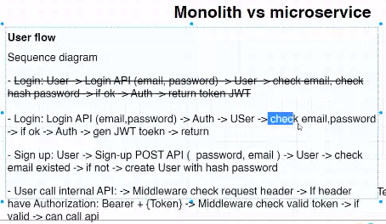

# Bear login

* 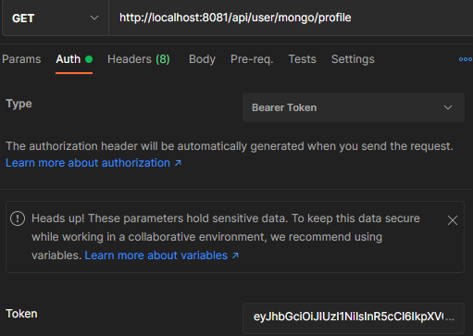
* See element of interface: Ctrl + Alt + B

https://stackoverflow.com/questions/51452148/how-can-i-make-a-request-with-a-bearer-token-in-go

* 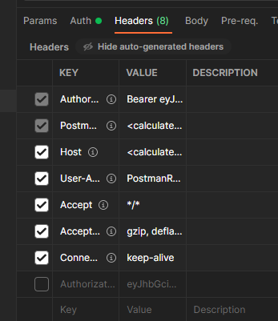

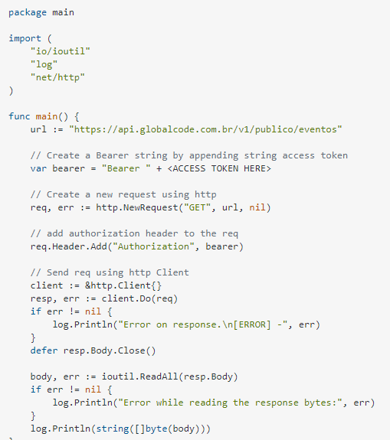

# 2 Database:

* 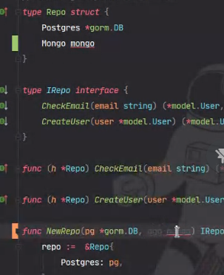
* Create by mongo
* Add by mongo
* Convert to table (mapping and parse
* Create by mongo
* 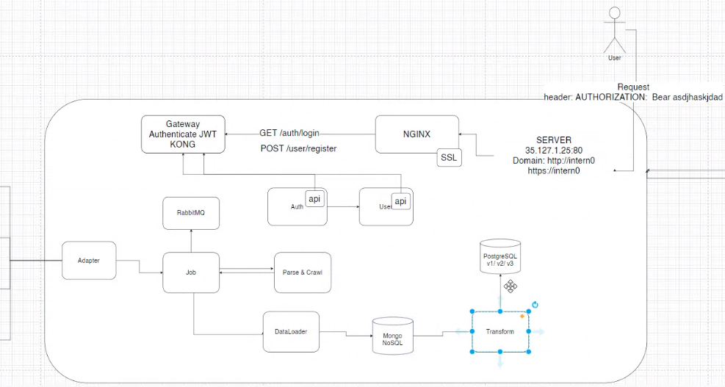

# Nginx

# Figma

# Unit test

* Chủ yếu viết ở tầng service
* 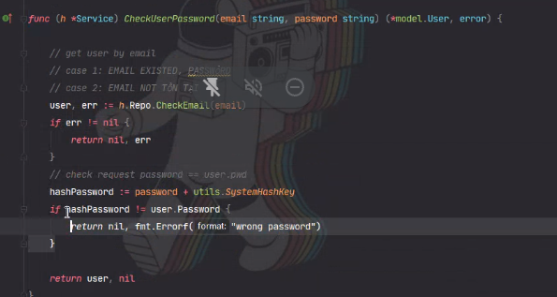
* 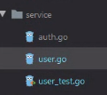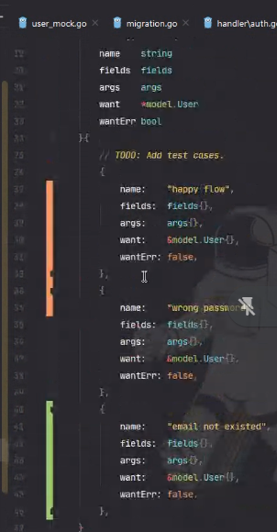
* 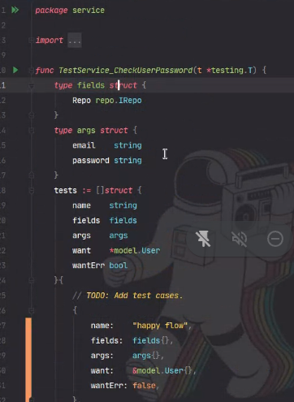

# Crawl history

* Cron job:
* Trigger APIS
* 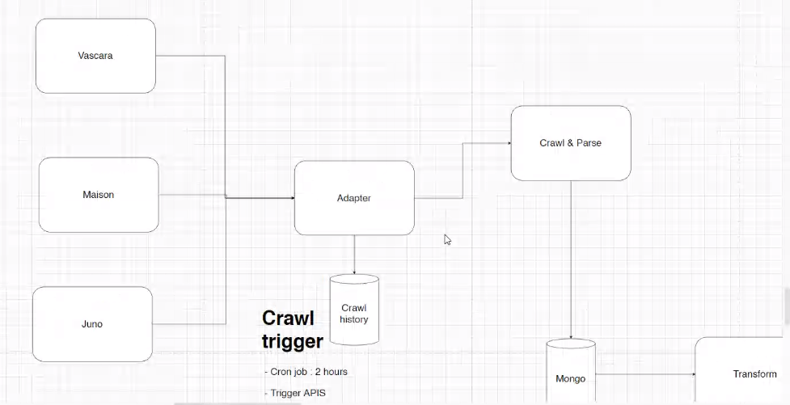
* 

# Some knowledge

* 