Source : <https://www.youtube.com/watch?v=2tJedF8I-8Q>

https://blog.logrocket.com/ssg-vs-ssr-in-next-js/

* Client Side Rendering (CSR)
* Server Side Rendering (SSR)
* Static Site Generation (SSG)

<https://www.jackherrington.com/csr-ssr-and-ssg-on-nextjs/>

so what is server side in nextjs:

<https://www.educative.io/blog/nextjs-tutorial-examples>

https://unicorn-utterances.com/posts/what-is-ssr-and-ssg/

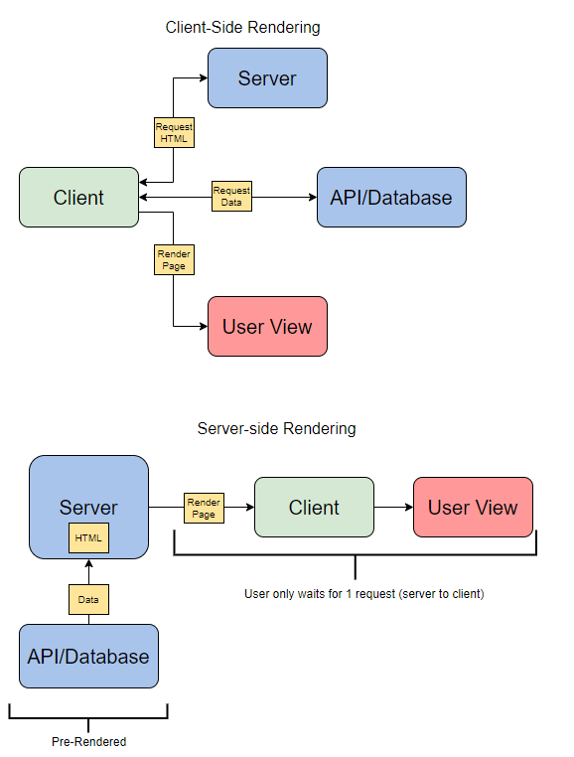

Vanilla HTML sites:

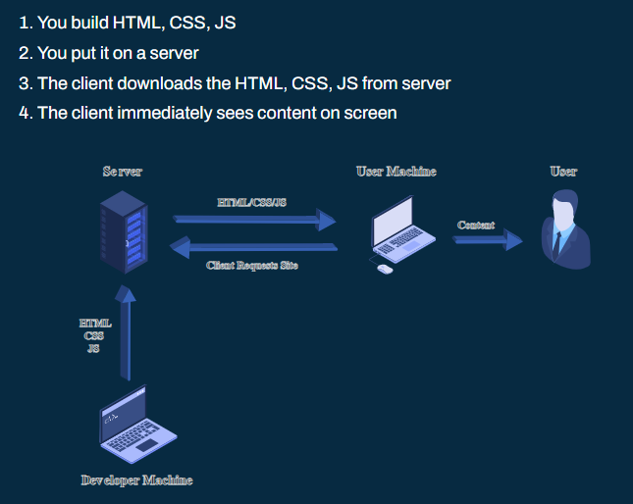

Client side rendering (CLR)

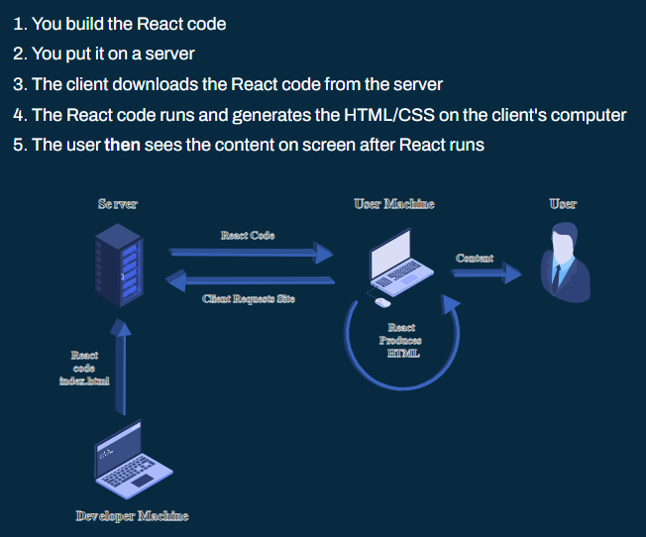

Server side rendering (SSR)

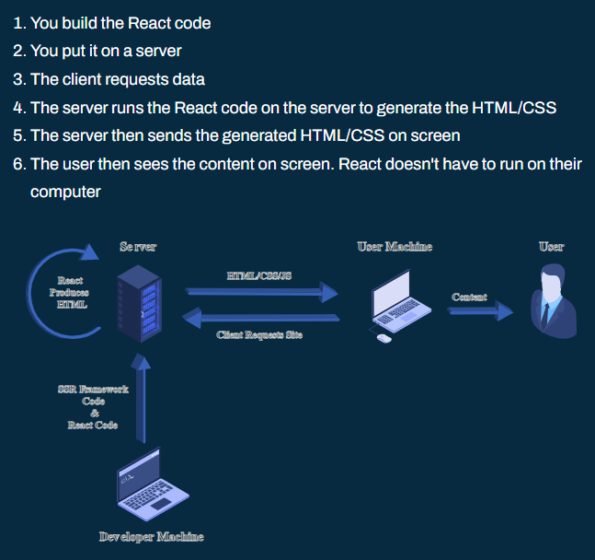

Static Site Generation (SSG)

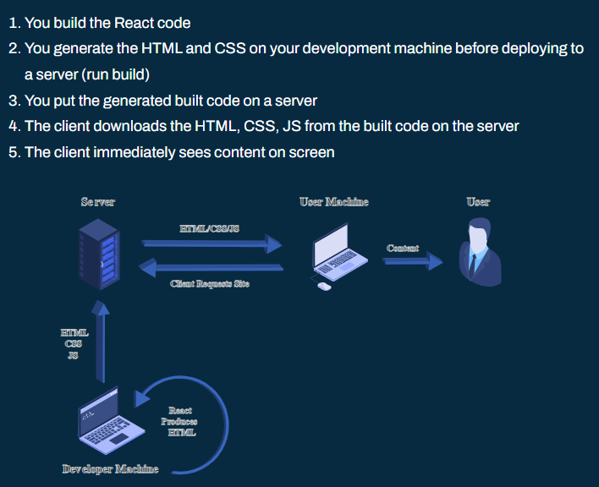

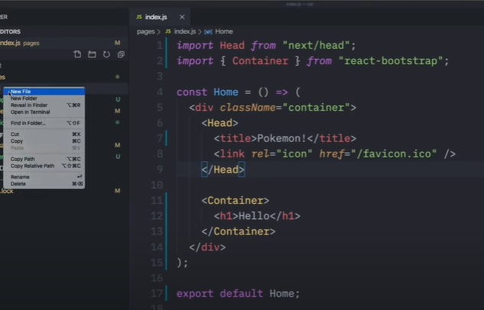

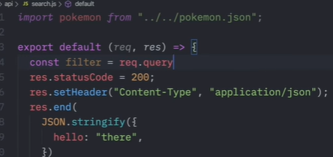 



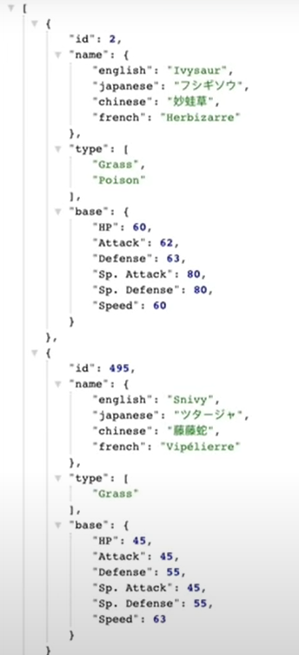

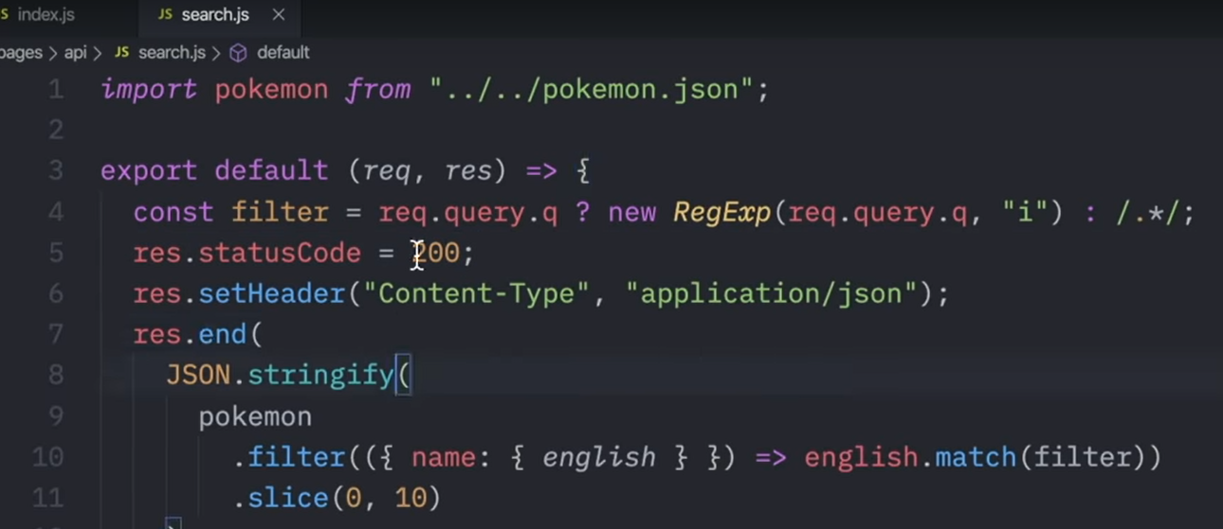

Yarn add axios react-query

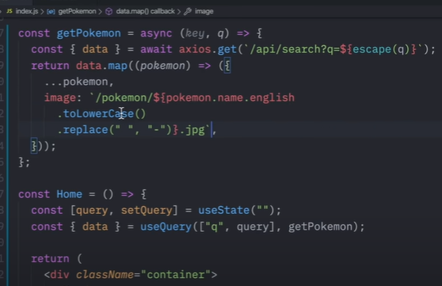

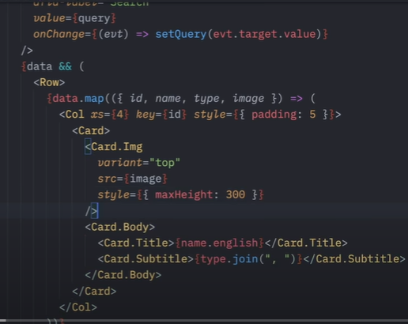

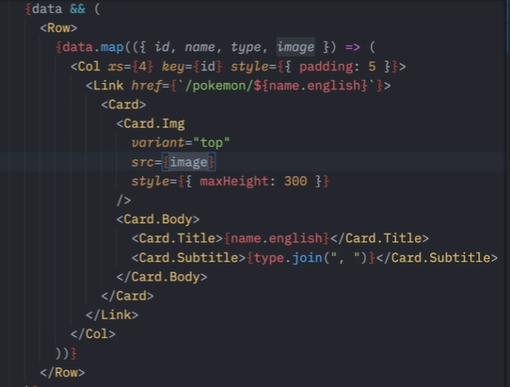

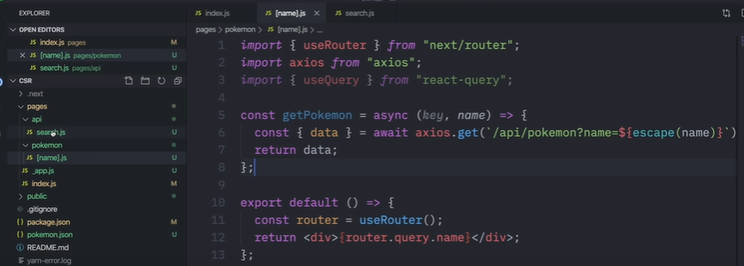

# Server-side rendering:

* 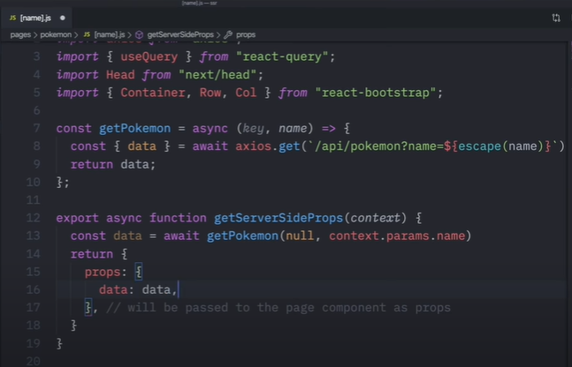
* 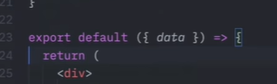

# Static site generation

https://nextjs.org/docs/basic-features/data-fetching#getstaticprops-static-generation

* 
 