# Global State:



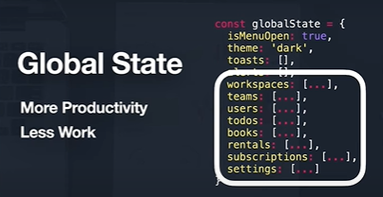

Client state | server state







Async Data != Client State:

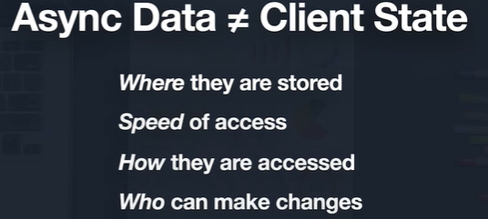





React query



useRef(): <https://viblo.asia/p/thao-tac-voi-cac-phan-tu-dom-voi-react-hook-su-dung-useref-bWrZnxrr5xw>

<https://react-query.tanstack.com/>

react query vs axios

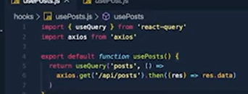

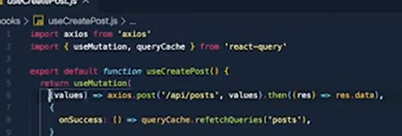

* The query cache to notify any related queries that they need to be refreshed and
* Optimistic update

# All about react query: