**MINI- PROJECT**

**ELECTRONIC VOTING MACHINE USING C PROGRAMMING**

**Submitted By**

**Aishwarya K.H**

**Candidate Id - 105108**

**TABLE OF CONTENTS**

|  |  |  |
| --- | --- | --- |
| SL NO | CONTENTS | PAGE NUMBER |
| 1 | Problem Statement | 3 |
| 2 | Introduction | 3 |
| 3 | Description | 3 |
| 4 | System Requirements | 4 |
| 5 | Test Plan | 4 |
| 6 | Test cases | 5 |
| 7 | Advantages | 6 |
| 8 | Expected Results | 6 |
| 9 | Conclusion | 6 |
| 10 | Reference | 7 |

**PROBLEM STATEMENT**

To implement “Electronic Voting Machine” using C programming.

**INTRODUCTION**

An election is a formal [group decision-making](https://en.wikipedia.org/wiki/Group_decision-making) process by which a population chooses an individual or multiple individuals to hold [public office](https://en.wikipedia.org/wiki/Public_administration). Voting is the process through which individuals convey their opinion and has the freedom to elect a leader of the choice to signify and address the issues.

Electronic Voting Machine (EVM) retains all the characteristics of voting by ballot papers, while making polling a lot more expedient. Being fast and absolutely reliable, the EVM saves considerable time, money and manpower. And, of course, helps maintain total voting secrecy without the use of ballot papers.

Through ballet voting the people elect their representatives in the past days but it was a time consuming process for the counting the votes. Due to the development of electronic technology there is a need of an electronic voting to meet the growing requirements.

**DESCRIPTION**

Electronic Voting comprises the use of a computer rather than the traditional use of ballot at polling centre or by postal mail. Here the user can be an admin or a voter .If the user is a voter he can vote to the candidate of his choice. If the user is an admin he can view the vote count as well as the leading candidate and finally the winner of the election will be displayed based on the received votes.

**SYSTEM REQUIREMENTS**

* Operating system: windows 7 or higher.
* Code blocks.

**TEST PLAN**

* To check whether the user is an admin/voter.
* To provide the candidates names if the user is a voter.
* To properly count the number of votes each candidates has got.
* To display the options whether to view the vote count or to find the leading candidate if the user is a admin.
* To display the vote count (i.e number of votes each candidate has received) only to admin.
* To display the leading candidate only to admin.

**Flow Diagram**:

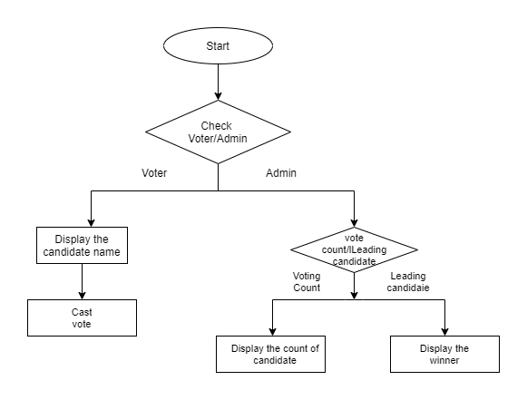

**TEST CASES**

|  |  |  |
| --- | --- | --- |
| SL.NO | Cases | Description |
| 1 | Check voter /admin. | Enter correct user name and password if the user is admin. |
| 2 | Check whether candidate names are displayed to voter. | Names of all the candidates participating in the election should be displayed. |
| 3 | Receive the voter’s choice. | For valid choice increment the vote count else display invalid. |
| 4 | Check the leading candidate | Compare the vote count and display the leading candidate. |
| 5 | Count votes. | Display winner based on vote count. If vote counts are same give warning message. |

**ADVANTAGE OF USING AN ELECTRONIC VOTING MACHINE**

It is very difficult to announce the details when there are more number of voters, but by using a electronic voting machine we can announce the results within a few minutes. In ballet voting we find many cast votes gets rejected as the voter may not stamp the mark properly on his desired party, but by using electronic voting there will not be any wastage of votes. In ballet voting there a chance of casting more number of votes on the name of a single person but in electronic voting it is not possible.

**EXPECTED RESULTS**

* First the user has to say whether he/she is an admin or voter.
* If the user is a voter, then candidates name with their respective index should be displayed.
* Voter has to just give the index of the candidate to vote.
* If the user is a admin, then he/she has the provision to view the vote count and to know the leading candidate.
* If the admin chooses to view the vote count then candidate name with the number of votes they have got should be displayed.
* If the admin chooses to view the leading candidate then leading candidate name should be displayed.

**CONCLUSION**

Election system make a fundamental contribution to democratic governance. Here we are using C programme to implement election system. By using this system we can get the voting statistics and leading count.

**REFERENCE**

* [**https://www.elections.in/importance-of-elections-in-india.html**](https://www.elections.in/importance-of-elections-in-india.html)
* [**https://hemanthglabs.wordpress.com/2013/08/14/electronic-voting-source-code-in-c-language**](https://hemanthglabs.wordpress.com/2013/08/14/electronic-voting-source-code-in-c-language)
* [**https://www.researchgate.net/publication/319176839_Design_and_Implementation_of_Electronic_Voting_System**](https://www.researchgate.net/publication/319176839_Design_and_Implementation_of_Electronic_Voting_System)
* [**http://www.researchgate.net/publication/274183078_A_Simplified_Electronic_Voting_Machine_System**](http://www.researchgate.net/publication/274183078_A_Simplified_Electronic_Voting_Machine_System)