Name_______________________________________________________
CSC 205 FALL 2012 Programming Project 2: Points 30
DUE November 7, 2012
(AC-C1, AC-C2, AC-C4, AC-D1, AC-E1..AC-E4)
(IS-C1, IS-C2, IS-C4, IS-D1, IS-E1..IS-E4)

First you are given a problem stereotype and its solution. After that you are given another problem of the same type.

Problem Stereotype: Expression Evaluator: Evaluate an arithmetic expression that contains +, -, *, / operators and integer operands. (Using a Stack data structures)

Problem: Given an arithmetic expression that uses only add (+), subtract (-), multiply (*) and divide (/) operators and positive integer arguments and evaluates the expression.

Use Case Name: | Evaluate Expression
Description:
Given an arithmetic expression (in infix notation) that uses only add (+), subtract (-), multiply (*) and divide (/) operators; open and closed parentheses and positive integer arguments, computes the value of the expression.
Preconditions:
/* What data should be known? */
Knows Expression class.
Constants:
addOperator = '+'
subOperator = '-'
mulOperator = '*'
divOperator = '/'
modOperator = '%'
openParen = '('
closedParen = ')'

Instance Variables:
infixExpression
infixToPostfixConverter
postfixExpression
postfixEvaluator
valueOfExpression
Workflow:
/* What do you do with the data you are given? */
- ExpressionEvaluator creates an infixToPostfixConverter
- ExpressionEvaluator creates a postfixEvaluator
- ExpressionEvaluator sends the infixExpression to the infixToPostfixConverter and asks it to covert it.
- inFixToPostfixConverter converts infixExpression to postfixExpression
- Expression evaluator gets the postfixExpression from infixToPostfuxConverter
- ExpressionEvaluator sends the postfixExpression to postfixEvaluator and asks it to evaluate it.
- postfixEvaluator evaluates postfixExpression, computing valueOfExpression, which it returns to its requestor (ExpressionEvaluator).
- ExpressionEvaluator returns valueOfExpression to its requestor.

Results:
/* What do you get back after doing this thing? */
Return an integer value representing value of expression (infixExpression) passed to it.
Alternates:
/* What can go wrong? */
- infixToPostfixConverter reports an error: Report Error – syntax error in expression
- postfixEvaluator returns an error: Report Error – syntax error in expression

CRC Cards (We assume that Classes Token, Expression, TokenStack exist).

Class Name: | ExpressionEvaluator
Description:
Given an arithmetic expression in the infix notation, computes its value using the InfixToPostfixConverter and a PostfixEvaluator
Subclass:
-None-
Superclass:
-None-
Attribute: |  | Type:
/* Attributes and types */

Method: |  | Collaborating Classes:
/* List Methods */  public int evaluate(Expression infix) |  | InfixToPostfixConverter, PostfixEvaluator

Class Name: | InfixToPostfixConverter
Description:
Converts an Infix Expression into Postfix Notation
Subclass:
-None-
Superclass:
-None-
Attribute: |  | Type:
/* Attributes and types */  infixExpression  postfixExpression |  | Expression  Expression
Method: |  | Collaborating Classes:
/* List Methods */  public InfixToPostfixConverter( Expression infix)  public void convertToPostfix()  public Expression getPostfix() |  | String, TokenStack

Class Name: | PostfixEvaluator
Description:
Evaluates a Postfix Expression
Subclass:
-None-
Superclass:
-None-
Attribute: |  | Type:
/* Attributes and types */  postfixExpression  valueOfExpression |  | Expression  Integer
Method: |  | Collaborating Classes:
/* List Methods */
public PostfixEvaluator( Expression postfix)
public int eval()

SOLUTION FRAMEWORK: The following classes are given to you (on Angel)

package stack: Two stack implementations

package expression:
Classes: Token, Expression, InfixToPostfixConverter, PostfixEvaluator, ExpressionEvaluator, and ExpressionEvaluatorTester, ExpressionGUI

Your Problem:

C language does not have separate boolean data type and hence has NO boolean expressions. It handles boolean values true and false as non-zero and zero numbers. (Zero is false, and anything non-zero is true). An expression in C contains, numbers, arithmetic and comparison operators and logical connectives.
- For simplicity, we will only handle:
  - comparison operators: <, <=, >, >=, ==, !=
  - binary logical operators: &&, ||.
  - Binary arithmetic operators +, -, *, /, %
- We allow positive integer arguments and only those operators mentioned above.
- We assume C-style evaluation: false = 0 and true = 1 (anything non-zero). Thus 1 > 2 has a value of 0 (false).

Precedence of Operators (As usual, parentheses override precedence)
- <, <=, >, >= 1
- ==, != 2
- || 3
- && 4
- +, - 5
- *, /, % 6

Examples: Here are examples of C-style expressions and their values. Evaluate some of them by hand to convince yourself that they are correct.

Expression | Value
1 < 2 | 1
1 == 2 | 0
1 != 2 | 1
1 > 2 | 0
1 >= 2 | 0
1 <= 2 | 1
1 && 0 | 0
25 || 26 | 1
25 || 0 | 1
25 && 26 | 1
25 || 26 && 0 | 1
( 25 || 26 ) && 0 | 0
1 < 2 && 2 < 3 | 1
1 < 2 && 2 > 3 | 0
1 < 2 || 2 < 3 | 1
1 < 2 || 2 > 3 | 0
1 > 2 || 2 > 3 | 0
1 < 2 < 3 | 1
1 < 2 > 3 | 0
1 < 2 + 5 | 1
( 1 < 2 ) + 5 | 6
2 < 3 * 5 + 4 | 1
( 2 < 3 ) * ( 5 + 4 ) | 9
( 2 < 3 * 5 ) + 4 | 5
( 25 + ( 10 > 5 ) * 3 ) % 6 | 4
( 25 < 8 < 9 ) + (8 * 3 > 2 ) | 2
25 + 45 | 70
10 * ( 5 + 3 ) | 80
20 | 20
10 * 5 + 3 | 53
10 * ( 7 + ( 12 - 9 ) ) / 10 | 10
100 % ( ( 3 + 2 ) + 3 ) / 4 | 1

REMEMBER: FALSE = 0, NON-ZERO = TRUE, A true expression has value 1.

Your assignment: Write a GUI-based program that evaluates a C-style arithmetic expression and displays its value.

Activities:
Study the Code given to you in each of the classes and figure out what modifications it needs to handle the C-style expressions.
- Modify the Token, Expression and PostfixEvaluator classes to handle all the operators specified above.
- Modify the ExpressionEvaluatorTester to handle all the test data that is given above.
- Write an ExpressionGUI class to produce a display as shown below. The user enters the expression in to the top-right box and the system will output the value in the box below.

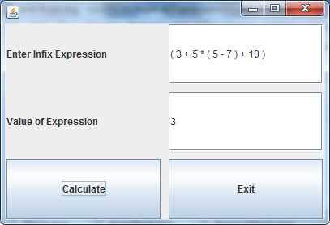

Turn in:
- Modified Code: Only the classes that you modified. Your code must be well-documented using javadoc-style comments.
- Execution Window showing the execution of the Tester. The tester should test all the examples given in the above table.
- The GUI showing the evaluation of this expressions:

102 % ( ( 3 + 2 * 10 ) - 10 - 5 ) / 3
( 25 + ( 10 > 5 ) * 3 ) % 6
( 25 < 8 < 9 ) + (8 * 3 > 2 )

Matt Andre Project 2

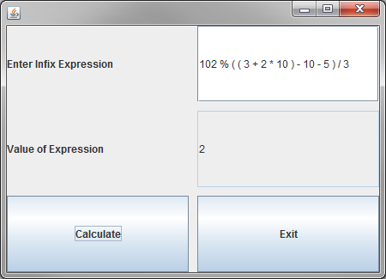
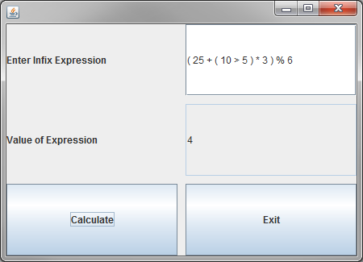

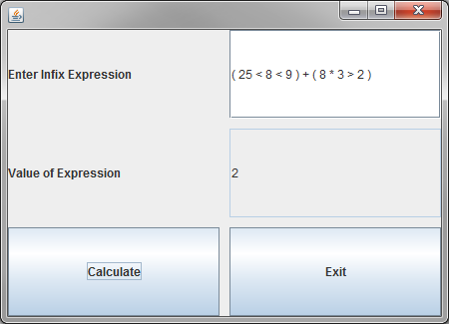

Test Cases Output:

Postfix Expression: 1 2 <
Infix Expression: 1 < 2
Value of Expression: 1
Result: Passed

Postfix Expression: 1 2 ==
Infix Expression: 1 == 2
Value of Expression: 0
Result: Passed

Postfix Expression: 1 2 !=
Infix Expression: 1 != 2
Value of Expression: 1
Result: Passed

Postfix Expression: 1 2 >
Infix Expression: 1 > 2
Value of Expression: 0
Result: Passed

Postfix Expression: 1 2 >=
Infix Expression: 1 >= 2
Value of Expression: 0
Result: Passed

Postfix Expression: 1 2 <=
Infix Expression: 1 <= 2
Value of Expression: 1
Result: Passed

Postfix Expression: 1 0 &&
Infix Expression: 1 && 0
Value of Expression: 0
Result: Passed

Postfix Expression: 25 26 ||
Infix Expression: 25 || 26
Value of Expression: 1
Result: Passed

Postfix Expression: 25 0 ||
Infix Expression: 25 || 0
Value of Expression: 1
Result: Passed

Postfix Expression: 25 26 &&
Infix Expression: 25 && 26
Value of Expression: 1
Result: Passed

Postfix Expression: 25 26 0 && ||
Infix Expression: 25 || 26 && 0
Value of Expression: 1
Result: Passed

Postfix Expression: 25 26 || 0 &&
Infix Expression: ( 25 || 26 ) && 0
Value of Expression: 0
Result: Passed

Postfix Expression: 1 2 2 && < 3 <
Infix Expression: 1 < 2 && 2 < 3
Value of Expression: 1
Result: Passed

Postfix Expression: 1 2 2 && < 3 >
Infix Expression: 1 < 2 && 2 > 3
Value of Expression: 0
Result: Passed

Postfix Expression: 1 2 2 || < 3 <
Infix Expression: 1 < 2 || 2 < 3
Value of Expression: 1
Result: Passed

Postfix Expression: 1 2 2 || < 3 >
Infix Expression: 1 < 2 || 2 > 3
Value of Expression: 0
Result: Passed

Postfix Expression: 1 2 2 || > 3 >
Infix Expression: 1 > 2 || 2 > 3
Value of Expression: 0
Result: Passed

Postfix Expression: 1 2 < 3 <
Infix Expression: 1 < 2 < 3
Value of Expression: 1
Result: Passed

Postfix Expression: 1 2 < 3 >
Infix Expression: 1 < 2 > 3
Value of Expression: 0
Result: Passed

Postfix Expression: 1 2 5 + <
Infix Expression: 1 < 2 + 5
Value of Expression: 1
Result: Passed

Postfix Expression: 1 2 < 5 +
Infix Expression: ( 1 < 2 ) + 5
Value of Expression: 6
Result: Passed

Postfix Expression: 2 3 5 * 4 + <
Infix Expression: 2 < 3 * 5 + 4
Value of Expression: 1
Result: Passed

Postfix Expression: 2 3 < 5 4 + *
Infix Expression: ( 2 < 3 ) * ( 5 + 4 )
Value of Expression: 9
Result: Passed

Postfix Expression: 2 3 5 * < 4 +
Infix Expression: ( 2 < 3 * 5 ) + 4
Value of Expression: 5
Result: Passed

Postfix Expression: 25 10 5 > 3 * + 6 %
Infix Expression: ( 25 + ( 10 > 5 ) * 3 ) % 6
Value of Expression: 4
Result: Passed

Postfix Expression: 25 8 < 9 < 8 3 * 2 > +
Infix Expression: ( 25 < 8 < 9 ) + ( 8 * 3 > 2 )
Value of Expression: 2
Result: Passed

Postfix Expression: 25 45 +
Infix Expression: 25 + 45
Value of Expression: 70
Result: Passed

Postfix Expression: 10 5 3 + *
Infix Expression: 10 * ( 5 + 3 )
Value of Expression: 80
Result: Passed

Postfix Expression: 20
Infix Expression: 20
Value of Expression: 20
Result: Passed

Postfix Expression: 10 5 * 3 +
Infix Expression: 10 * 5 + 3
Value of Expression: 53
Result: Passed

Postfix Expression: 10 7 12 9 - + * 10 /
Infix Expression: 10 * ( 7 + ( 12 - 9 ) ) / 10
Value of Expression: 10
Result: Passed

Postfix Expression: 100 3 2 + 3 + % 4 /
Infix Expression: 100 % ( ( 3 + 2 ) + 3 ) / 4
Value of Expression: 1
Result: Passed

Postfix Expression: 102 3 2 10 * + 10 - 5 - % 3 /
Infix Expression: 102 % ( ( 3 + 2 * 10 ) - 10 - 5 ) / 3
Value of Expression: 2
Result: Passed

Postfix Expression: 25 10 5 > 3 * + 6 %
Infix Expression: ( 25 + ( 10 > 5 ) * 3 ) % 6
Value of Expression: 4
Result: Passed

All Tests Pass?: true

