(AC-C1, AC-C2, AC-C4, AC-D1, AC-E1..AC-E4) (IS-C1, IS-C2, IS-C4, IS-D1, IS-E1..IS-E4)
CSC 205 Fundamentals of CS II Fall 2012
T.M. Rao Programming Project 1 Points 30
Due September 26, 2012

Objectives: Ability to read and understand Use Cases, CRC Cards, GUI Mockups and Implement a solution; Use of ArrayList and Simple Java Swing GUI components; Reading data from a file.

Individual Programming Assignment
(This is NOT a pair-programming assignment.
You are required to work individually)

Real Estate Listings

Problem Statement: Suppose you are looking to buy a house. You have certain criteria in mind such as: price range, square-footage, number of bedrooms, etc. You would like to enter your criteria and expect that the real estate program to come up with a list of houses that satisfy those criteria. You are asked to write a program that does exactly that.

A “House” (i.e. a house that is for sale) for us is defined by the following data:
- address – This is the street address such as 23-Canal-Street. Even though there can be many words, we make it one word by introducing hyphens.
- price – This is a number like 149999
- area – the square-footage of the house, such as 1800
- numberOfBedrooms – small number like 3

A “HouseList” consists of an array list of ‘House’s that are for sale.

A “Critreia” represents a buyer’s criteria. A ‘criteria’ consists of the following data:
- minimumPrice
- maximumPrice
- minimumArea
- maximumArea
- minimumNumberOfBedrooms
- maximumNumberOfBedrooms

You are asked to write a GUI-based interactive program with the following specifications. The following design documents are provided for your use:

Use Case Name: | RealEstateAgent
Description:
Given criteria to select houses, this selects and prints houses that satisfy those criteria
Preconditions:
/* What data should be known? */
houses.txt – A text file containing the data about houses for sale is created and data is entered.
Workflow:
/* What do you do with the data you are given? */
- The agent reads all the data from the houses.txt file and creates a houseList
- The agent accepts the criteria from the user: minimumPrice, maximumPrice, minimumArea, maximumArea, minimumNumberOfBedrooms, maximumNumberOfBedrooms.
- The agent searches through the houseList and prints ALL the ‘house’s that satisfy the criteria.
Results:
/* What do you get back after doing this thing? */
A print out of the houses that satisfy the criteria.
Alternates:
/* What can go wrong? */
- Unable to read from file for some reason: Report error and Stop.

Class Name: | House
Description:
/* General Description of the class */
It represents the details of a house for sale.
Subclass:
/* List any subclasses here */
None
Superclass:
/* List any class that this is a subclass of */
None
Attribute: |  | Type:
/* List attributes and their types */
address;
city;
price;
area;
numBedrooms;

Method: |  | Collaborating Classes:
/* List Methods */  Constructor  get methods for all the instance variables  public boolean satisfies(Criteria c) – does this house meet the criteria specified by c.  public String toString() – to create a nice printable string |  | Criteria

Class Name: | Criteria
Description:
/* General Description of the class */
This contains the criteria specified by the user to select houses.
Subclass:
/* List any subclasses here */
None
Superclass:
/* List any class that this is a subclass of */
None
Attribute: |  | Type:
/* List attributes and their types */
minimumPrice
maximumPrice
minimumArea
maximumArea
minimumNumberOfBedrooms maximumNumberOfBedrooms

Method: |  | Collaborating Classes:
/* List Methods */
Constructor
Get methods for all instance variables

Class Name: | HouseList
Description:
/* General Description of the class */
Contains an ArrayList of House objects. Reads the data from a file called houses.txt and adds them to the array list. Allows for searching of houses that satisfy criteria.
Subclass:
/* List any subclasses here */
None
Superclass:
/* List any class that this is a subclass of */
None
Attribute: |  | Type:
/* List attributes and their types */  houseList; |  | ArrayList<House>
Method: |  | Collaborating Classes:
/* List Methods */
public HouseList(String fileName): reads data from file, creates House objects and adds them to houseList
public void printHouses(Criteria c) – print all the houses that satisfy this criterion c

Use the following data for your HouseListTester:

minPrice maxPrice minArea maxArea minBed maxBed
1000 500000 100 5000 0 10
1000 100000 500 1200 0 3
100000 200000 1000 2000 2 3
200000 300000 1500 4000 3 6
100000 500000 2500 5000 3 6

Class Name: | HouseListTester
Description:
/* General Description of the class */
Interacts with the user. Accepts user criteria and arranges for search
Subclass:
/* List any subclasses here */
None
Superclass:
/* List any class that this is a subclass of */
None
Attribute: |  | Type:
/* List attributes and their types */  availableHouses |  | HouseList
Method: |  | Collaborating Classes:
/* List Methods */
Just the main method:
- Create the HouseList object names availableHouses using “houses.txt”
- Create 5 different Criteria objects with varying upper and lower limits for price, area and number of bedrooms.
- For each criteria, use printHouses to print a list of houses that satisfy the criterion.

Write a HouseListGUI class that displays the following GUI

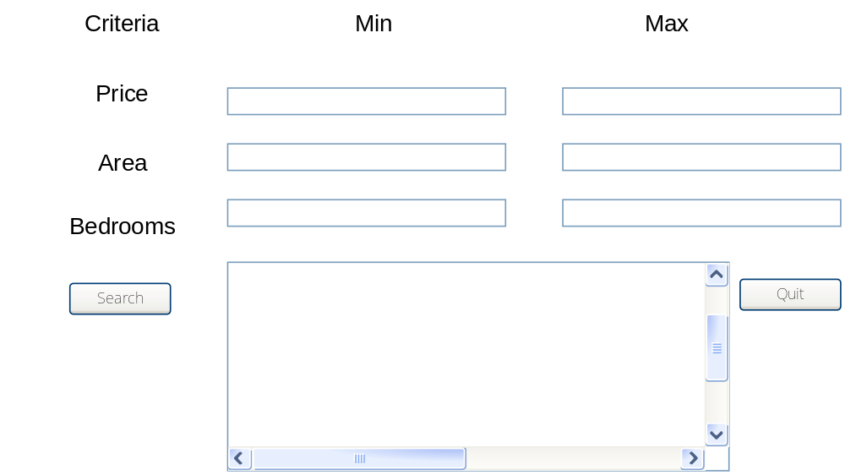

Note: Criteria, Min, Max, Price, Area, Bedrooms -- JLabel
The empty boxes JTextField
Search, Quit JButton
Big box in the middle: JTextArea

Typically, a user enters data in the text fields and hits the search button. The system displays all the houses that satisfy the criteria in the text area.

When the quit button is clicked, the program stops.

Data for the houses.txt file (Create the file in Notepad and copy and paste the data). Use the Scanner class to read data from the file.

123-canal-street 129000 1800 3
124-main-street 89000 1600 3
125-college-street 199000 2000 4
126-lincoln-street 56000 1200 2
127-state-street 82000 1500 3
223-canal-street 385000 4500 5
224-main-street 40000 800 2
225-college-street 37999 800 2
226-lincoln-street 125000 1200 2
227-state-street 130000 1250 3
323-canal-street 60000 900 2
324-main-street 80000 1000 2
325-college-street 45000 800 1
326-lincoln-street 63000 900 1
327-state-street 145000 1400 3
423-canal-street 199999 2000 4
424-main-street 250000 3500 5
425-college-street 350000 4600 6
426-lincoln-street 133000 1300 2
427-state-street 68000 850 1

Turn in
  - Java Code for all classes, well-documented in javadoc style.
  - Print out of the terminal window showing results for ‘tester’ class
  - Capture of GUI’s (Just 1 or 2 transactions)

