Name:_Matt Andre___Jeff Fisher______________________________________
CSC 205.01 FALL 2012 Lab 3 Points = 20

Hand-written Exercises

1. For each of the following problems, think about an algorithm to solve it. Write a segment of java code showing how you would solve it and indicate its time complexity. Assume that a and b are integer arrays of size N. (8)
(AC-A5, IS-A6)

a. Print the value at the middle of the array (You can assume that the length of the array is an odd number).
System.out.println(a[a.length / 2]);

O(1)

b. Print the smallest element of the array a (assuming that a is NOT sorted)
int smallest = a[0];
for(int i = 0; i < a.length; i++){
if(smallest > a[i]){
smallest = a[i];
}
}
System.out.println(smallest);

O(n)

c. Print the smallest element of the array a (assuming a is sorted in ascending order)
System.out.println(a[0]);

O(1)

d. A "pair" is two consecutive locations in the array having the same value. ({2, 3, 3, 4, 2} has a pair 3, 3. But {4, 5, 2, 9, 2} doesn't have a pair). Find if the array a has a pair in it.

for(int i = 1; i < a.length; i++){
if(a[i]==a[i-1]){
System.out.println("Has a pair!");
}
}

O(n)

e. Find if any two values in the array are the same (i.e. a has a repeated element). For example {2,3,3,4,2} has two repeated elements but {4,5,2,9,6} doesn't have repeated elements.
for(int i = 0; i < a.length; i++){
for(int n = 0; n < a.length; n++){
if(a[i]==a[n]){
System.out.println("Has a repeated element!");
}
}
}

O(n²)

f. Find how many times a certain number x appears in the array a.
int numRepeats = 0;
for(int i = 0; i < a.length; i++){
if(a[i] == x){
numRepeats++;
}
}
System.out.println("x is in the array " + numRepeats + " times");

O(n)

g. Find if there are any numbers common between arrays a and b.
for(int i = 0; i < a.length; i++){
for(int n = 0; n < b.length; n++){
if(a[i]==b[n]){
System.out.println("arrays share an element!");
}
}
}

O(n²)

h Assuming both a and b are sorted in increasing order, decide if any element of a is less than any element of b.
if(a[0] < b[b.length - 1]){
System.out.println("an element of a is " +
"< some element of b");
}

O(1)

Programming Exercise (AC-D1, IS-D1) (12)

Reading data from a file; creating a test plan and testing the code with it; implementing a graphical user interface for an application.

You are given the Java code for two classes:
- Student: Student class represents one student. A student’s data consists of a name, a grade1, and a grade2. A letter grade is computed using the average of the two grades. It is assumed that names are unique.
- StudentList: A StudentList contains an ArrayList of students. The constructor creates the ArrayList object and fills the data by reading it off a txt file whose name is passes to the constructor as a parameter (by the caller).

You are also given a data file called studentAccountData.txt that contains the following data:
(The first number 10 represents the number of lines of data, and each line consists of a name, a grade1 and a grade2)

10
bob 54 65
jen 64 81
tom 95 92
pat 54 72
jill 78 86
joey 66 88
cathy 54 42
ben 87 89
jane 97 99
jake 65 59

Your assignment is to:
- Create a test data table using the data given in the studentData.txt file:

Name | Grade1 | Grade2 | Expected  Letter grade | Computed  Letter grade
Bob | 54 | 65 | E | E
Jen | 64 | 81 | C | C
Tom | 95 | 92 | A | A
Pat | 54 | 72 | D | D
Jill | 78 | 86 | B | B
Joey | 66 | 88 | C | C
Cathy | 54 | 42 | E | E
Ben | 87 | 89 | B | B
Jane | 97 | 99 | A | A
Jake | 65 | 59 | D | D

- write the StudentListTester class:
  - First create the StudentList object by passing "src\\Lab03\\studentData.txt” as the argument.
  - The tester
- Write the StudentListGUI class that displays GUI that asks the user to enter a student name. When the Letter Grade button is clicked it will display that student’s two grades and the letter grade as shown in the display below. If there is no student by that name, it should display a message saying ‘Student Not Found’. Quits when the QUIT button is clicked.

Test Data:

Name | Grade1 | Grade2 | Expected  Letter grade | Computed  Letter grade
Bob | 54 | 65 | E | E
Jen | 64 | 81 | C | C
Tom | 95 | 92 | A | A
Pat | 54 | 72 | D | D
Jill | 78 | 86 | B | B
Joey | 66 | 88 | C | C
Cathy | 54 | 42 | E | E
Ben | 87 | 89 | B | B
Jane | 97 | 99 | A | A
Jake | 65 | 59 | D | D

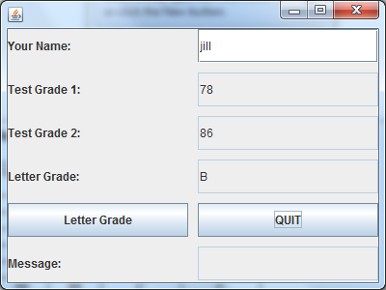\ 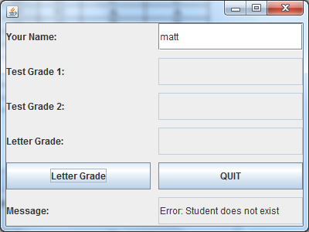

Study the StudentBank Application program we have discussed in class and the code posted on Angel. Model your tester and GUI classes on similar classes in StudentBank application.

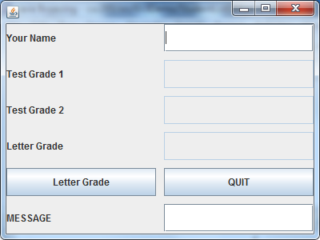

First create a package called Lab03 and copy and paste these two classes into it. Write your tester and GUI classes in the same package.

package Lab03;
//------------------------------------------------------------
/**
* A student's record is represented by a name and two
* numerical grades, assumed to be out of 100
* @author trao
*
*/
public class Student {
private String name;
private int grade1;
private int grade2;
public Student(String n, int g1, int g2)
{
name = n;
grade1 = g1;
grade2 = g2;
}
//------------------------------------------------------------
/**
* Computes letter grade using the scheme
* >= 90 ==> 'A'
* etc.
* @return
*/
public char getLetterGrade()
{
char letG = ' ';
double numG = (grade1+grade2)/2.0;
if (numG >= 90)
letG = 'A';
else if (numG >= 80)
letG = 'B';
else if (numG >= 70)
letG = 'C';
else if (numG >= 60)
letG = 'D';
else
letG = 'E';
return letG;
}
//------------------------------------------------------------
/**
* Just the getter methods
* @return
*/
public String getName()
{
return name;
}
public int getGrade1()
{
return grade1;
}
public int getGrade2()
{
return grade2;
}
}

package Lab03;
import java.io.*;
import java.util.*;
//------------------------------------------------------------
/**
* Represents a collection of Student objects
* Creates the data in the constructor
* Provides a method to search for a student
* given the name
* @author trao
*
*/
public class StudentList {
private ArrayList<Student> studentList;

public StudentList(String filename)
{
studentList = new ArrayList<Student>();
Scanner myFileIn = null;
try
{
myFileIn= new Scanner(new File(filename));
} catch (FileNotFoundException e2)
{
System.out.println("File: "+filename+" is not found");
System.exit(0);
}
int numRecords = myFileIn.nextInt();
String name;
int grade1;
int grade2;

for (int k = 0; k < numRecords; k++)
{
name = myFileIn.next();
grade1 = myFileIn.nextInt();
grade2 = myFileIn.nextInt();
Student nextStudent = new Student(name, grade1, grade2);
studentList.add(nextStudent);
}
}
//------------------------------------------------------------
/**
* search for s student with this name. If present,
* return the Student object. Otherwise, return null.
*/
public Student search(String name)
{
Student stu = null;
for (int k = 0; k < studentList.size(); k++)
{
stu = studentList.get(k);
if (stu.getName().equals(name))
return stu;
}
return null;
}
//------------------------------------------------------------
/**
* Return all the details of a student with this name
*/
public String getDetails(String studentName)
{
Student stu = search(studentName);
if (stu != null)
return "name = "+stu.getName()+
" grade1 = " + stu.getGrade1() +
" grade2 = " + stu.getGrade2() +
" Letter Grade = " + stu.getLetterGrade();
else
return "Student with name = "+studentName+" was not found";
}

}

