Advance data structure:

Banalnced binary tree:
Pre-knowledge:
Basic knowledge of binary tree, that is, simple graph theory knowledge.
Meet BSTBST:
BST is short for (BinarySearchTree)
To understand balanced trees, we must first understand such a basic data structure: a binary search tree.
So next I will discuss BSTBST
After learning about BST, TreapTreap became logical.
Binary trees have two very important properties:
1: Heap property
Heap properties are further divided into large root pile properties and small root pile properties. The root node of the small root heap is smaller than the left and right children, and this is a recursive definition. For large root heaps it is greater than. Prioriotyque provided by C ++ is a big root heap.
2: BST properties
Given a binary tree, each node on the tree carries a value, which becomes the "key code" of the node. For any node in the tree to satisfy the BSTBST property, it means:
The key code of this node is not less than the key code of any node in his left subtree.
The key code of this node is not greater than the key code of any node in his right subtree.
Here is a picture of a Cartesian tree to help everyone understand the nature of BSTBST and the nature of the heap
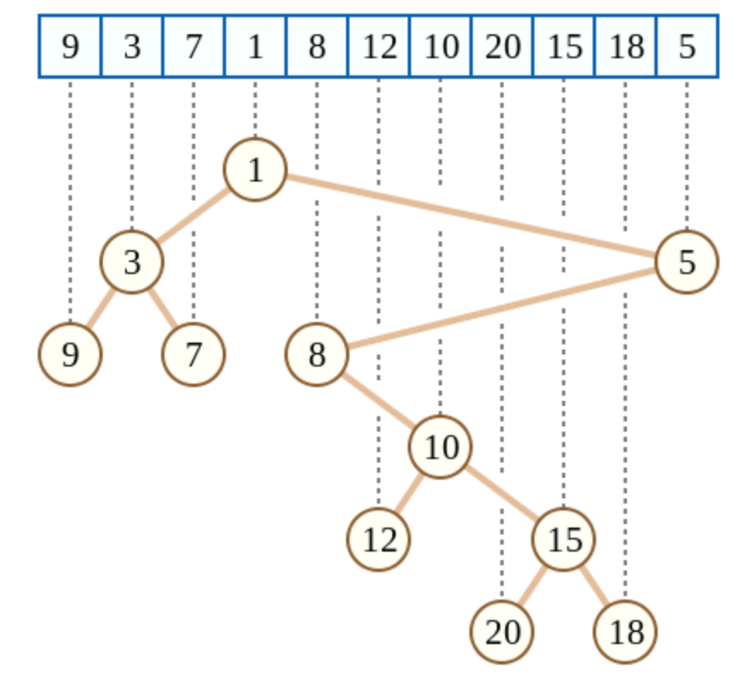
The index in the Cartesian tree satisfies the BST property, and the value satisfies the heap property.
Where index is the order in which the blue boxes appear in the figure, and val is the weight of the blue boxes.
Obviously this tree satisfies the properties of small root heap and also BST.
Then the binary search tree that we introduce next is a binary tree that satisfies the BST property. You can use this graph to deepen your understanding.
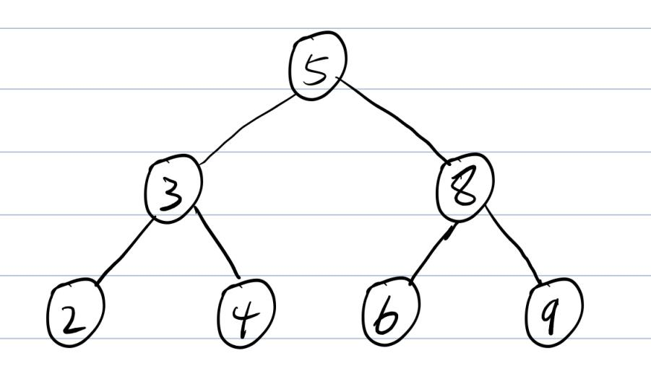
BST related operations:
Establishment of BST:
To avoid out-of-bounds arrays and reduce special judgments, we generally insert two extra nodes in the BST, one of which has a weight of + INF and the other of −INF.
onst int INF = 0x3f3f3f3f;
int tot, root, n;
struct Treap //baisc balanced binary tree
{
int l, r; // index of left and right node
int val; //value
}a[maxn];

int New(int val)
{
a[++tot].val = val;
return tot;
}

void Build()
{
New(-INF), New(INF);
root = 1; a[1].r = 2;
}
BST retrieval:
For convenience, we assume that there are no nodes with the same weight in the tree.
Retrieve the node whose key code is valval in BST. According to the nature of BST, we can:
When val is equal to the key of the current node
This node was found
When val is less than the key code of the current node
If the left subtree of the current node is empty, then no val exists.
Otherwise recursively enter the left subtree.
When val is greater than the key code of the current node
If the current node's right subtree is empty, then no val exists.
Otherwise recursively into the right subtree:
int Get(int &p, int val)
{
if(p == 0)
{
p = New(val);
return;
}
if(val == a[p].val) return p;
return val < a[p].val ? Get(a[p].l, val) : Get(a[p].r, val);
}
BST insertion:
For convenience, we assumes that the weight of the point to be inserted does not exist in the tree.
Similar to the retrieval process, when it is found that the child node to be moved is empty, a new node whose key code is val is directly established as a child node of p.
void ins(int &p, int val)
{
if(p == 0)
{
p = New(val);
return;
}
if(val == a[p].val) return;
if(val < a[p].val) ins(a[p].l, val);
else ins(a[p].r, val);
}
BST seeking predecessor / successor:
The predecessor of val refers to the largest number less than val, and the successor of val refers to the largest number less than val.
Seek successor:
Initialize ans to the number of the node with a positive infinite key. Then retrieve the valval from the BST. In the retrieval process, every time a node passes, the key code of the node is checked to determine whether the requested successor can be updated.
There are three possibilities for retrieval completion:
1: 1: No val is found, at this time the successor of val is in the node that has passed. At this time ans is asking.
2: 2: Node p with key val is found, but p has no right subtree. Then the ans is what I want.
3: 3: Find node p with key valval, and p has a right subtree. Then start from the right child of p and go left, and find the successor of val.
int GetNext(int val)
{
int ans = 2; // a[2].val = INF
int p = root;
while(p)
{
if(val == a[p].val)
{
if(a[p].r > 0)
{
p = a[p].r;
while(a[p].l > 0) p = a[p].l;
ans = p;
}
break;
}
if(a[p].val >val && a[p].val < a[ans].val) ans = p;
p = val < a[p].val ? a[p].l : a[p].r;
}
return a[ans].val;
}
BST node deletion:
Delete the number of node weights from the BST.
First retrieve the node p with weight val.
The number of children of node p is less than two, then the node is directly deleted, and the children are replaced by the position of p.
If the p node has a left subtree and a right subtree, the successor node next to p is obtained. According to our analysis above, the successor is going to the left after entering the right subtree, so this successor node next will not have a left subtree. This point can be easily proved by contradiction.
If the nextnext node has a left sub-tree at this time, then look at the subsequent definition: the minimum number greater than valval, then at this time, nextnext can go left to get a number greater than valval and smaller than the nextnext node weight. That is, next is not a successor of pp. contradiction.
At this point we directly delete the node next (remember to record it before deleting), and then use the right subtree of next to replace the position of node next, then delete p, and then use the recorded next to replace the position of p.
other:
Let's solve the reason why inserting two special nodes can reduce the special judgment.
Subjectively, we go to draw a graph to simulate such a BST. It doesn't matter if there are two nodes. But in the code implementation, inserting these two nodes has greatly facilitated our code writing.
Manually insert a few nodes and try it out:
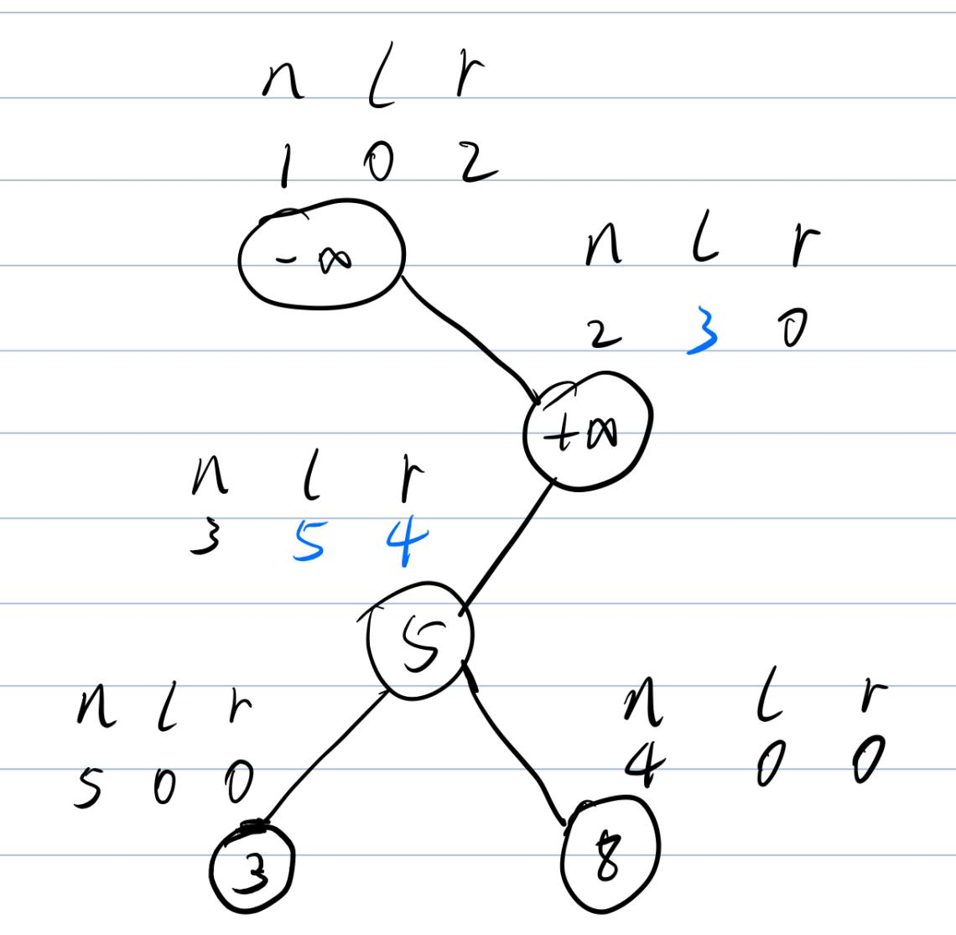

Treap
Rotate operation:
For a sequence 1,2,3,4,5, or out of order 2,3,1,5,4. Insert them into the BST, and the resulting BST is actually equivalent. But the first is clearly not dominant in complexity.
We will change the shape of the BST by deforming it, but at the same time let him keep the original information. This operation is called "rotation". Rotation is divided into left-handed and right-handed.
Can be combined with this picture to deepen understanding
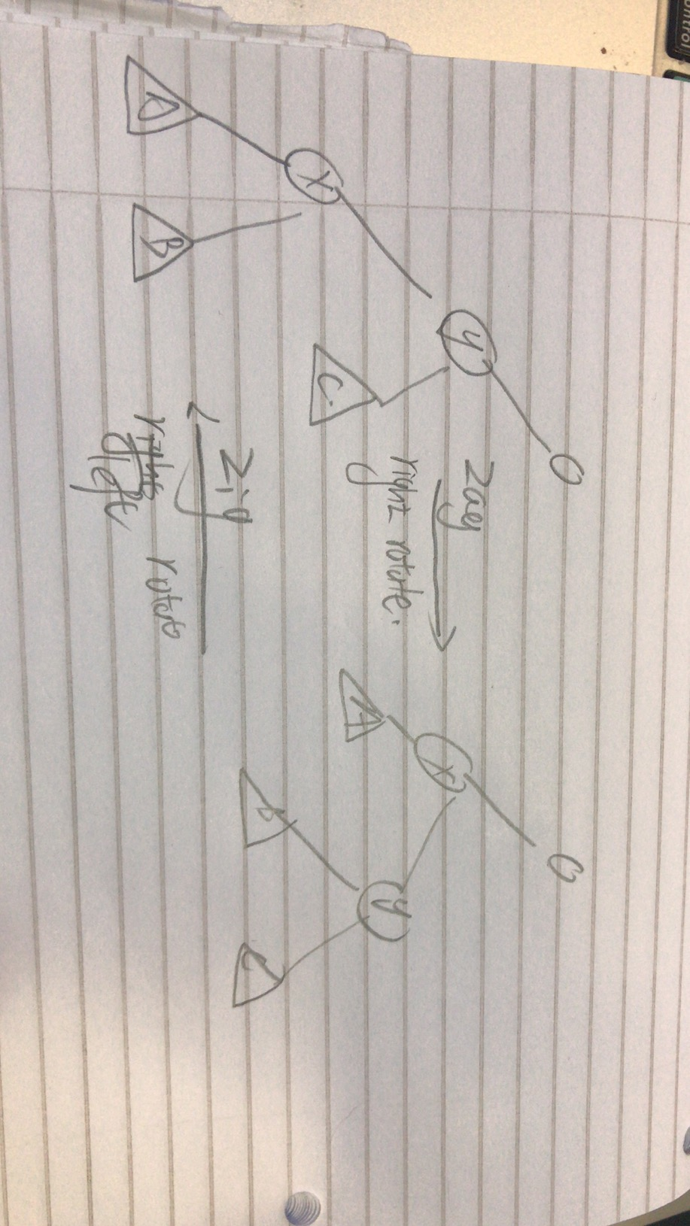

That is, we can use rotation to transform the originally degraded BST into a tree that can guarantee complexity.
What kind of rotation is reasonable?
Under random data, a BST is balanced. So the idea of treatreap is to use randomness to create equilibrium conditions.
treap is a combination of tree and heap. So treap has two keywords, one is the value attached randomly, and the other is the original weight.
When we insert a new node, we attach a random value to it, and then adjust it left-handed or right-handed like a binary heap to adjust, which can ensure both balance and BST properties.
Code:
include<bits/stdc++.h>
using namespace std;
typedef long long ll;
const int maxn = 1e5 + 10;
const int INF = 0x3f3f3f3f;

int tot, root, n;
struct Treap
{
int l, r; //Left and right child nodes
int val, dat; //Bst weight Heap weight satisfies large root heap properties
int cnt, sz; //Number of duplicates The size of the subtree (including the root node)
}a[maxn];

//Create a new node
int New(int val)
{
a[++tot].val = val;
a[tot].dat = rand(); //Attach a random value to that part of the heap
a[tot].cnt = a[tot].sz = 1; //Both the repeat number and the subtree are 1
return tot;
}

void update(int p){ //Update the information of the current parent node
a[p].sz = a[a[p].l].sz + a[a[p].r].sz + a[p].cnt;
}

//The initial establishment of the treap has two special nodes
void Build()
{
New(-INF), New(INF);
root = 1; a[1].r = 2;
update(root); //Update the root node
}

int GetRankByVal(int p, int val)
{
if(p == 0) return 0; //if without this node
//If found at this time, then the ranking is a number less than him + itself
if(val == a[p].val) return a[a[p].l].sz + 1;
//Can go straight to the left
if(val < a[p].val) return GetRankByVal(a[p].l, val);
//Going to the right is actually equivalent to the left half plus the root all smaller than him
return GetRankByVal(a[p].r, val) + a[a[p].l].sz + a[p].cnt;
}

//Find the number ranked by rk
int GetValByRank(int p, int rk)
{
if(p == 0) return INF; //empty node
//If the size of the left subtree of the current node is greater than rk
//Then the answer must be in the left subtree
if(a[a[p].l].sz >= rk)
return GetValByRank(a[p].l, rk);
if(a[a[p].l].sz + a[p].cnt >= rk)
return a[p].val;
//When going to the right, rk needs to subtract the size of the left subtree and the root node.
return GetValByRank(a[p].r, rk - a[a[p].l].sz - a[p].cnt);
}

void zig(int &p) //right rotate
{
int q = a[p].l; //Left subtree
a[p].l = a[q].r; //The right subtree of the left subtree is spliced to the left subtree of the root node
a[q].r = p; //The right subtree of the left subtree becomes the root node. The left subtree of the left subtree is unchanged.
p = q; //Exchange the information of the original left subtree
update(a[p].r); update(p);//Routine update of two parent nodes
}

void zag(int &p) //Left-hand operation
{
int q = a[p].r;
a[p].r = a[q].l; a[q].l = p; p = q;
update(a[p].l); update(p);
}

//Insert and delete operations generally involve rotation
//So at this time, recursive writing is used to update the node information.
void ins(int &p, int val)
{
if(p == 0)
{
p = New(val);
return;
}
if(val == a[p].val)
{
a[p].cnt++; update(p);
return;
}
if(val < a[p].val)
{
ins(a[p].l, val); //Because it needs to meet the big root heap
//When the heap weight of my left child node is greater than the root node
//rotating right the left node and exchange
if(a[p].dat < a[a[p].l].dat) zig(p);
}
else
{
ins(a[p].r, val);
if(a[p].dat < a[a[p].r].dat) zag(p);
}
update(p);
}

//Find the node you want to delete and spin it down to the leaf node and delete
//Reduce complex issues such as maintaining node information
void del(int &p, int val)
{
if(p == 0) return;
if(val == a[p].val)//finding val
{
if(a[p].cnt > 1)
{
a[p].cnt--, update(p); //Just subtract one copy
return; //退出
}
if(a[p].l || a[p].r)//Not leaf nodes rotate down
{
if(a[p].r == 0 || a[a[p].l].dat > a[a[p].r].dat)
{zig(p); del(a[p].r, val);} //Turn right and enter the right subtree
else {zag(p); del(a[p].l, val);}
update(p);//Routine update of parent node information
}
else p = 0; //Is a leaf node to delete
return;
}
val < a[p].val ? del(a[p].l, val) : del(a[p].r, val);
update(p);
}

int GetPre(int val)
{ //Predecessor: less than x and the largest number
int ans = 1; //a[1].val = -INF
int p = root;
while(p)
{
if(val == a[p].val) //Found the same node value
{
if(a[p].l > 0) //If there is a left subtree
{
p = a[p].l; //Keep right
while(a[p].r > 0) p = a[p].r;
ans = p;
}
break; //Ans at this time is the answer
}
//Even if no val precursor can be found, it is passed by ans
if(a[p].val < val && a[p].val > a[ans].val) ans = p;
p = val < a[p].val ? a[p].l : a[p].r;
}
return a[ans].val;
}

int GetNext(int val)
{ //Successor: greater than x and smallest number
int ans = 2; // a[2].val = INF
int p = root;
while(p)
{
if(val == a[p].val)
{
if(a[p].r > 0)
{
p = a[p].r;
while(a[p].l > 0) p = a[p].l;
ans = p;
}
break;
}
if(a[p].val >val && a[p].val < a[ans].val) ans = p;
p = val < a[p].val ? a[p].l : a[p].r;
}
return a[ans].val;
}

int main()
{
Build();
scanf("%d", &n);
int op, x;
while(n--)
{
scanf("%d%d", &op, &x);
if(op == 1)
{//insert x
ins(root, x);
}
if(op == 2)
{//delte (if is has mutile,only delte one)
del(root, x);
}
if(op == 3)
{// Query the rank of x (the rank is defined as the number smaller than the current number + 1)
// If there are multiple identical numbers, output the smallest ranking
printf("%d\n", GetRankByVal(root, x) - 1);
//Note: Because an INF and -INF are inserted during initialization, the query is -1
}
if(op == 4)
{//Query the number ranked x
printf("%d\n", GetValByRank(root, x + 1));
//The same reason: when querying, we need to check x + 1 names because (-INF)
}
if(op == 5)
{//Find the precursors of x (less than x and the largest number)
printf("%d\n", GetPre(x));
}
if(op == 6)
{//Find the successor of x (the smallest number greater than x)
printf("%d\n", GetNext(x));
}
}
return 0;
}

Splay
Splay is called a stretch tree, and the general operations on the stretch tree are based on the stretch operation:
Suppose you want to perform a series of operations on a binary tree. In order to make the entire operation time shorter, the frequently operated entry should be near the root of the tree.
So you can design it like this, rebuild the tree after each operation, and move the operated item closer to the root of the tree.
Splay came into being. It is a self-adjusting binary search tree. It will follow a path from a node to the root of the tree, and move this node near the root of the tree through a series of rotations.
Splay related operations:
Define SplayTree:
Put the code directly here and read the comments.:
struct SplayTree
{
int val; //value of node
int fa; //father node
int ch[2];// 0 is for left son ,1 is for right son
int cnt; //the time of the current appreaance
int sz; //the size of substree(includeing it self)
}a[maxn];
int tot; // how many nodes in the tree
Can we find a way to merge left and right handedness? The answer is yes.
Before understanding the rotate function, let us introduce three auxiliary functions.
update function:
At the most basic level, we need the update function to update the node information
inline void update(int p){
a[p].sz = a[a[p].ch[0]].sz + a[a[p].ch[1]].sz + a[p].cnt;
}
identify function:
We need the function identify to determine if a node is the left or right child of his father.
inline bool identify(int p){
return a[a[p].fa].ch[0] == p ? 0 : 1;
}
The left child returns 0 and the right child returns 1.
connect function
At the same time, because there are more parent nodes here, we also need to have a function connect to connect two points to make one of them a child of the other
//connect function(son ,father ,left/right son)
inline void connect(int p, int f, int son){
a[p].fa = f;
a[f].ch[son] = p;
} //Connect node p below fa, as to which son is determined by son
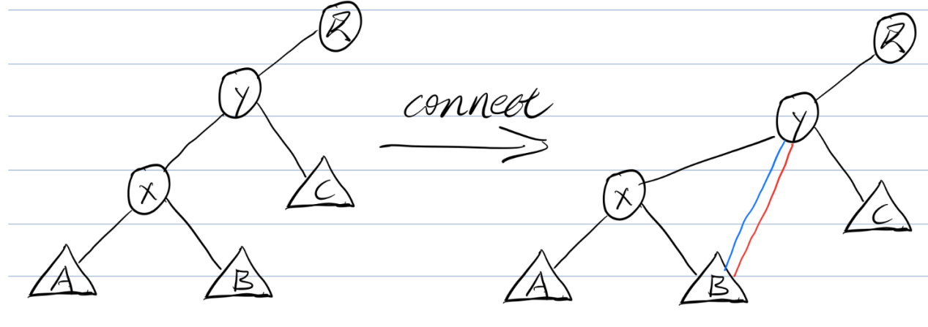
Here we find that although y and BB have a father-son relationship, B's father is no longer x, but B is still x's right son.
So in the following, we need to pay attention to this problem and take some actions to avoid such time bombs.
rotate function:
With the help of these two functions, let's focus on how to write the rotate function.
We found that it only takes three connect operations + two updates to complete the rotation. The above picture is an example.

Set B's parent node to y. I.e. connect (B, y)
Set the parent node of y to x. I.e. connect (y, x)
Set the parent node of x to R. I.e. connect (x, R)
update (y), update (x)
At the same time, for the time bomb just mentioned, "three bombs" can also be completed through these three connections.
Explanation: It's very difficult to explain, because he won't have any conflicts in this way, you can understand according to the code drawing.
This is a right-handed operation, and of course the same applies to a left-handed operation. You can take out the pen yourself and look at the left-hand operation above, you will find that the same operation only requires three rotations and two update operations.
At the same time, whether it is left-handed or right-handed, it is only related to nodes x, y, and B.

And it can be noted that the connection direction of xx and yy is different from the connection direction of xx and BB. So we can use the identify function to determine the parent-child relationship between xx and yy, so as to determine which direction to rotate.
Consider the connection process (combining left-handed and right-handed operations):
Which son of B becomes y is the same as which son of x is y.
Which son of y becomes x is the opposite of which son of x is y.
Which son of x becomes R is the same as which son of y is R.
At this point, the rotatee function can be completely written.
inline void update (int p) {
a [p] .sz = a [a [p] .ch [0]]. sz + a [a [p] .ch [1]]. sz + a [p] .cnt;
}

inline bool identify (int p) {
return a [a [p] .fa] .ch [0] == p? 0: 1;
}

// connect function connect (son, fa, left son / right son)
inline void connect (int p, int f, int son) {
a [p] .fa = f;
a [f] .ch [son] = p;
} // Connect node p below fa, as to which son is determined by son

void rotate_node (int x)
{
int y = a [x] .fa;
int r = a [y] .fa;
int yson = identify (x); // which child of x is y
int rson = identify (y); // Which child of y is r
int b = a [x] .ch [yson ^ 1]; // b is opposite to which child x is y
connect (b, y, yson); // The relationship between b and y is the same as the relationship between x and y
connect (y, x, yson ^ 1); // The relationship between y and x is opposite to the relationship between x and y
connect (x, r, rson); // The relationship between x and r is the same as the relationship between y and r
update (y); update (x);
}
Stretch operation Splay:
The splay (x, to) function moves the x node to the position of to.
The simplest method, for the node x, we spin up several times until to.
Generally speaking, there are three types.
1: 1: to yes x dad
Then just spin it up.
Explanation: I'm home ~
2: 2: x is in a line with his dad and his grandpa (three points and one line), that is, identify (x) = identify (x.fa) identify (x) = identify (x.fa)
At this time, rotate xx father up first, then rotate x up
Explanation: Look at the picture
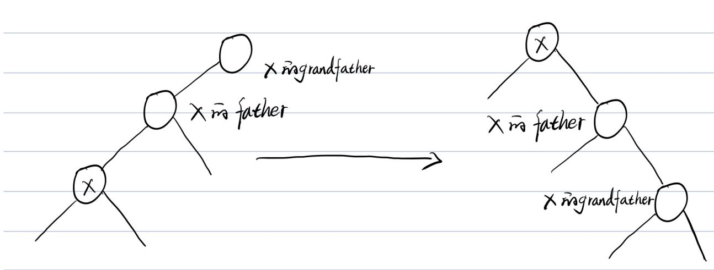

3: 3: x is not in line with his dad and his grandpa (not in line)

Now rotate x twice.
Explanation: Understand situation 2.
void splay (int x, int to)
{
to = a [to] .fa;
while (a [x] .fa! = to)
{
int y = a [x] .fa;
if (a [y] .fa == to) // to is the father of x
rotate_node (x); // Rotate directly
else if (identify (x) == identify (y))
{// Three points in line
rotate_node (y); // First turn x's father up
rotate_node (x); // then rotate x up
}
else // x and his dad and his grandpa are not on the same line
{
rotate_node (x);
rotate_node (x);
}
}
}
insert:
First we need a function to create nodes:
int newnode (int val, int fa)
{
a [++ tot] .fa = fa;
a [tot] .val = val;
a [tot] .sz = a [tot] .cnt = 1;
return tot;
}
Then insert it according to the BST property.
Of course, according to the operation of splay, after inserting a number, you want to rotate it to the root.
int newnode (int val, int fa)
{
a [++ tot] .fa = fa;
a [tot] .val = val;
a [tot] .sz = a [tot] .cnt = 1;
return tot;
}

// Insert a node whose value is val
void ins (int val)
{
int p = a [0] .ch [1];
// If it is an empty node
if (p == 0) a [0] .ch [1] = newnode (val, 0);
else
{
while (true)
{
a [p] .sz + = 1;
if (a [p] .val == val)
{
a [p] .cnt + = 1;
splay (p, a [0] .ch [1]);
return;
}
int son = val <a [p] .val? 0: 1;
if (! a [p] .ch [son]) // If the node is empty
{// Create new node
int q = newnode (val, p);
a [p] .ch [son] = q;
splay (q, a [0] .ch [1]);
return;
}
p = a [p] .ch [son];
}
}
}
delete:
Delete a node with a node weight of val.
Find him first.
These situations can occur:
1: 1: Nodes appear more than 11 times
At this time, directly subtract 11 from his sz and cnt.
2: 2: The node has no left and right subtrees, that is, it is a leaf node.
Delete directly.
3: 3: Node has no left son.
Delete the node and let the right son take his place.
4: 4: Node has left son.
Find the precursor of the node, that is, go to the left sub-tree first and then keep going to the right.
Rotate the predecessor to the left child of the root node, then turn the right child of the root node into the right child of the left node of the root node, and let the left child become the root.
Then delete the node you want to delete.
int find_node (int val)
{
int p = a [0] .ch [1];
while (true)
{
if (a [p] .val == val)
{
splay (p, a [0] .ch [1]);
return p;
}
int son = val <a [p] .val? 0: 1;
if (! a [p] .ch [son]) return 0;
p = a [p] .ch [son];
}
}

void del (int val)
{
// Find points with weight val
// Splay him to the root node at the same time
int p = find_node (val);
if (! p) return;
if (a [p] .cnt> 1)
{
a [p] .sz-= 1;
a [p] .cnt-= 1;
}
else
{
// if the left and right subtrees do not exist
if (! a [p] .ch [0] &&! a [p] .ch [1])
a [0] .ch [1] = 0; // Delete directly
// if there is no left subtree
else if (! a [p] .ch [0])
{
a [0] .ch [1] = a [p] .ch [1]; // Let the right tree replace him
a [a [0] .ch [1]]. fa = 0; // Delete
}
else
{
int l = a [p] .ch [0];
while (a [l] .ch [1])
l = a [l] .ch [1]; // Find the precursor
splay (l, a [p] .ch [0]); // Put the precursor to the left
connect (a [p] .ch [1], l, 1);
// Then connect the right child of p to the right child of the precursor
connect (l, 0, 1); // turn the precursor into root
update (l); // Update node information
}
}
}
As for why to do it, because it can keep BST nature duck.
Query Ranking:
I wrote a function to find a specific number, and then just use it directly.
int GetRankByVal (int val)
{
int p = find_node (val);
return a [a [p] .ch [0]]. sz + 1;
}
Query weight:
Similar to treap operation
// Query the number ranked by rk
int GetValByRank (int rk)
{
int p = a [0] .ch [1];
while (true)
{
int delta = a [p] .sz-a [a [p] .ch [1]]. sz;
if (rk> a [a [p] .ch [0]]. sz && rk <= delta) // At this time, rk falls within the range of cnt
{
splay (p, a [0] .ch [1]);
return a [p] .val;
}
if (rk <delta) p = a [p] .ch [0]; // left subtree query
else
{
rk-= delta;
p = a [p] .ch [1]; // Enter the right subtree query
}
}
}
Query the precursor:
Predecessor: less than x and the largest number
Similar to treap
int GetPre (int val)
{
int p = a [0] .ch [1];
int ans = -INF;
while (p)
{
if (a [p] .val <val && a [p] .val> ans)
ans = a [p] .val;
if (val> a [p] .val) p = a [p] .ch [1];
else p = a [p] .ch [0];
}
return ans;
}
Query successor:
Successor: greater than x and smallest number
Similar to treap
int GetNext (int val)
{
int p = a [0] .ch [1];
int ans = INF;
while (p)
{
if (a [p] .val> val && a [p] .val <ans)
ans = a [p] .val;
if (val <a [p] .val) p = a [p] .ch [0];
else p = a [p] .ch [1];
}
return ans;
}
Total code:
#include <bits / stdc ++. h>
using namespace std;
const int maxn = 1e5 + 10;
const int INF = 0x3f3f3f3f;

struct SplayTree
{
int val; // The weight of the node
int fa; // parent node
int ch [2]; // 0 is left son, 1 is right son
int cnt; // Number of occurrences of this weight
int sz; // The subtree size of this node (including itself)
} a [maxn];
int tot; // how many nodes are on the tree

inline void update (int p) {
a [p] .sz = a [a [p] .ch [0]]. sz + a [a [p] .ch [1]]. sz + a [p] .cnt;
}

inline bool identify (int p) {
return a [a [p] .fa] .ch [0] == p? 0: 1;
}

// connect function connect (son, fa, left son / right son)
inline void connect (int p, int f, int son) {
a [p] .fa = f;
a [f] .ch [son] = p;
} // Connect node p below fa, as to which son is determined by son

void rotate_node (int x)
{
int y = a [x] .fa;
int r = a [y] .fa;
int yson = identify (x); // which child of x is y
int rson = identify (y); // Which child of y is r
int b = a [x] .ch [yson ^ 1]; // b is opposite to which child x is y
connect (b, y, yson); // The relationship between b and y is the same as the relationship between x and y
connect (y, x, yson ^ 1); // The relationship between y and x is opposite to the relationship between x and y
connect (x, r, rson); // The relationship between x and r is the same as the relationship between y and r
update (y); update (x);
}

void splay (int x, int to)
{
to = a [to] .fa;
while (a [x] .fa! = to)
{
int y = a [x] .fa;
if (a [y] .fa == to) // to is the father of x
rotate_node (x); // Rotate directly
else if (identify (x) == identify (y))
{// Three points in line
rotate_node (y); // First turn x's father up
rotate_node (x); // then rotate x up
}
else // x and his dad and his grandpa are not on the same line
{
rotate_node (x);
rotate_node (x);
}
}
}

int newnode (int val, int fa)
{
a [++ tot] .fa = fa;
a [tot] .val = val;
a [tot] .sz = a [tot] .cnt = 1;
return tot;
}

// Insert a node whose value is val
void ins (int val)
{
int p = a [0] .ch [1];
// If it is an empty node
if (p == 0) a [0] .ch [1] = newnode (val, 0);
else
{
while (true)
{
a [p] .sz + = 1;
if (a [p] .val == val)
{
a [p] .cnt + = 1;
splay (p, a [0] .ch [1]);
return;
}
int son = val <a [p] .val? 0: 1;
if (! a [p] .ch [son]) // If the node is empty
{// Create new node
int q = newnode (val, p);
a [p] .ch [son] = q;
splay (q, a [0] .ch [1]);
return;
}
p = a [p] .ch [son];
}
}
}

int find_node (int val)
{
int p = a [0] .ch [1];
while (true)
{
if (a [p] .val == val)
{
splay (p, a [0] .ch [1]);
return p;
}
int son = val <a [p] .val? 0: 1;
if (! a [p] .ch [son]) return 0;
p = a [p] .ch [son];
}
}

void del (int val)
{
// Find points with weight val
// Splay him to the root node at the same time
int p = find_node (val);
if (! p) return;
if (a [p] .cnt> 1)
{
a [p] .sz-= 1;
a [p] .cnt-= 1;
}
else
{
// if the left and right subtrees do not exist
if (! a [p] .ch [0] &&! a [p] .ch [1])
a [0] .ch [1] = 0; // Delete directly
// if there is no left subtree
else if (! a [p] .ch [0])
{
a [0] .ch [1] = a [p] .ch [1]; // Let the right tree replace him
a [a [0] .ch [1]]. fa = 0; // Delete
}
else
{
int l = a [p] .ch [0];
while (a [l] .ch [1])
l = a [l] .ch [1]; // Find the precursor
splay (l, a [p] .ch [0]); // Put the precursor to the left
connect (a [p] .ch [1], l, 1);
// Then connect the right child of p to the right child of the precursor
connect (l, 0, 1); // turn the precursor into root
update (l); // Update node information
}
}
}

int GetRankByVal (int val)
{
int p = find_node (val);
return a [a [p] .ch [0]]. sz + 1;
}

// Query the number ranked by rk
int GetValByRank (int rk)
{
int p = a [0] .ch [1];
while (true)
{
int delta = a [p] .sz-a [a [p] .ch [1]]. sz;
if (rk> a [a [p] .ch [0]]. sz && rk <= delta)
{
splay (p, a [0] .ch [1]);
return a [p] .val;
}
if (rk <delta) p = a [p] .ch [0]; // left subtree query
else
{
rk-= delta;
p = a [p] .ch [1]; // Enter the right subtree query
}
}

}

int GetPre (int val)
{
int p = a [0] .ch [1];
int ans = -INF;
while (p)
{
if (a [p] .val <val && a [p] .val> ans)
ans = a [p] .val;
if (val> a [p] .val) p = a [p] .ch [1];
else p = a [p] .ch [0];
}
return ans;
}

int GetNext (int val)
{
int p = a [0] .ch [1];
int ans = INF;
while (p)
{
if (a [p] .val> val && a [p] .val <ans)
ans = a [p] .val;
if (val <a [p] .val) p = a [p] .ch [0];
else p = a [p] .ch [1];
}
return ans;
}

int main ()
{
int n, op, x;
scanf ("% d", & n);
while (n--)
{
scanf ("% d% d", & op, & x);
if (op == 1) ins (x);
if (op == 2) del (x);
if (op == 3) // Query the rank of x number
printf ("% d \ n", GetRankByVal (x));
if (op == 4) // Query the number ranked x
printf ("% d \ n", GetValByRank (x));
if (op == 5) // precursor of x
printf ("% d \ n", GetPre (x));
if (op == 6) // successor to x
printf ("% d \ n", GetNext (x));
}
return 0;
}
Splay maintenance interval operation:
Suppose at this point we want to do something in the interval [l, r], first rotate l−1 to the root node, and then transfer r + 1 to the right son of the root node.
Then the left son of the right son of the root node represents the interval [l, r].
The text may not be so intuitive, draw a picture to express it.
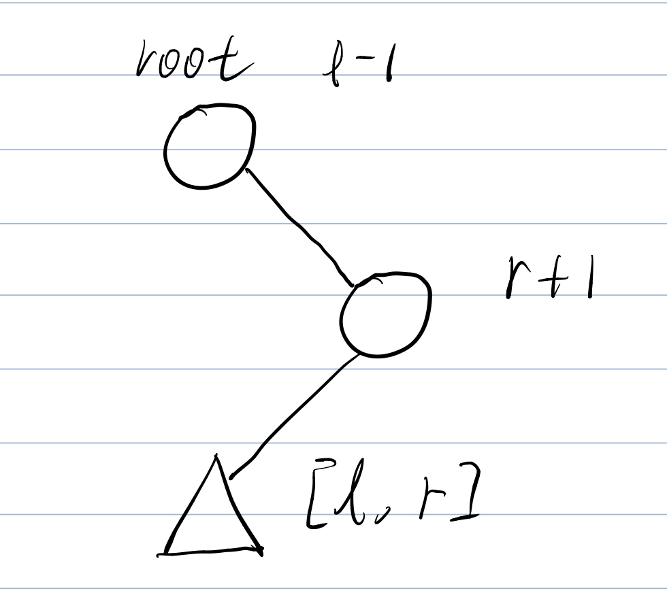

Segment Tree
Introduction
Line segment tree is a data structure that can handle interval query and interval modification problems well. Although tree arrays can also implement interval modification through the idea of difference, tree arrays can only be used for interval summation, while line tree Able to deal with a series of problems such as interval maximum / minimum.

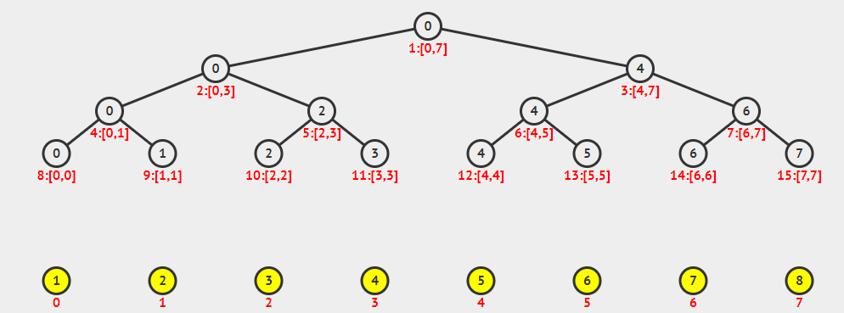
Although the segment tree looks like a tree structure, we usually use arrays to hold the segment tree. Suppose we originally had an array of size n.
Then the space needed for the line segment tree is generally 4 ∗ n.
Intuitively, similar to a full binary tree, it seems that it only needs 2 ∗ n space.
Now we consider an array with exactly N = 2 ^ k + 1 nodes
Then this segment tree has k + 1 layers (although the last layer has only two nodes on the far left)
But for a tree with a depth of k + 1,
The number of nodes in its full binary tree is 2 ^ (k + 2) -1.
We can get lim 2 ^ (k + 2) -1 / 2 ^ k + 1 = 4 ;.
So in extreme cases, we need to open 4 ∗ n space.
In a line segment tree, each node represents an interval, and leaf nodes represent intervals of length 1.
. Suppose the interval represented by a node is [L, R] [,
We have mid = (L + R) / 2
Then the interval represented by its left child is [L, mid],
The interval represented by the right child is [mid + 1, R].
For convenience, the length of the line tree array is 4 ∗ n
Given a sequence of positive integers a1, a2, ..., an, each number is between 0∼p−1.
Two operations can be performed on this column number:
Add operation: add a number to the sequence, the sequence length becomes n + 1;
Query operation: Ask what is the largest number of the last L numbers in this sequence.
At the beginning of the program, the sequence of integers is empty.
Write a program that reads in a sequence of operations and outputs the answer to a query operation.
Input format
The first line has two positive integers m, p, meaning as described in the title;
The next m lines, each line represents an operation.
If the content of this line is Q L, it means that this operation is asking what is the maximum number of the last L numbers in the sequence;
If it is A t, it means add a number to the back of the sequence, and the added number is (t + a) mod p. Where t is the input parameter and a is the answer to the last query operation before this add operation (a = 0 if there was no previous query operation).
The first operation must be an add operation. For the query operation, L> 0 and does not exceed the length of the current sequence.

Output format
For each query operation, one line is output. The line has only one number, the maximum number of the last L numbers in the sequence.

data range
1≤m≤2 × 105,
1≤p≤2 × 109,
0≤t <p
Input example:
10 100
A 97
Q 1
Q 1
A 17
Q 2
A 63
Q 1
Q 1
Q 3
A 99
Sample output:
97
97
97
60
60
97
Sample explanation
The final sequence is 97,14,60,96.

Code:
#include<cstdio>
#include<cstring>
#include<iostream>
#include<algorithm>
using namespace std;
struct Node
{
int l,r;
int v ;// the max value in interval[L,R]
}tr[N*4];

void build(int u,int l,int r)
{
tr[u] = {l,r};
if(l ==r) return;
int mid = l+r>>1;
build(u<<1,l,mid),build(u<<1|1,mid+1,r);
}
void pushup(int u)// baseon the sub node to update father node
{
tr[u].r = max(tr[u<<1].v,tr[u<<1|1].v);
}
int query(int u,int l,int r)
{
if(tr[u].l >= l & tr[u].r<=r)
return tr[u].v;// node in the tree [L,R]
int mid = tr[u].l + tr[u].l >>1;
int v = 0;
if(l <=mid) v= query(u<<1,l,r);
if(r>mid) v= max(v,query(u<<1|1,l,r));
return v;
}
//edit signal node if it need edit the interval ,using lazy tag
void modiy(int u,int x,int v)
{
if(tr[u].l == x && tr[u].r == x)
tr[u].v = v;
else
{
int mid tr[u].l + tr[u].r >>1;
if(x<=mid) modify(u<<1,x,v);
else modify(u<<1|1,x,v);
pushup(u);//son ->father
}
}
int main()
{
int n = 0 ,last = 0;
scanf("%d%d",&m,&p);
build(1,1,m);
int x;
char op[2];
while(m--)
{
scanf("%s%d",op,&x);
if(*op == 'Q')
{
last = query(1,n-x+1,n);
printf("%d\n",last);
}
else
{
modify(1,1,(last+x)%p);
n++;
}
}

return 0;
}
Given a sequence A of length N and M instructions, each instruction may be one of two:

1. "C l r d" means to add d to A [l], A [l + 1], ..., A [r].

2. "Q l r" means the sum of the l ~ r numbers in the query sequence.

For each query, output an integer representing the answer.

Input format
The first two integers N, M.

The second line is N integers A [i].

The next M lines represent M instructions, and the format of each instruction is shown in the title description.

Output format
For each query, output an integer representing the answer.

Each answer is on a separate line.

data range
1≤N, M≤105,
| d | ≤10000,
| A [i] | ≤1000000000
Input example:
10 5
1 2 3 4 5 6 7 8 9 10
Q 4 4
Q 1 10
Q 2 4
C 3 6 3
Q 2 4
Sample output:
4
55
9
Code:
#include<cstdio>
#include<cstring>
#include<iostream>
#include<algorithm>
using namespace std;
typedef long long LL;
const int N = 100010;
int n,m;
int w[N];
struct Node
{
int l,r;
LL sum,add; //add is a lazy tag from father node to child node
}tr[N*4];
void pushup(int u)
{
tr[u].sum = tr[u<<1].sum + tr[u<<1|1].sum ;
}
void build(int u,int l,int r)
{
if(l == r) tr[u] = {l,r,w[r],0};
else
{
tr[u] = {l,r};
int mid = l+r>>1;
build(u<<1,l,mid),build(u<<1|1,mid+1,r);
pushup(u);
}
}
void pushdown(int u)
{
auto &root = tr[u],&left = tr[u<<1],&right = tr[u<<1|1];
if(root.add）
{
left.add += root.add,left.sum +=(LL)(left.r-left.l+1)*root.add;
right.add += root.add,right.sum +=(LL)(right.r-right.l+1)*root.add;
root.add = 0;
}
}
void modify(int u,int l,int r,int d)
{
if(tr[u]l>=l && tr[u].r<=r)
{
tr[u].sum +=(LL)(tr[u].r-tr[i].l+1)*d;
tr[u].add +=d;
}
else
{
// it must be spliting
pushdown(u);
int mid = tr[u].l + tr[u].r>>1;
if(l<=mid) modiy(u<<1,l,r,d);
if(r>mid) modify(u<M1|1,l,r,d);
pushup(d);
}
}
LL query(int u ,int l,int r)
{
if(tr[u].l>=l &&tr[u].r<=r) return tr[u].sum;
pushdown(u);
int mid = tr[u].l+tr[u].r>>1;
LL sum = 0 ;
if(l<=mid) sum+= query(u<<1,l,r);
if(r>mid) sum += query(u<<1|1,l,r);
return sum;
}

int int main(int argc, char const *argv[])
{
scanf("%d%d",&n,&m);
for(int i = 1;i<=n;i++) scanf("%d",&w[i]);
build(1,1,n);
char op[2];
int l,r,d;
while(m--)
{
scanf("%s%d%d",op,&l,&r);
if(*op == 'C')
{
scanf("%d",&d);
modify(1,l,r,d);
}
else
{
printf("ld\n",query(1,l,r));
}
}
return 0;
}
Binary-Indexed-Tree/Fenwick Tree
Introduction
Consider the following question: Given an array, we need to perform the following two operations:
Single point update: modify a number in the array.
Interval Sum: Sum the numbers in a certain interval.
For problem one, we can usually solve it in O (1) time, and for problem two, we can usually solve it in O (n) time. If we use prefix and solve problem two, we can solve the prefix sum in O (1) time, but when we modify the array elements, we need to recalculate the prefix and array O (n). Assuming we have m queries, then we can use the RMQ algorithm to reduce the total time complexity to O (mlogn), but we can use a tree-like array that is easier to encode (no more than ten rows) at the same time complexity Solve the same problem.

Basic Idea

Each integer can be composed of several integers. Similarly, for the interval summation problem, we can decompose the interval into several small intervals for summing. To facilitate subsequent calculations in the tree array, we assume that all array indices start from 1. For a given array A [1,…, n], we construct an auxiliary array tree [1, .., n] with a length of nn. The special tree [idx] stores sumRange (idx−2r + 1 , idx) sumRange (idx−2r + 1, idx) The sum of the number of 2r2r. Here rr represents the lowest non-zero bit in the binary representation of idxidx. For example, the lowest non-zero bit in 5 (101) is r = 0r = 0, so tree [5] = sumRange (5,5), Similarly, the lowest non-zero bit of 6 (110) is r = 1, so tree [6] = sumRange (6−2 + 1,6) is the sum of two numbers. The following gives the value of a tree array auxiliary array of length 16.
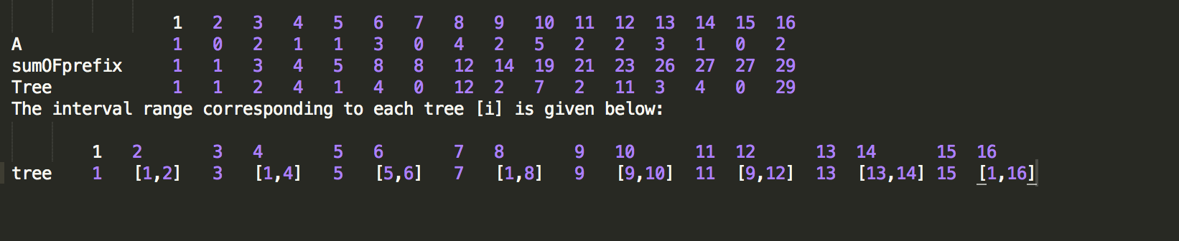
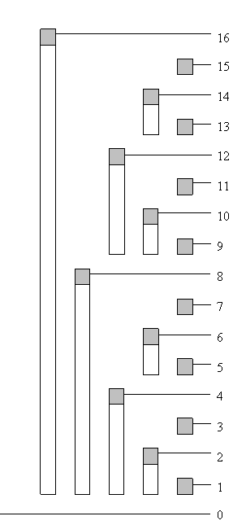
Isolating the last bit
According to the above findings, if we can quickly find the position of each 1 in the binary representation of nn, we can quickly find the prefix sum. For any non-zero number, its binary representation is a1b, b represents several zeros, and a represents higher digits. We know that when a computer represents a negative number, it uses the two's complement to invert the binary representation of the positive number and adds 1.
Consider the binary representation of -n as
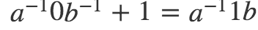
Here a ^ -1 represents the negation of this part of the binary code.
We try n & (− n) n & (− n) and we can get
A1b
& A ^ −11b
= (000) 1 (0000)
So for each idx, it contains the interval size exactly 2 ^ r = idx & (− idx), tree [idx] = sumRange (idx−2r + 1, idx)
Prefix and solve:
Suppose we want to find the prefix sum of the first idx elements, we do the following:
Add the value of tree [idx] to the answer
Subtract the value of idx from the number of elements in tree [idx] idx & −idx
Repeat the above operation until idx <= 0
int read(int idx)
{
int sum = 0;
while(idx > 0)
{
sum += tree[idx];
idx -= (idx & -idx);
}
return sum
}
Below we give a solution example with idx = 13
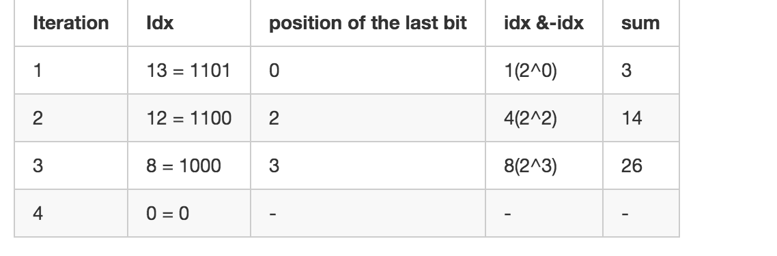
Time complexity is(logn)
Single point update:
When we want to modify the value of an element in the array, we need to modify the value of the tree array and the value of the element to be modified accordingly. In the process of finding the prefix sum, we continuously remove the last bit of idx. It is interesting to note that during the single-point update process, we are constantly adding the last bit of idx. We do the following.
Modify the value of] tree [idx]
Add idxi value to idx & −idxi
Repeat the above operation until idx> n
// Note that val here refers to the delta value, not the modified value
void update (int idx, int val)
{
while (idx <= n)
{
tree [idx] + = val;
idx + = (idx & -idx);
}
}
Suppose we want to modify the value of idx = 5, the iteration process is as follows:
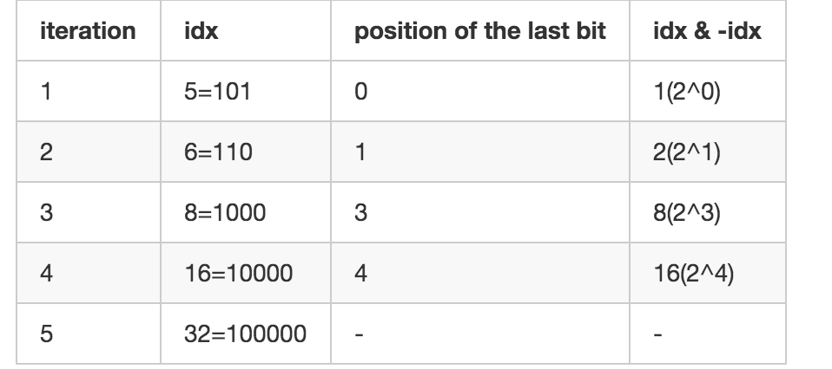
Time complexity O(logn)
Single point query
If we want to get the value of the array element A [idx] A [idx], we usually do it in two ways:
Use extra space to maintain array AA, and update array A at the same time every single point update, so that we can solve in O (1) time
Use two interval lookups because A [idx] = sumRange (1, idx) −sumRange (1, idx−1) A [idx] = sumRange (1, idx) −sumRange (1, idx−1), This way we can solve in O (logn) time.
Suppose we want to solve the sum in a section, the two subscripted paths to the root node, these two paths will definitely meet at a certain node, after that, they will overlap, such as the interval [6,7], read [5] = tree [5] + tree [4], read [7] = tree [7] + tree [4]. tree [4] is their common part, in fact, there is no need to calculate.

Now suppose we want to find A [idx]. Let x = idx, y = idx−1. In the binary representation y = a0b, b represents a continuous segment of 1, x = a1b−x = a1b−, b− represents continuous A period of 0. After the first iteration of read (x), we will remove the 1 on the lowest bit of xx. At this time x = a0b−, we let z = x = a0b−. At this time we continuously erase the low 1 of y, and we can get y = a0b− = zy. This means that the way from 0 to x and 0 to y met.
int readSingle(int idx)
{
int sum = tree[idx];
int y = idx --;
if(idx > 0)
{
int idx = idx - (idx & -idx);
while(y!= idx)
{
sum -= tree[y];
y -= (y & - y);
}
}
return sum
}
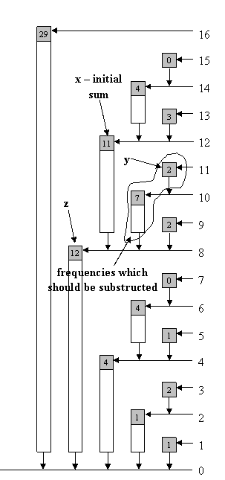
This algorithm is faster than calling the read function twice, and when the idx is an odd number, we can jump out on the first loop and use O (1) time to get the answer. In fact, in the tree, the elements at the corresponding positions in the original array are stored at the odd positions.
Interval summation
Based on the above ideas, we can get the algorithm of interval summation:
inline int lowbit(x){return x & -x;}
int sumRange(int i,int j)
{
int res = 0;
i --;
while(i != j)
{
res = res + tree[j] - tree[i];
i -= lowbit(i);
j -= lowbit(j);
}
return res;
}
Scale array elements by a constant factor
void scale(int c){
for (int i = 1 ; i <= MaxIdx ; i++)
tree[i] = tree[i] / c;
}
Find the prefix and the index exactly equal to the target
If the elements in the array are positive or negative, we can only iterate through all idxidx, and use the read (idx) function to solve, with time complexity O (nlogn).
If the elements in the array have only non-negative numbers, then we can use the idea of dichotomy to solve, the time complexity O (lognlogn) O (lognlogn)
Two-dimensional tree array
Consider the following problem. In the first quadrant of a two-dimensional plane (coordinates are positive numbers), we need to perform the following two operations:
Modify the value of coordinates (x, y)
Similar to the one-dimensional tree-like array, we design a two-dimensional tree-like array to solve this problem.
Update operation:

inline int lowbit (x) {return x & -x;}
void update (int x, int y, int delta)
{
for (int i = x; i <= A.size (); i + = lowbit (i))
{
for (int j = y; j <= A [0] .size (); j + = lowbit (j))
{
A [i] [j] + = delta;
}
}
}
Sum operation:

inline int lowbit (x) {return x & -x;}
void read (int x, int y)
{
int sum = 0;
for (int i = x; i> 0; i-= lowbit (i))
{
for (int j = y; j> 0; j-= lowbit (j))
{
sum + = A [i] [j];
}
}
return sum;
}
Tree array with interval modification and single point query
The tasks we need to complete in this problem are:
Increase the number in a range by the same value
Find the value of a certain position.
Here we can use the idea of difference. Assuming the initial array is AA, we first construct a difference array C about A, where $ C [1] = A [1], C [i] = A [i]-Ai- 1 $.
Then we want to increase the number in the interval [L, R] by the same value, then we only need to modify the elements at two positions in the difference array
If we want to require the value A [idx] at a certain position, then A [idx] = sumRange (C [1, idx]).
Based on the above ideas, our tree-like array treetree here is about the difference array C.
nline int lowbit(int x) {return x & -x;}
void init(int[] A)
{
int n = A.size();
for(int i = 1;i < n;i ++)
{
C[i] = A[i] - A[i - 1];
update_dot(i,C[i]);
}
}
void update_dot(int idx,int val)
{
while(idx <= n)
{
tree[idx] += val;
idx += (idx & -idx);
}
}
void update(int L,int R,int delta)
{
update_dot(L,delta);
update_dot(R,-delta);
}
void read(int idx)
{
int res = 0;
while(idx > 0)
{
res += tree[idx];
idx -= lowbit(idx);
}
return res;
}

Interval modification, interval query tree array
In this task, we need to address the following issues:

Add values within a range to the same value
Querying the sum of an interval
The above problem can be solved using a line segment tree, but slightly improving our tree array can also accomplish the above task. Similarly we use the difference array CC defined in the previous section. We know that if we want to solve a S = A [1: n] prefix sum, we have:
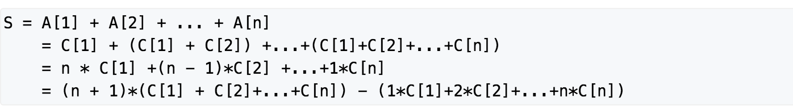
Therefore, we can use another auxiliary array D to maintain the value of D [i] = i ∗ C [i]. The overall code is similar to the above code. The template questions are given below (the line tree can do). Here tree1 and tree2 respectively represent tree arrays of the auxiliary array C and the auxiliary array D.
#include<cstring>
#include<iostream>
#include<algorithm>
using namespace std;
const static int N = 100010;
typedef long long ll;
int n,m;
ll A[N],tree1[N],tree2[N];
inline int lowbit(int x) {return x & -x;}
void update_dot(int idx,ll delta)
{
for(int i = idx ; i <= n ; i += lowbit(i))
{
tree1[i] += delta;
tree2[i] += idx * delta;
}
}
void updateRange(int l,int r,ll delta)
{
update_dot(l,delta);
update_dot(r + 1,-delta);
}
ll ask(int idx)
{
ll res = 0;
for(int i = idx ;i > 0;i -=lowbit(i))
res += (idx + 1) * tree1[i] - tree2[i];
return res;
}
ll rangeQuery(int l,int r)
{
return ask(r) - ask(l - 1);
}
int main()
{
scanf("%d %d",&n,&m);
for(int i = 1; i <= n ; i ++)
{
scanf("%lld",&A[i]);
update_dot(i,A[i] - A[i - 1]);
}
for(int i = 1; i <= m ; i ++)
{
char ch;
cin >> ch;
if(ch == 'Q')
{
int start,end;
ll delta;
scanf("%d %d",&start,&end);
printf("%lld\n",rangeQuery(start,end));
}else
{
int start,end;
ll delta;
scanf("%d %d %lld",&start,&end,&delta);
updateRange(start,end,delta);
}
}
return 0;
}

Aho-Corasick automaton（kmp+trie)

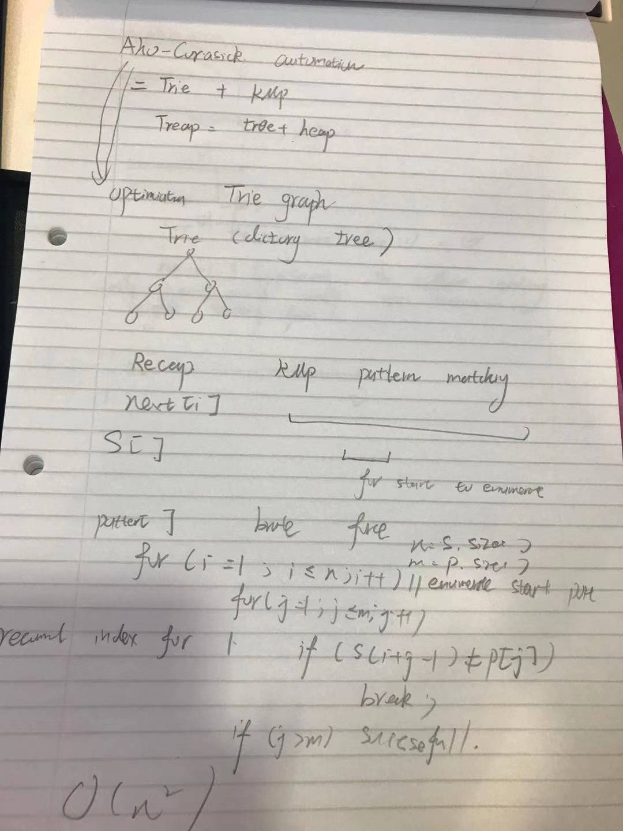

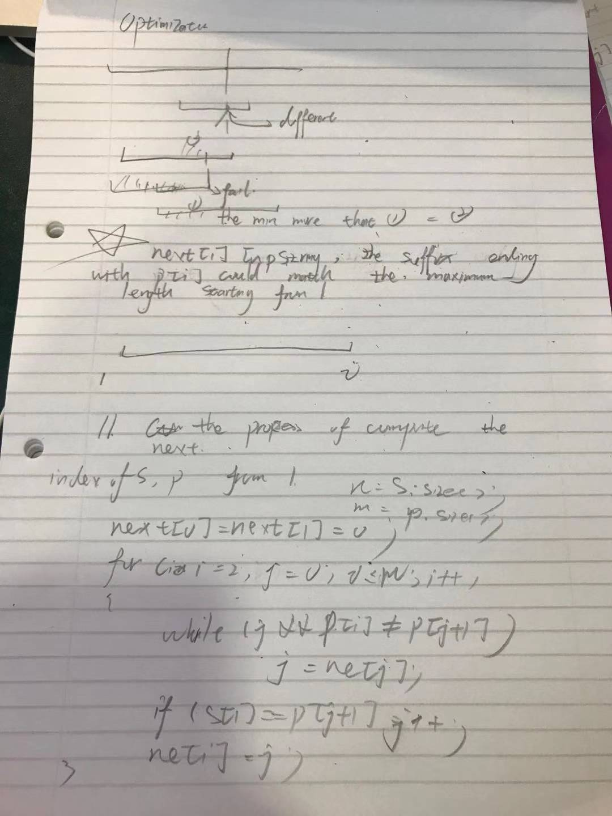
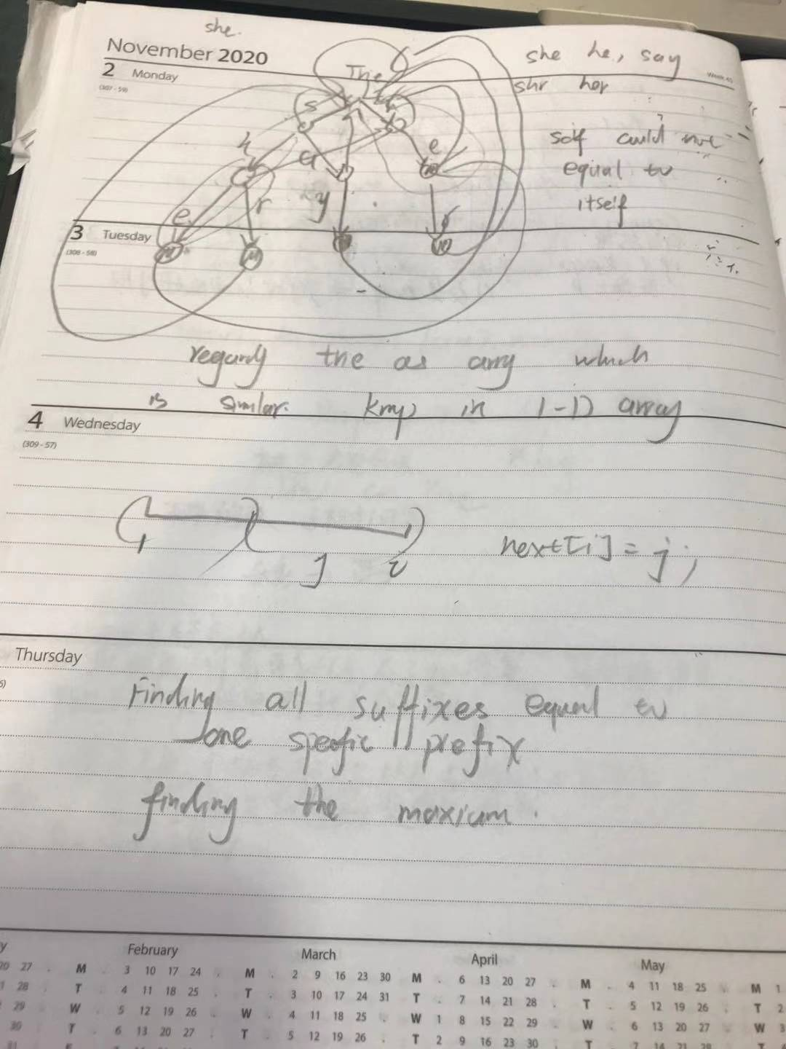
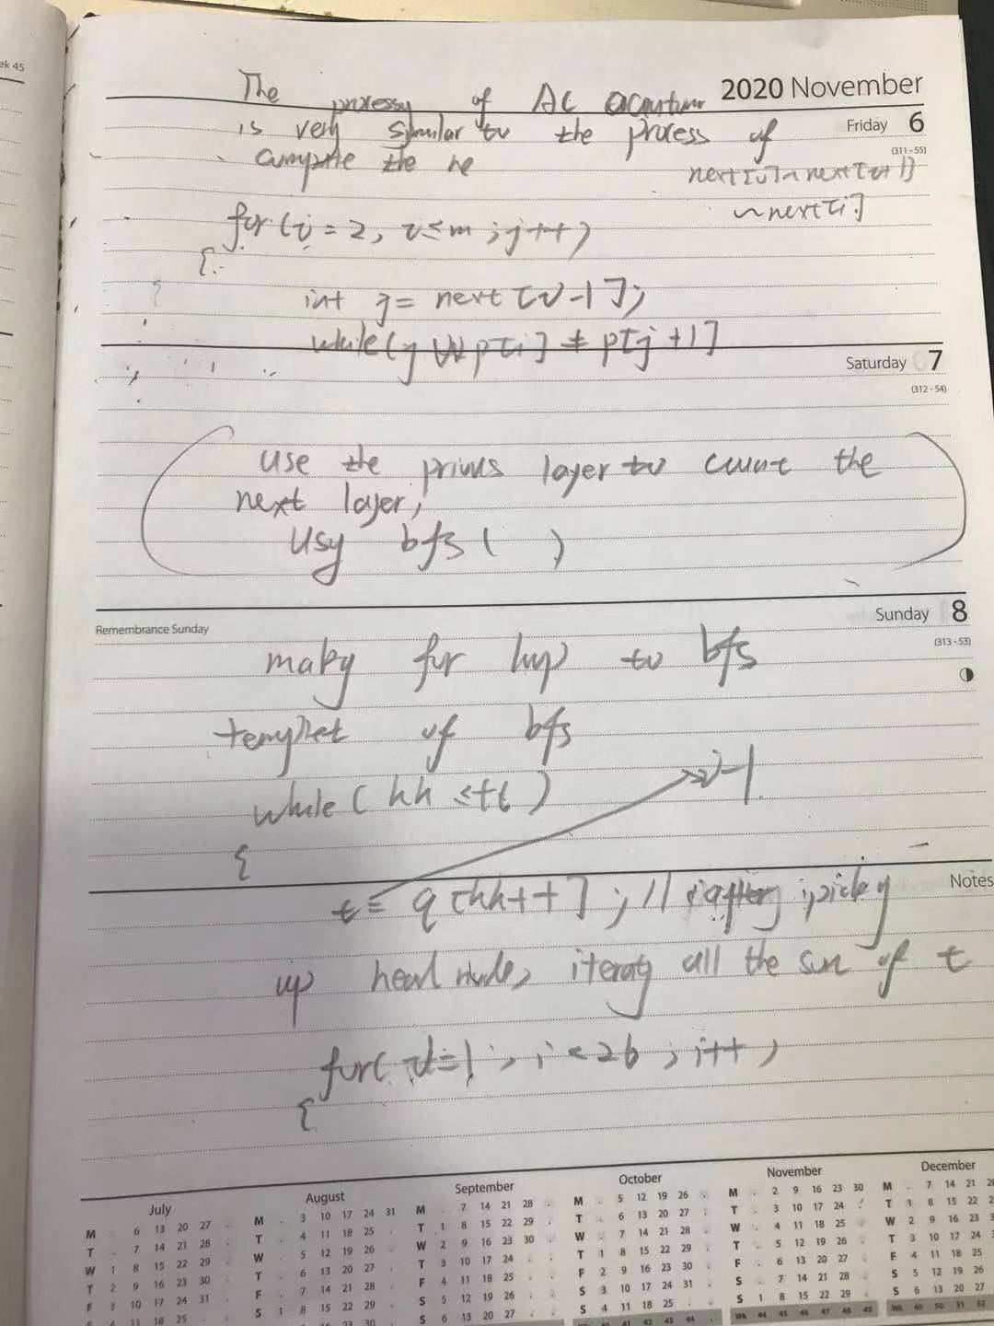
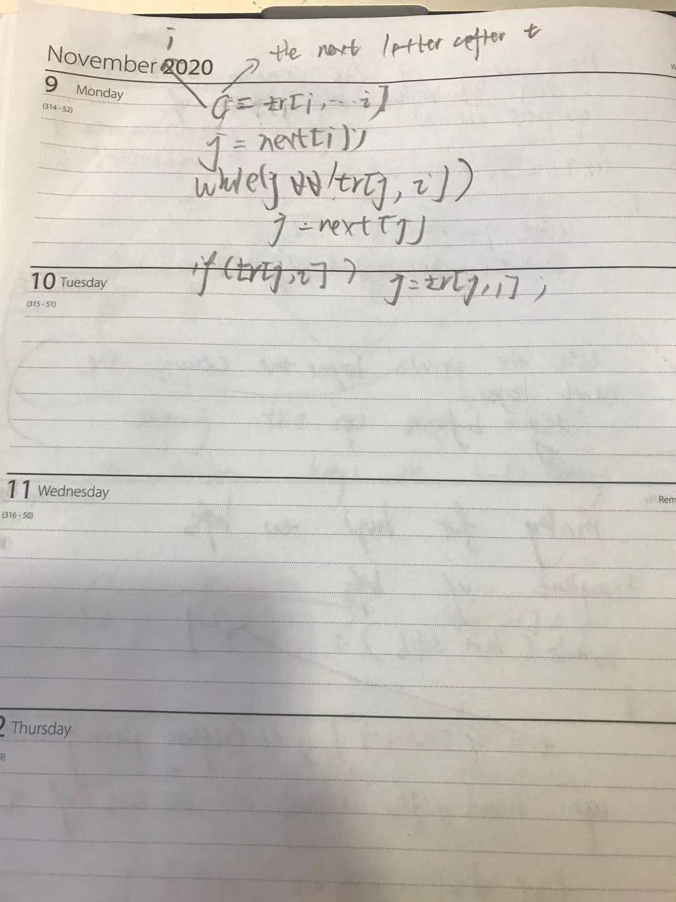
Question:Given n words up to 50 in length, and an article of m length.
Excuse me, how many words appear in the article.
Input format
The first line contains the integer T, which means that there are T sets of test data.
For each set of data, the first line contains an integer n, the next n lines represent n words, and the last line enters a string representing the article.
Output format
For each set of data, output a one-line integer indicating how many words appear in the article.
data range
1≤n≤104,
1≤m≤106
Input example:
1
5
she
he
say
shr
her
yasherhs
Sample output:
3
Code:
#include<cstdio>
#include<cstring>
#include<algorithm>
#include<iostream>
using namespace std;
const int N = 10010,S = 55,M=1000010;
int n;
char str[M];
int tr[N*S][25],cnt[N*S],idx;
int q[N*S],next[N*S];
void insert()
{
int p = 0;
for(int i = 0;str[i];i++)
{
int t = str[i]-'a';
if(!tr[p][t])
tr[p][t]=++idx;
p = tr[p][t];
}
cnt[p]++;
}
void build()//bfs
{
int hh = 0,tt=-1;
for(int i = 0 ;i<26;i++)
if(tr[0][i])
q[++tt] = tr[0][i];
while(hh<=tt)
{
int t = q[hh++];
for(int i = 0;i<26;i++)
{
int c = tr[t][i];
if(!c) continue;
int j = next[t];
while(j&&!tr[j][i]) j = next[j];
if(tr[j][i]) j = tr[j][i];
next[c] =k;
q[++tt]=c;
}
}
}
int main()
{
int T ;
scanf("%d",&T);
while(T--)
{
memset(tr,0,sizeof tr);
memeset(cnt,0,sizeof cnt);
memset(next,0,sizeof next);
idx = 0;
}

scanf("%d",&n);
for(int i = 0;i<n;i++)
{
scanf("%s",str);
insert();
}
build();
scanf("%s",str);
int res = 0;
for(int i = 0,j = 0;str[i];i++)
{
int t = str[i]-'a';
while(j&&!tr[j][t]) j = ne[j];
if(tr[j][t]) j tr[j][t];
/*
j matches the deepest node up to i, plus the position where j matches next [j], traversing to the suffix point with its position
*/
int p = j;
while(p)
{
res += cnt[p];
cnt[p]=0;
p = next[p];
}
printf("%d\n")
}
return res;
}

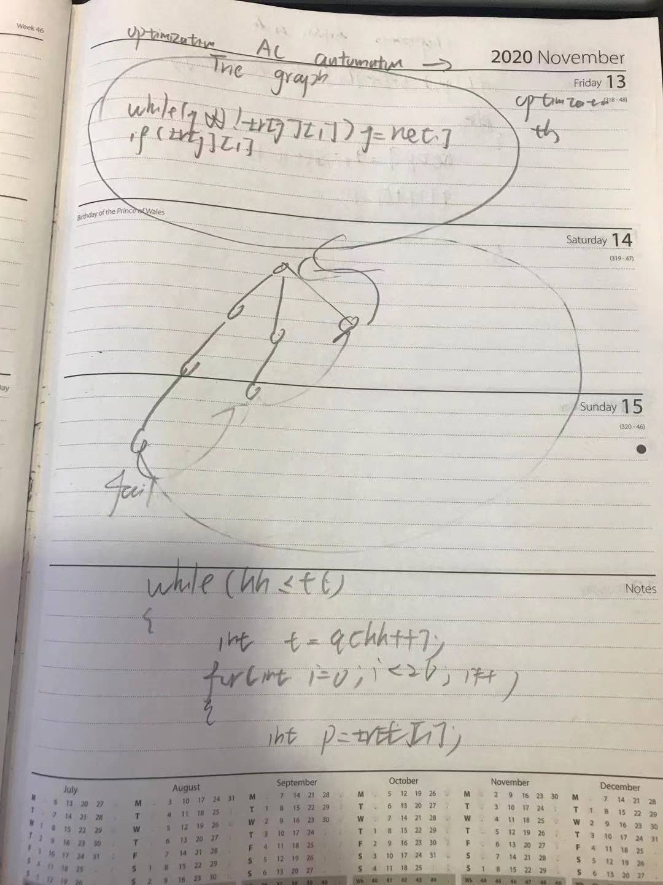
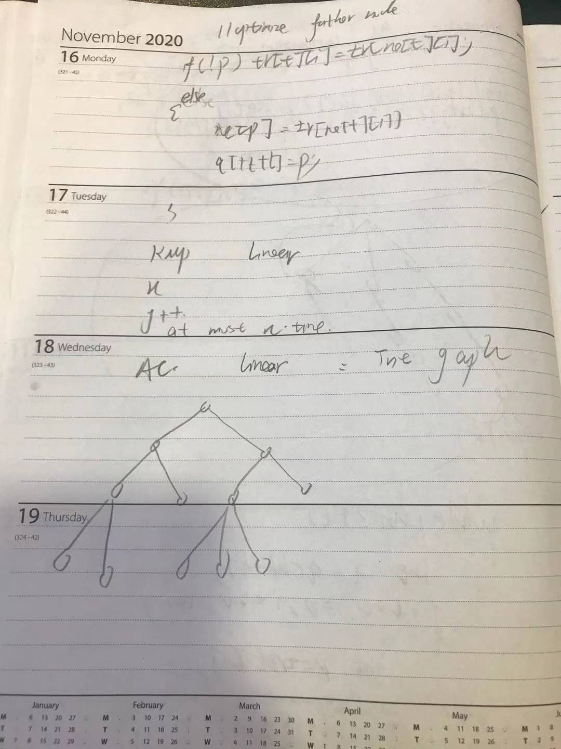
Biologists have finally invented the technology to repair DNA, which can repair DNA fragments containing a variety of genetic diseases.
For simplicity, DNA is considered as a string of ‘A’, ‘G’, ‘C’, and ‘T’.
The repair technique is to eliminate the pathogenic fragments contained in the string by changing some characters in the string.
For example, we can change the two characters to change the DNA fragment "AAGCAG" to "AGGCAC", so that the DNA fragment no longer contains the pathogenic fragments "AAG", "AGC", "CAG" to repair the DNA The purpose of the fragment.
Please note that the repaired DNA fragments still only contain the characters 'A', 'G', 'C', 'T'.
Please help biologists repair a given DNA fragment, and the number of characters changed during the repair process should be as small as possible.
Input format
The input contains multiple sets of test data.
The first line of each set of data contains the integer N, which represents the number of pathogenic DNA fragments.
The next N lines, each line contains a non-empty string of no more than 20 characters, and the string contains only the characters 'A', 'G', 'C', 'T', which are used to represent disease-causing DNA fragments.
Another line contains a non-empty string of no more than 1000 in length. The string contains only the characters 'A', 'G', 'C', 'T', which is used to indicate the DNA fragment to be repaired.
The last set of test data is followed by a line containing a 0, which indicates the end of the input.
Output format
One result is output for each set of data, and each result is on a separate line.
The input is "Case x: y", where x is the test data number (starting from 1), y is the minimum number of characters that need to be changed during the repair process, and if a given DNA fragment cannot be repaired, y is "- 1".
data range
1≤N≤50
Input example:
2
AAA
AAG
AAAG
2
A
TG
TGAATG
4
A
G
C
T
AGT
0
Sample output:
Case 1: 1
Case 2: 4
Case 3: -1

The first i letters of f (i, j), which is currently at the j position of the AC automaton. The least modified number of letters in all schemes.
//Enumerate previous letters from after
for(int i =1;i<=n;i++)
for(j = 0;j<=idx;j++)//Every position of the current AC automaton
for(int k = 0;k<4;k++)//
{
p =
if(dar[p]==0)
if(i+p);
}

triep[] = 1;
Code:
#include<cstdio>
#include<cstring>
#include<iostream>
#include<algorithm>
using namespace std;
const int N = 1010;
int n,m;
int tr[N][4],dar[N],idx;
int q[N],ne[N];
char str[N];
int f[N][N];
void insert()
{
int p = 0;
for(int i = 0 ;str[i];i++)
{
int t = get(str[i]);
if(tr[p][t]==0) tr[p][t] ==++idx;
}
dar[p] =1;// labeling ending is true;
//skip all the labeled node
}
int get(char c)
{
if(c == 'A') return 0;
if(c == 'T') return 1;
if(c == 'G') return 2;
return 3;
}
void build()
{
int hh = 0,tt =-1;
for(int i = 0 ;i<4;i++)
if(tr[0][i])
q[++tt] = tr[0][i];
while(hh<=tt)
{
int t = q[hh++]
for(int i = 0 ;i<4;i++)
{
int p = tr[t][i];
if(!p) tr[t][i] = tr[ne[t][i]];
else
{
ne[p] = tr[ne[t][i]];
q[++tt] = p;
dar[p] = dar[ne[p]];
}
}
}
}

int main()
{
int T = 1;
while(scanf("%d",&n),n)
{
memset(tr,0,sizeof tr);
memset(dar,0,sizeof dar);
memset(ne,0,sizeof ne);
idx = 0;
for(int i =0;i<n;i++)
{
scanf("%s",str);
insert();
}
}
build();
scanf("%s",str+1);
m = strlen(s+1);
memset(f,0x3f,sizeof f);
for(int i = 0 ;i<m;i++)
for(int j = 0;j<=idx;j++)
for(int k = 0;i<4;i++)
{
int t = get(str[i+1])!=k;
int p = tr[j][k];
if(!dar[p])
{
f[i+1][p] = min(f[i+1][p],f[i][j]++t);
}
}
int res = 0x3f3f3f3f;
for(int i = 0;i<=idx;i++)
res = min(res,f[m][i]);
if(res == 0x3f3f3f) res= -1;
printf("%d\n",res);
}

