OutLine
Basic trick:
Discretization：(when the range of input is 10^9,but the the range of the output is only 10^5
Maintaining its original order:
vector<int> alls; // store all the value that are ready to decreaitazation
sort(alls.begin(), alls.end()); // sort
alls.erase(unique(alls.begin(), alls.end()), alls.end()); // delte the duplicate element

// using binary search to the value x that are already dicreatation
int find(int x) // finding the first value that are greater or equal(>=) to x
{
int l = 0, r = alls.size() - 1;
while (l < r)
{
int mid = l + r >> 1;
if (alls[mid] >= x) r = mid;
else l = mid + 1;
}
return r + 1; // mapping into 1,2,3,......
}

Not remaining its order (there are two ways to implement 1 map 2 hash
I like use map to implement since stl has unorder_map library
#include<unorderdered_map>
Unorder_map<int,int>S;
int get(int x)
{
If(S.count(x) ==0) S[x]+=n;
Return S[n];
}

The sum of prefix
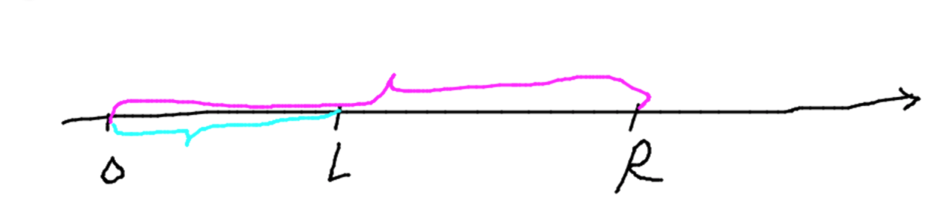
S[i] = a[1] + a[2] + ... a[i]
a[l] + ... + a[r] = S[r] - S[l - 1]
Difference:
Adding a number in the range of [L,R] o(1)
B[l] += c, B[r + 1] -= c

Lowbit(X)= x&-x:finding the last 1 in the binary
Eg x = 6 = 00000110(2) -x = x(2-complement) =11111010(2)
Therefore lowbit(x) = x&-x =10(2) = 2;
Int lowbit(int x)
{
Return x&-x;
}
We would use this function in binary index tree
Binary search
bool check(int x):this function to check x belonging to specfic features
while(l<r)
//the minumum element in >= x
{
int mid=(l+r)>>1;
if(a[mid]>=x) r=mid;
else l=mid+1;
}
------------------------
while(l<r)
//the max element in <= x
{
int mid=(l+r+1)>>1;
if(a[mid]<=x) l=mid;
else r=mid-1;
}
------------------------
while(l<r)
{
int mid=(l+r)>>1;
if(check(mid)) r=mid;
else l=mid+1;
//else......
}

Graph theory:
The storage of graph:
Using adjacency matrix
The first index representing the node i ,the second index representing node j
For undirected graph graph[i][j = graph[i][j]
For directed graph graph[i][j] !=graph[j][i]

The weight graph[i][j] representing the edge from the node i to j,eg graph[1][2] =3 ,using INF (we could set 0x3f3f3f3 or using #include<climit> INT_MAX to represent infinitely)
Advantage:easy
Disadvantage:O(V^2) is to large to storage ,if we use it to store sparse graph,a lot of space would be wasted .Beside it could not store the mutiple edges between two node .
But there is one algorithm it must be use adjacency matrix to implement.That is Floyd
Another method to use normal array to simulate linklist
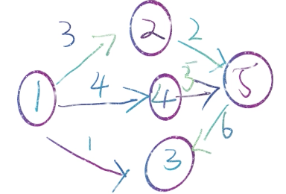
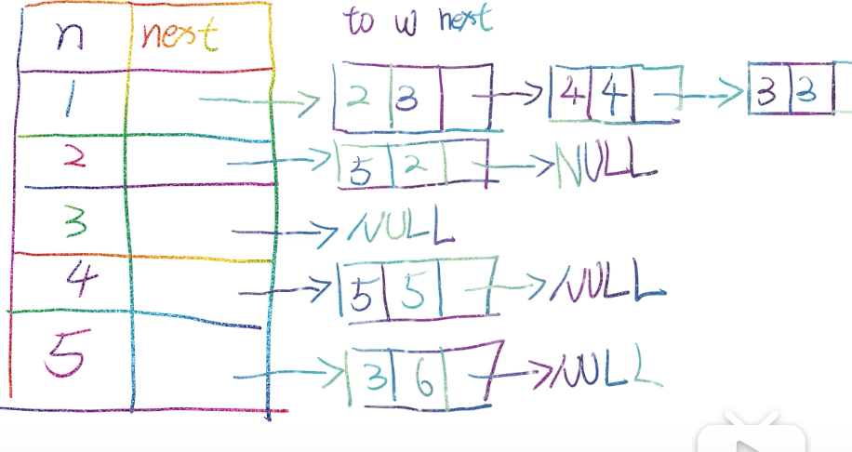
// 对于每个点k，开一个单链表，存储k所有可以走到的点。h[k]存储这个单链表的头结点
// for each node k,opening a single linklist and storaging the node that k could reach.h[k] is use for storage the head node of this linklist
int h[N], e[N], ne[N], idx;
// e[] representing edge array ,ne[] is representing next pointer,idx is for counting number for node
// adding an edge from a to b
void add(int a, int b)
{
e[idx] = b, ne[idx] = h[a], h[a] = idx ++ ;
}
if it has weight

void add(int a,int b,int c)
int h[N], e[N], ne[N], idx,w[N];
// w[] is for weight or value of each edge
void add(int a,int b,int c)
{
e[idx]= b,w[idx]=c,nex[idx]= h[a],h[a] =idx++;
}
// initalization
idx = 0;
memset(h, -1, sizeof h);

Iteration from node i
for(int i = h[start];~i;i = ne[i]) // ~i is also written as i !=-1 since i initaliza all the node is -1
{
Int j = e[i];
}
Short path:

Dijkstra
Naive version and the version of using heap(in stl priority_queue
Single-source shortest path algorithm (non-negative weighted edge)
Naive Dijkstra Algorithm
dijkstra is based on the greedy algorithm. If there is a negative weight edge, it will cause the greedy algorithm to be incorrect. For example:

a-> b = 50, a-> c = 60, c-> b = -100, then the shortest path of a-> b should be a-c-b, but the greedy algorithm will determine it in the first step The shortest path to b is 50.

The core of this algorithm is to divide all points into two parts, one is the point with the shortest distance to the source point has been determined, and the other is not yet determined. Every time we find a point that is closest to the source point among all the points that have not yet determined the shortest distance, this point is the new determined point, and then we use this latest point to update the shortest distance of the remaining points that have not been determined. The shortest distance up to all points has been determined.

We use the visit array(visit[]) to mark whether each point has been determined, and the dist array (dist[])to mark the shortest distance from each point to the source point.

Time complexity: O (n^2) , space complexity o (n^2)

Question:
Given a directed graph with n points and m edges, there may be multiple edges and self-loops in the graph, and all edge weights are positive values.

Please find the shortest distance from point 1 to point n. If you cannot walk from point 1 to point n, then output -1.

Input format
The first line contains integers n and m.

Each of the next m lines contains three integers x, y, and z, which indicates that there is a directed edge from point x to point y, and the side length is z.

Output format
Output an integer representing the shortest distance from point 1 to point n.

If the path does not exist, -1 is output.

data range
1≤n≤500,
1≤m≤105,
The length of each side involved in the figure does not exceed 10,000.
Input sample:
3 3
1 2 2
2 3 1
1 3 4
Output sample:
3
Code:
#include<stdio.h>
#include<cstring>
#include<iostream>

using namespace std;

const int N = 510;
int graph[N][N],dist[N];
bool visit[N];
int n,m,from,to,weight;
int main()
{
scanf("%d %d",&n,&m);
memset(graph,0x3f,sizeof(graph));
memset(dist,0x3f,sizeof(dist));
for(int i = 1 ; i <= n ; i ++)
graph[i][i] = 0;
for(int i = 0 ; i < m ; i ++)
{
scanf("%d %d %d",&from,&to,&weight);
graph[from][to] = min(graph[from][to],weight);
}
dist[1] = 0;
for(int i = 0 ; i < n ; i ++)
{
int t = -1;
for(int j = 1 ; j <= n ; j ++)
{
if(visit[j] == true) continue;
if(t == -1 || dist[j] < dist[t])
t = j;
}
visit[t] = true;
for(int j = 1 ; j <= n ; j ++)
dist[j] = min(dist[j],dist[t] + graph[t][j]);
}
if(dist[n] == 0x3f3f3f3f) printf("-1");
else printf("%d",dist[n]);
return 0;
}
Naive dijstra is mainly for dense graph The time complex is O(n*m) n is node m is edge

Heap-optimized dijkstra algorithm The time complex is O(mlogn)
First of all, we found in the naive dijkstra algorithm that every time we have to traverse n vertices to find the next current minimum, we naturally think of using a small top heap to optimize the search for the current minimum.
First we use chained forward stars to store sparse graphs: The main principle of chained forward stars (the method i have mentioned before using array to simulate the single linklist) is to use a static array to simulate a linked list that stores all edges starting with each point.
The array includes the linked list head node array h [N], which is initially -1, indicating that there are no nodes currently.
Edge weight array w [N], which stores the weight of the ith edge
End point array e [N], which stores the end point of the ith edge
Linked list array ne [N], stores the sequence number of the next edge among all edges with the same starting point as the i-th edge
idx, which indicates how many edges have been stored, and also represents the serial number of the next edge read
Here we need to pay extra attention: the h array is about the nodes open to N, but the w, e, ne arrays are stored edges and need to be opened to M, and if it is a bidirectional graph, it needs to be opened to 2 * m.
adding an edage from a to b,the weight
void add(int a,int b,int weight)
{
e [idx] = b; // the end point of the idx edge b
w [idx] = weight; // The weight of the idx edge is weight
ne [idx] = h [a]; // h [a] is the sequence number of the last edge read from a, and we point the idx edge to this edge
h [a] = idx ++; // Update the sequence number of the last edge read by h [a].
}
Iterate over all edges starting from ver vertex:
for (int i = h [ver]; i! = -1; i = ne [i])
{
// i represents the number of the current edge, w [i] represents the weight of the current edge, and e [i] represents the end of the current edge.
}

We first initialize the array of head nodes, the distance array, the label array, and the edge numbers, and then we read in all the edges. We use a priority queue for pair <int, int> to maintain the current feasible distance to all points. The two keywords represent the current shortest distance from point 1 to point i, respectively. Initially we put {0,1} into the priority queue and initialize dist [1] = 0, which means that the shortest path from node 1 to node 1 is 0.

Then we pop the queue head element in turn. If the shortest distance to the current node has been confirmed, then we skip directly. Otherwise we mark the current node ver as true, which means that the shortest distance of the current node is confirmed at this moment. We next traverse the end point j of all edges starting from node ver and try to update its shortest path through ver. If the shortest path to vertex j is greater than the shortest path through vertex ver, then we update the shortest path to the shortest The path is added to the queue.

#include<stdio.h>
#include<cstring>
#include<iostream>
#include<limits.h>
#include<queue>
using namespace std;
typedef pair<int,int> PII;
const int N = 100010;
int h[N],w[N],e[N],ne[N],idx = 0;
int dist[N];
bool visit[N];
void add(int a,int b,int weight)
{
e[idx] = b;
w[idx] = weight;
ne[idx] = h[a];
h[a] = idx ++;
}
int main(){
int n,m,first,second,weight;
scanf("%d %d",&n,&m);
memset(dist,0x3f,sizeof(dist));
memset(h,-1,sizeof(h));
for(int i = 0 ; i < m ; i ++)
{
scanf("%d %d %d",&first,&second,&weight);
add(first,second,weight);
}
priority_queue<PII,vector<PII>,greater<PII>> heap;
heap.push({0,1});
dist[1] = 0;
while(!heap.empty())
{
auto t = heap.top();
heap.pop();
int ver = t.second,distance = t.first;
if(visit[ver]) continue;
visit[ver] = true;
for(int i = h[ver] ; i != -1 ; i = ne[i])
{
int j = e[i];
//the end point of i-th is j
if(dist[j] > distance + w[i])
{
dist[j] = distance + w[i];
heap.push({dist[j],j});
}
}
}
int res = (dist[n] == 0x3f3f3f3f ? -1 : dist[n]);
printf("%d",res);
return 0;
}
Single-source shortest path (with negative weighted edges)

Why doesn't Dijkstra's algorithm work for negative weight edges?

https://stackoverflow.com/questions/13159337/why-doesnt-dijkstras-algorithm-work-for-negative-weight-edges
Bellman-Ford algorithm
We know that the dijsktra algorithm has no way to deal with negatively weighted edges, and naturally propose a shortest path algorithm that can judge negatively weighted edges. We need to know the fact that in a graph of n vertices, the shortest path between any two points passes through at most n-1 edges. Then we can use the idea of ​​dynamic programming to solve the shortest path problem, and the shortest path problem through a maximum of k vertices to determine the negative loop problem.
The Bellman-Ford algorithm is essentially a dynamic programming optimization using a rolling array. After the i-th iteration, dist [to] represents the shortest distance to reach the point through the i edges at most.

We first read in all the edges. Here we use the Edges array to store all the edges, the dist array to store the shortest, and the backup array as the backup rolling array. In the i-th iteration, we all need to traverse all edges (from, to), and we judge that the distance we can reach the node to is reduced by this edge. That is, the state transition is:
dist [to] = min (dist [to], backup [from] + weight)
dist [to] = min (dist [to], backup [from] + weight)

Where backup [from] represents the shortest distance to i from only passing through i-1 edges.

After the traversal is completed, we need to determine whether point 1 and point n are connected. At this time, we cannot directly determine whether it is equal to 0x3f3f3f3f. This is because if another point p and point 1 are not connected, but it is connected with point n. And dist [p] [n] <0, then when updating, dist [n] will be changed to a value slightly smaller than 0x3f3f3f3f.

In addition, if there is no maximum number of edges, we can avoid using the backup array.

In addition, we can perform n iterations. If the nth iteration, the shortest path of some edges is modified, indicating that a negative ring exists at this time.
Time complexity analysis O (n ∗ m)
Question:
Given a directed graph with n points and m edges, the graph may have multiple edges and self-loops, and the edge weights may be negative.

Please find the shortest distance from point 1 to point n with at most k edges. If you cannot walk from point 1 to point n, the output is impossible.

Note: There may be negative weight loops in the figure.

Input format
The first line contains three integers n, m, k.

The next m lines, each containing three integers x, y, and z, indicate that there is a directed edge from point x to point y, with an edge length of z.

Output format
Output an integer indicating the shortest distance from point 1 to point n with at most k edges.

If there is no path that meets the conditions, "impossible" is output.

data range
1≤n, k≤500,
1≤m≤10000,
The absolute value of any side length does not exceed 10000.
input sample：
3 3 1
1 2 1
2 3 1
1 3 3
output sample：
3
Code :
#include<stdio.h>
#include<iostream>
#include<cstring>

using namespace std;

const int N = 510,M = 10010;
struct edge{
int from,to,weight;
edge(){}
edge(int from,int to,int weight):from(from),to(to),weight(weight){}
}Edges[M];
int dist[N],backup[N];
int main()
{
int n,m,k,from,to,weight;
scanf("%d %d %d",&n,&m,&k);
memset(dist,0x3f,sizeof(dist));
dist[1] = 0;
for(int i = 0 ; i < m ; i ++)
{
scanf("%d %d %d",&from,&to,&weight);
Edges[i] = edge(from,to,weight);
}
for(int i = 0 ; i < k ; i ++)
{
memcpy(backup,dist,sizeof(dist));
for(int j = 0 ; j < m ; j ++)
{
from = Edges[j].from,to = Edges[j].to,weight = Edges[j].weight;
dist[to] = min(dist[to],backup[from] + weight);
}
}
if(dist[n] > 0x3f3f3f3f / 2) printf("impossible");
else printf("%d",dist[n]);
return 0;
}

Shortest path faster algorithm(SPFA)
SPFA (Shortest Path Fast Algorithm)
SPFA is actually an optimized version of the Bellman-Ford algorithm, but it should be pointed out that although its average time complexity is O (m), its worst time complexity is O (nm) .
The idea of ​​SPFA is as follows:

Use a queue to hold the nodes to be optimized. We use the state array(state[]) to mark whether node i is in the queue. Initially, only source point 1 is in the queue.
Take a head node p in the queue each time, and traverse all edges e starting from point p and the corresponding end point j. If the path through point p to point j can be made shorter, then we update dist [j] At the same time, if node j is not in the queue and j is added to the queue, this is because if the shortest path to j is updated, then the path to other nodes after j point is likely to be updated as well.
Repeat until the queue is empty.
If we want to determine whether there is a negative ring in the graph, we can use an array of counts to represent the number of points that have passed in the shortest path from the source point to a point. If the number of points is greater than n, then there is a negative ring.

Question:
iven a directed graph with n points and m edges, the graph may have multiple edges and self-loops, and the edge weights may be negative.

Please find the shortest distance from point 1 to point n. If you cannot walk from point 1 to point n, the output is impossible.

The data guarantees that there is no negative weight loop.

Input format
The first line contains integers n and m.

Each of the next m lines contains three integers x, y, and z, which indicates that there is a directed edge from point x to point y, and the side length is z.

Output format
Output an integer representing the shortest distance from point 1 to point n.

If the path does not exist, "impossible" is output.

data range
1≤n, m≤105,
The absolute value of the involved side lengths in the figure does not exceed 10,000.
sampe input ：
3 3
1 2 5
2 3 -3
1 3 4
sample output:
2
Code:
#include<stdio.h>
#include<iostream>
#include<cstring>
#include<queue>
using namespace std;

const int N = 100010;
int h[N],w[N],e[N],ne[N],idx = 0;
int dist[N];
bool state[N];
void add(int from,int to,int weight)
{
w[idx] = weight;
e[idx] = to;
ne[idx] = h[from];
h[from] = idx ++;
}
int main()
{
int n,m,from,to,weight;
scanf("%d %d",&n,&m);
memset(h,-1,sizeof(h));
memset(dist,0x3f,sizeof(dist));
for(int i = 0 ; i < m; i ++)
{
scanf("%d %d %d",&from,&to,&weight);
add(from,to,weight);
}
queue<int> q;
q.push(1);
dist[1] = 0;
state[1] = true;
while(!q.empty())
{
int p = q.front();
q.pop();
state[p] = false;

for(int i = h[p] ; i != -1 ; i = ne[i])
{
int j = e[i];
if(dist[j] > dist[p] + w[i])
{
dist[j] = dist[p] + w[i];
if(state[j] == false)
{
q.push(j);
state[j] = true;
}
}
}
}
if(dist[n] == 0x3f3f3f3f) printf("impossible");
else printf("%d",dist[n]);
return 0;
SPFA find negative ring
When solving the negative loop, we use the cnt array to mark the minimum number of points that must pass through the shortest path from the source point to the point i. If it exceeds n-1, then there is a negative loop. On the other hand, at this time, we can't just put the source point in the queue, but we should put all the points in the queue, in order to prevent the negative ring and the source point from being in a connected block.
#include<stdio.h>
#include<iostream>
#include<cstring>
#include<queue>
using namespace std;

const int N = 100010;
int h[N],w[N],e[N],ne[N],idx = 0;
int n,m,from,to,weight;
int dist[N],cnt[N];
bool state[N];
void add(int from,int to,int weight)
{
w[idx] = weight;
e[idx] = to;
ne[idx] = h[from];
h[from] = idx ++;
}
bool spfa()
{
queue<int> q;
dist[1] = 0;
for(int i = 1 ; i <= n ; i ++)
{
q.push(i);
state[i] = true;
}
while(!q.empty())
{
int p = q.front();
q.pop();
state[p] = false;

for(int i = h[p] ; i != -1 ; i = ne[i])
{
int j = e[i];
if(dist[j] > dist[p] + w[i])
{
cnt[j] = cnt[p] + 1;
if(cnt[j] >= n) return true;
dist[j] = dist[p] + w[i];
if(state[j] == false)
{
q.push(j);
state[j] = true;
}
}
}
}
return false;
}
int main()
{
scanf("%d %d",&n,&m);
memset(h,-1,sizeof(h));
memset(dist,0x3f,sizeof(dist));
for(int i = 0 ; i < m; i ++)
{
scanf("%d %d %d",&from,&to,&weight);
add(from,to,weight);
}
if(spfa()) printf("Yes");
else printf("No");
return 0;
}
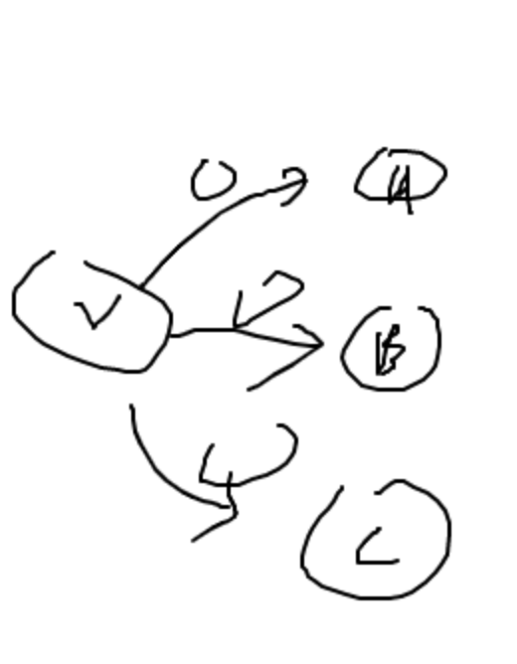
if it has multiple source node and sink node ,we could imagine and add a super source node or super sink node .The super node connected to the start node in the question is 0
Int n = n+1;if adding a super node
Add(0,ver,0);

Floy-Barshell
Multi-source shortest path algorithm
Floyd algorithm
Floyd's algorithm can handle negative weighted edges, but it cannot handle cases with negative loops.

The time complexity is O (n3) O (n3), and the space complexity is O (n2) O (n2).

The Floyd algorithm also uses the idea of dynamic programming. After the k-th iteration, dist [i] [j] represents the shortest distance between the vertices i and j after passing only the first k points as a transit.

Question:

Given a directed graph with n points and m edges, the graph may have multiple edges and self-loops, and the edge weights may be negative.
Given k queries, each query contains two integers x and y, which indicates the shortest distance from the point x to the point y. If the path does not exist, it outputs "impossible".
The data guarantees that there are no negative weight loops in the graph.

Input format
The first line contains three integers n, m, k
The next m lines, each containing three integers x, y, and z, indicate that there is a directed edge from point x to point y, with an edge length of z.
The next k lines, each line contains two integers x, y, indicating the shortest distance from the query point x to the point y.
Output format
There are k lines, and each line outputs an integer indicating the result of the query. If there is no path between the two points, the output is "impossible".

data range
1≤n≤200,
1≤k≤n2
1≤m≤20000,
The absolute value of the involved side lengths in the figure does not exceed 10,000.

Input example:
3 3 2
1 2 1
2 3 2
1 3 1
2 1
1 3
Sample output:
impossible
1

Code:
#include<stdio.h>
#include<cstring>
#include<iostream>
using namespace std;
const int N = 210;
int dist[N][N];
int main()
{
int n,m,k,from,to,weight;
scanf("%d %d %d",&n,&m,&k);
memset(dist,0x3f,sizeof(dist));
for(int i = 1 ; i <= n ; i ++)
dist[i][i] = 0;
for(int i = 0 ; i < m ; i ++)
{
scanf("%d %d %d",&from,&to,&weight);
dist[from][to] = min(weight,dist[from][to]);
}
for(int k = 1 ; k <= n ; k ++)
for(int i = 1 ; i <= n ; i ++)
for(int j = 1 ; j <= n ; j ++)
dist[i][j] = min(dist[i][j],dist[i][k] + dist[k][j]);
for(int i = 0 ; i < k ; i ++)
{
scanf("%d %d",&from,&to);
if(dist[from][to] > 0x3f3f3f3f / 2) printf("impossible\n");
else printf("%d\n",dist[from][to]);
}
return 0;
}

Layer graph:

Applicable scene:
For some graph topics, such as shortest path, network flow, etc., the topic provides optional operations on the edge weights. For example, you can halve a certain number of edge weights to solve the optimal solution on this basis.

Algorithm idea:
Depending on whether to perform the operation provided by the question and the number of operations, there will be a lot of situations. If you consider when to use the operation, the situation is even more. If the solution of the shortest path on the graph is regarded as being performed on a two-dimensional plane, and the number of operations k is introduced as the third dimension, then this three-dimensional space should be able to contain all cases and can be solved in this three-dimensional space. problem.

Each time an operation (k + 1) is performed, there is no change in the other edges except the operating edge. The graph is the same at k = 0,1,2, ..., then the graph is copied into k + 1 copies. The i-th level graph represents the graph after i operations.

Each connection between two adjacent layers of the graph should determine on which edge (and when) the operation occurs. According to the characteristics of the operation (the modification of the edge weights), an operation can be expressed from the edge of the i-layer point to the i + 1-layer point.

Example: Weighted edge <u, v> = w, Optional: Modify weight to 0

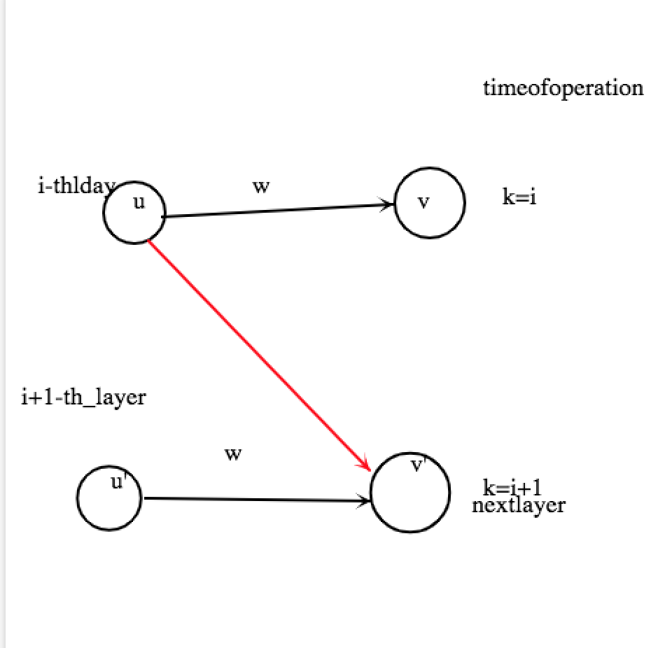
Because the edges connecting the two layers represent an irreversible edge weight operation, they are all directed edges
The edges inside each layer of the graph are the same as the original
Simple explanation
Some people may have questions. After copying the graph to the K layer, space and time will not explode?
Although the layered graph has a total of K + 1 layers
But because each layer is just a simple copy of the original image
So the content is the same, there is generally no need to create a new map
We just need to represent the point number and the number of layers in a two-dimensional array
For example, when finding the shortest path, use dis [x] [k] to represent the shortest distance of the x points in the layer k in the layer graph
That is, the shortest distance of x points where k edge operations have been performed in the original image This eliminates the need for new maps
Question:
There are N cities in the country, and M directional roads from u to v(1≤u,v≤n). Every road has a distance ci​. Haze is a Magical Girl that lives in City 1, she can choose no more than K roads and make their distances become 0. Now she wants to go to City N, please help her calculate the minimum distance.

Input
The first line has one integer T(1≤T≤5), then following T cases.

For each test case, the first line has three integers N,M and K.

Then the following M lines each line has three integers, describe a road, Ui​,Vi​,Ci​. There might be multiple edges between u and v.

It is guaranteed that N≤100000,M≤200000,K≤10,
0 ≤Ci​≤1e9. There is at least one path between City 1 and City N.

Output
For each test case, print the minimum distance.
sample input
1
5 6 1
1 2 2
1 3 4
2 4 3
3 4 1
3 5 6
4 5 2
sample output
3

The main idea of the question: there are N cities, M directed edges, and there may be multiple edges between cities. You can choose to make the length of at most K edges to 0. In the best case, ask from city 1 to city N. What is the shortest path

Solution: Dijkstra algorithm + layered graph idea, see the code to understand the layered graph idea

Code:

#include<iostream>
#include<vector>
#include<queue>
#include<cstring>

using namespace std;

typedef long long ll;

const int INF=0x3f3f3f3f;
const int N=100003;

struct Edge{//边
int v,w;//起点到终点v的花费为w
Edge(int v,int w):v(v),w(w){}
};

struct Node{
int u;
int w;
Node(){}
Node(int u,int w):u(u),w(w){}
bool operator<(const Node &a)const//Use priority queue, so < reoperatre is greater than meaning
{
return w>a.w;
}
};

vector<Edge>g[N];
ll dist[N][11];//dist [i] [j] represents the shortest path from source point to node i with j edges being 0
bool vis[N][11];

void dijkstra(int s,int n,int k)//The source point is s, there are n nodes in total. You can choose k edges to be 0.
{
priority_queue<Node>q;
memset(vis,false,sizeof(vis));
memset(dist,INF,sizeof(dist));
dist[s][0]=0;
q.push(Node(s,0));
while(!q.empty()){
Node e=q.top();
q.pop();

int z=e.u/(n+1);//z mean that the length of z edges is 0
int u=e.u%(n+1);//u represent current node number

if(!vis[u][z]){//如果还未用dist[u][z]更新其他状态就进行更新
vis[u][z]=true;
int num=g[u].size();//There are num points connected to u
for(int i=0;i<num;i++){
int v=g[u][i].v;//v is the point connected to u
if(vis[v][z])//Skip if dist [u] [z] has already been obtained
continue;
int c=g[u][i].w;//c is the distance from node u to node v
//option1 : not let this edge is zero
if(dist[v][z]>dist[u][z]+c){
dist[v][z]=dist[u][z]+c;
/*The first parameter z * (n + 1) + v is to make z obtainable by e.u / (n + 1), u can be
Get by e.u% (n + 1) */
q.push(Node(z*(n+1)+v,dist[v][z]));
}
if(z==k)//If k edges have been made 0, skip
continue;
//Choice 2: Let this edge be 0, then dist [v] [z] becomes dist [v] [z + 1] because one more edge becomes 0
if(dist[v][z+1]>dist[u][z]){
dist[v][z+1]=dist[u][z];
q.push(Node((z+1)*(n+1)+v,dist[v][z+1]));
}
}
}
}
}

int main()
{
int t,n,m,a,b,k,c;
scanf("%d",&t);
while(t--){
scanf("%d%d%d",&n,&m,&k);
for(int i=0;i<=n;i++)
g[i].clear();
while(m--){
scanf("%d%d%d",&a,&b,&c);
g[a].push_back(Edge(b,c));
}
dijkstra(1,n,k);
printf("%lld\n",dist[n][k]);
}
return 0;
}

The connection between dynamic programing and graph theory :
f(i,j) = max(f(i-1,j),f(i-1,j-vi)+wi)
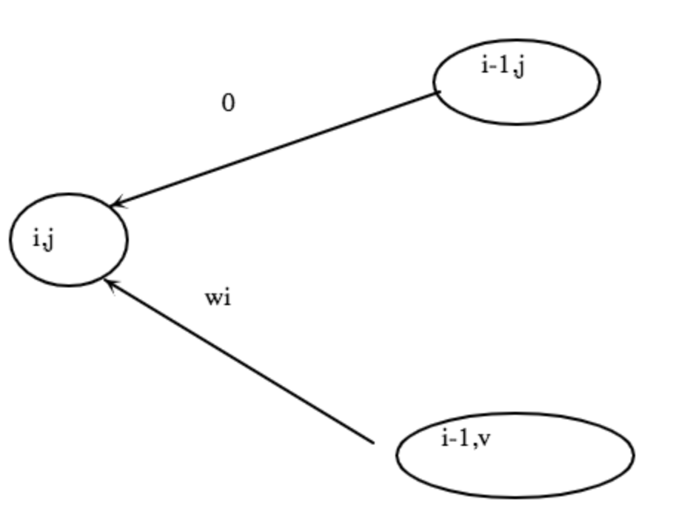
Dynamic programming is the based on the topology of graph to compute the shortest path
Bellman-ford algorithm is based on dynamic programming
The state indicates that all the paths in the set starting from i and finally reaching j, and only passing through all paths with node numbers not exceeding k
Attribute: The youngest child of the path
State calculation d [k, i, j]

Minimum spinning tree:
Prim
Kruskal
Prim's algorithm is to choose an arbitrary point, and then select the shortest point of the connected block to join the set
Kruskal algorithm is similar to set hebing
In simple terms, prim is a dot expansion, similar to the base expansion in the game.
kruakal is similar to tribal merger so use and check

Question:
Farmer John was elected mayor of their town!
One of his campaign promises was to build the internet in the town and connect it to all the farms.
John has arranged a high-speed network line for his farm, and he wants to share this line with other farms.
John's farm is numbered 1 and other farms are numbered 2∼n.
To minimize costs, he wanted the total length of fiber used to connect all the farms be as short as possible.
You will get a list of connection distances between farms. You have to find a solution that connects all farms and minimizes the fiber used.
Input format
The first line contains an integer n, which represents the number of farms.
For the next n rows, each containing n integers, enter a symmetric matrix with all zeros on the diagonal.
The integer in row x + 1 and column y represents the fiber length required to connect farm x to farm y.
Output format
Output an integer indicating the minimum fiber length required.
data range
3≤n≤100
The distance between each two farms is a non-negative integer and does not exceed 100,000.
Input example:
4
0 4 9 21
4 0 8 17
9 8 0 16
21 17 16 0
output sample：
28

Code :#include<cstring>
#include<iostream>
#include<algorithm>
using namespace std;
const int N = 110;
int n;
int w[N][N];
int dist[N];
bool st[N];
int main()
{
cin>>n;
for（int i = 1;i<=n;i++)
for(int j = 1;j<=n;j++)
cin>>w[i][j];
cout<<prim()<<endl;
return 0;
}
int prim()
{
int res = 0;
memeset(dist,0x3f3f3f,sizeof dist);
dist[1] = 0;
for(int i = 0;i<n;i++)
{
int t= -1;
for(int j= 1;j<=n;j++)
{
if(!st[j]&&(t==-1))
t=j;not connected ,so conneted
}
res+= dist[t];
st[t] = true;
for(int j = 1;j<=n;j++) //update
dist[j] = min(dist[j],w[i][j]);
}
return res;
}
Kruskal algorithm is to use union find
Krukal suànfǎ 1 xiān jiāng suǒyǒu biān cóngxiǎo dào dà páixù 2 cóngxiǎo dào dà sǎo àomiào suǒyǒu biàn, yīcì jiāng méiyǒu hébìng de diǎn hé bīn
您是不是要找： kruskal算法 1先将所有边从小到大排序 2 从小到大扫奥妙所有变,依次将没有合并的点河滨
48/5000
Krukal algorithm
1 first sort all edges from small to large
2 All changes from small to large sweeping mystery, in turn will be the point of no merger

Question:
There are n computers and k two-way network cables in a local area network. The numbers of the computers are 1∼n. Due to the negligence of the staff when setting up the local area network, the connections within the local area network now form a loop. We know that if the local area network forms a loop, data will be continuously transmitted in the loop, causing a network block phenomenon.

note:

For a certain connection, although it is bidirectional, we do not consider it as a loop. The circuit described in this question must contain at least two different connections.
There can be at most one connection between two computers.
There is no connection, and it is connected to the same computer at both ends.
Because the network cables connected to the computer are different, some of the connections are not very smooth. We use f (i, j) to indicate the smoothness of the connection between i and j. The smaller the value of f (i, j) is The smoother the connection is, f (i, j) is 0, which means there is no network cable connection between i and j.

Now we need to solve the loop problem, we will remove some connections so that there are no loops in the network and the connectivity is not affected (that is, if some two points were connected before, they must also be connected after completion), and the network cable was removed Σf (i, j) is the largest, and this maximum is requested.

Input format
The first line is two positive integers n, k.

The next k lines of three positive integers i, j, m each indicate that i, j has a network cable connection between the two computers, and the patency is m.

Output format
A positive integer representing the maximum value of Σf (i, j) with the network cable removed.

data range
1≤n≤100
0≤k≤200
0≤f (i, j) ≤1000
input sample
5 5
1 2 8
1 3 1
1 5 3
2 4 5
3 4 2
output sample：
8
Solution:k changes in n points Undirected edge
f (i, j) is unblocked, 0 is connected
In each connected block of this graph, find a spanning tree. Remove the largest edge weight in the connected block, leaving the latest
Code:
#include<cstring>
#include<iostream>
#include<algorithm>
using namespace std;
const int N = 110,M = 220;
int n,m;
struct Edge
{
int a,b,w;
bool operator<(const Edge &t)const
{
return t<t.w;
}
}e[M];
int p[N]; array for union-find
int find(int x)
{
/*
function for union find and for path compression

*/
if(p[x]!=x) p[x] = find(p[x]);
return p[x];
}
int main()
{
cin>>n>>m;
for(int i = 1;i<=n;i++)
cin>>p[i];//initialize the union find
for(int i = 0;i<m;i++)
{
int a,b,w;
cin>>a>>b>>w;
e[i] = {a,b,w};
}
sort(e,e+m);
int res =0;
for(int i = 0;i<m;i++)
{
int a = find(e[i].a),b = find(e[i].b);
w=e[i].w;
if(a!=b)
{
p[a]= b;
}
else
{
res+=w;
}
}
cout<<res<<endl;
}
Extended application of minimum spanning tree
Theoretical basis:
1 Must contain undirected graphs
2 give another undirected graph
m = E, select n-1 transitions from E to form a generated forest of G. If you select n-1-k edges from the remaining mk transitions and add them to the generated forest, make it G Spanning tree, and the sum of the weights of the selected edges is the smallest. Then the spanning tree must contain the smallest edge of m-k edges that connects the two disconnected nodes of the generated forest.

Second-smallest spanning tree
Definition: Given a weighted graph, the weights of all spanning trees in the graph are sorted from small to large, and the second smallest becomes the next smallest spanning tree.
Method 1: First find the minimum spanning tree, and then enumerate the edges of the minimum spanning tree. Time complexity O (mlogn)
Method two: first find the minimum production, then enumerate the non-tree edges in order, add the edges to the tree, and remove an edge from the tree at the same time, so that the graph is still a tree
Farmer John wants to ship his milk to various points of sale.
During transportation, milk can be transported to some sales points first, and then these sales points can be transported to other sales points respectively.
The smaller the total distance of transportation, the lower the cost of transportation.
Low-cost shipping is what Farmer John wanted.
However, he didn't want his competitors to know his specific transportation plan, so he wanted to use the second least expensive transportation plan instead of the smallest.
Please help me find the transportation plan now.
note::
If at least one of the two schemes has different edges, we consider them to be different schemes;
The second least expensive solution must be strictly smaller in value than the least expensive solution;
The answer is guaranteed to have a solution;
Input format
The first line is two integers N, M, which represents the number of points of sale and the number of transportation lines;
The next M lines are 3 integers x, y, z each, indicating that there is a line between point of sale x and point of sale y with length z.
Output format
Output the total transportation distance of the second smallest transportation scheme.
data range
1≤N≤500,
1≤M≤104,
1≤z≤109,
The data may contain multiple edges.
Input example:
4 4
1 2 100
2 4 200
2 3 250
3 4 100
Sample output:
450

Code :
#include<cstring>
#include<cstdio>
#include<algorithm>
#include<iostream>
using namespace std;
typedef long long LL;
const int N = 510,M = 10010;
int n,m;
struct Edge
{
int a,b,w;
bool f;
bool operator <(const Edge& t)const
{
return w<t.w;
}
}edge[M];
int p[N];
int dist[N][N];//undirected graph
int h[N],e[N*2],w[N*2],ne[N*2],idx;
void add(int a,int b,int c)
{
e[idx] =b,w[idx]=c,ne[idx]=h[a],h[a] =idx++;
}
int find(int x)
{
if(p[x]!=x) p[x] = find(p[x]);
return p[x];
}
int main()
{
scanf("%d%d",&n,&m);
memeset(h,-1,siezeof h);
for(int i = 0;i<m;i++)
{
int a,b,w;
scanf("%d%d%d",&a,&b,&w);
edge[i] = {a,b,w};
}
sort(edge,edge+m);
for(int i = 1;i<=n;i++)
p[i] = i;
LL sum = 1e18;//assignment a very big number to represent infinitely
for(int i =0;i<m;i++)
{
int a = edge[i].a,b= edge[i].b,w = edge[i].w;
int pa = find(a),pb = find(b);
if(pa!=pb)
{
p[pa] =pa;
sum+=w;
add(a,b,w);
add(b,a,w);
edge[i].f = true;
}
}
for(int i = 1;i<=n;i++)
dfs(i ,-1,0,dist[i]);
for(int i = 0;i<m;i++)
if(!edge[i].f)
{
int a = edge[i].a ,b=edge[i].b,w= edge[i].w;
if(w>dist[a][b])
res= min(res,sum+w-dist[a][b]);
}
printf("%lld\n",res);
}
void dfs(int a ,int fa,int maxd,int d[])
{
d[a] =maxd;
for（int i = h[a];i!=-1;i=ne[i])
{
int j = e[i];
if(j!=fa)
{
dfs(j,a,max(maxd,w[i]),d);
}
}
}
0/1 score planning
A directed graph with L points and P edges, f [i] is the weight, and the edge weight is t [i];
f [i] / t [i]> mid uses the idea of dichotomy
Given a directed graph with L points and P edges, each point has a weight f [i] and each edge has a weight t [i].
Find a ring in the graph, so that "the sum of the weights of the points on the ring" divided by "the sum of the weights of the edges on the ring" is the largest.
Output this maximum.
Note: The data guarantees that at least one ring exists.
Input format
The first line contains two integers L and P.
The next L lines each have an integer, which represents f [i].
Then the next P lines, each with three integers a, b, t [i], indicate that there is an edge between points a and b, and the weight of the edge is t [i].
Output format
Output a number to represent the result, leaving two decimal places.
data range
2≤L≤1000,
2≤P≤5000,
1≤f [i], t [i] ≤1000
Input example:
5 7
30
10
10
5
10
1 2 3
2 3 2
3 4 5
3 5 2
4 5 5
5 1 3
5 2 2
Sample output:
6.00
Code :
#include<cstdio>
#include<cstring>
#include<algorithm>
using namespace std;
const int N = 1010,M = 5010;
int wf[N];
int h[N],e[M],W[M],ne[M],idx;
double dist[N];
int q[N],cnt[N];
bool st[N];
void add(int a,int b,int c)
{
e[idx] =b,w[idx] =c,ne[idx] = h[a],h[a] = idx++;
}
int main()
{
cin>>n>>m;
memset(h,-1,sizeof h);
for(int i = 1;i<=n;i++)
cin>>wf[i];
while(m--)
{
int a,b,c;
cin>>a>>b>>c;
add(a,b,c);
}
double l = 0,r = 1010;
while(r-l>1e-4)
{
double mid = (l+r)/2;
if(check(mid)) l = mid;
else r = mid;
}
printf("%.2f\n",r);
}
bool check(double mid)
{
memset(st,0,sizeof st);
memset(cnt,0,sizeof cnt);
int hh = 0,tt=0;]
for(int i = 1;i<=n;i++)
{
q[tt++] =i;
st[i] = true;
}
while(hh!=tt)
{
int t = q[h++];
if(hh == N) h = 0;
st[t] = false;
for(int i = h[t];i!=-1;i=ne[i])
{
int j = e[i];
if(dist[j]<dist[t]+wf[t]-mid*mt[i])
{
dist[j] = dist[t]+wf[t]-mid*wt[i];
cnt[j] = cnt[t]+1;
if(cnt[j]>=n)
return true;
if(!st[j])
{
q[tt++] = j;
if(tt==N) tt=0;
st[j] = true;
}
}
}
}
return false;
}

Difference constraint
The difference constraint system is a special system of n-ary linear inequalities. It contains n variables x1, x2, ... xn and m constraints. Each constraint is formed by the difference between two variables. For example, xi-xj <ck, where ck is a constant (can be non-negative or negative). The problem we want to solve is: find a set of solutions x1 = a1, x2 = a2 ,,,,, xn = an, so that all constraints are satisfied, otherwise it is judged that there is no solution.

Each constraint condition xi-xj <= ck in the differential constraint system can be transformed into xi <= xj + ck, which is very similar to the triangle inequality (dist [y] <= dist [x] + z in the single-source shortest path) Similar. Therefore, we can treat each variable as a node in the graph. For each constraint xi-xj <= ck, connect a directed edge of length ck from node j to node i.

Note that if {a1, a2 ,,,, an} is a set of solutions for the difference constraint system, then for any constant d, {a1 + d, a2 + d ,,,,, an + d} obviously It is also a set of solutions of the differential constraint system, because d is just eliminated after doing so.

Set dist [0] = 0 and connect one edge to each point, and run the shortest single source. If there is a negative loop in the figure, the given difference constraint system has no solution. Otherwise, xi = dist [i] is the difference. A set of solutions to the constraint system.

Bellman-Ford or queue-optimized Bellman-Ford (commonly known as SPFA, which runs fast in some random graphs) is generally used to determine whether there is a negative loop in the graph, and the worst time complexity is.s) is generally used to determine whether there is a negative loop in the graph, and the worst time complexity is.
Question:
Little K has built many and many farms in MC, a total of n, so that he has forgotten the specific number of crops planted in each farm. He only remembers some vague information (a total of m). Form description:

Farm a has at least c more crops than farm b,
Farm a has at most c units of crops more than farm b,
Farm a has as many crops as farm b.
However, because Xiao K's memory is somewhat biased, he wants to know whether there is a situation that makes the number of crops grown on the farm match all the information in his memory.

Input format
The first line contains two integers n and m, which represent the number of farms and the number of messages in small K memory, respectively.

The next m lines:

If the first number of each line is 1, then there are 3 integers a, b, c, indicating that Farm a has at least c more crops than Farm b.

If the first number of each line is 2, then there are 3 integers a, b, c, indicating that Farm a has at most c units of crops grown on Farm b. If the first number of each row is 3, then there are 2 integers a, b, which means that farm a has planted as many as b.

Output format
If there is a situation that matches the memory of K, output "Yes", otherwise output "No".
input sample:
3 3
3 1 2
1 1 3 1
2 2 3 2
output sample
Yes:
Code:
#include <algorithm>
#include <cstdio>
#include <cstring>
using namespace std;
const int maxn = 400010;
int n, m, op, u, v, we, cur, h[maxn], nxt[maxn], p[maxn], w[maxn], dist[maxn];
bool tf[maxn], ans;
inline void add_edge(int x, int y, int z) {
cur++;
nxt[cur] = h[x];
h[x] = cur;
p[cur] = y;
w[cur] = z;
}
void dfs(int x) {
tf[x] = true;
for (int j = h[x]; j != -1; j = nxt[j])
if (dist[p[j]] > dist[x] + w[j]) {
if (tf[p[j]] || ans) {
ans = 1;
break;
}
dist[p[j]] = dist[x] + w[j];
dfs(p[j]);
}
tf[x] = false;
}
int main() {
cur = 0;
ans = false;
memset(h, -1, sizeof h);
memset(dist, 127, sizeof dist);
scanf("%d%d", &n, &m);
while (m--) {
scanf("%d%d%d", &op, &u, &v);
if (op == 1)
scanf("%d", &we), add_edge(u, v, -we);
else if (op == 2)
scanf("%d", &we), add_edge(v, u, we);
else if (op == 3)
add_edge(u, v, 0), add_edge(v, u, 0);
}
for (int i = 1; i <= n; i++) {
dfs(i);
if (ans) break;
}
if (ans)
printf("No\n");
else
printf("Yes\n");
return 0;
}
Least common ancestor:
http://wcipeg.com/wiki/Lowest_common_ancestor#Offline
Question:
Given a rooted undirected tree with n nodes, the node numbers are different from each other, but not necessarily 1∼n.

There are m queries, each of which gives a pair of node numbers x and y, asking about the grandparent relationship between x and y.

Input format
The first line of the input contains an integer representing the number of nodes;

The next n lines are a pair of integers a and b, indicating that there is an undirected edge between a and b. If b is −1, then a is the root of the tree;

Line n + 2 is an integer m indicating the number of queries;

The next m lines, each with two different positive integers x and y, represent a query.

Output format
For each query, 1 is output if x is the ancestor of y, 2 is output if y is the ancestor of x, and 0 is output otherwise.

data range
1≤n, m≤4 × 104,
1≤the number of each node≤4 × 104
Input example:
10
234 -1
12 234
13 234
14 234
15 234
16 234
17 234
18 234
19 234
233 19
5
234 233
233 12
233 13
233 15
233 19
Sample output:
1
0
0
0
2
#include<stdio>
#include<cstring>
#include<iostream>
#include<algorithm>
using namespace std;
const int N = 40010,M = N*2;
int n,m;
int h[N],e[M],ne[M],idx;
int depth[N],depth[N][16];
int q[N];
void add(int a,int b)
{
e[idx] = b,ne[idx] = h[a],h[a] = idx++;
}
int main()
{
scanf("%d",&n);
int root = 0;
memeset(h,-1,sizeof h);
for(int i = 0;i<n;i++)
{
int a,b;
scanf("%d%d",&a,&b);
if(b==-1) root =a;
else add((b,a),add(a,b);
}
bfs(root);
scanf("%d",&m);
while(m--)
{
int a,b;
scanf("%d%d",&a,&b);
int p = lca(a,b);
if(p==a) puts("1");
else if(p==b) puts("2");
else puts("0");
}
return 0;
}
void bfs(int root)
{
memeset(depth,0x3f,sizeof depth);
depth[0] =0,depth[root] =1;
int hh = 0,tt=0;
q[0] = root;
while(hh<=tt)
{
int t = q[hh++];
for(int i = h[t];i!=-1;i=ne[i])
{
int j = e[i];
if(depth[j]>depth[t]+1)
{
depth[j] = depth[t]+1;
q[++tt] =j;
fa[j][0] =t;
for(int k = 1;i<=t;k++)
fa[j][k] =fa[fa[j][k-1]][k-1];
}
}
}
}
int lca(int a,int b)
{
if(depth[a]<depth[b])
swap(a,b);
for(int k = 15;k>=0;k--)
if(depth[fa[a][k]]>=depth[b])
a=fa[a][k];
if(a==b) return a;
for(int k= 15;k>=0;k--)
if(fa[a][k]!=fa[a][k])
{
a = fa[a][k];
b = fa[b][k];
}
return fa[a][0];
}
Tarjan algorithm¶
Tarjan's algorithm is an offline algorithm. It needs to use and check the set to record the ancestor nodes of a certain node. The practice is as follows:

First accept input (adjacent linked list), query (stored in another adjacent linked list). The query edge is actually a virtual plus edge. For convenience, every time a query edge is entered, this edge and its reverse edge are added to the queryEdge array.
Then perform a DFS traversal, while using the visited array to record whether a node has been visited, and parent records the parent node of the current node.
This involves the idea of backtracking. Every time we traverse to a certain node, we think that the root node of this node is itself. After the DFS with this node as the root node is completely traversed, the root node of this node is set as the parent node of this node.
When backtracking, if this node is used as the starting point, another node on the queryEdge query edge also just visited, then the LCA result of the query edge is directly updated.
Finally output the result.
#include <algorithm>
#include <iostream>
using namespace std;

class Edge {
public:
int toVertex, fromVertex;
int next;
int LCA;
Edge() : toVertex(-1), fromVertex(-1), next(-1), LCA(-1){};
Edge(int u, int v, int n) : fromVertex(u), toVertex(v), next(n), LCA(-1){};
};

const int MAX = 100;
int head[MAX], queryHead[MAX];
Edge edge[MAX], queryEdge[MAX];
int parent[MAX], visited[MAX];
int vertexCount, edgeCount, queryCount;

void init() {
for (int i = 0; i <= vertexCount; i++) {
parent[i] = i;
}
}

int find(int x) {
if (parent[x] == x) {
return x;
} else {
return find(parent[x]);
}
}

void tarjan(int u) {
parent[u] = u;
visited[u] = 1;

for (int i = head[u]; i != -1; i = edge[i].next) {
Edge& e = edge[i];
if (!visited[e.toVertex]) {
tarjan(e.toVertex);
parent[e.toVertex] = u;
}
}

for (int i = queryHead[u]; i != -1; i = queryEdge[i].next) {
Edge& e = queryEdge[i];
if (visited[e.toVertex]) {
queryEdge[i ^ 1].LCA = e.LCA = find(e.toVertex);
}
}
}

int main() {
memset(head, 0xff, sizeof(head));
memset(queryHead, 0xff, sizeof(queryHead));

cin >> vertexCount >> edgeCount >> queryCount;
int count = 0;
for (int i = 0; i < edgeCount; i++) {
int start = 0, end = 0;
cin >> start >> end;

edge[count] = Edge(start, end, head[start]);
head[start] = count;
count++;

edge[count] = Edge(end, start, head[end]);
head[end] = count;
count++;
}

count = 0;
for (int i = 0; i < queryCount; i++) {
int start = 0, end = 0;
cin >> start >> end;

queryEdge[count] = Edge(start, end, queryHead[start]);
queryHead[start] = count;
count++;

queryEdge[count] = Edge(end, start, queryHead[end]);
queryHead[end] = count;
count++;
}

init();
tarjan(1);

for (int i = 0; i < queryCount; i++) {
Edge& e = queryEdge[i * 2];
cout << "(" << e.fromVertex << "," << e.toVertex << ") " << e.LCA << endl;
}

return 0;
}

Connect component:（Tarjan algorithm)
Strongly connected component (Directed Graph)
The definition of strong connectivity is: a directed graph G strong connectivity refers to any two nodes in G being connected.
The definition of Strongly Connected Components (SCC) is: a very strong strongly connected subgraph.
What I want to introduce here is how to find strong connected components.
Tarjan algorithm
Robert E. Tarjan (1948 ~) American.
Tarjan invented many algorithmic structures. There are many Tarjan algorithms, such as the Tarjan algorithm for various connected components and the Tarjan algorithm for LCA (Lowest Common Ancestor). Parallel collections, Splay, and Toptree were also invented by Tarjan.
DFS Spanning Tree
Before introducing the algorithm, let's understand the DFS spanning tree. Let's take the following directed graph as an example:
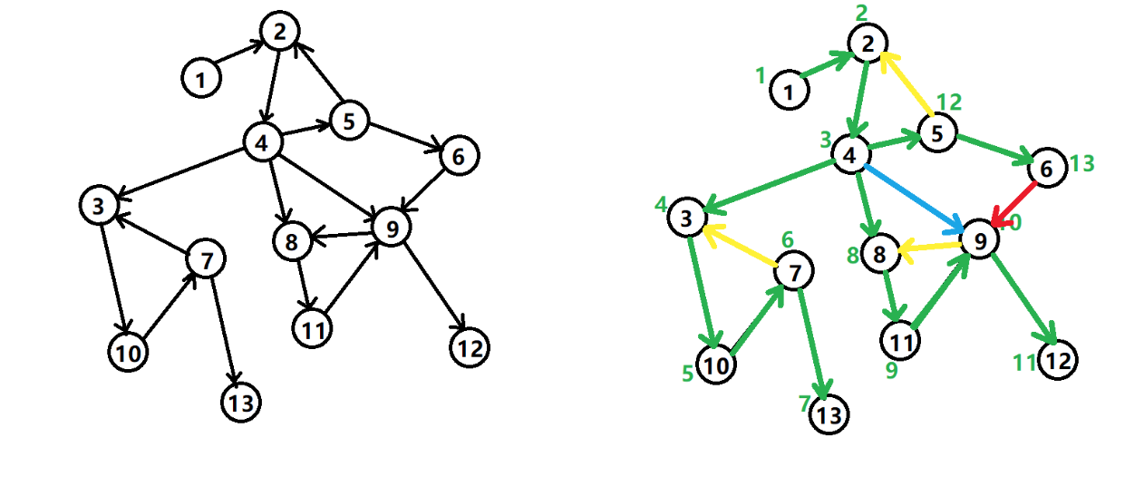
The DFS spanning tree of a directed graph mainly has 4 kinds of edges (not necessarily all of them):

Tree edge: A green edge. Each time a search finds a node that has not been visited, a tree edge is formed.
Back edge: The yellow edge, also called the back edge, is the edge that points to the ancestor node.
Cross edge: A red edge. It mainly encounters a node that has been visited during the search, but this node is not formed by the ancestor of the current node.
Forward edge: The blue edge is formed when the nodes in the subtree are encountered during the search.
We consider the relationship between DFS spanning trees and strongly connected components.

If the node is the first node encountered by a strongly connected component in the search tree, the remaining nodes of this strongly connected component must be in the subtree rooted in the search tree. Called the root of this strongly connected component.

Contradictory method: Suppose there is a node in the strongly connected component but not in the subtree that is the root, then the path to must have an edge that leaves the subtree. However, such edges can only be cross-edged edges or anti-ancestor edges. However, the nodes pointed to by both edges have already been visited, which is in contradiction with the first visited node. Get it.

Tarjan algorithm for strong connected components¶
The following variables are maintained for each node in the Tarjan algorithm:

: The order in which nodes are searched during depth-first search traversal.
: Let's take the subtree rooted as. Defined as the minimum of the following nodes: nodes in; from nodes reachable through an edge that is not on the search tree.
The dfn of a node in a node's subtree is greater than the dfn of the node.

Dfn on a path starting from the root is strictly increasing, and low is strictly non-decreasing.

All nodes in the graph are searched according to the search order of the depth-first search algorithm. During the search process, three cases are considered for the node and its neighboring nodes (v is not the parent of u):

Not visited: Deep search continues. During the backtracking process, update with. Because there is a direct path from to, the nodes that can be traced back to already in the stack must also be traced back.
Visited, already in the stack: that is, already visited, according to the definition of the value (the earliest node that can be traced back to the already in the stack), then use.
Visited, no longer in the stack: Explanation The search has been completed, and its connected components have been processed, so there is no need to do any operations on it.
Write the above algorithm as pseudo code:
vis[u]=true
low[u]=dfn[u]=++dfncnt
push u to the stack
for each (u,v) then do
if v hasn't been search then
TARJAN_SEARCH(v) //search low[u]=min(low[u],low[v])// backtracking
else if v has been in the stack then
low[u]=min(low[u],dfn[v])

Question:
The desire of every cow is to become one of the most popular cows.

Now there are N cows, numbered from 1 to N, giving you M pairs of integers (A, B), indicating that cow A thinks cow B is popular.

This relationship is transitive. If A considers B popular and B considers C popular, then cattle A also considers cattle C popular.

Your task is to find out how many cows are considered welcome by all but yourself.

Input format
The first two numbers N, M;

The next M lines, each with two numbers A, B, means that A thinks B is welcome (the information given may be repeated, that is, there may be multiple A, B).

Output format
Outputs the number of cattle considered popular by all but one of them.

data range
1≤N≤104,
1≤M≤5 × 104
Input example:
3 3
1 2
2 1
2 3
Sample output:
1
Sample explanation
Only the third cow is considered welcome by all but one of them.
Code:
#include<cstring>
#include<cstdio>
#include<iostream>
#include<algorithm>
using namespace std;
const int N = 10010,M = 50010;
int n,m;
int h[N],e[M],ne[M],idx;
int dfn[N],low[N],timestamp;
int stk[N],top;
bool in_stk[N];
int id[N],scc_cnt,size[N];
int dout[N];
void add(int a,int b)
{
e[idx] =b,ne[idx] =h[a],h[a] =idx++;
}
int main()
{
scanf("%d%d",&n,&m);
memeset(h,-1,sizeof h);
while(m--)
{
int a,b;
scanf("%d%d",&a,&b);
add(a,b);
}
for(int i = 1;i<=n;i++)
if(!dfn[i])
tarjan(i);
for(int i = 1;i<=n;i++)
for(int j = h[i];j!=-1;j=ne[i])
{
int k = e[j];
int a = id[i],b = id[k];
if(a!=b)
dout[a]++;
}
int zeros = 0,sum = 0;
for(int i = 1;i<=scc_cnt;i++)
if(dfn[i])
{
zeros++;
sum+=size[i];
if(zeros>1)
{
sum=0;
break;
}
}
printf("%d\n",sum);
return 0;
}
void tarjan(int a)
{
dfn[a] = low[a] = ++timestamp;
stk[++top] = a.in_stk[a] = true;
for(int i = h[a;i!=-1;i=ne[i])
{
int j = e[i];
if(!dfn[j])
{
tarjan(j);
low[u] = min(low[u],low[j]);
}
else if(in_stk[j])
low[a] =min(low[a],dfn[j]);
}
if(dfn[a]==low[u])
{
++scc_cnt;
int y ;
do
{
y = stk[top--];
in_stk[y] = false;
id[y] = scc_cnt;
size[scc_cnt]++;
}while(y!=u);
}

}
Bi-connected component
Double connected component

In a connected undirected graph, for two points u and v, if no edge can be deleted (only one can be deleted) can't make them disconnected, we say that u and v edges are double connected.

In a connected undirected graph, for two points u and v, if no matter which point is deleted (only one can be deleted, and u and b cannot be deleted), they cannot be disconnected, we say u Connected to point v.

Edge-double connectivity is transitive, that is, if x, y edges are double-connected, and y, z edges are double-connected, then x, z edges are double-connected.

Point dual connectivity is not transitive. For example, in the figure below, points A and B are dual connected, points B and C are dual connected, and points A and C are not dual connected.
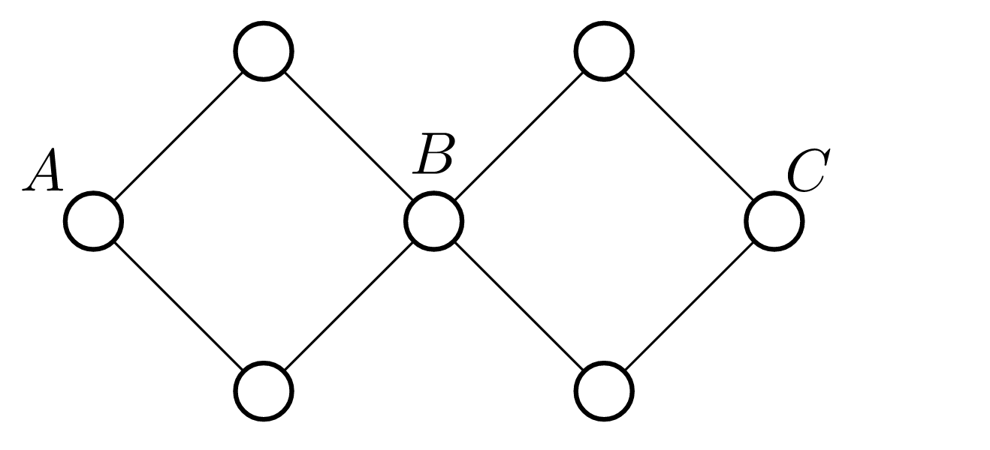
DFS¶
For a connected undirected graph, we can start DFS from any point to get a spanning tree of the original graph (take the point where DFS started as the root). The edges on this spanning tree are called tree edges and are not generated Edges on trees are called non-tree edges.

Due to the nature of DFS, we can guarantee that all two points connected by non-tree edges meet the ancestors of which one is the other in the spanning tree.

The DFS code is as follows:
void DFS(int p) {
visited[p] = true;
for (int to : edge[p])
if (!visited[to]) DFS(to);
}
DFS finds bridge and judges edge dual connectivity
First, DFS the original image.
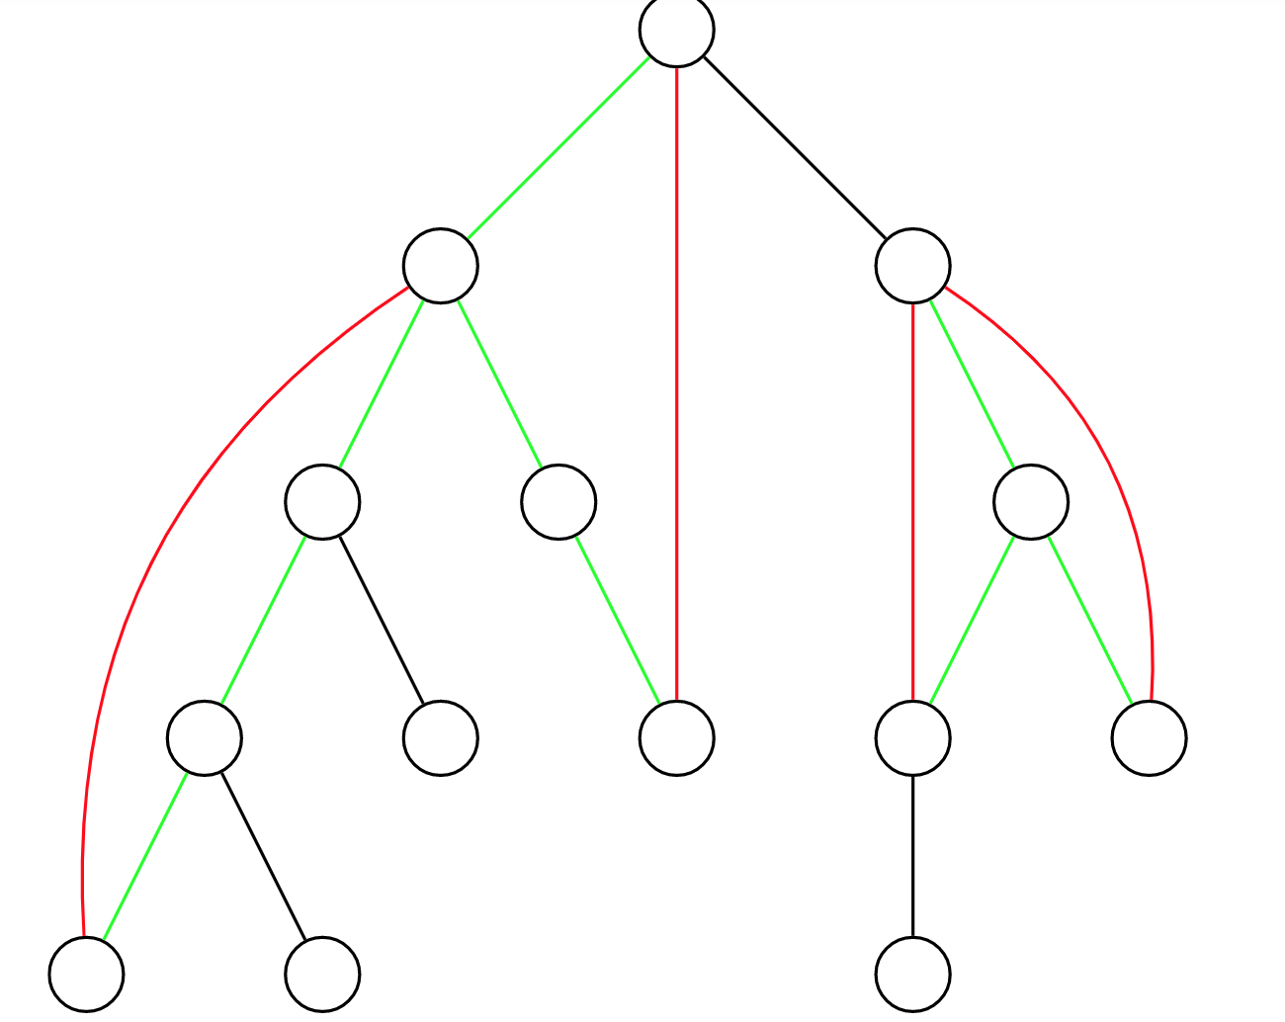

As shown above, the black and green edges are tree edges, and the red edges are non-tree edges. The two points connected by each non-tree edge correspond to a simple path on the tree. We say that this non-tree edge covers all edges on the path of this tree. The green tree edge is covered by at least one non-tree edge, and the black tree edge is not covered by any non-tree edge.

How can we tell if an edge is a bridge? Obviously, non-tree edges and green tree edges must not be bridges, and black tree edges must be bridges.

How to use algorithms to achieve the above process? First, there is a more violent approach. For each non-tree edge, the edge of each tree covered by it is set to green one by one.

How to optimize it? Can use differential. For each non-tree edge, place a -1 mark at points on its tree with a smaller depth and a +1 mark at points with a larger depth on its tree. Then find the sum of the labels inside the subtree of each point. For a point, the sum of the marks inside the subtree is equal to the number of non-tree edges covering the tree edges between and of the fathers of. If this value is not, then the tree edge between and 's father is not a bridge, otherwise it is a bridge.

After the above method is used to find out whether each edge is a bridge, the two points are double connected, if and only if their path does not include a bridge.
DFS finds cut point and judges point dual connectivity
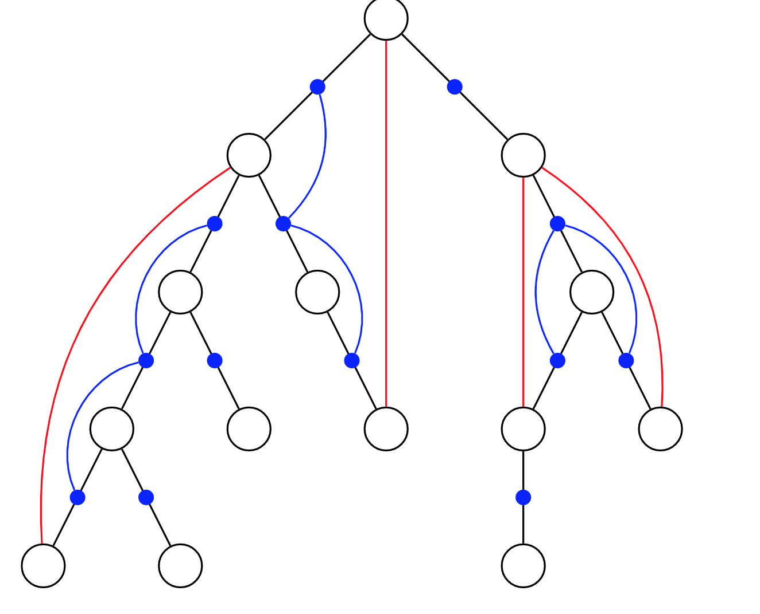
As shown in the figure above, the black edges are tree edges and the red edges are non-tree edges. The two points connected by each non-tree edge correspond to a simple path on the tree.

Consider a new graph, where each point in the new graph corresponds to each tree edge in the original image (indicated by the blue dots in the image above). For each non-tree edge in the original image, connect all the edges in the simple path on the tree corresponding to this non-tree edge to the blue points in the new image to form a connected block (this is also shown in blue in the above image) (The edges are reflected).

In this way, a point is not a bridge if and only if all the blue points corresponding to all edges connected to it in the new graph belong to the same connected block. Two points are double-connected if and only if all the edges in the path of the tree on the original graph correspond to the blue points in the new graph that belong to the same connected block.

The connectivity between blue dots can be maintained in a similar way to the difference used when finding edges and double connectivity, with time complexity O (n + m).
2-satisatifability
2-SAT
SAT is short for Satisfiability. The general form is k-wellness, referred to as k-SAT. The problem was NP-complete at that time. So we only study the case of k = 2.

definition¶
2-SAT, in short, gives n sets, each set has two elements, and several <a, v> are known, which means that a and b conflict (where a and b belong to different sets). Then select one element from each set, and determine whether you can select a total of two elements that do not contradict each other. Obviously, there may be multiple options, and only one is required in general questions.

Realistic significance¶
For example, inviting people to have a wedding drink, the couple must go to one, but some people have conflicts (such as Mr. A and Ms. B, and Ms. C do not want to be with Mr. D), then we must determine whether we can There are no contradictions between people and sometimes a plan is needed. This is a common problem in life.

The above problem is expressed using a Boolean equation. Let a mean that Mr. A goes to participate, then Ms. B cannot participate (not a); b means that Ms. C participates, then not b must be established (Mr. D does not participate). To sum up, (a | b) (at least one of the variables a, b). To construct a directed graph of these variable relationships, there are: not a-> b and not b-> a (if a is not true, b must be true; similarly, if b is not true, a must be true). After building the map, we can use the shrink point algorithm to solve the 2-SAT problem.

Common solutions¶
Tarjan SCC contraction points¶
The algorithm is exquisite in building maps. Let us take an example:

Suppose there are two pairs of a1, a2 and b1, b2. It is known that there is a contradiction between a1 and b2. Therefore, for self-consistent solution, we must choose one of the two. ) And (b2, a2) indicate that if you choose a1, you must choose b1, and if you choose b2, you must choose v2 to be able to agree.

Then through this way we run the Tarjan SCC again to determine whether there are two elements in a set in the same SCC. If there are, the output is impossible, otherwise the output scheme. The construction plan only needs to put together a few non-contradictory SCCs.

When the scheme is output, the value of the variable can be determined by the topological order of the variable in the figure. If the topological order of the variable is after, then the value is true. The contraction point applied to the Tarjan algorithm, that is, true if the SCC number is before. Because Tarjan's algorithm uses the stack to find strong connected components, the SCC number obtained by Tarjan is equivalent to the anti-topological order.

Obviously, the time complexity is o (n + m).
Question:
There were n couples who were invited to a party, because of the problem of the venue, only one of each couple could attend the meeting. Among the 2n individuals, some people have great contradictions (of course there is no contradiction between husband and wife), and the two people who have conflicts will not appear at the party at the same time. Is it possible for n people to be present at the same time?

Input
n: indicates that n couples were invited (n <= 1000)
m: indicates that there are m contradictory relations (m <(n-1) * (n -1))

In the next m lines, each line will have 4 numbers, namely A1, A2, C1, C2
A1 and A2 are the numbers of the couple
C1, C2 indicate wife or husband, 0 indicates wife, 1 is husband
Couple numbers from 0 to n -1

Output
If there is a case, output YES
Otherwise output NO
Sample Input
2
1
0 1 1 1

Sample Output
YES
#include <algorithm>
#include <cstdio>
#include <cstring>
#include <iostream>
#define maxn 2018
#define maxm 4000400
using namespace std;
int Index, instack[maxn], DFN[maxn], LOW[maxn];
int tot, color[maxn];
int numedge, head[maxn];
struct Edge {
int nxt, to;
} edge[maxm];
int sta[maxn], top;
int n, m;
void add(int x, int y) {
edge[++numedge].to = y;
edge[numedge].nxt = head[x];
head[x] = numedge;
}
void tarjan(int x) { /
sta[++top] = x;
instack[x] = 1;
DFN[x] = LOW[x] = ++Index;
for (int i = head[x]; i; i = edge[i].nxt) {
int v = edge[i].to;
if (!DFN[v]) {
tarjan(v);
LOW[x] = min(LOW[x], LOW[v]);
} else if (instack[v])
LOW[x] = min(LOW[x], DFN[v]);
}
if (DFN[x] == LOW[x]) {
tot++;
do {
color[sta[top]] = tot; // color
instack[sta[top]] = 0;
} while (sta[top--] != x);
}
}
bool solve() {
for (int i = 0; i < 2 * n; i++)
if (!DFN[i]) tarjan(i);
for (int i = 0; i < 2 * n; i += 2)
if (color[i] == color[i + 1]) return 0;
return 1;
}
void init() {
top = 0;
tot = 0;
Index = 0;
numedge = 0;
memset(sta, 0, sizeof(sta));
memset(DFN, 0, sizeof(DFN));
memset(instack, 0, sizeof(instack));
memset(LOW, 0, sizeof(LOW));
memset(color, 0, sizeof(color));
memset(head, 0, sizeof(head));
}
int main() {
while (~scanf("%d%d", &n, &m)) {
init();
for (int i = 1; i <= m; i++) {
int a1, a2, c1, c2;
scanf("%d%d%d%d", &a1, &a2, &c1, &c2); //
add(2 * a1 + c1,
2 * a2 + 1 - c2); // We denote 2i + 1 as the i-th pair and 2i as the wife.
add(2 * a2 + c2, 2 * a1 + 1 - c1);
}
if (solve())
printf("YES\n");
else
printf("NO\n");
}
return 0;
}

Bipartite graph:(hungary algorithm)
Judgment bipartite graph
Let G = (V, E) G = (V, E) be an undirected graph. If the vertex VV can be divided into two disjoint subsets (V1, V2) (V1, V2), and The two vertices ii and jj associated with each edge (i, j) (i, j) belong to the two different vertex sets i∈V1, j∈V2i∈V1, j∈V2, then the graph GG is called A bipartite graph.

That is, if we can divide all the vertices in the graph into two parts, then for any edge, its two endpoints are in different sets of points. An equivalent condition for judging a bipartite graph is that there are no rings with odd vertices in the graph.

Therefore, we can use the coloring method to solve such a problem. Each time we select an unstained point in the figure to dye it into color 1, and dye its adjacent unstained vertex to the opposite color. If the color is the same as the current color, a conflict has occurred.

We can use BFS or DFS to complete the staining process.
Question:
Given an undirected graph with n points and m edges, there may be multiple edges and self-loops in the graph.

Please judge whether this graph is a bipartite graph.

Input format
The first line contains two integers n and m.

The next m lines, each containing two integers u and v, indicate that there is an edge between points u and v.

Output format
If the given graph is a bipartite graph, output "Yes", otherwise output "No".

data range
1≤n, m≤105
Input example:
4 4
1 3
1 4
2 3
2 4
Sample output:
Yes
#include<stdio.h>
#include<cstring>
#include<iostream>
#include<queue>
using namespace std;

const int N = 100010,M = 200010;
int h[N],e[M],ne[M],idx = 0;
int st[N];//0 is for uncolor 1 is for color 1 2 is for color 2
bool res = true;
void add(int from,int to)
{
e[idx] = to;
ne[idx] = h[from];
h[from] = idx ++;
}
bool bfs(int u)
{
queue<int> q;
q.push(u);
st[u] = 1;
while(!q.empty())
{
int p = q.front(),color = st[p],next_color = 3 - color;
q.pop();
for(int i = h[p] ; i != -1 ; i = ne[i])
{
int j = e[i];
if(st[j] == color)
return false;
else if(st[j] == 0)
{
st[j] = next_color;
q.push(j);
}
}
}
return true;
}
bool dfs(int u,int c)
{
st[u] = c;
for(int i = h[u] ; i != -1 ; i = ne[i])
{
int j = e[i];
if(st[j] == c)
return false;
else if(st[j] == 0 && !dfs(j,3 - c))
return false;
}
return true;
}
int main()
{
int n,m,from,to;
scanf("%d %d",&n,&m);
memset(h,-1,sizeof(h));
memset(st,0,sizeof(st));
for(int i = 0 ; i < m ; i ++)
{
scanf("%d %d",&from,&to);
add(from,to);
add(to,from);
}
for(int i = 1 ; i <= n ; i ++)
{
if(st[i] == 0)
{
if(dfs(i,1) == false)
{
res = false;
break;
}
}
}
if(res) printf("Yes");
else printf("No");
return 0;
}
Bipartite graph maximum match
Matching of a bipartite graph: Given a bipartite graph G, in a subgraph M of G, any two edges in the edge set E of M are not attached to the same vertex, then M is called a match. Matching is essentially a set of edges, and any two edges have no intersection.

Maximum match of bipartite graph: The set of matches that contains the most edges in all matches is called the maximum match of the bipartite graph, and the number of edges is the maximum number of matches.

Here we mainly use the Hungarian algorithm for solving. Before introducing the algorithm, we need to introduce two concepts:

Staggered path: Given a matching M of graph G, if the edges of a path appear alternately in M and do not appear in M, we call it an M-interlaced path.

Augmented path: If an M-interleaved path has neither end point associated with an edge in M, we call this path an M-augmented path.
As picture shown below
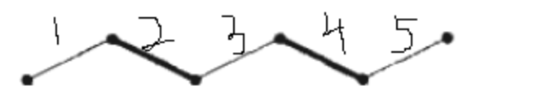
For matching M = {2,4} where the edge set {2,3,4} is an interlaced path, and the edge set {1,2,3,4,5} is an augmented path.
We can find that for an augmented path, we can change the matching edges into non-matching edges and non-matching edges into matching edges. Get a bigger match {1,3,5}. So our goal is to find the augmentation path in the picture.
Hungarian Algorithm
Suppose we are given a bipartite graph where the set of points is X, and we need to find a maximum match for it. We traverse the vertices in the set X in turn.
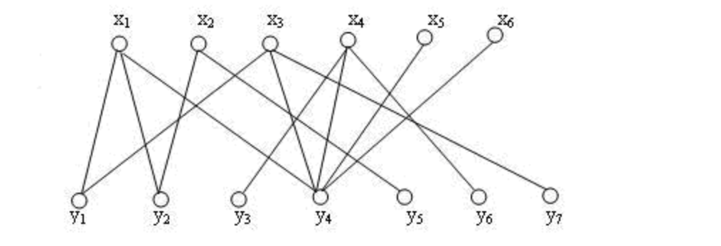
At the beginning, matching M is an empty set. We randomly select an edge (x1, y1) (x1, y1) and add it to the matching to get:
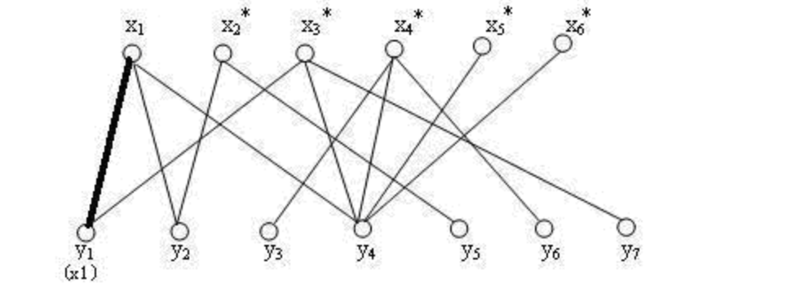
Then we select (x2, y2) (x2, y2) to add a match, and we get:
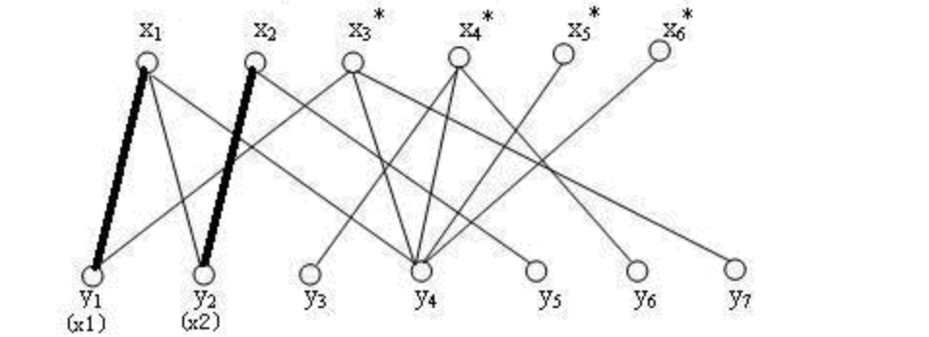
Next we want to find a matching point for x3x3. Our algorithm does not directly assign y4y4 to him, but we first match with y1y1. At this time (x3, y1) (x3, y1), then x1x1 is isolated. Then, he goes to find y2y2 and gets edge (x1, y2) (x1, y2). At this time, x2x2 is isolated, then he finds y5y5 to form edge (x2, y5) (x2, y5).

We can find that if the original relationship can be constantly changed, and an endpoint x2x2 that was previously matched can find a non-matching point y5y5, our number of matches will increase. If there are not many, then the size of our edges can be maintained. No change, just the matching relationship has changed.

Therefore, the core of the Hungarian algorithm is: constantly searching for the augmenting path of the original matching M, because finding an augmenting path of the M matching means a larger matching M ′, which just has one more edge than M.
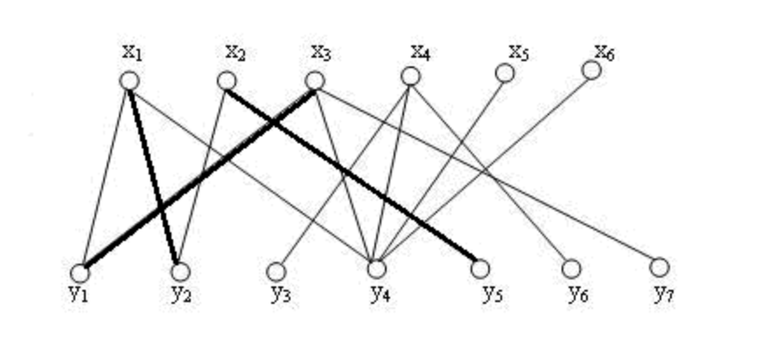
Next we try to add the last three points in turn to get a maximum match:
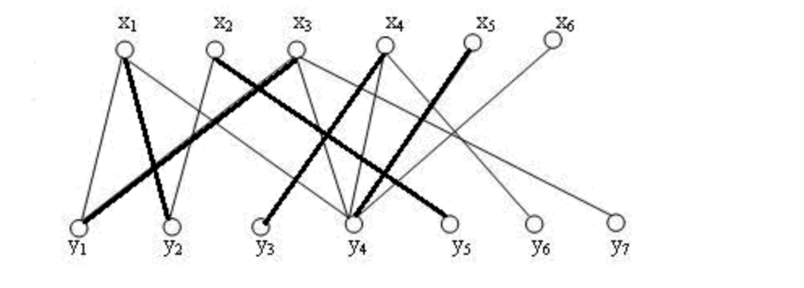
Question:
Given a bipartite graph, the left half contains n1 points (numbered 1 to n1) and the right half contains n2 points (numbered 1 to n2). The bipartite graph contains m edges.

The data guarantees that neither endpoint of any edge can be in the same part.

Please find the maximum number of matches in the bipartite graph.

Matching of a bipartite graph: Given a bipartite graph G, in a subgraph M of G, any two edges in the edge set {E} of M do not depend on the same vertex, then M is said to be a match.

Maximum match of bipartite graph: The set of matches that contains the most edges in all matches is called the maximum match of the bipartite graph, and the number of edges is the maximum number of matches.

Input format
The first line contains three integers n1, n2, and m.

The next m lines, each containing two integers u and v, indicate that there is an edge between the point u in the left half point set and the point v in the right half point set.

Output format
Output an integer representing the maximum number of matches in the bipartite graph.

data range
1≤n1, n2≤500,
1≤u≤n1,
1≤v≤n2,
1≤m≤105
Input example:
2 2 4
1 1
1 2
2 1
2 2
Sample output:
2
Code :
#include<stdio.h>
#include<cstring>
#include<iostream>
using namespace std;
const int N = 510,M = 100010;
int h[N],e[M],ne[M],idx = 0;//存储点和边
int st[N];//存储当前集合2中的点是否被使用了
int match[N];//存储当前集合2中的点匹配的是集合1中的哪一个点。
int n1,n2,m,from,to,res = 0;
void add(int x,int y)
{
e[idx] = y;
ne[idx] = h[x];
h[x] = idx ++;
}
bool find(int x)
{
// traverse the endpoint j corresponding to all edges of x, if j has not been used, then we will use (x, j) as an edge in the match
// At this time, we take a look at the corresponding endpoint of endpoint j in the previous match is match [j]. If it has not been used in the previous match, then it can add a new edge and return directly, otherwise we force match [j] Find another vertex to match. Also update match [j] = x, which is the currently matched node.
{
int j = e[i];
if(st[j] == 0)
{
st[j] = 1;
if(match[j] == 0 || find(match[j]))
{
match[j] = x;
return true;
}
}
}
return false;
}
int main()
{
scanf("%d %d %d",&n1,&n2,&m);
memset(h,-1,sizeof(h));
for(int i = 0 ; i < m ; i ++)
{
scanf("%d %d",&from,&to);
add(from,to);
}
// Each time an augmentation path is found for the points in set 1, the marker needs to be cleared. If an augmentation path is found, the answer is increased by 1.
for(int i = 1 ; i <= n1 ; i ++)
{
memset(st,0,sizeof(st));
if(find(i)) res ++;
}
printf("%d",res);
return 0;
}

Minimum vertex coverage in bipartite graphs
Definition: If a point is selected, it is equivalent to covering all edges with it as the endpoint. Minimal vertex coverage is to select the fewest points to cover all edges.

Theorem: The minimum vertex coverage is equal to the maximum match of the bipartite graph.

Maximum independent set of bipartite graphs
Definition: Select some vertices so that these vertices are not adjacent to each other. The set of these points is called an independent set. Finding an independent set with the most vertices is called the maximum independent set.

Theorem: maximum independent set = number of all vertices-minimum vertex coverage = number of all vertices-maximum match

Euler path(dfs)
Topology(bfs)

Netflow:
Maxflow
Maxflow-mincost:Dinic
Network flow
First, please make clear the concepts of network (or flow network) and network flow (flow).
The network refers to a directed graph G = (V, E)
Each edge (u, v) ∈ E has a weight c (u, v), which is called capacity. When (u, v) ∉E, there is c (u, v) = 0
Two special points, source s ∈ V and sink t ∈ V (s ≠ t)
flow
Let f (u, v) be a real function defined in a two-tuple (u∈V, v∈V) such that
1 Capacity limit: For each edge, the flow through the edge must not exceed the capacity of the edge, that is, f (u, v) <= c (u, v)
2 Oblique symmetry: the sum of the traffic of each side and the traffic of its opposite side is 0, that is, f (u, v) = -f (u, v)
3 Conservation: The flow from the source is equal to the flow from the sink, that is,
Then called the flow function of network G. For (u, v) ∈ E, f (u, v (referred to as the edge traffic, c (u, v) -f (u, v) is referred to as the remaining capacity of the edge. The traffic of the entire network is v) ∈ f (s, v), which is the sum of all traffic sent from the source.

Generally speaking, the network flow can also be understood as the flow of the entire graph. And this flow must meet the above three properties.

Note: The complete definition of the stream function is
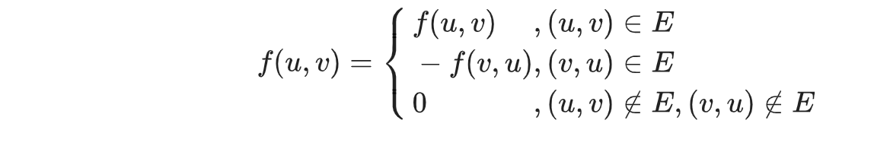
Common problems with network streaming¶
There are three common types of network flow problems: maximum flow, minimum cut, and cost flow.

Maximum flow
We have a map that requires the maximum flow from the source to the sink (there can be many ways to reach the sink), which is our maximum flow problem.

Minimum cost maximum flow
The minimum cost and maximum flow problem is this: each edge has a cost, which represents the cost of unit traffic flowing through this edge. We want to find the maximum flow while requiring the minimum cost.

Minimal cuts¶
Cut actually means to delete the edge. Of course, the smallest cut is to cut off the X edges to make S and T not communicate. We require that the combined traffic of the edges be minimal. This is the minimum cut problem.
Fulkerson algorithm
https://en.wikipedia.org/wiki/Ford%E2%80%93Fulkerson_algorithm
#define maxn 250
#define INF 0x3f3f3f3f

struct Edge {
int from, to, cap, flow;
Edge(int u, int v, int c, int f) : from(u), to(v), cap(c), flow(f) {}
};

struct EK {
int n, m;
vector<Edge> edges;
vector<int> G[maxn];
int a[maxn], p[maxn];

void init(int n) {
for (int i = 0; i < n; i++) G[i].clear();
edges.clear();
}

void AddEdge(int from, int to, int cap) {
edges.push_back(Edge(from, to, cap, 0));
edges.push_back(Edge(to, from, 0, 0));
m = edges.size();
G[from].push_back(m - 2);
G[to].push_back(m - 1);
}

int Maxflow(int s, int t) {
int flow = 0;
for (;;) {
memset(a, 0, sizeof(a));
queue<int> Q;
Q.push(s);
a[s] = INF;
while (!Q.empty()) {
int x = Q.front();
Q.pop();
for (int i = 0; i < G[x].size(); i++) {
Edge& e = edges[G[x][i]];
if (!a[e.to] && e.cap > e.flow) {
p[e.to] = G[x][i];
a[e.to] = min(a[x], e.cap - e.flow);
Q.push(e.to);
}
}
if (a[t]) break;
}
if (!a[t]) break;
for (int u = t; u != s; u = edges[p[u]].from) {
edges[p[u]].flow += a[t];
edges[p[u] ^ 1].flow -= a[t];
}
flow += a[t];
}
return flow;
}
};
Dinic
https://en.wikipedia.org/wiki/Dinic%27s_algorithm
define maxn 250
#define INF 0x3f3f3f3f

struct Edge {
int from, to, cap, flow;
Edge(int u, int v, int c, int f) : from(u), to(v), cap(c), flow(f) {}
};

struct Dinic {
int n, m, s, t;
vector<Edge> edges;
vector<int> G[maxn];
int d[maxn], cur[maxn];
bool vis[maxn];

void init(int n) {
for (int i = 0; i < n; i++) G[i].clear();
edges.clear();
}

void AddEdge(int from, int to, int cap) {
edges.push_back(Edge(from, to, cap, 0));
edges.push_back(Edge(to, from, 0, 0));
m = edges.size();
G[from].push_back(m - 2);
G[to].push_back(m - 1);
}

bool BFS() {
memset(vis, 0, sizeof(vis));
queue<int> Q;
Q.push(s);
d[s] = 0;
vis[s] = 1;
while (!Q.empty()) {
int x = Q.front();
Q.pop();
for (int i = 0; i < G[x].size(); i++) {
Edge& e = edges[G[x][i]];
if (!vis[e.to] && e.cap > e.flow) {
vis[e.to] = 1;
d[e.to] = d[x] + 1;
Q.push(e.to);
}
}
}
return vis[t];
}

int DFS(int x, int a) {
if (x == t || a == 0) return a;
int flow = 0, f;
for (int& i = cur[x]; i < G[x].size(); i++) {
Edge& e = edges[G[x][i]];
if (d[x] + 1 == d[e.to] && (f = DFS(e.to, min(a, e.cap - e.flow))) > 0) {
e.flow += f;
edges[G[x][i] ^ 1].flow -= f;
flow += f;
a -= f;
if (a == 0) break;
}
}
return flow;
}

int Maxflow(int s, int t) {
this->s = s;
this->t = t;
int flow = 0;
while (BFS()) {
memset(cur, 0, sizeof(cur));
flow += DFS(s, INF);
}
return flow;
}
};

Cost flow
Given a network G = (V, E), each edge has a unit limit w (u, v) in addition to the capacity limit c (u, v).
When the flow of (u, v) is f (u, v), it takes f (u, v) * w (u, v).

Also oblique symmetry is satisfied, that is w (u, v) =-w (v, u).

Then the maximum flow with the smallest total cost in this network is called the minimum cost maximum flow, that is, sigma (u, v) ∈ Ef (u, v) * w (u, v).

Dinic-like algorithm
We can improve on the basis of the Dinic algorithm, and change the BFS layered graph to use SPFA (due to negative weight edges, so Dijkstra cannot be used directly) to find a path with the smallest unit cost sum, that is, w ( u, v) as the edge weight and then find the shortest path on the residual network, of course, it must be slightly modified in DFS. In this way, the minimum cost and maximum flow of the network flow graph can be obtained.

How to build a reverse edge? For an edge (u, v, w, c) (where w and c are capacity and cost, respectively), we establish a forward edge (u, v, w, c) and a reverse edge (v, u, 0,- c) (where -c is the cost that is returned when passing from the opposite edge).
z#include <algorithm>
#include <cstdio>
#include <cstring>
#include <queue>

const int N = 5e3 + 5, M = 1e5 + 5;
const int INF = 0x3f3f3f3f;
int n, m, tot = 1, lnk[N], cur[N], ter[M], nxt[M], cap[M], cost[M], dis[N], ret;
bool vis[N];

void add(int u, int v, int w, int c) {
ter[++tot] = v, nxt[tot] = lnk[u], lnk[u] = tot, cap[tot] = w, cost[tot] = c;
}
void addedge(int u, int v, int w, int c) { add(u, v, w, c), add(v, u, 0, -c); }
bool spfa(int s, int t) {
memset(dis, 0x3f, sizeof(dis));
memcpy(cur, lnk, sizeof(lnk));
std::queue<int> q;
q.push(s), dis[s] = 0, vis[s] = 1;
while (!q.empty()) {
int u = q.front();
q.pop(), vis[u] = 0;
for (int i = lnk[u]; i; i = nxt[i]) {
int v = ter[i];
if (cap[i] && dis[v] > dis[u] + cost[i]) {
dis[v] = dis[u] + cost[i];
if (!vis[v]) q.push(v), vis[v] = 1;
}
}
}
return dis[t] != INF;
}
int dfs(int u, int t, int flow) {
if (u == t) return flow;
vis[u] = 1;
int ans = 0;
for (int &i = cur[u]; i && ans < flow; i = nxt[i]) {
int v = ter[i];
if (!vis[v] && cap[i] && dis[v] == dis[u] + cost[i]) {
int x = dfs(v, t, std::min(cap[i], flow - ans));
if (x) ret += x * cost[i], cap[i] -= x, cap[i ^ 1] += x, ans += x;
}
}
vis[u] = 0;
return ans;
}
int mcmf(int s, int t) {
int ans = 0;
while (spfa(s, t)) {
int x;
while ((x = dfs(s, t, INF))) ans += x;
}
return ans;
}
int main() {
int s, t;
scanf("%d%d%d%d", &n, &m, &s, &t);
while (m--) {
int u, v, w, c;
scanf("%d%d%d%d", &u, &v, &w, &c);
addedge(u, v, w, c);
}
int ans = mcmf(s, t);
printf("%d %d\n", ans, ret);
return 0;
}

Dynamic programming:
Knapsack:
0/1 knapsack
Completed knapsack
Multiple knapsack
Group knapsack
Triangle shape
State machine
Tree shape DP
Digit counting DP
Memorized search
Longest increasing sequence
DP of range
Status compression DP
Slop optimization (Convex hull ,something related to computational geometry)
Monotonic queue optimization

Advance data structure:
Union find
Binary index tree
Sustainable data struture
Balanced binary tree:Treap and Splay
Segment tree
Aho-Corasick automaton（kmp+trie)

