Links:
https://codingcompetitions.withgoogle.com/kickstart/round/0000000000050edf/0000000000051004

Problem
Professor Scrmable noticed spelling mistakes in a research paper she was reviewing, but she had no difficulty in reading or understanding the words. Upon doing some research, she found an interesting article as described below:
According to a study at an English University, it doesn't matter in what order the letters in a word are, the only important thing is that the first and last letter be at the correct place. The rest can be a total mess and you can still read it without a problem. This is because the human mind does not read every letter by itself but the word as a whole.
Or rather ...
Aoccdrnig to a study at an Elingsh uinervtisy, it deosn't mttaer in waht oredr the ltteers in a wrod are, the olny iprmoetnt tihng is taht the frist and lsat ltteer be at the corecrt pclae. The rset can be a toatl mses and you can sitll raed it wouthit a porbelm. Tihs is bcuseae the huamn mnid deos not raed ervey lteter by istlef, but the wrod as a wlohe.
Professor Scrmable wants to explore this concept further and starts compiling different sentences containing similarly scrambled words to send to a popular publication. Unfortunately, the space key on the professor's keyboard is not working, so she has produced one long string of characters. She has asked you to determine how many of the words in her dictionary appear (at least once) as substrings in the long string of characters, either in their original or scrambled forms. (A scrambled form consists of the same set of letters with the first and last letters in the same places, and the others in any order.)
Note that a dictionary word can appear multiple times in the string (though it should be counted only once since we only need to know whether it shows up at least once). For example, if we had the word this in the dictionary, the possible valid words which would be counted are this (original version) and tihs (scrambled version), whereas tsih, siht and other variations are not valid since they do not start with t and end with s. Also, tis, tiss, and thiss are not scrambled forms, because they are not reorderings of the original set of letters.
Since the professor is extremely busy, she gives this task to you, her favorite and most trusted research assistant. Given a dictionary, can you count the number of words in the dictionary that appear as a substring in the professor's string at least once, in either their scrambled or original forms.

Input
The first line of the input gives the number of test cases, T. T test cases follow. Each testcase contains three lines. The first line contains an integer L. The second line contains a list of L words made of lowercase English letters; these make up the dictionary. The third line contains two lowercase English letters S₁ and S₂, and five integers N, A, B, C and D. S₁ and S₂ are the first two characters of the professor's string S, N is the length of S, and the other four integers are parameters that you should use to generate the characters of S, as follows:
First we define ord(c) as the decimal value of a character c and char(n) as the character value of a decimal n. For example, ord('a') = 97 and char(97) = 'a'. You can refer to ASCII table for other conversions.
Now, define x₁ = ord(S₁), x₂ = ord(S₂). Then, use the recurrence below to generate x_{i} for i = 3 to N:
- x_{i} = ( A * x_{i-1} + B * x_{i-2} + C ) modulo D.
We define S_{i} = char(97 + ( x_{i} modulo 26 )), for all i = 3 to N.

Output
For each test case, output one line containing Case #x: y, where x is the test case number (starting from 1) and y is the number of words from the dictionary that appear (in their original or scrambled forms, as defined above) as substrings of the given string.

Limits
1 ≤ T ≤ 20.
Memory limit: 1 GB.
No two words in the dictionary are the same.
Each word in the dictionary is between 2 and 10⁵ letters long, inclusive.
The sum of lengths of all words in the dictionary does not exceed 10⁵.
S₁ and S₂ are lowercase English letters.
0 ≤ A ≤ 10⁹.
0 ≤ B ≤ 10⁹.
0 ≤ C ≤ 10⁹.
1 ≤ D ≤ 10⁹.

Small dataset (Test set 1 - Visible)
Time limit: 20 seconds.
1 ≤ L ≤ 1000.
2 ≤ N ≤ 1000.

Large dataset (Test set 2 - Hidden)
Time limit: 150 seconds.
1 ≤ L ≤ 20000.
2 ≤ N ≤ 10⁶.

Sample
Input | Output
1  5  axpaj apxaj dnrbt pjxdn abd  a a 50 1 1 1 30 | Case #1: 4
In Sample Case #1, using the generation method, the generated string S is aapxjdnrbtvldptfzbbdbbzxtndrvjblnzjfpvhdhhpxjdnrbt. Scrambled or original occurences of dictionary words are highlighted as follows:
- axpaj occurs in its scrambled form as aapxjdnrbtvldptfzbbdbbzxtndrvjblnzjfpvhdhhpxjdnrbt.
- apxaj occurs in its scrambled form as aapxjdnrbtvldptfzbbdbbzxtndrvjblnzjfpvhdhhpxjdnrbt. Note that even though apxaj is the scrambled form of another dictionary word axpaj, both should be counted.
- dnrbt occurs twice in its original form as aapxjdnrbtvldptfzbbdbbzxtndrvjblnzjfpvhdhhpxjdnrbt, though it should be counted only once.
- pjxdn occurs in its scrambled form as aapxjdnrbtvldptfzbbdbbzxtndrvjblnzjfpvhdhhpxjdnrbt. Note this occurence overlaps with occurence of another dictionary word, but still they're counted independently.
- abd doesn't occur at all.
Note: We do not recommend using interpreted/slower languages for the Large dataset of this problem.

My idea:

How to check if two words are equivalent according to the Defintion of Scrambled words:
-- Verify the their starting and ending letters are equal
--Frequency arrays are same
(The strings in this problem consist of only lowercase English letters,the frequency array only needs to hold 26 integers)

Time completixty O(1) Dictionary tree
For small Dataser
1 <= L <=1000
2 <=N<=1000
For each word in the dictionary,iterate over the string and check for substring match at each position in the text.
And maintain a running frequency array(the size of this array is 26 )
The time complexity is O(NL)
For larger data set
1<=L<=20000
2<=N<10^6
it would be time limited error
Not need to iterate L times, for the words with same length,count together(Hash table or hash map )
The sum of lengths of all words in the dictionary does not exceed 10^5
The maximum possible number of distinct word lengths is at most sqrt(10^5)
Time Complextiy is O(sqrt(10^5)*n)

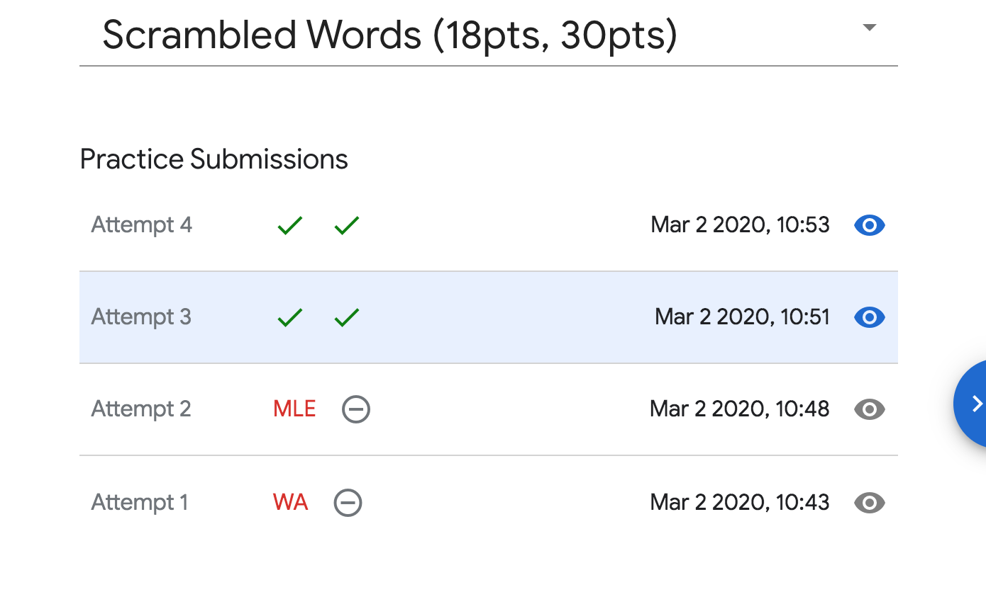
Code:
WA: I don not know why the first time to write it
#include <iostream>
#include <algorithm>
#include <cstdio>
#include <cstdlib>
#include <unordered_map>
#include <cstring>
// String Hash
using namespace std;
const int N = 1000010;
char str[N];
int X[N];
// a arbitary large prime number for seed
const int SEED = 13331;
unsigned long long getHash(char start,char end,int num[])
{
unsigned long long ret = start*SEED+end;
for(int i = 0 ;i<26;i++)
{
ret = ret*SEED+num[i];
}
return ret;
}
char dict[N];
unsigned long long dictHash[20010];
int num[26];
int Len[20010];

int main()
{
int T;
int iCase = 0;
scanf("%d",&T);
while(T--)
{
iCase++;
int L;
scanf("%d",&L);
int totLen = 0 ;
for(int i = 0;i<L;i++)
{
scanf("%s",dict);
int len =strlen(dict);
memset(num,0, sizeof(num));
for(int j = 1;j<len-1;j++)
{
num[dict[j]-'a']++;
}
dictHash[i] = getHash(dict[0],dict[len-1],num);
Len[totLen++]= len;
}
int N,A,B,C,D;
cin>>str[0];
cin>>str[1];
scanf("%d%d%d%d%d",&N,&A,&B,&C,&D);
X[0] = str[0];
X[1] = str[1];
for(int i = 2;i<N;i++)
{
X[i] =((long long)A*X[i-1]+(long long )B*str[i]);
//ascii of a
str[i] = (char)(97+X[i]%26);

}
str[N]=0;
sort(Len,Len+totLen);
//delete the same length and only appear once
totLen = unique(Len,Len+totLen)-Len;
unordered_map<unsigned long long,int>mp;
for(int i = 0;i<L;i++)
{
mp[dictHash[i]]++;
}
int ans = 0;
for(int j = 0;j<totLen;j++)
{
int len = Len[j];
if(len>N) continue;
memset(num,0, sizeof(num));
for(int i = 1;i<len-1;i++)
{
num[str[i]-'a']++;
}
unsigned long long temp1 = getHash(str[0],str[len-1],num);
if(mp.count(temp1))
{
ans+=mp[temp1];
mp.erase(temp1);
}
for(int i = len;i<N;i++)
{
num[str[i-1]-'a']++;
num[str[i-len+1]-'a']--;
unsigned long long temp = getHash(str[i-len+1],str[i-1],num);
if(mp.count(temp))
{
ans+=mp[temp];
mp.erase(temp);
}
}
}
printf("Case #%d: %d\n",iCase,ans);

}
return 0 ;
}

Correct Code (Passing):

#include <iostream>
#include <unordered_map>
#include <vector>
#include <array>
#include <unordered_set>
using namespace std;

namespace {

struct Key {
char first, last;
array<int, 26> freq;
};

bool operator== (const Key &a, const Key &b) {
return a.first == b.first && a.last == b.last && a.freq == b.freq;
}

struct KeyHash {
size_t operator()(const Key &k) const {
//31 is the closest prime number around the 26
size_t res = k.first + 31*k.last;
for (int i : k.freq) res = 31*res + i;
return res;
}
};

Key MakeKey(const string &word) {
Key key{word.front(), word.back(), {}};
for (char ch : word) key.freq[ch - 'a']++;
return key;
}

int Solve(const vector<string> &dictionary, const string &text) {
unordered_map<Key, int, KeyHash> groups;
unordered_set<int> word_lengths;
for (const string &word : dictionary) {
word_lengths.insert(word.size());
groups[MakeKey(word)]++;
}
int answer = 0;
for (int length : word_lengths) {
if (length > text.size()) continue;
Key key = {};
int i = 0;
for (; i < length - 1; ++i) {
key.freq[text[i] - 'a']++;
}
for (; i < text.size(); ++i) {
key.first = text[i - (length - 1)];
key.last = text[i];
key.freq[key.last - 'a']++;
auto it = groups.find(key);
if (it != groups.end()) {
answer += it->second;
groups.erase(it);
}
key.freq[key.first - 'a']--;
}
}
return answer;
}

} // namespace

int main() {
int T = 0;
cin >> T;
for (int t = 1; t <= T; ++t) {
int L = 0;
cin >> L;
vector<string> dictionary(L);
for (string &word : dictionary) cin >> word;
char S1 = 0, S2 = 0;
int N = 0, A = 0, B = 0, C = 0, D = 0;
cin >> S1 >> S2 >> N >> A >> B >> C >> D;
vector<int> X(N);
X[0] = S1;
X[1] = S2;
for (int i = 2; i < N; ++i) X[i] = ((long long)A*X[i - 1] + (long long)B*X[i - 2] + C)%D;
string S;
S.resize(N);
S[0] = S1;
S[1] = S2;
for (int i = 2; i < N; ++i) S[i] = char('a' + X[i]%26);
cout << "Case #" << t << ": " << Solve(dictionary, S) << endl;
}
}

