Link:
https://codingcompetitions.withgoogle.com/kickstart/round/0000000000050ee1/00000000000510ef

Problem
Supervin loves to eat candies. Today, his favorite candy shop is offering N candies, which are arranged in a line. The i-th candy in the line (counting starting from 1) has a sweetness level S_{i}. Note that the sweetness level of a candy might be negative, which means the candy tastes bitter.
Supervin likes to eat sweet candies. However, candies with a combined sweetness level of more than D would be too much sweetness even for him. Supervin also realises that a candy with an odd sweetness level is "odd", and he does not want to eat more than O odd candies. In other words, an odd candy is a candy with a sweetness level that is not evenly divisible by 2. Additionally, since Supervin is in a rush, he can only eat a single contiguous subset of candies.
Therefore, he wants to eat a contiguous non-empty subset of candies in which there are at most O odd candies and the total sweetness level is maximized, but not more than D. Help Supervin to determine the maximum total sweetness level he can get, or return IMPOSSIBLE if there is no contiguous subset satisfying these constraints.

Input
The first line of the input gives the number of test cases, T. T test cases follow. Each test case contains two lines. The first line contains three integers N, O, and D, as described above. The second line contains seven integers X₁, X₂, A, B, C, M, L; these values are used to generate the values S_{i}, as follows:
We define:
- X_{i} = (A × X_{i - 1} + B × X_{i - 2} + C) modulo M, for i = 3 to N.
- S_{i} = X_{i} + L, for i = 1 to N.

Output
For each test case, output one line containing Case #x: y, where x is the test case number (starting from 1) and y is the maximum total sweetness level Supervin can get, or IMPOSSIBLE if there is no possible contiguous subset satisfying the problem constraints.

Limits
1 ≤ T ≤ 100.
Time limit: 40 seconds per test set.
Memory limit: 1 GB.
2 ≤ N ≤ 5 × 10⁵.
0 ≤ O ≤ N.
-10¹⁵ ≤ D ≤ 10¹⁵.
0 ≤ X₁, X₂, A, B, C ≤ 10⁹.
1 ≤ M ≤ 10⁹.

Small dataset (Test set 1 - Visible)
L = 0.

Large dataset (Test set 2 - Hidden)
-5 × 10⁸ ≤ L ≤ 0.

Sample
Input | Output
5  6 1 1000000000000000  1 1 1 1 0 100 0  6 1 -100  1 1 1 1 0 100 0  10 1 8  4 3 4 1 5 20 -10  10 2 8  4 3 4 1 5 20 -10  10 1 8  4 3 4 1 5 20 -19 | Case #1: 13  Case #2: IMPOSSIBLE  Case #3: 7  Case #4: 8  Case #5: -5
Note that the last three sample cases would not appear in the Small dataset.
In Sample Case #1, the generated array of sweetness values S_{i} is: [1, 1, 2, 3, 5, 8], where the bold and underlined numbers are the odd numbers. Since Supervin can only eat one odd candy, he can get a maximum total sweetness level by taking the fifth and the sixth candies.
In Sample Case #2, the generated array of sweetness values S_{i} is the same as in Sample Case #1. However, this time Supervin cannot eat candies with a total sweetness level of more than -100, so no contiguous subset of candies satisfies the constraints.
In Sample Case #3, the generated array of sweetness values S_{i} is: [-6, -7, -9, 2, 4, 3, 1, -8, -6, -7], where the bold and underlined numbers are the odd numbers. Since Supervin can only eat one odd candy and he cannot eat candies with a total sweetness level of more than 8, he can get the maximum total sweetness level by taking the fifth and the sixth candies.
In Sample Case #4, the generated array of sweetness values S_{i} is the same as in Sample Case #3. However, this time Supervin can eat two odd candies. Therefore, he can get a maximum total sweetness level by taking the fifth, the sixth, and the seventh candies.
In Sample Case #5, the generated array of sweetness values S_{i} is: [-15, -16, -18, -7, -5, -6, -8, -17, -15, -16] where the bold and underlined numbers are the odd numbers. Note that it is possible for the maximum total sweetness level to be negative.
Note: We do not recommend using interpreted/slower languages for the Large dataset of this problem.

Idea:
Maximize the sum of [L,R],meet two restrictions:
1 At most O odd candies -- two pointer
2 The total sweetness level is not more than D
Get prefix Sum: Sum[i] = s1+s2+.....si
For each L,need to find the value of R,and meet the restrictions.
Use two pointers to meet restrictions 1, and use multiset or data structure(need insert or delete) to find maximum prefix sum
that it not more than D +Sum[L-1]

First, it has something to do with sections and sliding windows.
To calculate the interval sum, we must first calculate the initial sum
If I am fixing the left endpoint l, find the right endpoint r. Consistent, the endpoints of an interval must be fixed first, which can be left or right.
To ensure that the number of odd numbers in this interval does not exceed o
Then you need to find r, so that P [r] -P [l-1] is the largest one that satisfies P [r] -P [l-1] <= d. Therefore, if P [r] does not exceed P [l -1] + d but the one closest to it
This has to be done with upper_bound (if the right endpoint is fixed it is lower_bound)
Multiset can be used in C ++ (because the window may have the same value!), Remember that when deleting, you can only delete one! #include <stdio.h>

The sliding window here can be implemented with two pointers. When l increases by 1, r can only increase but not decrease, so it is the volume rule method.

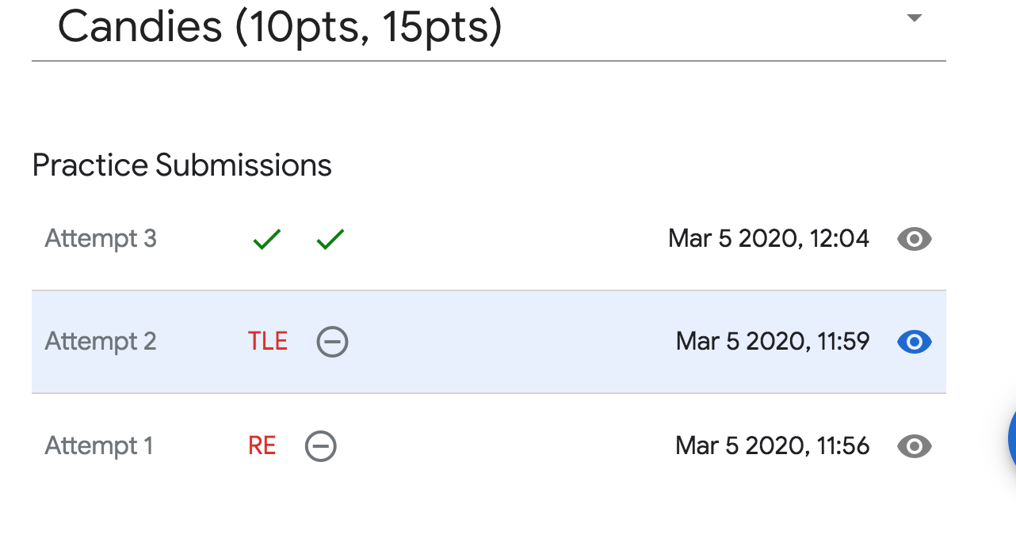
Code:
#include <stdio.h>
#include <string>
#include <iostream>
#include <memory.h>
#include <stdlib.h>
#include <set>
#include <cmath>
#include <vector>
#include <algorithm>
#define MAXN 500010
#define NINF 0x8000000000000000
#define INF 1000000010
using namespace std;
typedef long long lld;
lld A[MAXN],P[MAXN];
multiset<lld> minV;
void solve(lld n,lld o, lld d) {
P[0]=0;
// prefix sum
for(int i=1;i<=n;++i)
P[i] = P[i-1]+A[i];
minV.clear();
lld ans = NINF;
lld odds = 0;
// binary search
int l=1,r=l;
for(;l<=n;++l) {
r = max(r,l);
while(r<=n) {
if(A[r]%2==0) minV.insert(P[r]);
else {
if(odds<o) {
minV.insert(P[r]);
odds++;
} else break;
}
r++;
}
// second conditon
auto it = minV.upper_bound(d+P[l-1]);
if(it!=minV.begin()) {
it--;
ans = max(*it-P[l-1],ans);
}
if(l<r) {
if(A[l]%2!=0) odds--;
minV.erase(minV.find(P[l]));
}
}
if(ans==NINF) printf("IMPOSSIBLE\n");
else printf("%lld\n",ans);
}
int main() {
int t;
scanf("%d",&t);
for(int round=1;round<=t;++round) {
lld n,o,d,x1,x2,a,b,c,m,l;
scanf("%lld%lld%lld",&n,&o,&d);
scanf("%lld%lld%lld%lld%lld%lld%lld",&x1,&x2,&a,&b,&c,&m,&l);
A[1] = x1+l;
A[2] = x2+l;
for(int i=3;i<=n;++i) {
lld tmp = x2;
x2 = (a*x2%m+b*x1%m+c)%m;
x1 = tmp;
A[i] = x2+l;
}
printf("Case #%d: ",round);
solve(n,o,d);
}
}

