Link:
https://codingcompetitions.withgoogle.com/kickstart/round/0000000000051066/0000000000051187

Problem
Given N integers A₁, A₂, ..., A_{N}, count the number of triplets (x, y, z) (with 1 ≤ x < y < z ≤ N) such that at least one of the following is true:
- A_{x} = A_{y} × A_{z}, and/or
- A_{y} = A_{x} × A_{z}, and/or
- A_{z} = A_{x} × A_{y}

Input
The first line of the input gives the number of test cases, T. T test cases follow. Each begins with one line containing an integer N: the number of integers in array A. The second line consists of N integers A_{i}; the i-th of these is the value of the i-th integer, as described above.

Output
For each test case, output one line containing Case #x: y, where x is the test case number (starting from 1) and y is the number of triplets satisfying the condition given in the problem statement.

Limits
1 ≤ T ≤ 30.
Time limit: 40 seconds per test set.
Memory limit: 1 GB.
0 ≤ A_{i} ≤ 2 × 10⁵, for all i.

Small dataset (Test set 1 - Visible)
3 ≤ N ≤ 200.

Large dataset (Test set 2 - Hidden)
3 ≤ N ≤ 7000.

Sample
Input | Output
4  6  5 2 4 6 3 1  6  2 4 8 16 32 64  3  1 1 1  3  200000 200000 200000 | Case #1: 1  Case #2: 6  Case #3: 1  Case #4: 0
In Sample Case #1, the only triplet satisfying the condition given in the problem statement is (2, 4, 5). The triplet is valid since the second, fourth, and fifth integers are 2, 6, and 3, and 2 × 3 = 6.
In Sample Case #2, the six triplets satisfying the condition given in the problem statement are: (1, 2, 3), (1, 3, 4), (1, 4, 5), (1, 5, 6), (2, 3, 5), (2, 4, 6).
In Sample Case #3, make sure you only count the triplet (1, 2, 3) once.
In Sample Case #4, there is no triplet satisfying the condition given in the problem statement since the product of any pair of integers in the array will not be in the array.
When the product of two numbers is d:

d = 0, the product of 0 can be 3 0s, and 2 0s plus a non-zero number, so increase C (times [0], 3) + C (times [0], 2) * (n-times [0])
d = 1, the product of 1 can only be three 1, so increase C (times [1], 3)
d> 1, the last case is relatively simple, factorize d d = a * b:
If a> 1, b> 1: (Remember not to forget the multiplication [d])
If a! = b, then the answer is increased by [d] * times [a] * times [b]
If a == b, then the answer increases times [d] * C (times [a], 2)
For cases where there is 1 in a and b, the answer is a multiple [1] * C (times [d], 2)
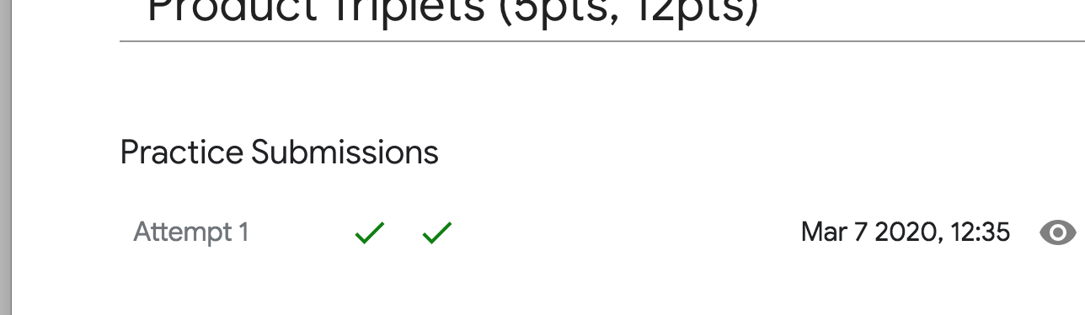
Code:
#include <iostream>
#include <stdlib.h>
#include <string.h>
#include <algorithm>
#include <string.h>
#include <cmath>
#include <map>
#include <set>
#include <vector>
#include <functional>
using namespace std;
const int MAXN = 400010;
const int MAXQ = 100010;
#define ZERO 10e-6
using namespace std;
typedef long long lld;
int n;
map<int,int>counter;
int main() {
int T;
scanf("%d",&T);
int iCase = 0;
while(T--)
{
iCase++;
int n;
scanf("%d",&n);
counter.clear();
for(int i = 0 ;i<n;++i)
{
int a;
scanf("%d",&a);
counter[a]++;
}
lld ans = 0;
for(auto &key :counter)
{
if(key.first<=1)
{
continue;
}
int up = sqrt(key.first);
for(int a = 2;a<=up;++a)
{
if(key.first %a==0)
{
int b = key.first /a;
if(a!=b)
{
ans +=(lld)key.second*counter[a]*counter[b];
}else{
ans += (lld)key.second*counter[a]*(counter[a]-1)/2;
}
}
}
ans += (lld)counter[1]*key.second*(key.second-1)/2;
}
int zeros = counter[0], ones = counter[1];
ans += (lld)zeros*(zeros-1)*(zeros-2)/6+(lld)zeros*(zeros-1)/2*(n-zeros);
ans += (lld)ones*(ones-1)*(ones-2)/6;
printf("Case #%d: %lld\n",iCase,ans);
}
return 0;
}

