Input 1:

colors = 3

# Here comes the graph

1,3

2,18

3,19

2,19

Output1:

Input 2:

# Coloring Problem, generated at: Wed Feb 17 13:47:48 EST 2021

# Colors

colors = 4

# Graph:

1,2

1,3

1,4

1,5

2,3

2,4

2,6

2,7

3,5

3,6

3,7

4,5

4,6

4,7

5,6

5,7

6,7

Input 3:

|  |
| --- |
| # Coloring Problem, generated at: Sun Feb 21 19:34:26 EST 2021 |
|  | # Colors |
|  | colors = 4 |
|  | # Graph: |
|  | 0,1 |
|  | 0,2 |
|  | 0,3 |
|  | 4,5 |
|  | 4,6 |
|  | 4,7 |
|  | 1,5 |
|  | 1,8 |
|  | 5,9 |
|  | 10,11 |
|  | 10,12 |
|  | 10,13 |
|  | 14,15 |
|  | 14,6 |
|  | 14,16 |
|  | 11,15 |
|  | 11,17 |
|  | 15,18 |
|  | 12,6 |
|  | 12,19 |
|  | 20,21 |
|  | 20,13 |
|  | 20,17 |
|  | 21,22 |
|  | 21,23 |
|  | 13,24 |
|  | 24,25 |
|  | 24,26 |
|  | 27,28 |
|  | 27,16 |
|  | 27,18 |
|  | 28,29 |
|  | 28,30 |
|  | 16,9 |
|  | 9,31 |
|  | 32,33 |
|  | 32,17 |
|  | 32,34 |
|  | 33,18 |
|  | 33,35 |
|  | 36,37 |
|  | 36,38 |
|  | 36,39 |
|  | 37,29 |
|  | 37,40 |
|  | 35,29 |
|  | 35,41 |
|  | 34,22 |
|  | 34,41 |
|  | 22,42 |
|  | 43,42 |
|  | 43,38 |
|  | 43,44 |
|  | 42,45 |
|  | 41,38 |
|  | 46,39 |
|  | 46,47 |
|  | 46,48 |
|  | 49,44 |
|  | 49,50 |
|  | 49,51 |
|  | 39,44 |
|  | 8,52 |
|  | 8,31 |
|  | 52,47 |
|  | 52,53 |
|  | 40,47 |
|  | 40,30 |
|  | 31,30 |
|  | 54,55 |
|  | 54,25 |
|  | 54,56 |
|  | 55,50 |
|  | 55,57 |
|  | 45,50 |
|  | 45,23 |
|  | 25,23 |
|  | 2,58 |
|  | 2,53 |
|  | 58,57 |
|  | 58,59 |
|  | 48,51 |
|  | 48,53 |
|  | 51,57 |
|  | 26,56 |
|  | 26,19 |
|  | 56,59 |
|  | 19,7 |
|  | 59,3 |
|  | 7,3 |

Output 3: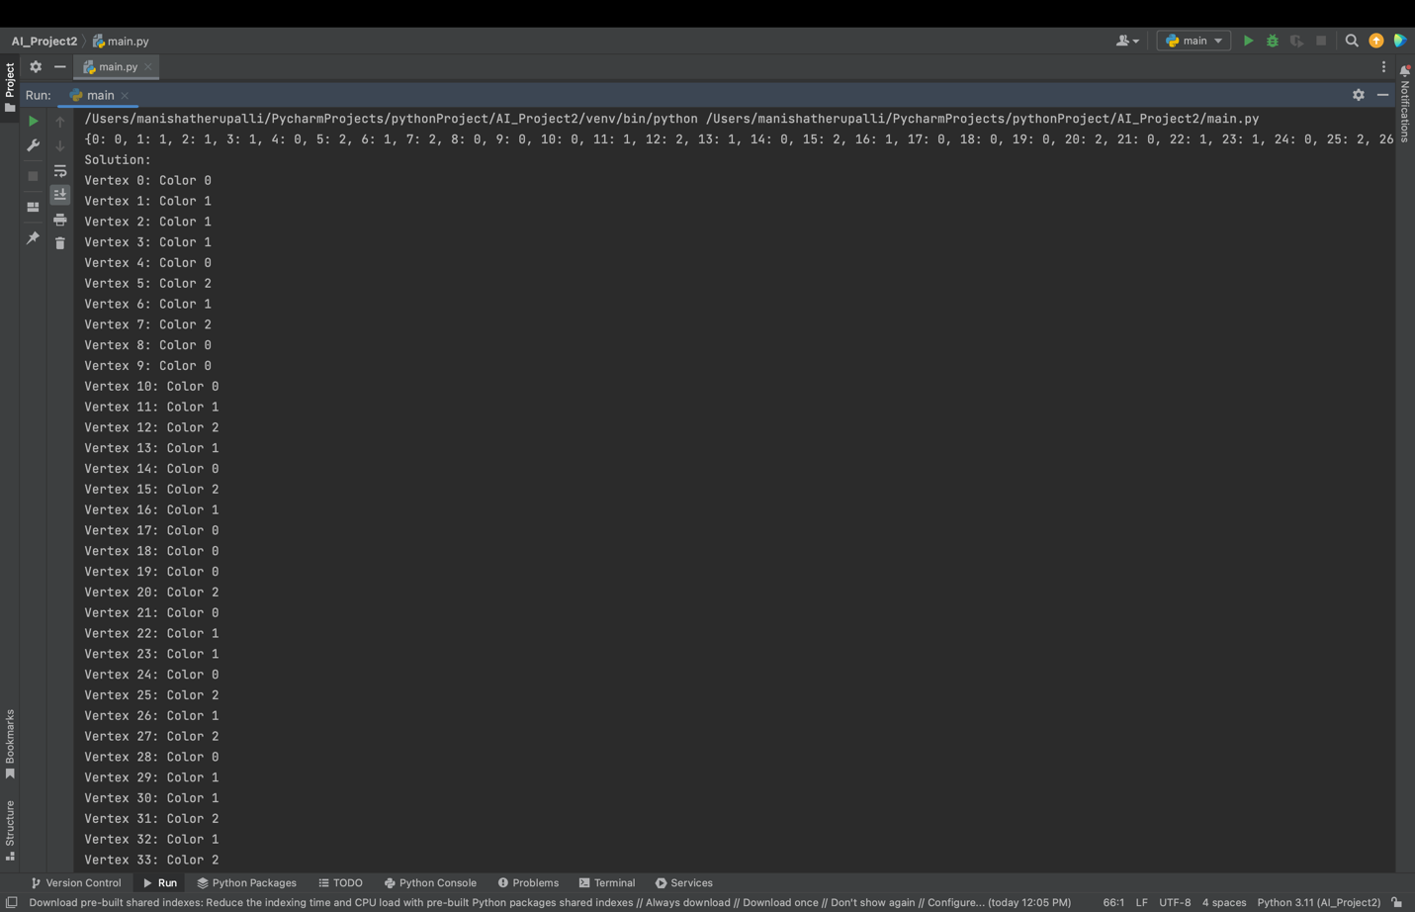

Input 4:

|  |
| --- |
| # Coloring Problem, generated at: Sun Feb 21 19:34:26 EST 2021 |
|  | # Colors |
|  | colors = 4 |
|  | # Graph: |
|  | 0,1 |
|  | 0,2 |
|  | 0,3 |
|  | 0,4 |
|  | 0,5 |
|  | 0,6 |
|  | 1,2 |
|  | 1,6 |
|  | 1,7 |
|  | 1,8 |
|  | 1,9 |
|  | 2,3 |
|  | 2,8 |
|  | 2,10 |
|  | 11,3 |
|  | 11,4 |
|  | 11,12 |
|  | 11,10 |
|  | 11,13 |
|  | 3,4 |
|  | 3,10 |
|  | 4,5 |
|  | 4,13 |
|  | 5,6 |
|  | 5,14 |
|  | 5,13 |
|  | 5,15 |
|  | 5,16 |
|  | 6,17 |
|  | 6,9 |
|  | 6,16 |
|  | 17,18 |
|  | 17,9 |
|  | 17,16 |
|  | 17,19 |
|  | 18,7 |
|  | 18,9 |
|  | 18,19 |
|  | 18,20 |
|  | 7,8 |
|  | 7,9 |
|  | 7,20 |
|  | 7,21 |
|  | 8,12 |
|  | 8,10 |
|  | 8,14 |
|  | 8,21 |
|  | 12,10 |
|  | 12,14 |
|  | 12,13 |
|  | 14,13 |
|  | 14,15 |
|  | 14,21 |
|  | 14,22 |
|  | 15,16 |
|  | 15,19 |
|  | 15,22 |
|  | 16,19 |
|  | 19,20 |
|  | 19,22 |
|  | 20,21 |
|  | 20,22 |
|  | 21,22 |

Output4:

Input 5 :

|  |
| --- |
| # Coloring Problem, generated at: Sun Feb 21 19:34:26 EST 2021 |
|  | # Colors |
|  | colors = 4 |
|  | # Graph: |
|  | 0,1 |
|  | 0,2 |
|  | 0,3 |
|  | 0,4 |
|  | 0,5 |
|  | 1,6 |
|  | 1,7 |
|  | 1,3 |
|  | 1,4 |
|  | 6,8 |
|  | 6,9 |
|  | 6,7 |
|  | 6,10 |
|  | 6,3 |
|  | 8,11 |
|  | 8,7 |
|  | 8,10 |
|  | 8,12 |
|  | 11,13 |
|  | 11,10 |
|  | 11,12 |
|  | 11,14 |
|  | 13,15 |
|  | 13,12 |
|  | 13,14 |
|  | 13,16 |
|  | 15,2 |
|  | 15,9 |
|  | 15,14 |
|  | 15,16 |
|  | 15,5 |
|  | 2,16 |
|  | 2,4 |
|  | 2,5 |
|  | 9,10 |
|  | 9,14 |
|  | 9,3 |
|  | 9,5 |
|  | 7,12 |
|  | 7,16 |
|  | 7,4 |
|  | 10,14 |
|  | 12,16 |
|  | 16,4 |
|  | 3,5 |

Output 5:

Input 6:

|  |
| --- |
| # Coloring Problem, generated at: Sun Feb 21 19:34:26 EST 2021 |
|  | # Colors |
|  | colors = 4 |
|  | # Graph: |
|  | 0,1 |
|  | 1,2 |
|  | 2,3 |
|  | 3,4 |
|  | 4,5 |
|  | 5,6 |
|  | 6,0 |
|  | 7,8 |
|  | 8,9 |
|  | 9,10 |
|  | 10,11 |
|  | 11,12 |
|  | 12,7 |
|  | 0,2 |
|  | 0,4 |
|  | 0,5 |
|  | 1,6 |
|  | 1,13 |
|  | 2,4 |
|  | 2,13 |
|  | 2,14 |
|  | 3,5 |
|  | 3,14 |
|  | 3,7 |
|  | 3,11 |
|  | 5,7 |
|  | 5,8 |
|  | 6,13 |
|  | 6,8 |
|  | 6,9 |
|  | 13,14 |
|  | 13,9 |
|  | 13,10 |
|  | 14,10 |
|  | 14,11 |
|  | 7,11 |
|  | 8,12 |
|  | 9,12 |
|  | 10,12 |

Output 6:

