# 项目立项报告

**项目名称：（暂未定名）**

**项目负责人 ：苏韦豪**

**开 发 人 员：苏韦豪**

**宋佳男**

**徐 溥**

**何志翔**

**指 导 教 师：李 宇**

**起 止 日 期：2020年2月-2020年6月**

1. Introduction

随着中国经济的发展，互联网技术的不断更替，网络购物成为中国购物方式的主流，而中国奢侈品市场近年来不断蓬勃发展，但是电子商务化程度不高，购物偏向门店。为了赶上国外奢侈品线上购物趋势，提升奢侈品购买体验，我们计划开发一个奢侈品电商平台，便于消费者们精确便捷地了解产品，购买产品。综上所述，我们对以上要求进行了分析与讨论，设计了一个满足高端客户需求的奢侈品电商平台，作为中间商为国外品牌和中国消费者搭建一个桥梁，并为管理人员提供仓库管理、信息管理、客户分析、KPI分析预测的平台。

2. Core technology and Innovation points

Core technologies:

1. Configurable software login verification method

2. Logistics tracking

3. Timely message reminder mechanism

4. The kpi algorithm

5. Flexible payment methods

6. Timely response mechanism

Innovation points

1. Big data analysis of Customers and KPIs

2. IOT techniques

3. PIECES Analysis

|  |  |  |
| --- | --- | --- |
| Performance | Throughput  Response Time | |
| Information  and Data | Outputs | Lack of any information  Lack of necessary information  Lack of relevant information  Too much information – information overload  Information that is not in a useful format  Information that is not accurate  Information that is difficult to produce  Information that is not timely to its subsequent use |
| Inputs | Data is not captured  Data is not captured in time to be useful  Data is not accurately captured – contains errors  Data is difficult to capture  Data us captured redundantly – same data is captured more than once  Too much data is captured  Illegal data is captured |
| Stored Data | Data is stored redundantly in multiple files and/or databases  Stored data is not accurate  Data is not secure from accident or vandalism  Data is not well organized  Data is not flexible – not easy to meet new information needs from stored data  Data is not accessible |
| Economics | Costs | Costs are unknown  Costs are untraceable  Costs are too high |
| Profits | New markets can be explored  Current marketing can be improved |
| Control and Security | Too little security or control | Input data is not adequately edited  Crimes (e.g. fraud, embezzlement) are (or can be) committed against the data  Ethics are breached on data or information – refers to data or information getting to unauthorized people  Redundantly stored data is inconsistent in different files or databases  Data privacy regulations or guidelines are being (or can be) violated  Processing errors are occurring (either by people, machines, or software)  Decision- making errors are occurring |
| Too much control or security | Bureaucratic red tape slows the system  Controls inconvenience customers or employees  Excessive controls cause processing delays |
| Efficiency | People, machines, or computers waste time | Data is redundantly input or copied  Data is redundantly processed  Information is redundantly generated |
| People, machines, or computers waste materials and suppliers | Effort required for tasks is excessive  Materials required for tasks is excessive |
| Service | The system produces inaccurate results  The system produces inconsistent results  The system produces unreliable results  The system is not easy to learn  The system is not easy to use  The system is awkward to use  The system is inflexible to new or exceptional situations  The system is inflexible to change  The system is incompatible with other systems  The system is not coordinated with other systems | |

4.Feasibility Analysis

|  |  |
| --- | --- |
| Culture Feasibility | Is the system supported by the administrator?  About which aspects will the user or administrator protest or complain? Will the working ambience of the users vary? Could the users adapt to this change?  What do the final users concern the role they play in the system? |
| Operation Feasibility | The problem solving and chance taking ability of the percept  The scale of satisfying the requirement |
| Technology Feasibility | Is the technological proposal realistic? Do we process the technique required? How familiar is the team with those technique?  Do we have experts of those domains? Is the progress rational? |
| Progress Feasibility | Is the deadline of the program rational? The deadline is obligatory or expectational? |
| Economy Feasibility | Does the possible profit make the program development worthy at the early phase? See the Budget Analysis table below |
| Law Feasibility | Copyright law The demand of financial report Data sharing protocal Processing and storage of data |

5. Budget Analysis

Personnel:

|  |  |  |
| --- | --- | --- |
| 1 | Systems Analysts | 10000yuan |
| 3 | Programmer/Analysts | 8000yuan |
| 5 | GUI Designer | 5000yuan |
| 1 | Telecommunications Specialist | 10000yuan |
| 1 | System Architect | 15000yuan |
| 1 | Database Specialist | 8000yuan |
| 1 | Security Specialist | 10000yuan |

New Software:

|  |  |  |
| --- | --- | --- |
| 1 | Development Server | 1600yuan |
| 1 | DBMS server software | 1500yuan |
| 4 | DBMS client software | 500yuan |

|  |
| --- |
| ￥107100 |

Total Development Costs:

PROJECTED ANNUAL OPERATING COSTS

Personnel:

|  |  |  |
| --- | --- | --- |
| 1 | Programmer/Analysts | 12000yuan/year |
| 1 | System Librarian | 18000yuan/year |

Expenses:

|  |  |  |
| --- | --- | --- |
| 1 | Maintenance Agreement for server | 1600yuan/year |
| 1 | Maintenance Agreement for server DBMS software | 1200yuan/year |
| 1 | Domain Name | 500yuan for 5 years |

|  |
| --- |
| ￥32900 |

Total Projected Annual Costs:

6.Planification of project

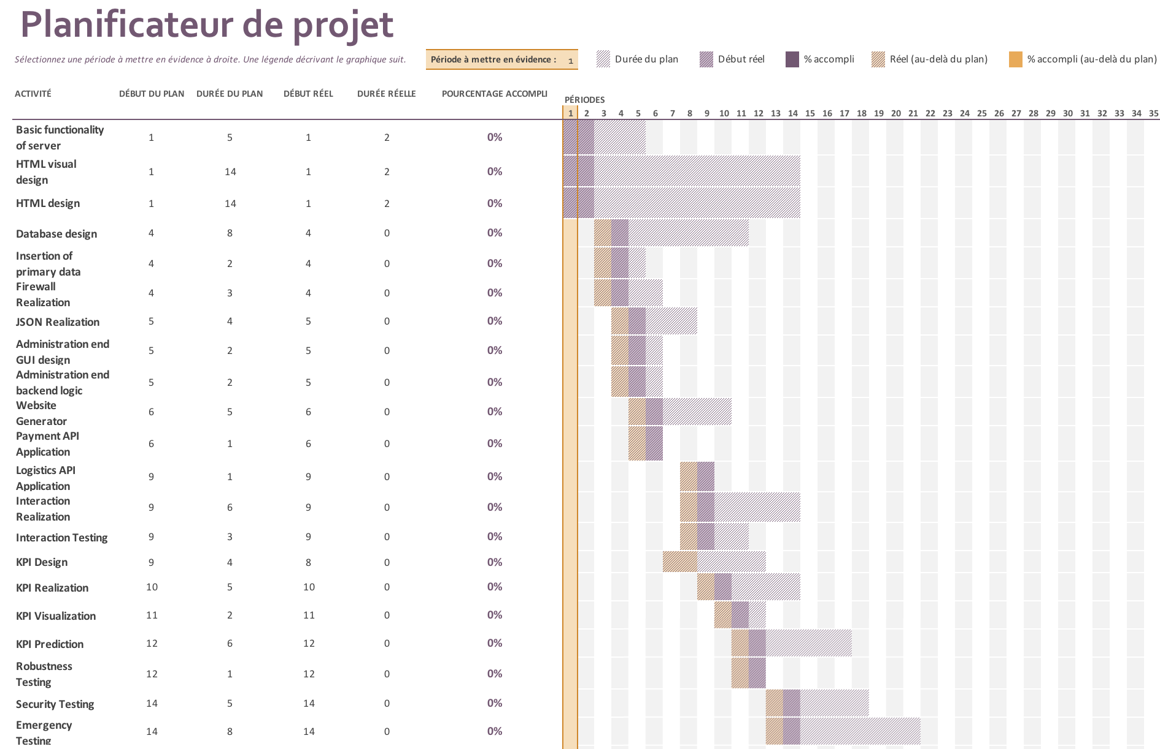

The structure of work