Game design report

Game name:

Long Liu 20104729

Software system practice Year 4

Date:

Supervisor:

**1. game overview**

**1.1 game concept**

This game is Horizon version adventure game . Players can move up, down ,left and right. Players have a base to upgrade abilities. The enemy will appear fixed range and attack the player. As the time goes on,player can collect materials to make tools and update modes. By these objects, payers can increase the maximum life value and power value and acquire new kills. When the game enters some specfic days, some enemies will actively attack player's base. Player need to guard base to avoid failure of the game. Player can gain materials by killing enemies and collecting. Materials can be used to upgrade base and player. On the base, player can build defense towers and trap.

**1.2 genre**

The type of the game will horizontal version adventure game. Players will watch the game horizontally from top to bottom and scroll horizontally.

**1.3 Target Audience**

My target audience will be people have interests in adventadure. It mainly refers to players who can accept pixel style , combat with enemies and discover new things. Targeting the market for high school students and college students.

**1.4 Game Flow Summary**

The game will load the main menu, where players can select new games, options, or archives. In the game itself, player need to upgrade base to the highest level, and hold the base during an attack triggered by the upgrade.

**1.5 Look and Feel**

I want the game to look and feel like a pixel adventure game. Similar to Terraria. Here are some relevant games pictures:

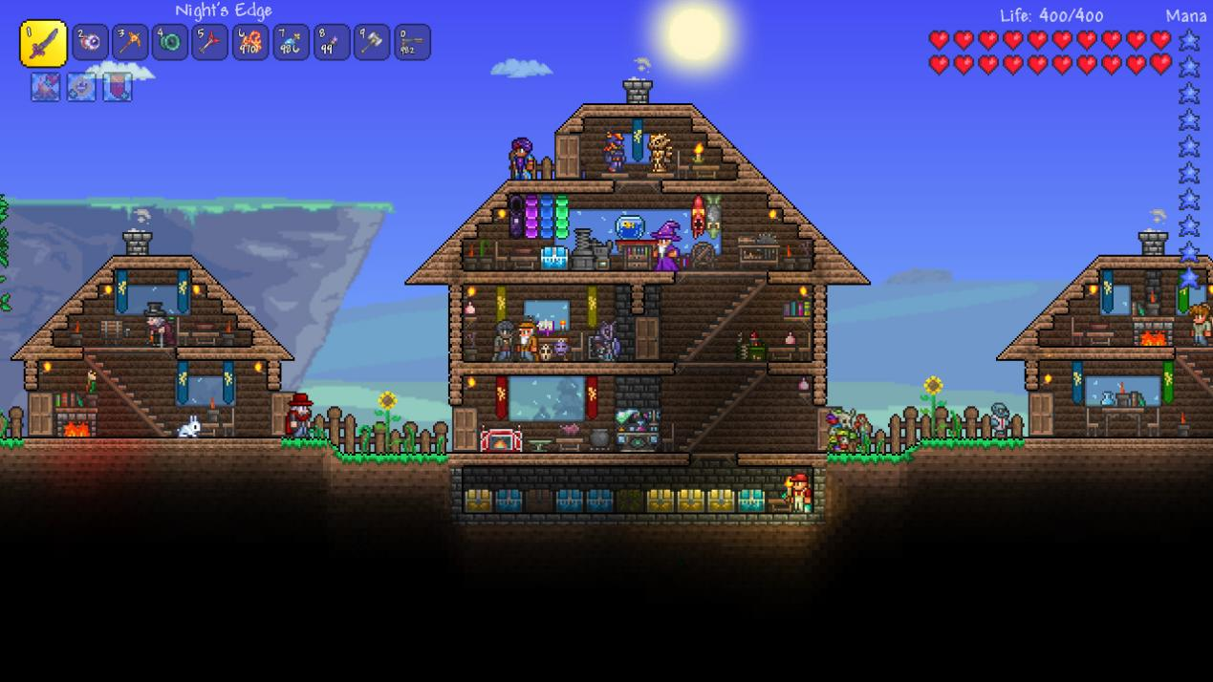

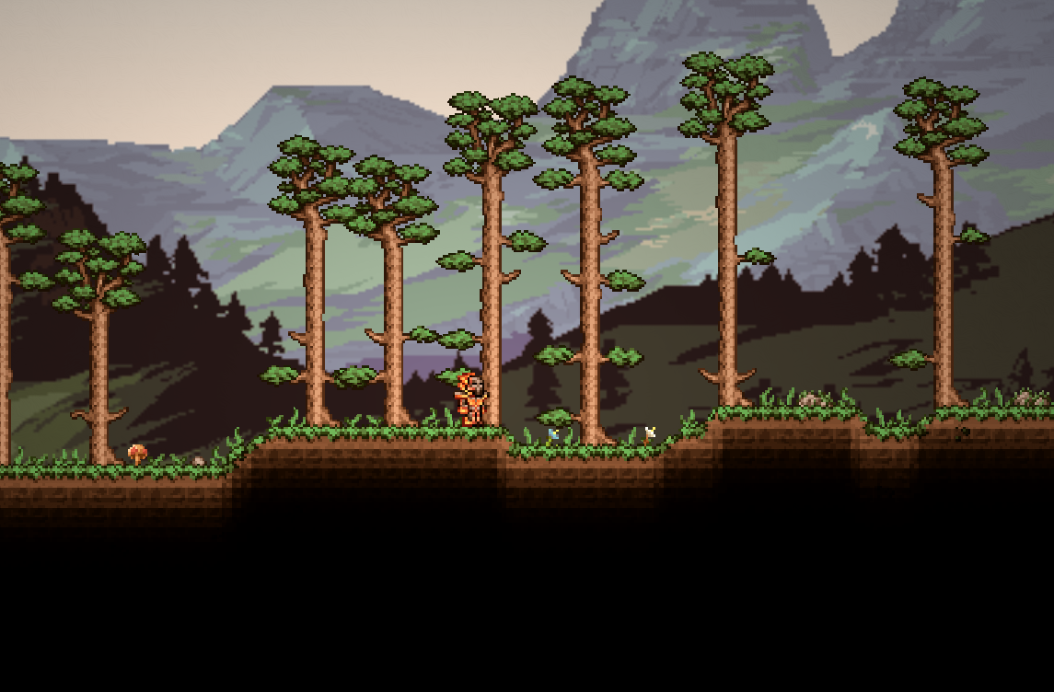

**7.3 Game Engine**

**Godot** is a cross-platform, free and open-source game engine released under the permissive MIT license. It was initially developed by Argentine software developers Juan Linietsky and Ariel Manzur for several companies in Latin America prior to its public release in 2014. The development environment runs on many platforms, and can export to several more. It is designed to create both 2D and 3D games targeting PC, mobile, and web platforms and can also be used to develop non-game software, including editors.

Godot allows video game developers to create 3D and 2D games using multiple programming languages, such as **C#**.