Game design report

Game name:

Long Liu 20104729

Software system practice Year 4

Date:

Supervisor:Mairead Meagher

**1. game overview**

**1.1 game concept**

This game is Horizon version adventure game. Players can move, left and right. Players have a base to upgrade abilities. The enemy will appear at a fixed range and attack the player. As time goes on, the player can collect materials to make tools and update modes. By these objects, payers can increase the maximum life value. When the game enters some specific days, some enemies will actively attack the player's base. Player need to guard base to avoid failure of the game. Player can gain materials by killing enemies and collecting. Materials can be used to upgrade base and player. On the base, player can build defense buildings.

**1.2 genre**

The type of the game will be a horizontal version adventure game. Players will watch the game horizontally from top to bottom and scroll horizontally.

**1.3 Target Audience**

My target audience will be people who have interests in adventure. It mainly refers to players who can accept pixel style, combat with enemies and discover new things. Targeting the market for high school students and college students..

**1.4 Game Flow Summary**

The game will load the main menu, where players can select new games, options, or archives. In the game itself, player needs to upgrade base to the highest level, and hold the base during an attack triggered by the upgrade.

**1.5 Look and Feel**

I want the game to look and feel like a pixel adventure game. Similar to “Kingdom: New Lands”or”Until We Die”. Here are some relevant games pictures:

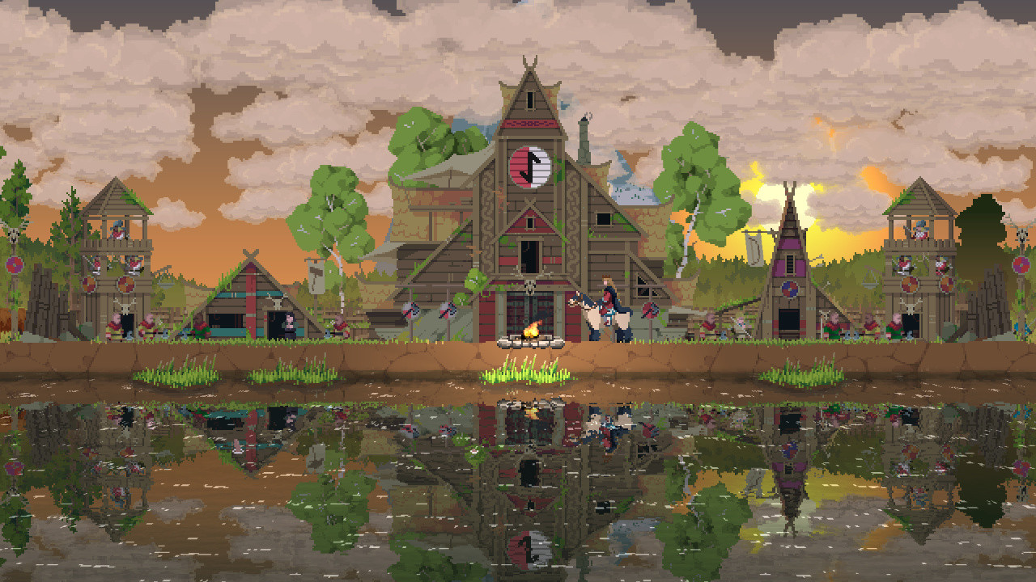

Kingdom: New Lands

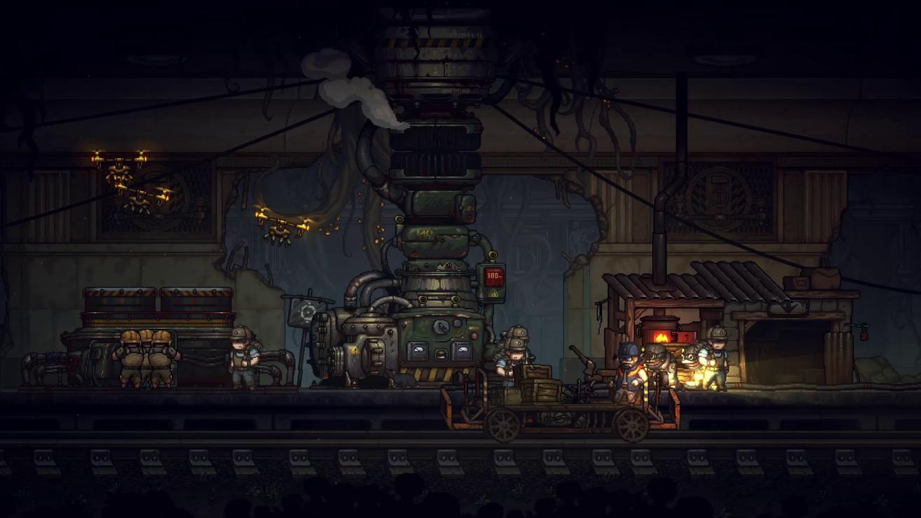

Until We Die

**1.6 Project Scope**

**1.6.1. Number of Location**

Player and enemies will born to an only one map. Player and base will appear on the centre of the map, and enemy nests will appear on the two ends of the map. Some broken buildings or hidden buildings will appear on the space between base with nests. Player can repair these broken buildings to get some annexe. These annexe can support some extra functions.

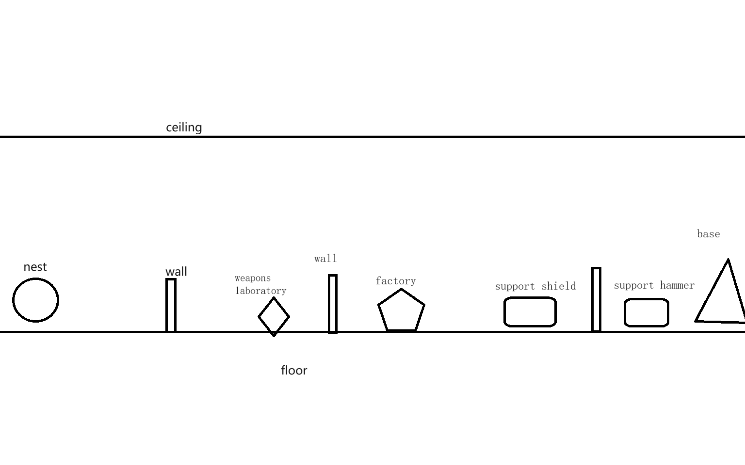

Left half map

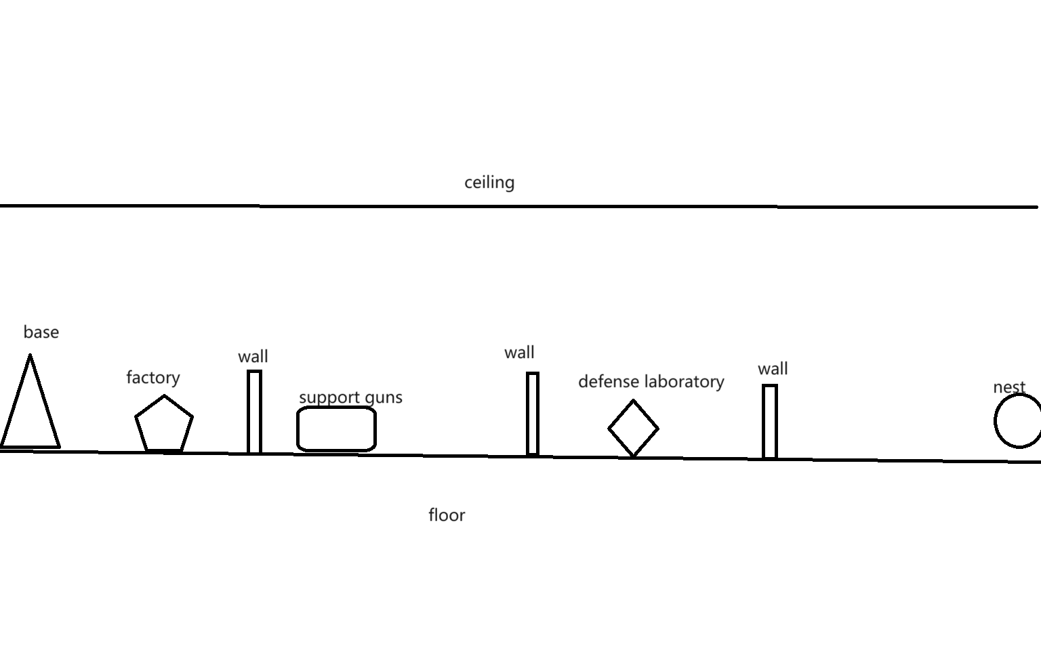

Right half map

**1.6.2. Number of Enemies**

There will be three kinds of enemies.

Crawler: attack from above, low health, fast speed , medium attack power

Attacker: attack from frontal, medium heath, medium speed ,medium power

Thrower: range attack, low heath medium speed, medium attack power

Every enemies come from nest.

**1.6.3. Number of Buildings**

Base location: 1 base, 2 nests

Annexe location:

6 wall building points

3 kinds of buildings for support tools

1 weapons laboratory

1 defense laboratory

2 factories

Base: improve other buildings’ max level, attract new refugees interval time, have 3 levels,

If base is destroied, the game will over.

Wall: defense attack ,have 3 levels

Weapons laboratory: improve attack power, have 2 levels, need workers to finish update projects

Defense laboratory: improve wall health, have 2 levels, need workers to finish update projects

Factory: produce materials, have 2 levels, need workers to work

buildings for support tools: support hammers, guns, shield, need workers to work

Nest: enemies will appear there, have 3 levels.

**1.6.3. Number of NPC**

There are 4 kinds of NPC.

Civilian: refugee will be civilian after they get one piece of material.

Worker: build buildings ,repair buildings, need hammer

Soldier: range attack, need guns

defender: have shield for blocking attack. Defender will use lance to attack, when they behind wall.

**1.6.3. Number of Player**

Range attack, have a bag, improve the bag volume rely on the level of base, medium attack power, high health, medium speed, use power increase speed in a short time,

If player died, the game will over.

**9. Technical**

**9.1. Target Hardware**

MINIMUM:

|  |  |
| --- | --- |
| OS: | Windows 7 |
| Processor: | Intel 4th Gen Dual Core 2.0Ghz |
| Memory: | 2 GB RAM |
| Graphics: | Nvida GTX Series 8 |
| Storage: | 4 GB available space |
| Additional Notes: | The game can likely run on lower rated hardware, but I can't guarantee the performance or provide support. |

**9.2. Development hardware and software**

**9.2.1 Hardware**

|  |  |
| --- | --- |
| OS: | Windows 11(x64) |
| Processor: | 13th Gen Intel(R) Core(TM) i9-13980HX 2.20 GHz |
| Memory: | 32.0 GB |
| Graphics: | Nvida RTX 4090 laptop |
| Storage: | 1 TB available space |

**9.2.2 Software**

Godot v4.12 is the latest official version when I started developing the prototype.

Git,Microsoft Visual Studio,etc.

**9.3. Game Engine**

**Godot** is a cross-platform, free and open-source game engine released under the permissive MIT license. It was initially developed by Argentine software developers Juan Linietsky and Ariel Manzur for several companies in Latin America prior to its public release in 2014. The development environment runs on many platforms, and can export to several more. It is designed to create both 2D and 3D games targeting PC, mobile, and web platforms and can also be used to develop non-game software, including editors.

Godot allows video game developers to create 3D and 2D games using multiple programming languages, such as C#,C++,GDscript.

**9.5. Scripting Language**

The scripting language that will be used for this project is C#. Because it is one of the main languages of choice for scripting in the Godot game engine.

**11. Project Management**

**11.1. Project Methodology**

In this game development project, I chose to adopt an agile development method. Agile methodologies are known for their high adaptability to rapid change and uncertainty and are well suited to meet the ever-changing needs and challenges of game development. In contrast to the waterfall model, agile development divides the development process into shorter iterative increments. At the end of each iteration, a final usable product is produced. If requirements change, the method can be developed in the next iteration cycle.

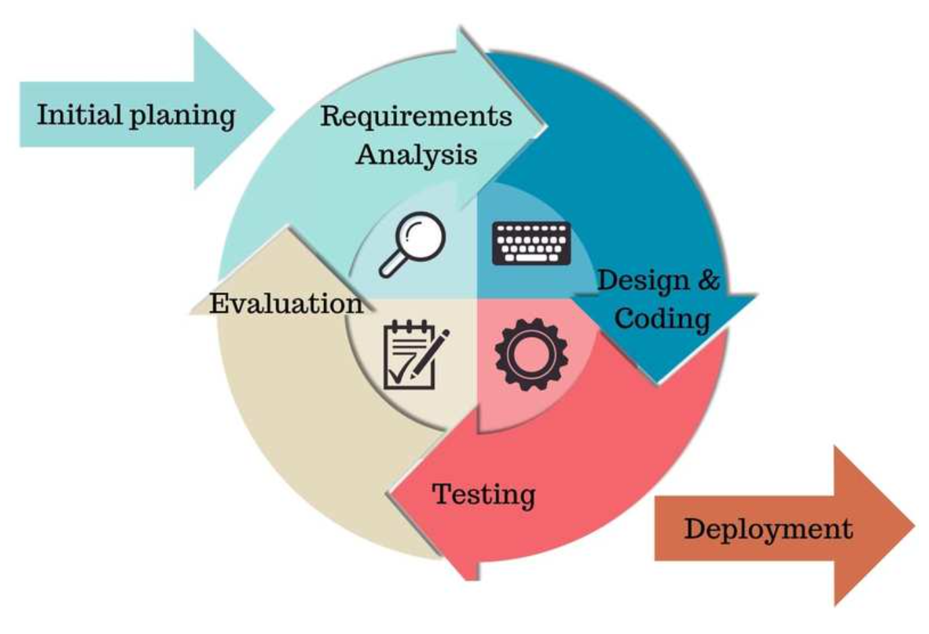

**11.2. Detailed Schedule**

|  |  |  |  |
| --- | --- | --- | --- |
|  | End date | Deliverables | progress |
| 1 | 23/11/19 | Doc:Gameplay and Mechanics part1 |  |
| 2 | 23/11/22 | Doc:Gameplay and Mechanics part2 |  |
| 3 | 23/11/26 | Doc:Story, Setting and Character |  |
| 4 | 23/11/29 | Doc:Interface(contains Visual System,audio,etc) |  |
| 5 | 23/12/3 | Doc:Game Art |  |

**11.3. Version control**

Github is a hosting platform for open source and proprietary software projects. As an open source repository and version control system, Github has more than 9 million developer users. As more and more applications move to the cloud, Github has become the preferred method for managing software development and discovering existing code. So I'll use Github to keep pushing code.

However, once the project exceeds 100MB, Github will refuse to upload it. So I only uploaded the part that designed the key code, not the whole project.

**11.4. Risk Analysis**

|  |  |  |  |
| --- | --- | --- | --- |
| Risk Description | Risk Probability | Risk Impact | Risk Mitigation Strategy |
| Underestimating engineering difficulty | High | High |  |
| Contracting illness | Low | Low | Avoiding Sickness |
| Inability to meet deadlines | Med | Med |  |
| Lose of Report/Documentation | Low | High | Documentation stored on Baidu Yun Drive with regular Copies stored on several devices locally. |
| Lose of Project/Workspace | Med | High | Project stored on Baidu Yun Drive with regular Copies stored on several devices locally.kept on local devices. |

**11.5. Test Plan**

|  |  |
| --- | --- |
|  | Test Plan |
| When? | At the end of every sprint. |
| Who? | People comes from Internet |
| Where? | Send testers a test version of the game via the game forum. The lack of connection between developers and testers facilitates critical analysis. |
| What? | Specific problems found during development. |
| How? | The developer will not be present and will provide playtesters with the game executable and a short questionnaire. Outside of the questionnaire, they can also make any complaints or suggestions they may have. |