**2218-CSE5335-004 PROJECT OVERVIEW**

**\*\*\*\*\* Any images used in this document are purely for illustrational purposes. \*\*\*\*\*\***

**\*\*\*\*\*\*\*\*\*\*\*\*Please do not copy the styling used here for your project\*\*\*\*\*\*\*\*\*\*\*\*\*\*\*\*\*\***

**\*\*\*\*\*\*\*\*\*\*\*\*\*Doing so will reduce your chances of scoring full points\*\*\*\*\*\*\*\*\*\*\*\*\*\*\*\*\*\***

**LIBELULA**

**Description**

Libelula is a unique exciting store. It offers several products such as shoes, bags, belts, cloth, slimming wear. It also produces cakes, cookies etc. Uniqueness from this site comes from having the owner of the place Lorena producing everything herself. She also offers other services such as doing some models for you, and you bring to other place. She offers course such as how to make cakes, how to make models, etc. She decided to have her own store, a nice entrepreneur. She is thinking about becoming a worldwide wholesale place. We want to help her.

She wants to offer all her services and products in her site.

She wants a site to offer her products, services and sell them.

Libelula site is an E-commerce that offers products and services and both products and services can be acquired from her site. We as developer need to define her catalog and setup a place to sell her products. Her site is in English and Spanish.

There are three roles in this site.

**Roles:**

Customer, Admin, Super-admin

**Features:**

Register Products

Register Services

Register courses

Register Places where courses are offered ( courses are online but places define currency conversion)

Register places where merchandise is sent.

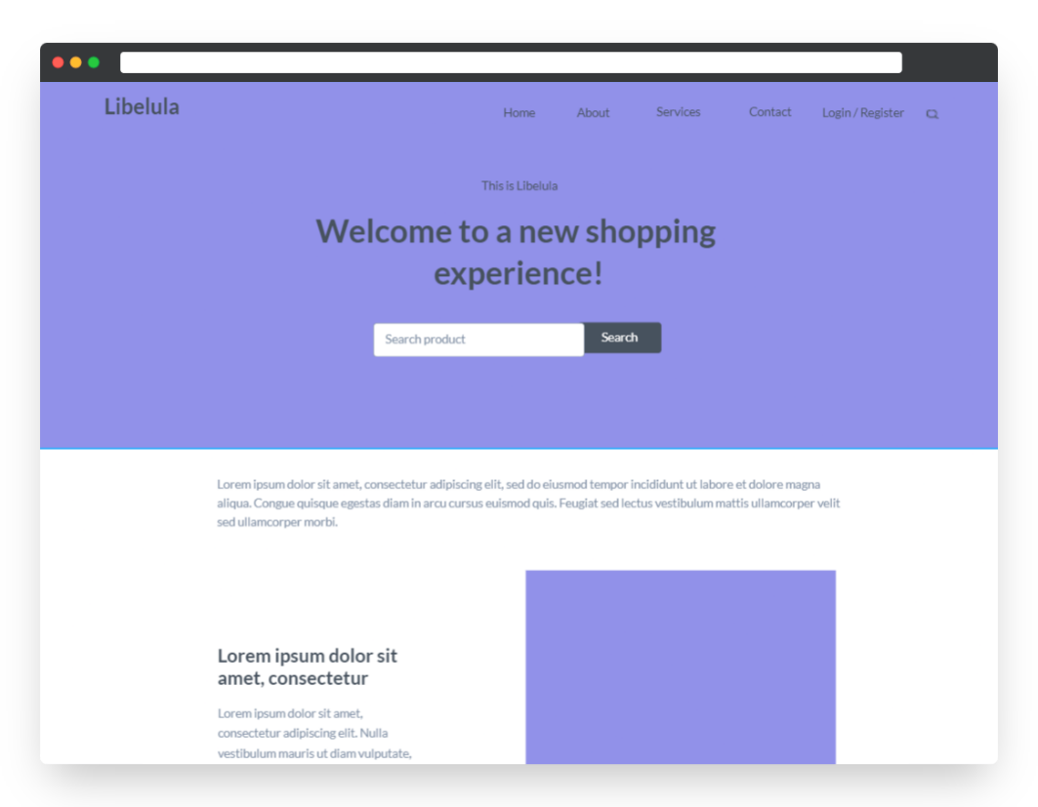**HOME PAGE**

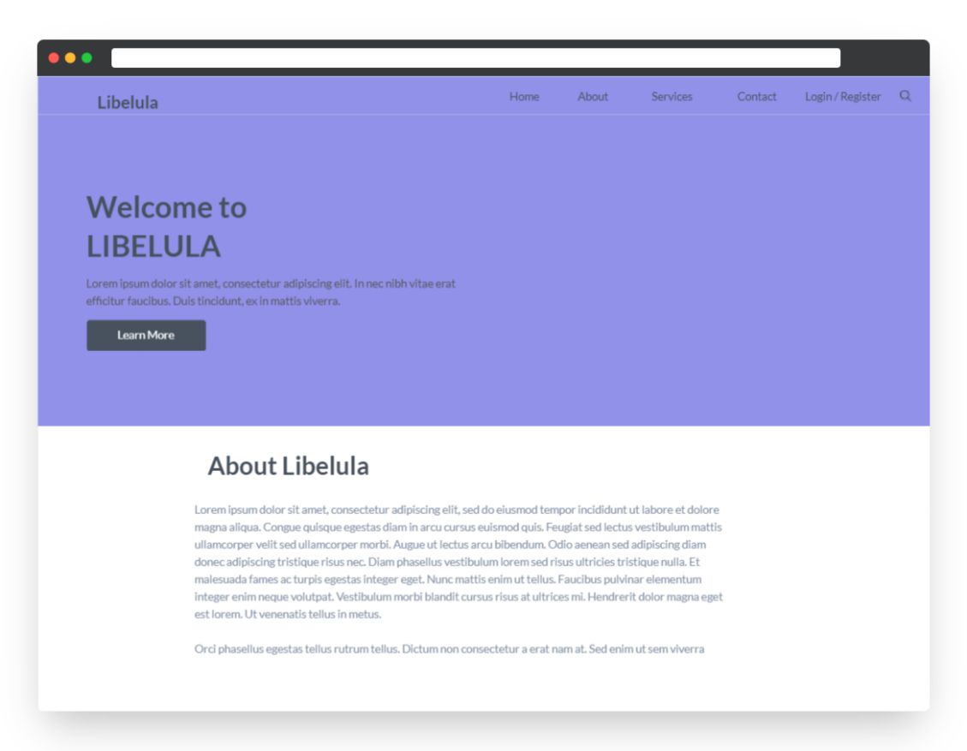**ABOUT PAGE**

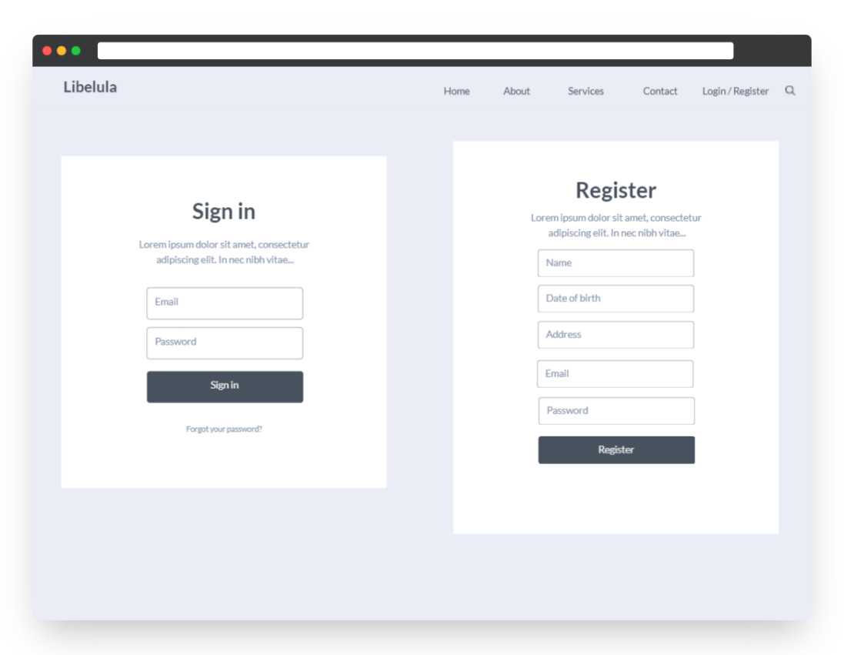**LOGIN PAGE**

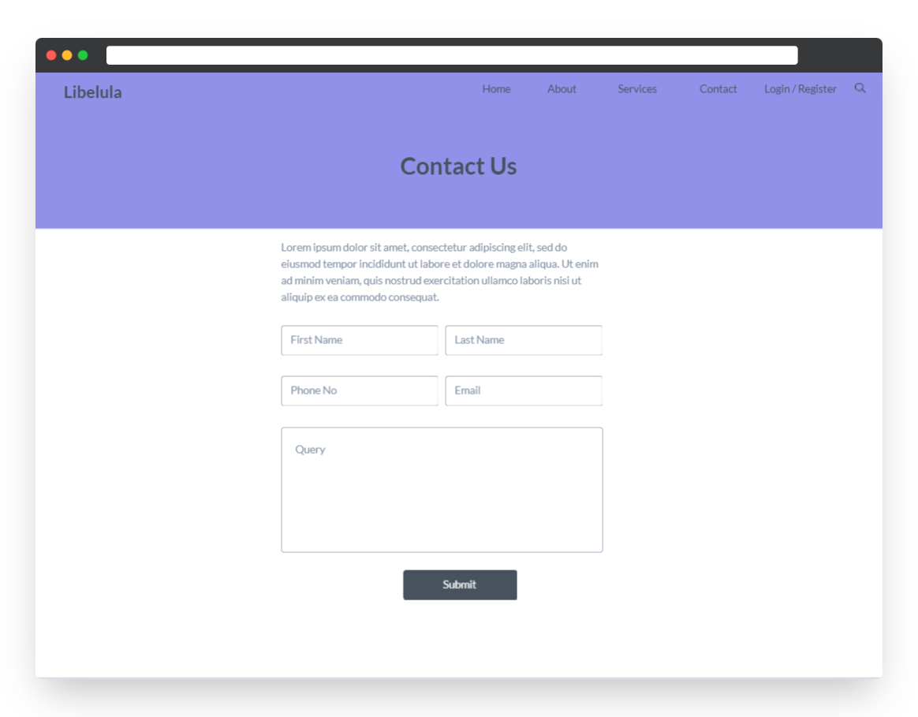**CONTACT PAGE**

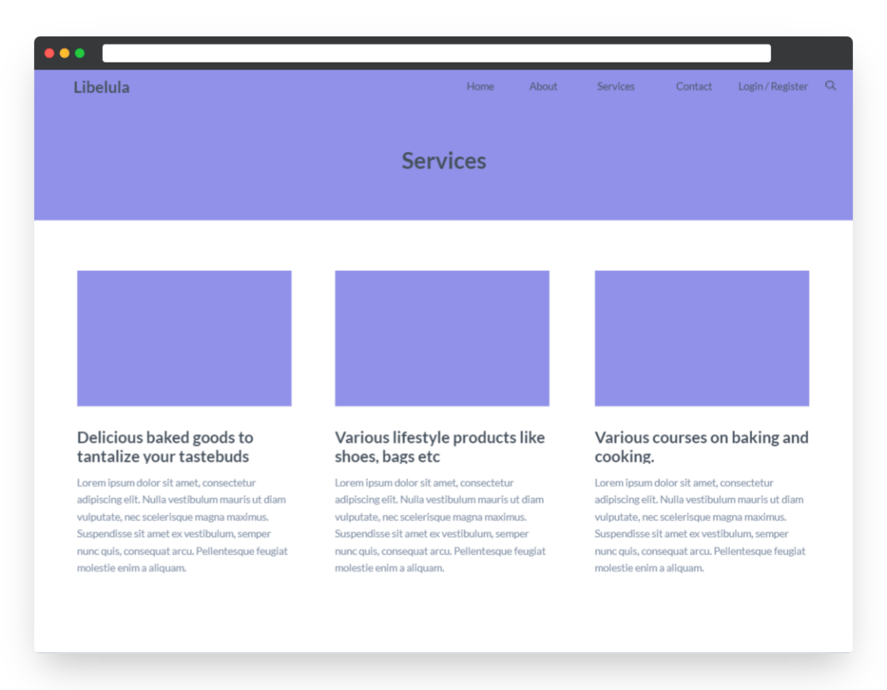**SERVICES PAGE**

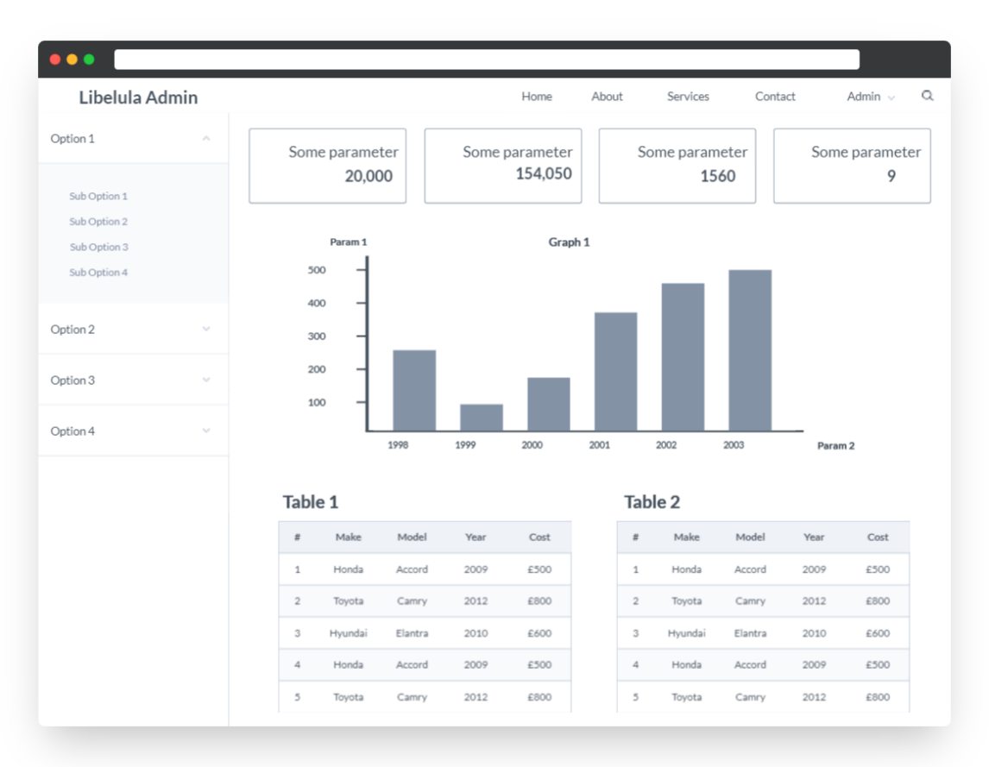**ADMIN PAGE**

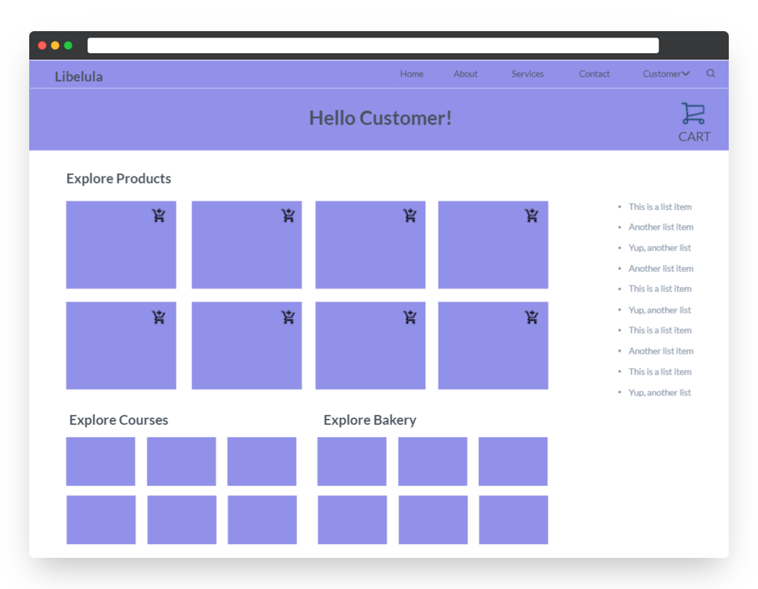**CUSTOMER PAGES**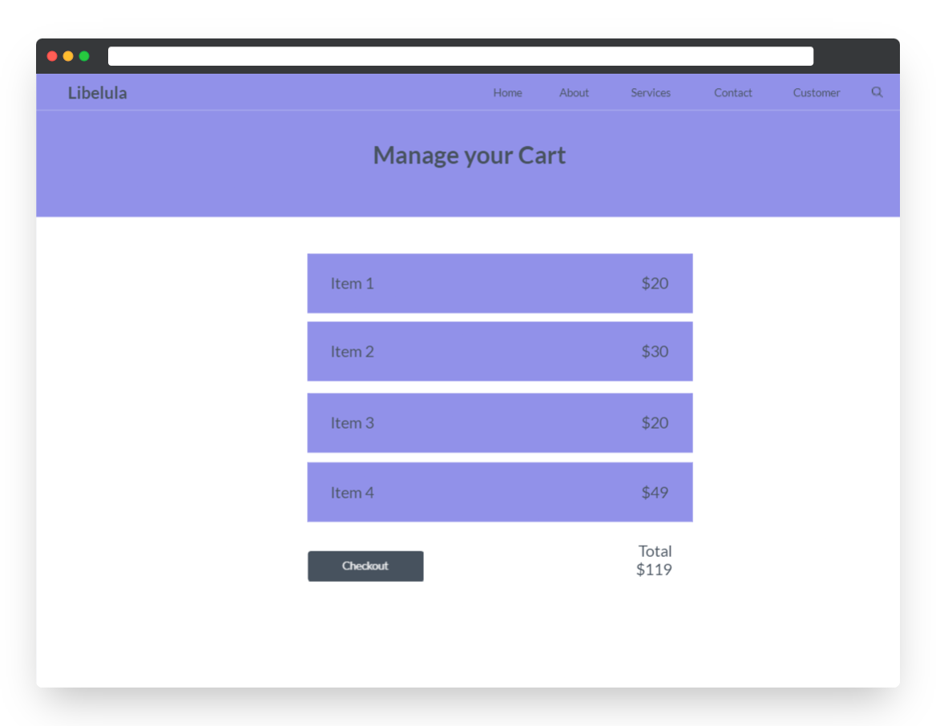

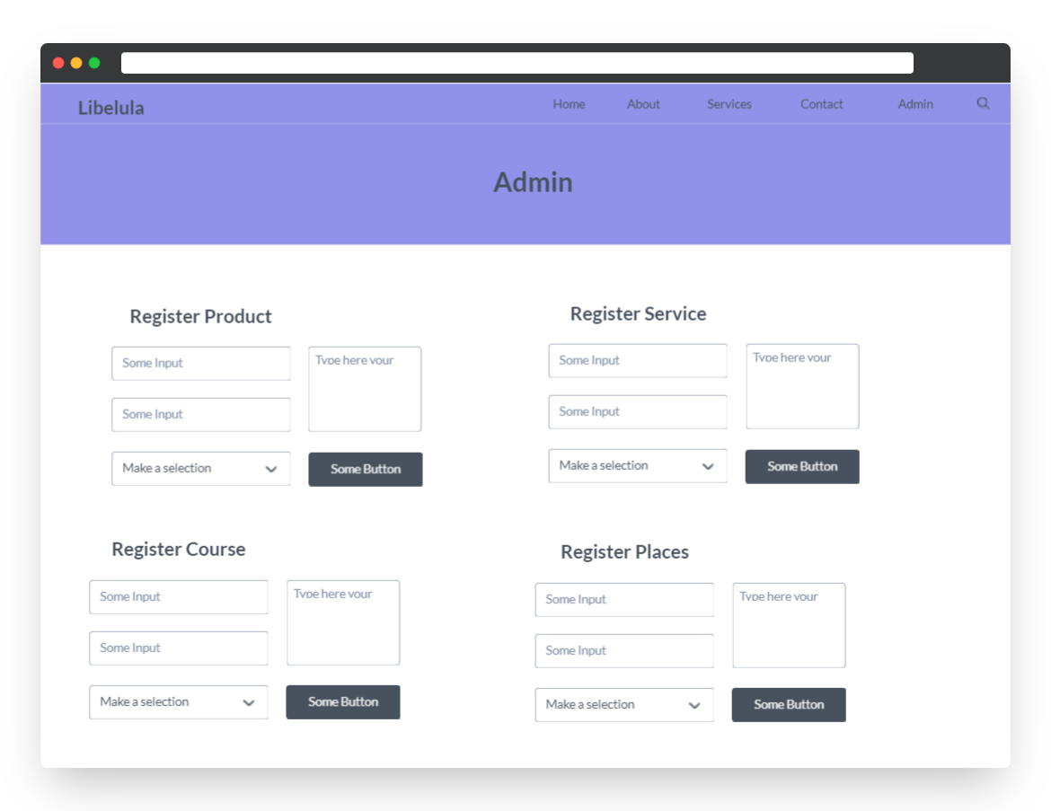**OWNER/ADMIN PAGE**

**Note:**

1. Be Creative on all pages, add more fields if you feel the need to get more information about Residents.

2. Register Residents separately.

3. Register the Inspector separately.

4. All input fields should have input validations.

5. Approach the project from a startup perspective. You are a startup trying to solve a problem. How would you implement the project?

6. The above mockups are purely for illustration. You **do** **not** have to implement it the same way or use those exact semantics. Use your imagination. Your end-product should be usable. If your project is released to a 100 people. They should have no trouble figuring out how to use it.

7. **Do not share your source code with other teams. In the spirit of friendly competition, the best project will be awarded 10 extra points at the end of the semester.**

**Pages After Login:**

**[READ EACH LINE CAREFULLY]**

* Pages correspond to the roles assigned: **Super Admin, Admin and Customer**
* Each role must have its own page/view where features for that role is present. The page/view should be displayed after that user logs in on your application.

Ex: If Customer logs in, they should see the page where all the products/services/courses are listed.

If an Admin logs in, they should see the page where all the owner related activities are present

* There should be a **chat feature** between the Customer and the Owner
* **Customer** – Should have features to register, see all products, add to car, checkout, see courses, register for courses
* **Admin** – Should have features to manage all the provided services.
* **Super Admin –** Can perform all functions of a Admin + they can see reports and insights about site wide working and operations.

**Report –**

The super admin role will have some reports. Use your imagination to figure out what kind of reports can be generated in this scenario.

* Reports about number of customer and services they have registered for
* Purchase history, profits etc
* Reports about courses etc.

**SITE MAP**

