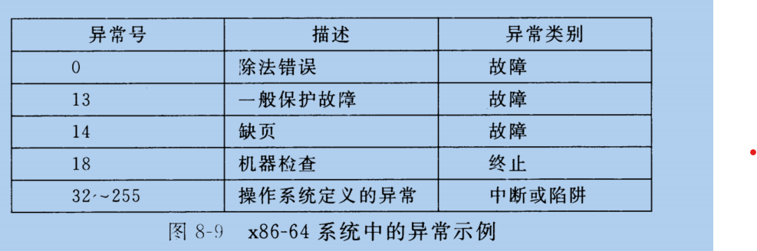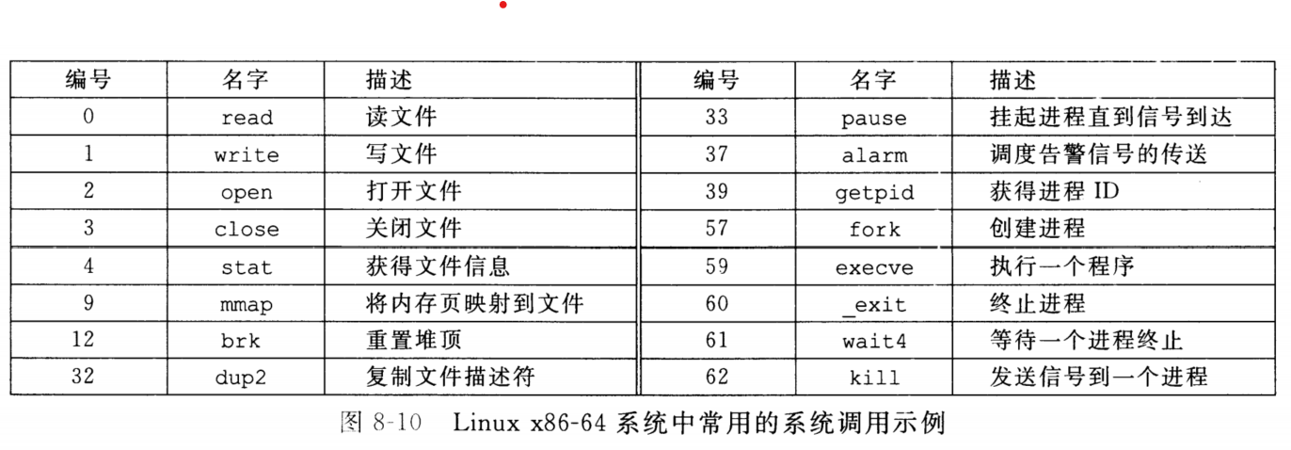

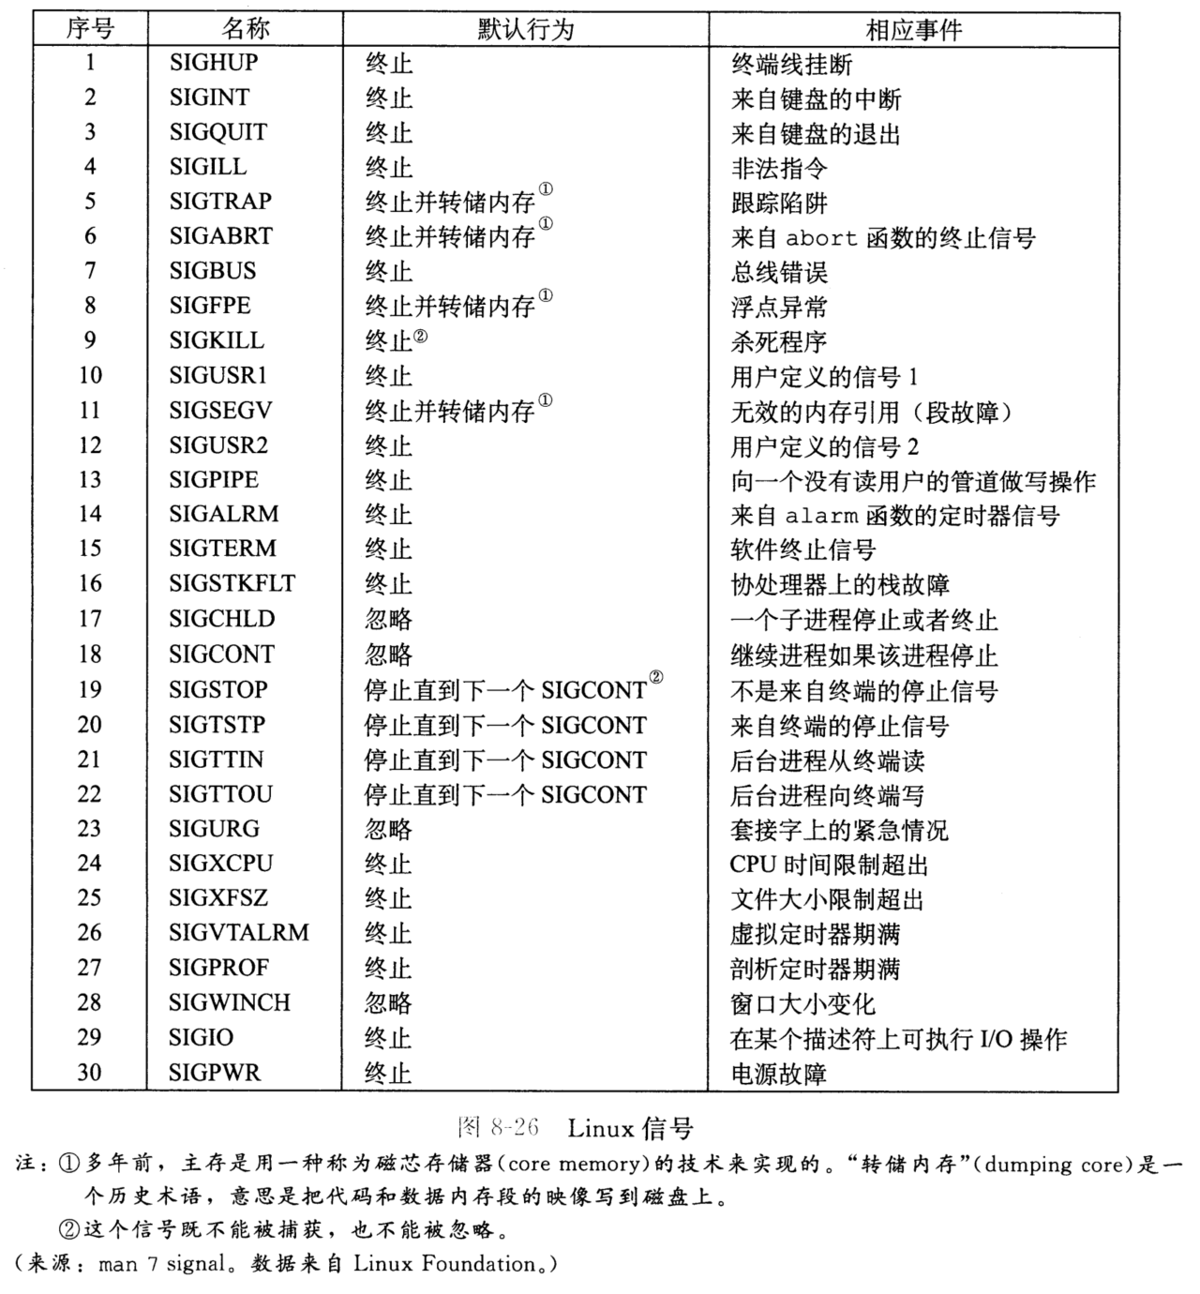

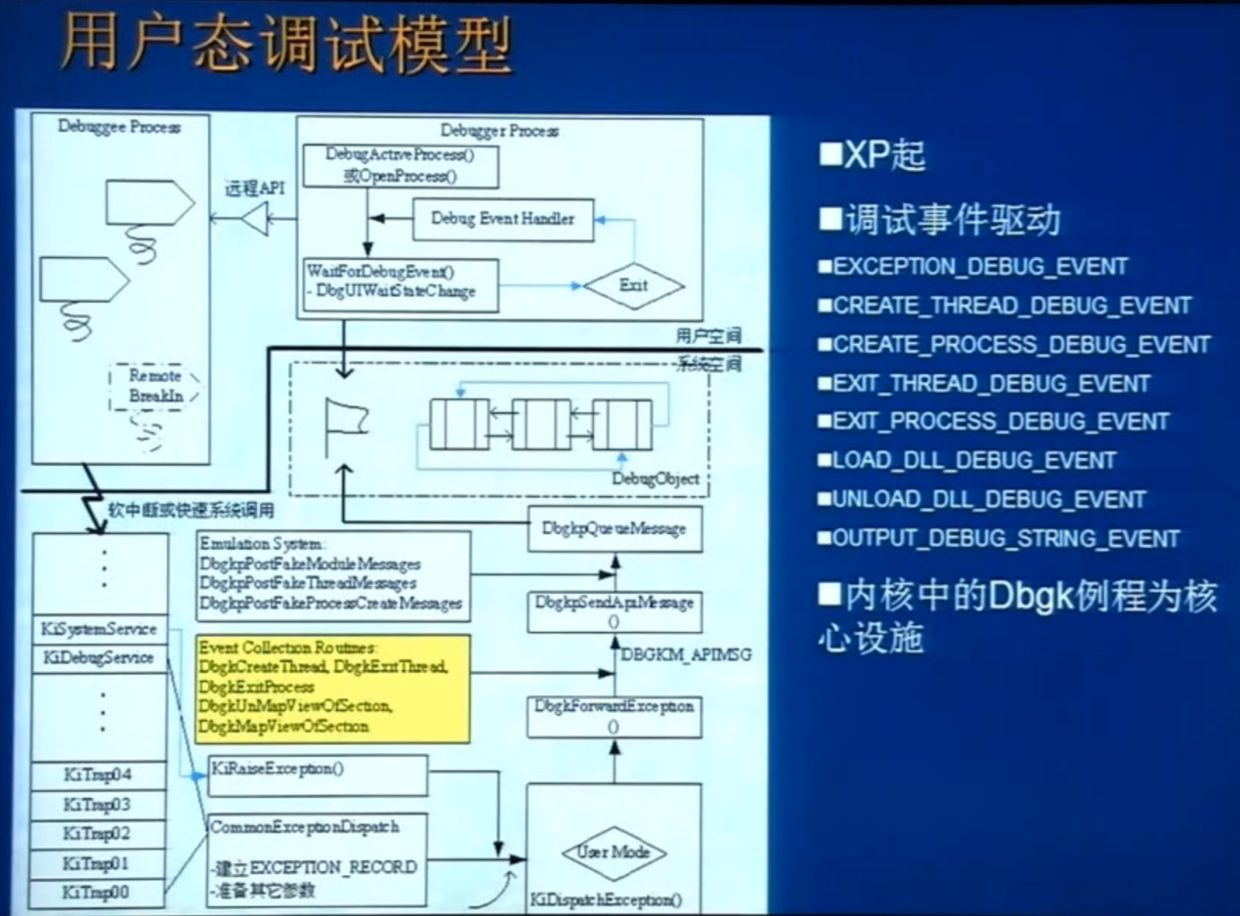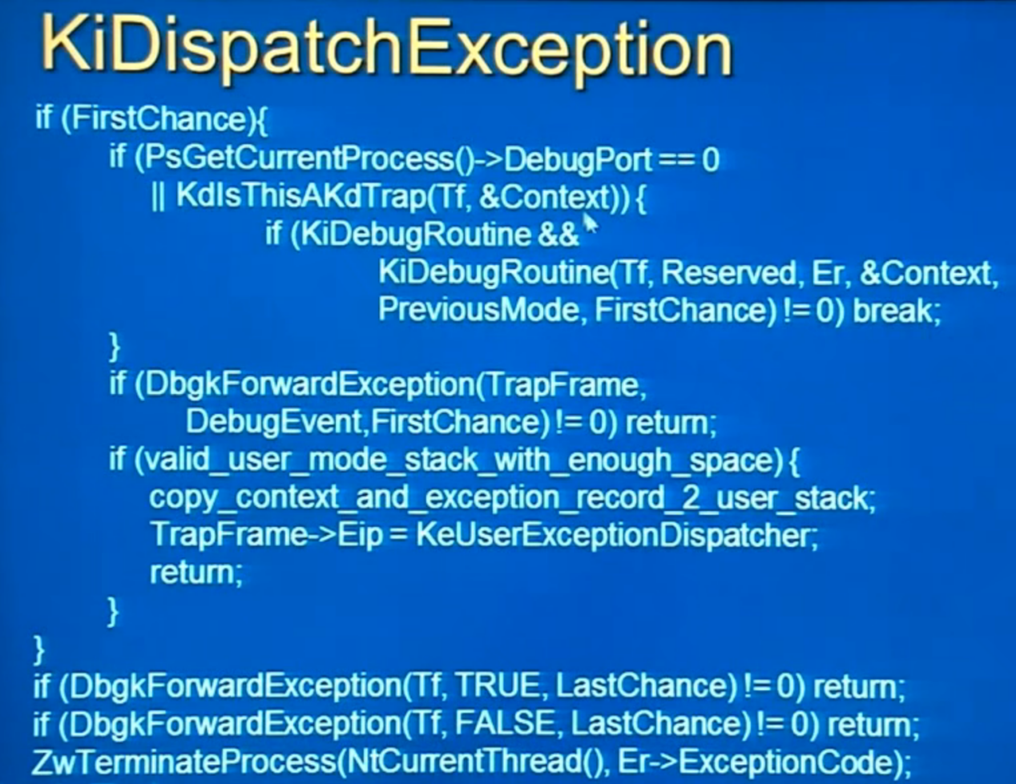

.logopen <file>

.shell

捕获c++异常（throw）

sxe eh

显示栈中局部变量

dx Debugger.Sessions[0].Processes[44360].Threads[7688].Stack.Frames[2].SwitchTo();dv /t /v

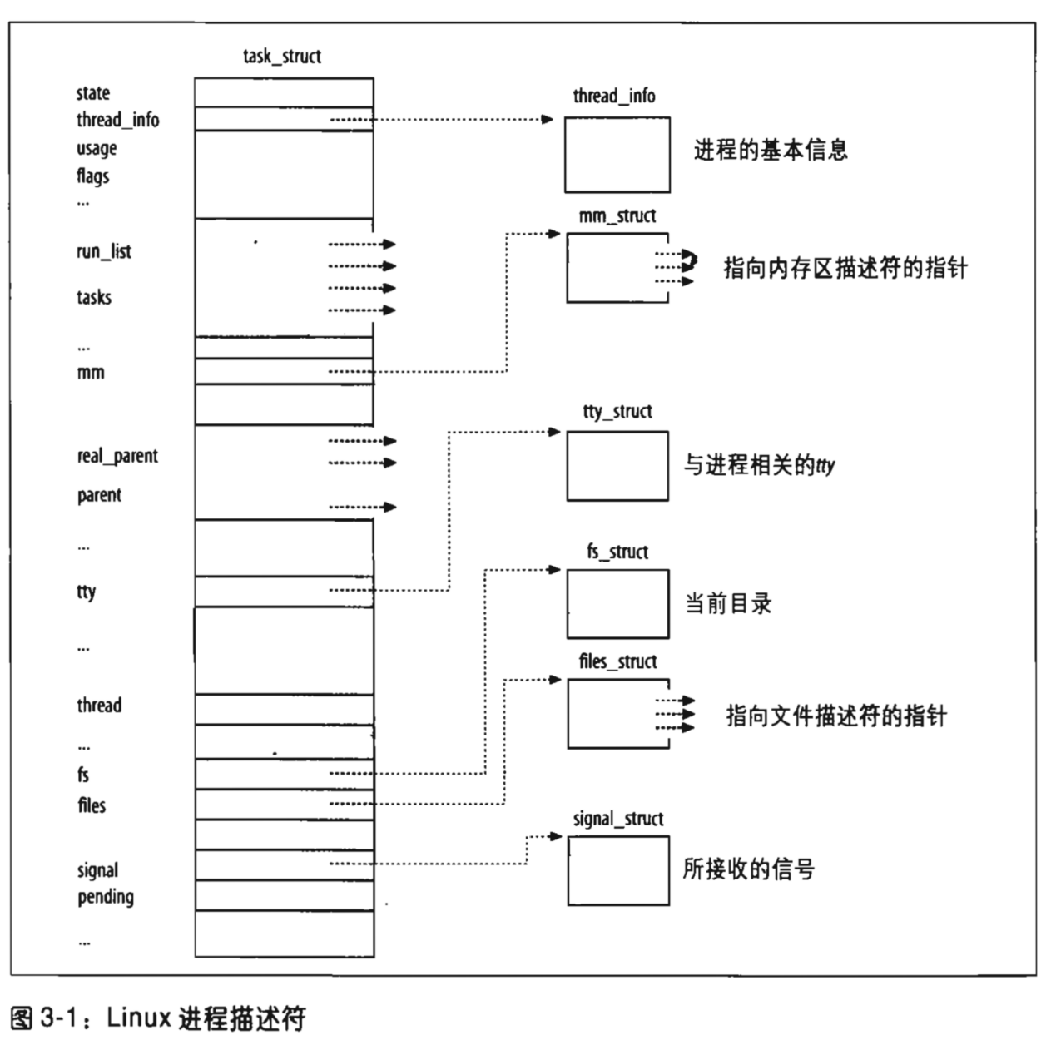

|  |  |  |
| --- | --- | --- |
|  | upcast | downcast |
| raw | ok | error |
| Raw pointer/reference | ok | error |
| Static_cast | ok | error |
| Static_cast pointer/reference | ok | ok |