SQL Like Operator:

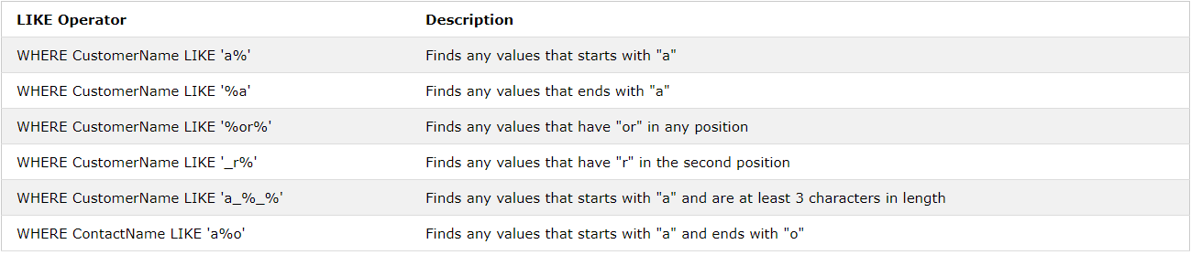

Different Joins:

