Software Requirements Specification (SRS) Template
ITS 450 —Software Assurance

The following annotated template shall be used to complete the Software Requirements Specification (SRS) assignment of ITS450. The instructor must approve any modifications to the overall structure of this document.

Template Usage:
Text contained within angle brackets (‘<’, ‘>’) shall be replaced by your project-specific information and/or details. For example, <Project Name> will be replaced with either ‘Smart Home’ or ‘Sensor Network’.

Italicized text is included to briefly annotate the purpose of each section within this template. This text should not appear in the final version of your submitted SRS.

This cover page is not a part of the final template and should be removed before your SRS is submitted.

Acknowledgements:
Sections of this document are based upon the IEEE Guide to Software Requirements Specification (ANSI/IEEE Std. 830-1984).

<Project Name>

Software Requirements Specification

<Version>

<Date>

<Your Name>
Lead Software Engineer

Revision History

Date | Description | Author | Comments
<date> | <Version 1> | <Your Name> | <First Revision>

Document Approval

The following Software Requirements Specification has been accepted and approved by the following:
Signature | Printed Name | Title | Date
 | <Your Name> | Lead Software Eng.

Table of Contents

Revision History ii
Document Approval ii
1. Introduction 1
1.1 Purpose 1
1.2 Scope 1
1.3 Definitions, Acronyms, and Abbreviations 1
1.4 References 1
1.5 Overview 1
2. General Description 2
2.1 Product Perspective 2
2.2 Product Functions 2
2.3 User Characteristics 2
2.4 General Constraints 2
2.5 Assumptions and Dependencies 2
3. Specific Requirements 2
3.1 External Interface Requirements 3
3.1.1 User Interfaces 3
3.1.2 Hardware Interfaces 3
3.1.3 Software Interfaces 3
3.1.4 Communications Interfaces 3
3.2 Functional Requirements 3
3.2.1 <Functional Requirement or Feature #1> 3
3.2.2 <Functional Requirement or Feature #2> 3
3.3 Use Cases 3
3.3.1 Use Case #1 3
3.3.2 Use Case #2 3
3.4 Non-Functional Requirements 4
3.4.1 Performance 4
3.4.2 Reliability 4
3.4.3 Availability 4
3.4.4 Security 4
3.4.5 Maintainability 4
3.4.6 Portability 4
3.5 Inverse Requirements 4
3.6 Design Constraints 4
3.7 Logical Database Requirements 4
3.8 Other Requirements 4
4. Analysis Models 4
4.1 Sequence Diagrams 5
4.3 Data Flow Diagrams (DFD) 5
4.2 State-Transition Diagrams (STD) 5
5. Change Management Process 5
A. Appendices 5
A.1 Appendix 1 5
A.2 Appendix 2 5

Introduction
The introduction to the Software Requirement Specification (SRS) document should provide an overview of the complete SRS document. While writing this document please remember that this document should contain all of the information needed by a software engineer to adequately design and implement the software product described by the requirements listed in this document. (Note: the following subsection annotates are largely taken from the IEEE Guide to SRS).

Purpose
The purpose of this document is to present a detailed description of the Coffee Sales Website System. It will explain the purpose and features of the system, the interfaces of the system, the function of the system, the constraints under which it must operate and how the system will react to external stimuli.
The expected audience of this document is the future developers of the sale system and the users of the sale system.
What is the purpose of this SRS and the (intended) audience for which it is written.

Scope
The Coffee Sale Webpage System (CSWS) is designed to run with PHP and SQL server. In this system, customers are allowed to browser the introduction of goodies such as several kinds of coffee, the books, the mugs and maintain their cart for add or remove the product over the systems. The system will also show the stock to the customers and send back the transaction information. ThisSystem reject invalid data .The facility to research previous record is present.
This subsection should:
(1) Identify the software product(s) to be produced by name; for example, Host DBMS, Report Generator, etc
(2) Explain what the software product(s) will, and, if necessary, will not do
(3) Describe the application of the software being specified. As a portion of this, it should:
(a) Describe all relevant benefits, objectives, and goals as precisely as possible. For example, to say that one goal is to provide effective reporting capabilities is not as good as saying parameter-driven, user-definable reports with a 2 h turnaround and on-line entry of user parameters.
(b) Be consistent with similar statements in higher-level specifications (for example, the System Requirement Specification) , if they exist.What is the scope of this software product.

1.3 Definitions, Acronyms, and Abbreviations

Term | Definition
Admin | The account holders who have the privileges that can add or remove the goodies, update the amount of any goodies.
CSWS | Coffee Sale Webpage System
Customer | The person, or persons, who pay for the product and usually (but not necessarily) decide the requirements.
Database | Collection of all the information monitored by this system
HTML | Hyper text markup language
IEEE | Institute of Electrical and Electronic Engineers
SCMP | Software Configuration Management Plan
SDD | Software Design Document
SRS | Software Requirements Specification
Survey | Form filled out and submitted by an Alum using the CISWAAB.
User | The person, or persons, who operate or interact directly with the product. The user(s) and the  customer(s) could not be the same person(s).

This subsection should provide the definitions of all terms, acronyms, and abbreviations required to properly interpret the SRS. This information may be provided by reference to one or more appendixes in the SRS or by reference to other documents.

References
[IEEE] The applicable IEEE standards are published in “IEEE Standards Collection,”
2001 edition.
This subsection should:
(1) Provide a complete list of all documents referenced elsewhere in the SRS, or in a separate, specified document.
(2) Identify each document by title, report number - if applicable - date, and publishing organization.
(3) Specify the sources from which the references can be obtained.
This information may be provided by reference to an appendix or to another document.

Overview
The next chapter, the General Description section, of this document fives an overview of the functionality of the system. It describes the informal requirements and is used to establish a context for the technical requirements specification in the next chapter.
The third chapter concerns details of each of the system functions and actions in full for the webpage developers’ assistance. These two sections are cross-referenced by topic; to increase understanding by both groups involved.
This subsection should:
(1) Describe what the rest of the SRS contains
(2) Explain how the SRS is organized.

2. General Description
This section of the SRS should describe the general factors that affect 'the product and its requirements. It should be made clear that this section does not state specific requirements; it only makes those requirements easier to understand.

2.1 Product Perspective
The Coffee Sale Webpage System (CSWS) enables administrators to add a new goody such as new type of coffee and other items like recommended book or remove the existed goodies or items. Customers can browse through the all sales and add the items into wish list or cart. In fact, CSWS is a good place that consumers can find high-quantity and testy coffee and other items such as books and mugs.
CSWS is intended to be a stand-alone product and should not depend on the availability of other software. It should run on both Linux and Windows based platform
This subsection of the SRS puts the product into perspective with other related products or
projects. (See the IEEE Guide to SRS for more details).

2.2 Product Functions
- User: Administrator
- Functions: When using Administrator’s account to login, it will show the totally different page with normal customers. The Administrator is the super user and has the complete control over all the activities that can be performed. The application notifies the administrator of all items amount update. Administrator can also view the exited orders and the information of the customers.
- User: Customers/Guests
- Functions: A registered customers can browse through the goodies, inventories and choose products to place in a wish list or a virtual shopping cart. The shopping cart details can be viewed and items can be removed from the cart. To proceed with the purchase, the customers should input their shipping information and payment information. In addition, if the amount of product they want to buy is more than the stock, the product will be moved into wish list automatically.
This subsection of the SRS should provide a summary of the functions that the software will perform.

2.3 User Characteristics
The users should be familiar with the terms like login, register, order system etc. They should be familiar with the Shopping Mall related terminology like Shopping cart/ Checking out/ Wish list etc. In addition, they should be familiar with the Internet.
This subsection of the SRS should describe those general characteristics of the eventual users of the product that will affect the specific requirements. (See the IEEE Guide to SRS for more details).

2.4 General Constraints
- There is no maintainability of back up so availability will get affected
- Limited to HTTP/HTTPS
- Real-life credit card validation and Banking system is not implemented.
- The new admin account need to be approved in SQL server.
This subsection of the SRS should provide a general description of any other items that will
limit the developer’s options for designing the system. (See the IEEE Guide to SRS for a partial list of possible general constraints).

2.5 Assumptions and Dependencies
- The system needs the browser support HTTPS protocol.
- The system needs a Internet or Apache service.
- Each customer needs register first.

This subsection of the SRS should list each of the factors that affect the requirements stated in the SRS. These factors are not design constraints on the software but are, rather, any changes to them that can affect the requirements in the SRS. For example, an assumption might be that a specific operating system will be available on the hardware designated for the software product. If, in fact, the operating system is not available, the SRS would then have to change accordingly.

3. Specific Requirements
This will be the largest and most important section of the SRS. The customer requirements will be embodied within Section 2, but this section will give the D-requirements that are used to guide the project’s software design, implementation, and testing.

Each requirement in this section should be:
- Correct
- Traceable (both forward and backward to prior/future artifacts)
- Unambiguous
- Verifiable (i.e., testable)
- Prioritized (with respect to importance and/or stability)
- Complete
- Consistent
- Uniquely identifiable (usually via numbering like 3.4.5.6)

Attention should be paid to the carefuly organize the requirements presented in this section so that they may easily accessed and understood. Furthermore, this SRS is not the software design document, therefore one should avoid the tendency to over-constrain (and therefore design) the software project within this SRS.

3.1 External Interface Requirements

3.1.1 User Interfaces
User Interface of this project interact with user through browser, and the related technologies listed in the following:
- HTML: language for page writing.
- PHP: script language for dynamic deal and data control in the page.
- Javascript: function language for dynamic deal in the page.

3.1.2 Hardware Interfaces
A browser support HTML&PHP&JAVASCRIPT.
A SQL cloud server.

3.1.3 Software Interfaces
Almost all browser supports this project, and the database of this project can receive request from every type of browser. Database record order, user and products data.

3.1.4 Communications Interfaces
This project has email sending. After finish the billing form, the final.php would writing a receipt and sending to the email address in the session.

3.2 Functional Requirements
This section describes specific features of the software project. If desired, some requirements may be specified in the use-case format and listed in the Use Cases Section.

3.2.1 create_form_input
3.2.1.1 Introduction
This function aims to create a form that include various types of fields and provide error array.
3.2.1.2 Inputs
$name: name element of input tags;
$type: type element of input tags;
$errors: errors array for save errors of each input value;
$values = 'POST': POST request;
$extras: extra information.'
3.2.1.3 Processing
Php script create input tags through ‘echo’ and infer the name and type values to the input tags.
3.2.1.4 Outputs
The form in the pages.
3.2.1.5 Error Handling
If input is not valid, the error message would be showed in the page.

3.2.2 array_key_exists
3.2.2.1 introduction
This function aimed to check if array exist values and keys. In this project, this function used to check if error array exist.

3.2.2.2 Inputs
$name: name element of input tag;
$errors: error array of the form.

3.2.2.3 Processing
If this function return true, create_form_input function would create a <span> tag with value $errors[$name] to expose the error of field in the page.

3.2.2.4 Outputs
If this function returns true, the value of $name in the errors array would be return to the page.

3.2.2.5 Error Handling

No error handling

3.3 Use Cases

3.3.1 Use Case #1
Admin create Inventory and products

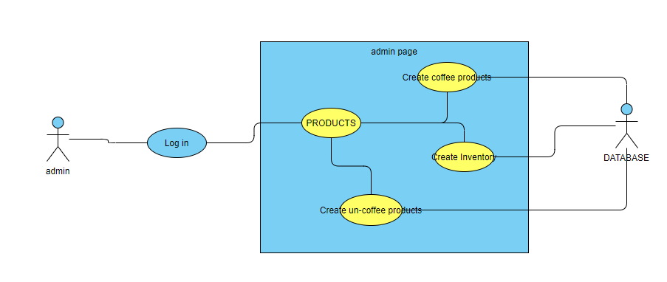

3.3.2 Use Case #2
Admin create or update a sale

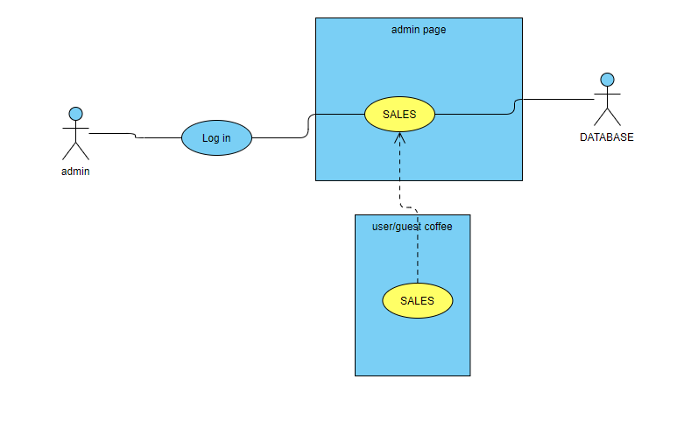

3.3.3 Use Case #3
Admin check the orders

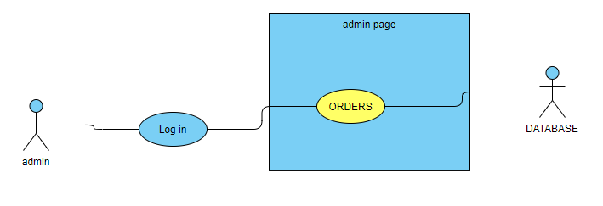

3.3.4 Use Case #4
Admin check the customers
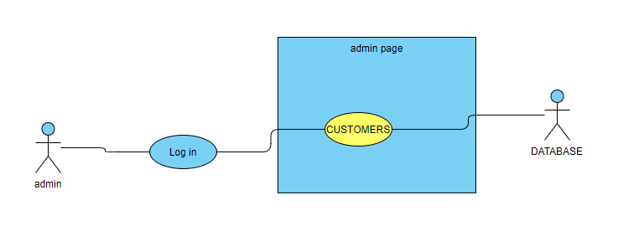

3.3.5 Use Case #5
Normal users add, remove, checkout the coffee and other goodies.
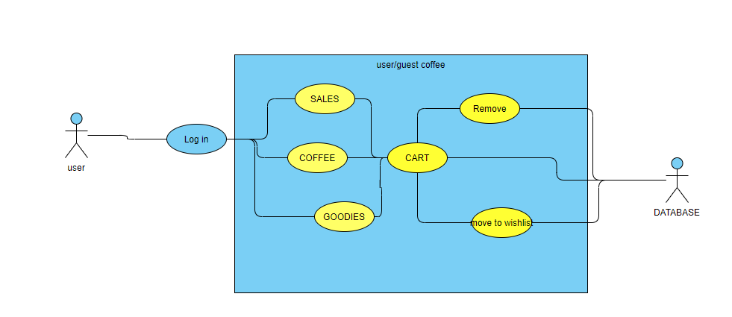

3.3.6 Use Case #6
Normal users complete buy coffee and goodies.
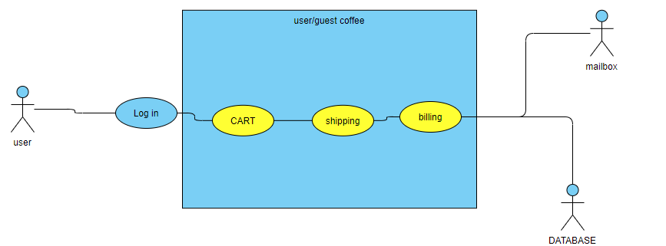

3.4 Non-Functional Requirements
Non-functional requirements may exist for the following attributes. Often these requirements must be achieved at a system-wide level rather than at a unit level. State the requirements in the following sections in measurable terms (e.g., 95% of transaction shall be processed in less than a second, system downtime may not exceed 1 minute per day, > 30 day MTBF value, etc).

3.4.1 Performance
Normal login process, register submit waste load time about 2 second.
Admin add products, sales and user checkout need load less than 1 second.

3.4.2 Reliability
Databases record each transaction in detail and rollback when any update fails.

3.4.3 Availability
New module deployment mustn’t impact login page, admin pages, and check out pages availability and mustn’t take longer than one hour.

When user enter a page that not exist, user would be forward to a page with “File not found.”.

3.4.4 Security
Access to admin system is only through the admin account.
Admin create new product is protect by Content-Security Policy.
Only admin can operate sale’s item and order situation.
Every input is limited by checking function for check the valid of input value in the page.

3.4.5 Maintainability
The administrator of this web application can maintain the balance of price, the parameters of sales products and check the order information.

3.4.6 Portability

3.5 Inverse Requirements
State any *useful* inverse requirements.

3.6 Design Constraints
Specify design constrains imposed by other standards, company policies, hardware limitation, etc. that will impact this software project.
- This project cannot really get separate guest and log in user because simple database.
- Any user must sign out through “go back” in browser.

3.7 Logical Database Requirements
Will a database be used? If so, what logical requirements exist for data formats, storage capabilities, data retention, data integrity, etc.
Each goodies and coffee products table provides contents to order table, and order table’s value consist to transactions table.

In the coffee tables, there are two tables associated together: sizes, general_coffees. Moreover, non_coffee_categories table provides elements to create elements in the non_coffee_products.

3.9 Other Requirements
Catchall section for any additional requirements.
Test requirement: every form of this project need to be test so that ensure they are safe.

4. Analysis Models
List all analysis models used in developing specific requirements previously given in this SRS. Each model should include an introduction and a narrative description. Furthermore, each model should be traceable the SRS’s requirements.

4.1 Sequence Diagrams

4.3 Data Flow Diagrams (DFD)

4.2 State-Transition Diagrams (STD)

5. Change Management Process
Identify and describe the process that will be used to update the SRS, as needed, when project scope or requirements change. Who can submit changes and by what means, and how will these changes be approved.

A. Appendices
Appendices may be used to provide additional (and hopefully helpful) information. If present, the SRS should explicitly state whether the information contained within an appendix is to be considered as a part of the SRS’s overall set of requirements.

Example Appendices could include (initial) conceptual documents for the software project, marketing materials, minutes of meetings with the customer(s), etc.

A.1 Appendix 1

A.2 Appendix 2

