**LAB NO4**

|  |
| --- |
| **Department of Software Engineering**  **Mehran University of Engineering and Technology, Jamshoro** |

|  |  |  |  |
| --- | --- | --- | --- |
| **Course: SWE324 - Data Warehousing and Data Mining** | | | |
| **Instructor** | Rabeea Jaffari | **Practical/Lab No.** | 04 |
| **Date** |  | **CLOs** | CLO-4: P3 & P4 |
| **Signature** |  | **Assessment Score** | 1 Mark |

|  |  |
| --- | --- |
| **Topic** | **To familiar with OLTP system reporting** |
| **Objectives** | * To learn report generation in OLTP systems |

|  |
| --- |
| **Lab Discussion: Theoretical concepts and Procedural steps** |

## Tables:

Customer Table

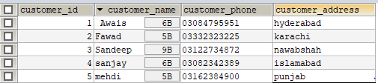

Expenditure

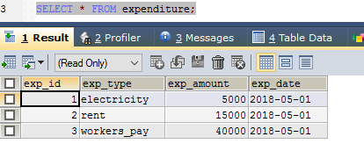

Product Table

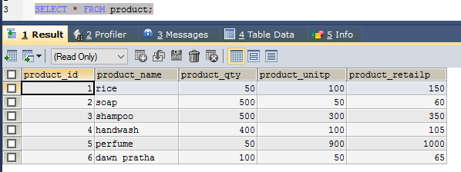

Order Table

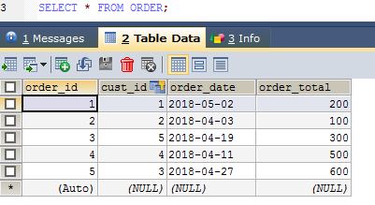

**Stored procedure** contains following queries:

1. **Total sales in a month** (Use only order table).
2. **Profit/loss in a month** (Use product (to account for purchasing costs), expenditure as well as order tables).
3. **Highest selling product of the month** (By highest sold quantity)
4. **Lowest selling product of the month** (By lowest sold quantity)

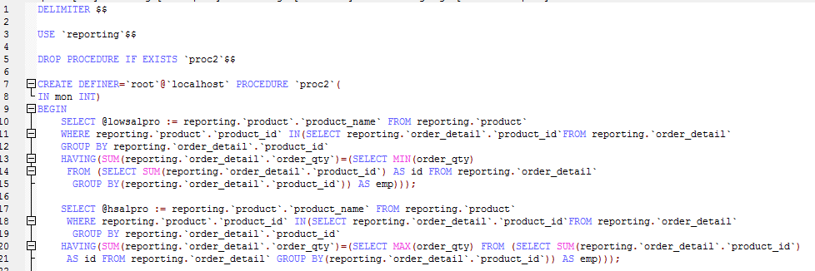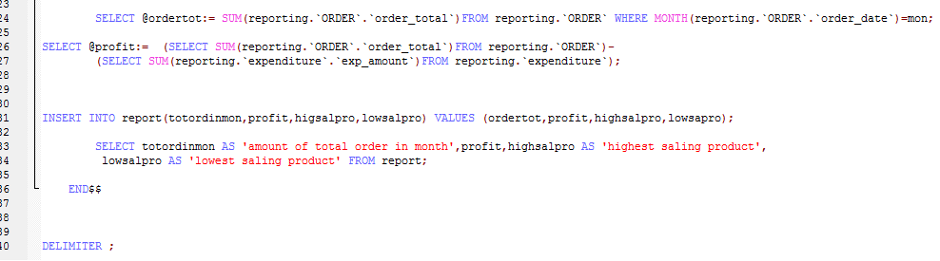

Call



Result

