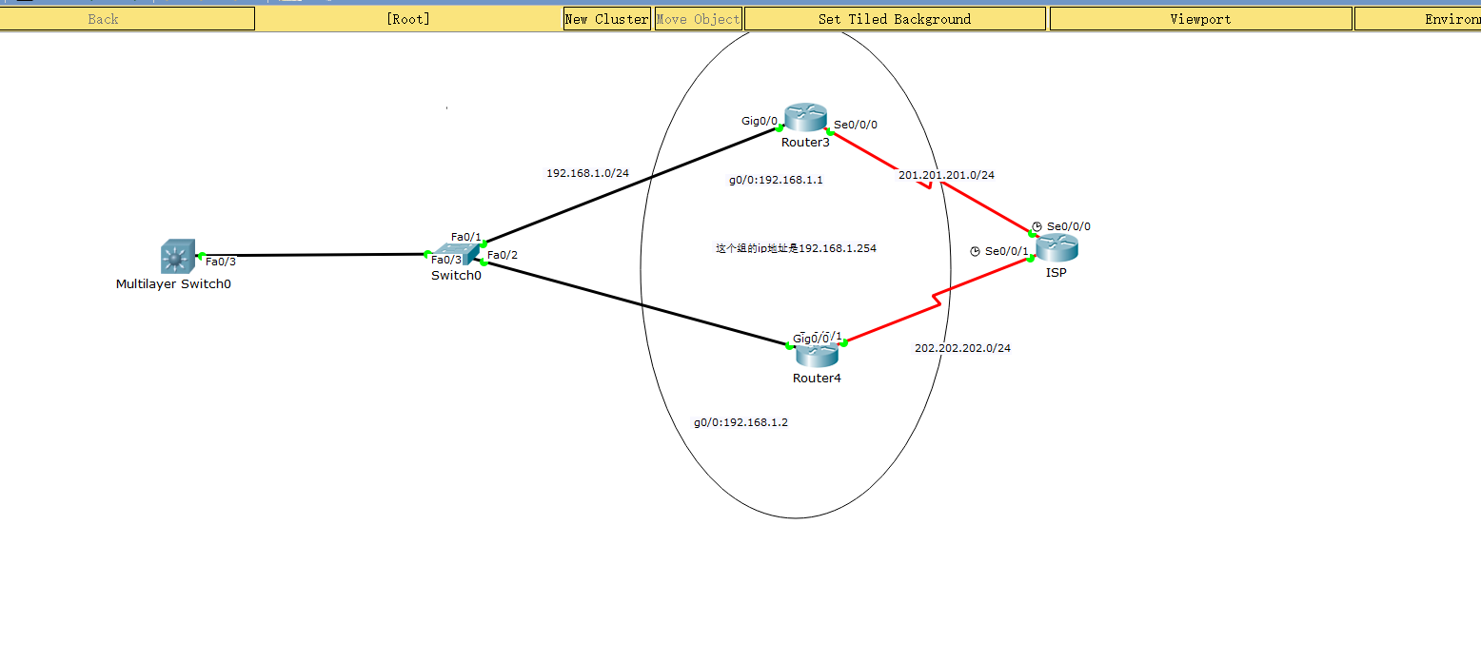

# Isp:

En

Conf t

Int se0/0/0

No shut

Ip add 201.201.201.1 255.255.255.0

Int se0/0/1

No shut

Ip add 202.202.202.1 255.255.255.0

# Router3:

En

Conf t

Int Se0/0/0

No shut

Ip add 201.201.201.2 255.255.255.0

Int g0/0

No shut

Ip add 192.168.1.1 255.255.255.0

Int g0/0

Standby 1 ip 192.168.1.254

Standby 1 priority 120

Standby preempt

Nat配置：

Ip nat pool lizheng 201.201.201.1 201.201.201.14 netmask 255.255.255.240

Access-list 1 permit 192.168.0.0 0.0.255.255

Ip nat inside source list 1 pool lizheng

Int se0/0/0

Ip nat outside

Int g0/0

Ip nat inside

Exit

Ip route 0.0.0.0 0.0.0.0 se0/0/0

# Router4:

En

Conf t

Int Se0/0/0

No shut

Ip add 202.202.202.2 255.255.255.0

Int g0/0

No shut

Ip add 192.168.1.2 255.255.255.0

Int g0/0

Standby 1 preempt

Standby 1 ip 192.168.1.254

Nat配置：

Ip nat pool zhengli 202.202.202.1 202.202.202.14 netmask 255.255.255.240

Access-list 1 permit 192.168.0.0 0.0.255.255

Ip nat inside source list 1 pool zhengli

Int se0/0/1

Ip nat outside

Int g0/0

Ip nat inside

Exit

Ip route 0.0.0.0 0.0.0.0 se0/0/1

# Multilayer switch 0

En

Conf t

Int fa0/3

No switchport

Ip add 192.168.1.10 255.255.255.0

Exit

Ip default-gateway 192.168.1.254