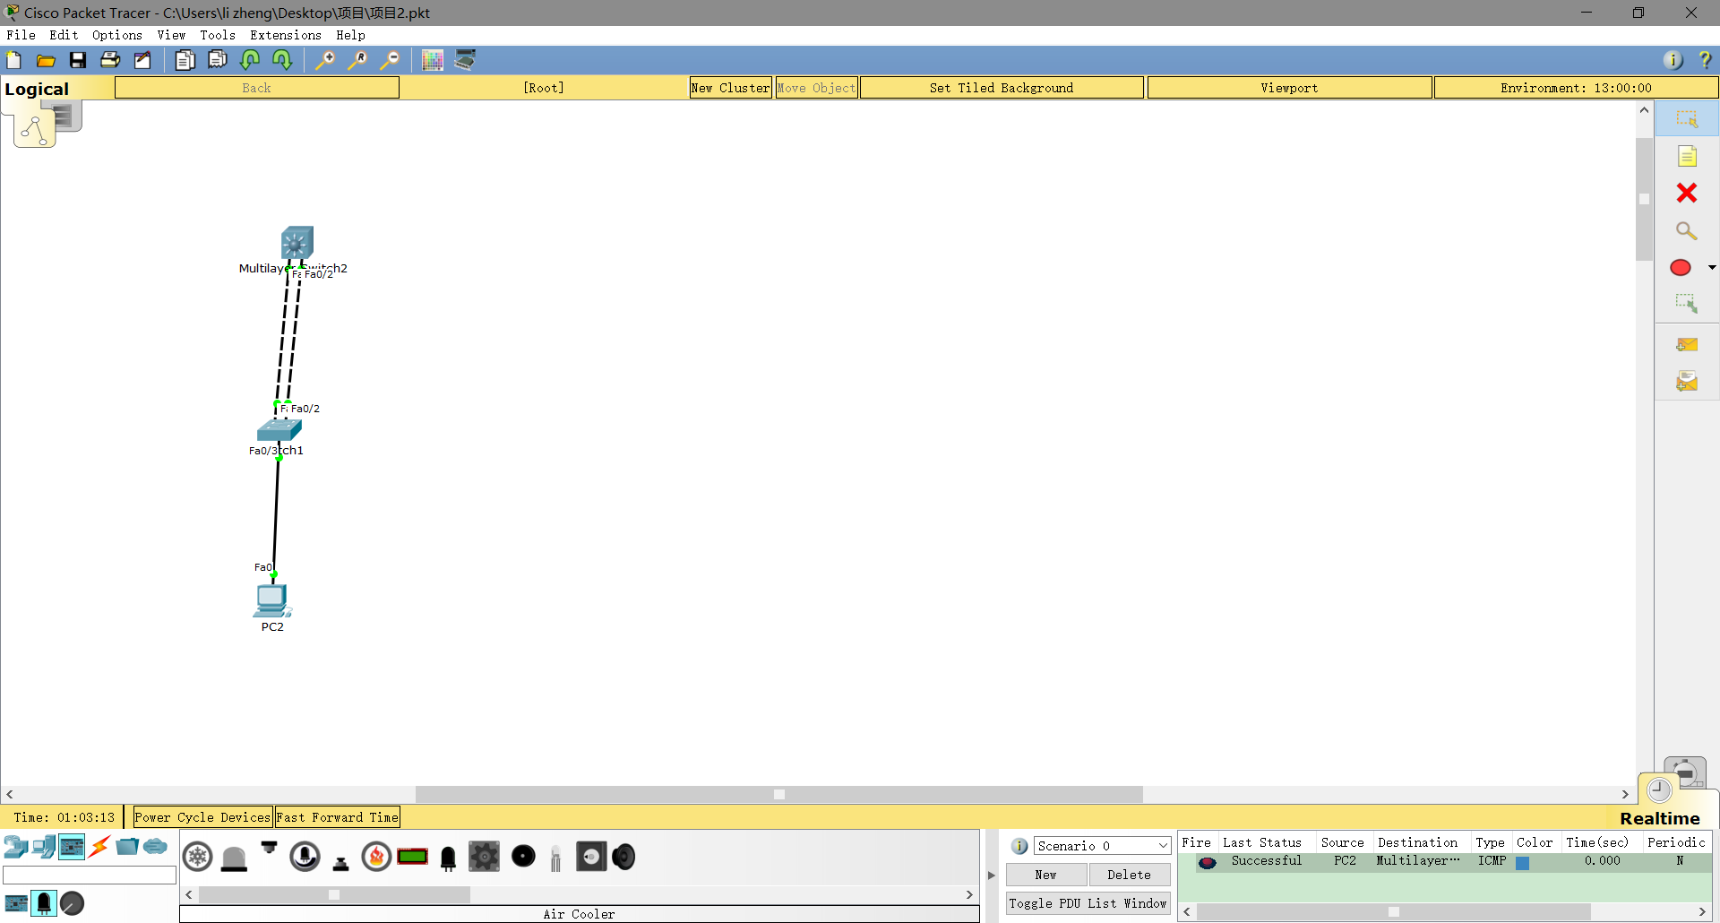

# MuLTILAYER SWITCH2；

En

Conf t

Int range fa0/1-2

Switchport

Channel-protocol lacp

Channel-group 1 mode active

switchport

Switchport trunk encapsulation dot1q

Switchport mode trunk

Switchport trunk allowed vlan all

Vlan 10

Exit

Int vlan 10

Ip add 192.168.1.254 255.255.255.0

No shut

最后interface rang fa0/1-2(如果不通就要配置这条命令)

No shut

# Switch1

En

Conf t

Int rang fa0/1-2

Switchport

Channel-protocol lacp

Channel-group 1 mode passive

Switcchport mode trunk

Swithport trunk allowed vlan all

Int fa0/3

Switchport mode access

Switchport access vlan 10