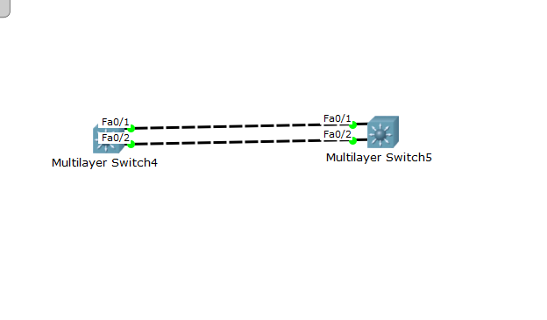

在这里，我使用的是vlan 1来配置地址代替channel 1 配置ip地址，关机重启后，能正常通信：

Multilayer switch 4:

En

Conf t

Interface rang fa0/1-2

Channel-group 1 mode on

Exit

Int port-channel 1

Switchport trunk encapsulation dot1q

Switchport mode trunk

Exit

Int vlan 1

Ip add 192.168.1.1 255.255.255.0

No shutdown

Multilayer switch 5:

En

Conf t

Int rang fa0/1-2

Channel-group 1 mode on

Exit

Int port-channel 1

Switchport trunk encapsulation dot1q

Switchport mode trunk

Exit

Int vlan 1

Ip add 192.168.1 .2 255.255.255.0

No shutdo wn