Task 1:

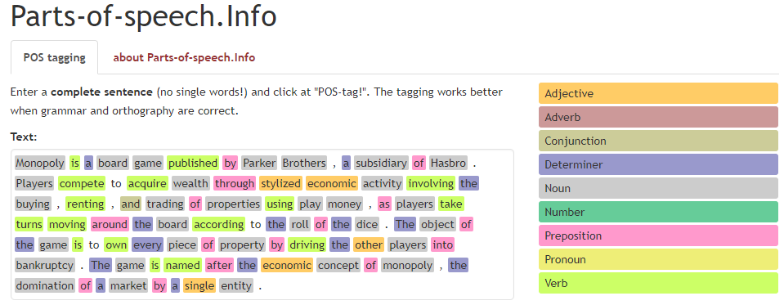Monopoly is a board game published by Parker Brothers , a subsidiary of Hasbro . Players compete to acquire wealth through stylized economic activity involving the buying , renting , and trading of properties using play money , as players take turns moving around the board according to the roll of the dice . The object of the game is to own every piece of property by driving the other players into bankruptcy . The game is named after the economic concept of monopoly , the domination of a market by a single entity .

N: / /player/dice/economic activity

V: / /

|  |  |  |  |
| --- | --- | --- | --- |
| Class | Player | Dice | Properties |
| Attribute | money |  |  |
| properties |  |  |
|  |  |  |
| Method | move | roll | buy/rent/trade |

Task 2

N: POS/ /cashier/

V: / / / /tells / /

|  |  |  |  |  |
| --- | --- | --- | --- | --- |
| Class | customer | Goods | system | receipt |
| Attribute |  | description | system logs | total |
|  | price | stock | Sale line |
| Method | arrives/pay | enters/records | Calculated/ update | presents |