Hospital Patient Pathway Optimization Report
  - Version comparison and response to teacher feedback

1 Overview
We improved the Hospital Patient Pathway project by clarifying task responsibilities, strengthening user-input checks, reorganizing the process and using tests to evaluate the changes. The teacher's feedback identified two priorities: “Implement Camunda-based roles” and “Add user-input validation.” Our response connects these requirements to the process model, application code and test evidence.
The two versions contribute different strengths. Version 1 contains the more complete role configuration and task-completion validation mechanism. Version 2 introduces a clearer process structure, individual forms and an HTTP integration for external availability. Version 1 already includes feedback-related improvements, so it should not be described as an original version with no roles or validation. [1, 2]

2 Main differences between the versions
Area | Version 1 | Version 2
Process organization | Integrated hospital model covering stages 1–17 | Main pathway with nine event subprocesses
User interaction | 70 hospital user tasks using shared forms | 37 hospital user tasks with individual forms
Roles | Candidate groups plus departmental role configuration | Candidate groups use redesigned group identifiers
Input validation | Form rules and server-side completion listeners | Form rules and selected Worker checks
External availability | Java-simulated availability response | REST Connector calling a local mock API

The change from 16 shared forms to 37 individual forms makes the redesign easier to maintain and explain task by task. It does not mean that more hospital activities are covered: the versions use different task granularity. Similarly, fewer tasks do not prove reduced staff workload without operational measurements.
Our optimization therefore focuses on clearer responsibilities, more reliable submissions, easier process review and better verification. We can demonstrate these implementation changes, but we do not claim measured improvements in patient waiting times, clinical outcomes or operating costs.
The comparison uses repository commit 1402859, reviewed on 19 October 2026. Current source checks, newly executed isolated tests and historical process tests are distinguished below so that results from different versions are not combined into an unsupported success claim.

3 Responding to the teacher feedback

Implement Camunda based roles
We translated hospital responsibilities into executable task assignments. Version 1 assigns candidate groups to all 70 hospital user tasks and removes fixed demonstration assignees. Its cluster configuration defines 11 departmental groups and corresponding roles, including secretaries, consultants, finance and booking teams. It enables authorization checks and includes the groups in the task-worker configuration. [1]
This improves the model because a lane only describes responsibility, whereas a task assignment can be used by Camunda to allocate work. For example, consultant review belongs to the consultant group and financial decisions belong to finance. The security contract tests check that task groups exist in the configuration and that every hospital task has the required completion validator.
However, group assignments must be connected to real authenticated accounts. Ordinary staff should not receive broader permissions that override the intended restrictions. An approved access-request form records a business decision; it does not itself grant platform permissions. Likewise, typing a staff name into a form does not authenticate that person.
Version 2 retains candidate groups on all 37 hospital tasks, but its identifiers differ from Version 1: finance replaces finance-team, for example. These identifiers need an explicit identity-configuration mapping. The recorded Version 2 browser demonstration used one demo account across groups and therefore did not prove role isolation. Separate non-administrator account tests remain necessary. [2, 5]

Add user input validation
Version 1 combines form constraints with server-side checks. The forms define required information, permitted choices, text lengths and numeric constraints. HospitalFormValidator also checks real calendar dates, positive waiting durations and relationships between fields. Examples include requiring an explanation for missing referral documents, preventing patientShare from exceeding estimatedCost, and requiring a destination for a transfer. [1, 3]
Each hospital user task has a completing listener connected to UserInputValidationWorker. The validator selects the contract using the task ID supplied by the engine, rather than trusting the user-controlled hospitalFormTask variable. Invalid input produces an explicit denial response. This protects against a caller selecting a different form section to avoid the active task's requirements. Tests cover malformed task data, whitespace, invalid dates, inappropriate amounts and unlisted choices.
Version 2 improves the interface through individual forms with required fields and fixed decision options. It also includes Worker checks for actions such as applying an unapproved treatment change. However, it does not contain Version 1's general completion-listener validation mechanism. Its requiredStartDate field illustrates the gap: a YYYY-MM-DD label and required text do not prove calendar-date validation. The next step is to preserve the clearer Version 2 forms while carrying over the stronger backend controls.

4 Process improvements and test evidence

Clearer workflow and external integration
Version 2 organizes the main patient journey separately from nine event subprocesses, including appointment changes, treatment changes, refunds, enquiries and clinic letters. Reviewers can follow the main flow and then open the relevant subprocess. This improves readability without presenting every support activity as a consecutive stage. [2]
Testing also led to a concrete treatment-change repair. An earlier urgent-change route bypassed the formal-authorization gateway and reached a Worker that rejected unapproved changes. The route was changed so both ordinary and retrospective paths pass through the gateway. A subsequent false-authorization test avoided the earlier incident. This links an observed failure to a specific model correction and retest. [6]
The current SP05 availability query uses a REST Connector. Recorded tests cover available capacity, unavailable capacity followed by release, and HTTP 503 failure. The success case completed the pathway; the error case produced the expected incident without creating an external booking. A separate browser run completed 12 submissions across nine form types and ended without an incident. These tests used a local mock service, not a real hospital system. [5]

What the tests show
Test evidence | Result | Interpretation
Fresh Version 1 isolated tests | 44 passed out of 44 | Security contracts, validation and persistence checks passed.
Fresh Version 2 ordinary tests | 14 passed and 1 failed | Explicit form deployment binding is missing.
Archived Version 1 suite | 28 passed out of 28 | Historical baseline, including six engine scenarios.
Archived Version 2 acceptance suite | 74 passed and 12 failed | Original business criteria are not fully satisfied.

The fresh tests were run against the reviewed source without starting a Camunda cluster. Version 2's failure comes from a test expecting bindingType="deployment". Structural inspection found that this declaration is absent on all 37 hospital form bindings. One failing test exposes the repeated configuration issue; it is not 37 separately executed failures.
The archived Version 2 acceptance run reports 401 of 401 counted route elements and flows covered, plus 37 of 37 user tasks completed through the engine API. This demonstrates substantial route execution, but does not mean every business rule passed. Coverage and acceptance answer different questions. The archived result applies to its frozen snapshot and should not be presented as a fresh full-system test of the latest Connector model. [4]

Testing improvements and regression priorities
We strengthened verification by testing alternative decisions, exceptions and timed behavior alongside the main patient journey. The supplied Version2AcceptanceIT screenshots show 58 tests passing in 5 minutes 32 seconds, and the console reports 100% process coverage for Process_HPAS (Figure 1). These are results from the illustrated run; the screenshots do not identify its source commit or establish equivalence with the archived original-plan acceptance suite.
The testing improvement is therefore both broader execution and more precise evidence. Process coverage shows which counted model elements were exercised. Business acceptance additionally requires assertions about authorization, dates, financial decisions and final records. The 58-test result should be recorded separately from the archived 74-pass, 12-failure result, because their test counts and scope differ. A green run alone does not demonstrate that the earlier unmet criteria have been resolved.
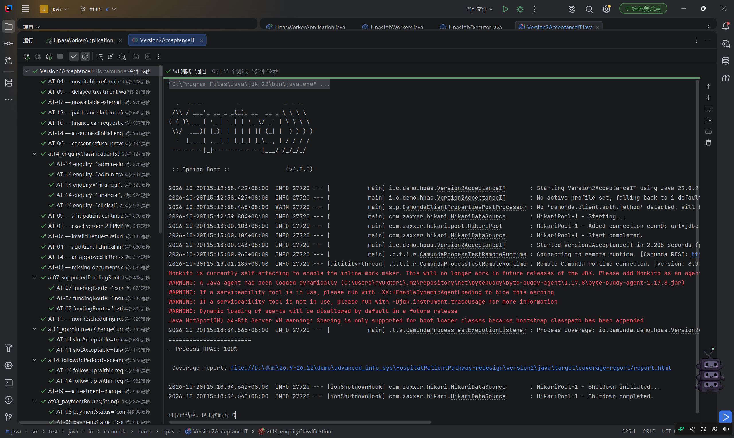
Figure 1. Version2AcceptanceIT run showing 58 passing tests and reported 100% Process_HPAS coverage. User-provided execution screenshot, 20 October 2026.

Broader scenarios and stronger assertions
Parameterized scenarios make important alternatives explicit. Figure 2 illustrates authorized and unauthorized access, refund-due decisions, treatment-change authorization and financial impact, cancellation outcomes, scheduling escalation and payment retries. It also includes monitoring at different overdue periods and a test labelled as repeating a seven-day reminder. These examples show how one business area can be checked through several inputs rather than a single successful route.
We should extend this approach with assertions on task ownership, rejected submissions, persisted audit records and the absence of unauthorized side effects. Reminder tests should observe multiple scheduled firings and confirm that reminders stop when preparation completes. Payment retries should check for duplicate charges, while refund tests should distinguish refund eligibility from explicit approval. Browser tests with separate staff accounts should verify the corresponding forms and access restrictions.
For reproducible regression testing, retain the BPMN and form hashes, source revision, runtime configuration and machine-readable test report for each run. Map each acceptance criterion to its scenarios and assertions, and report process coverage, business-rule results and browser evidence separately. Rerun the original criteria unchanged after each repair so that a model correction is supported by a specific regression result.
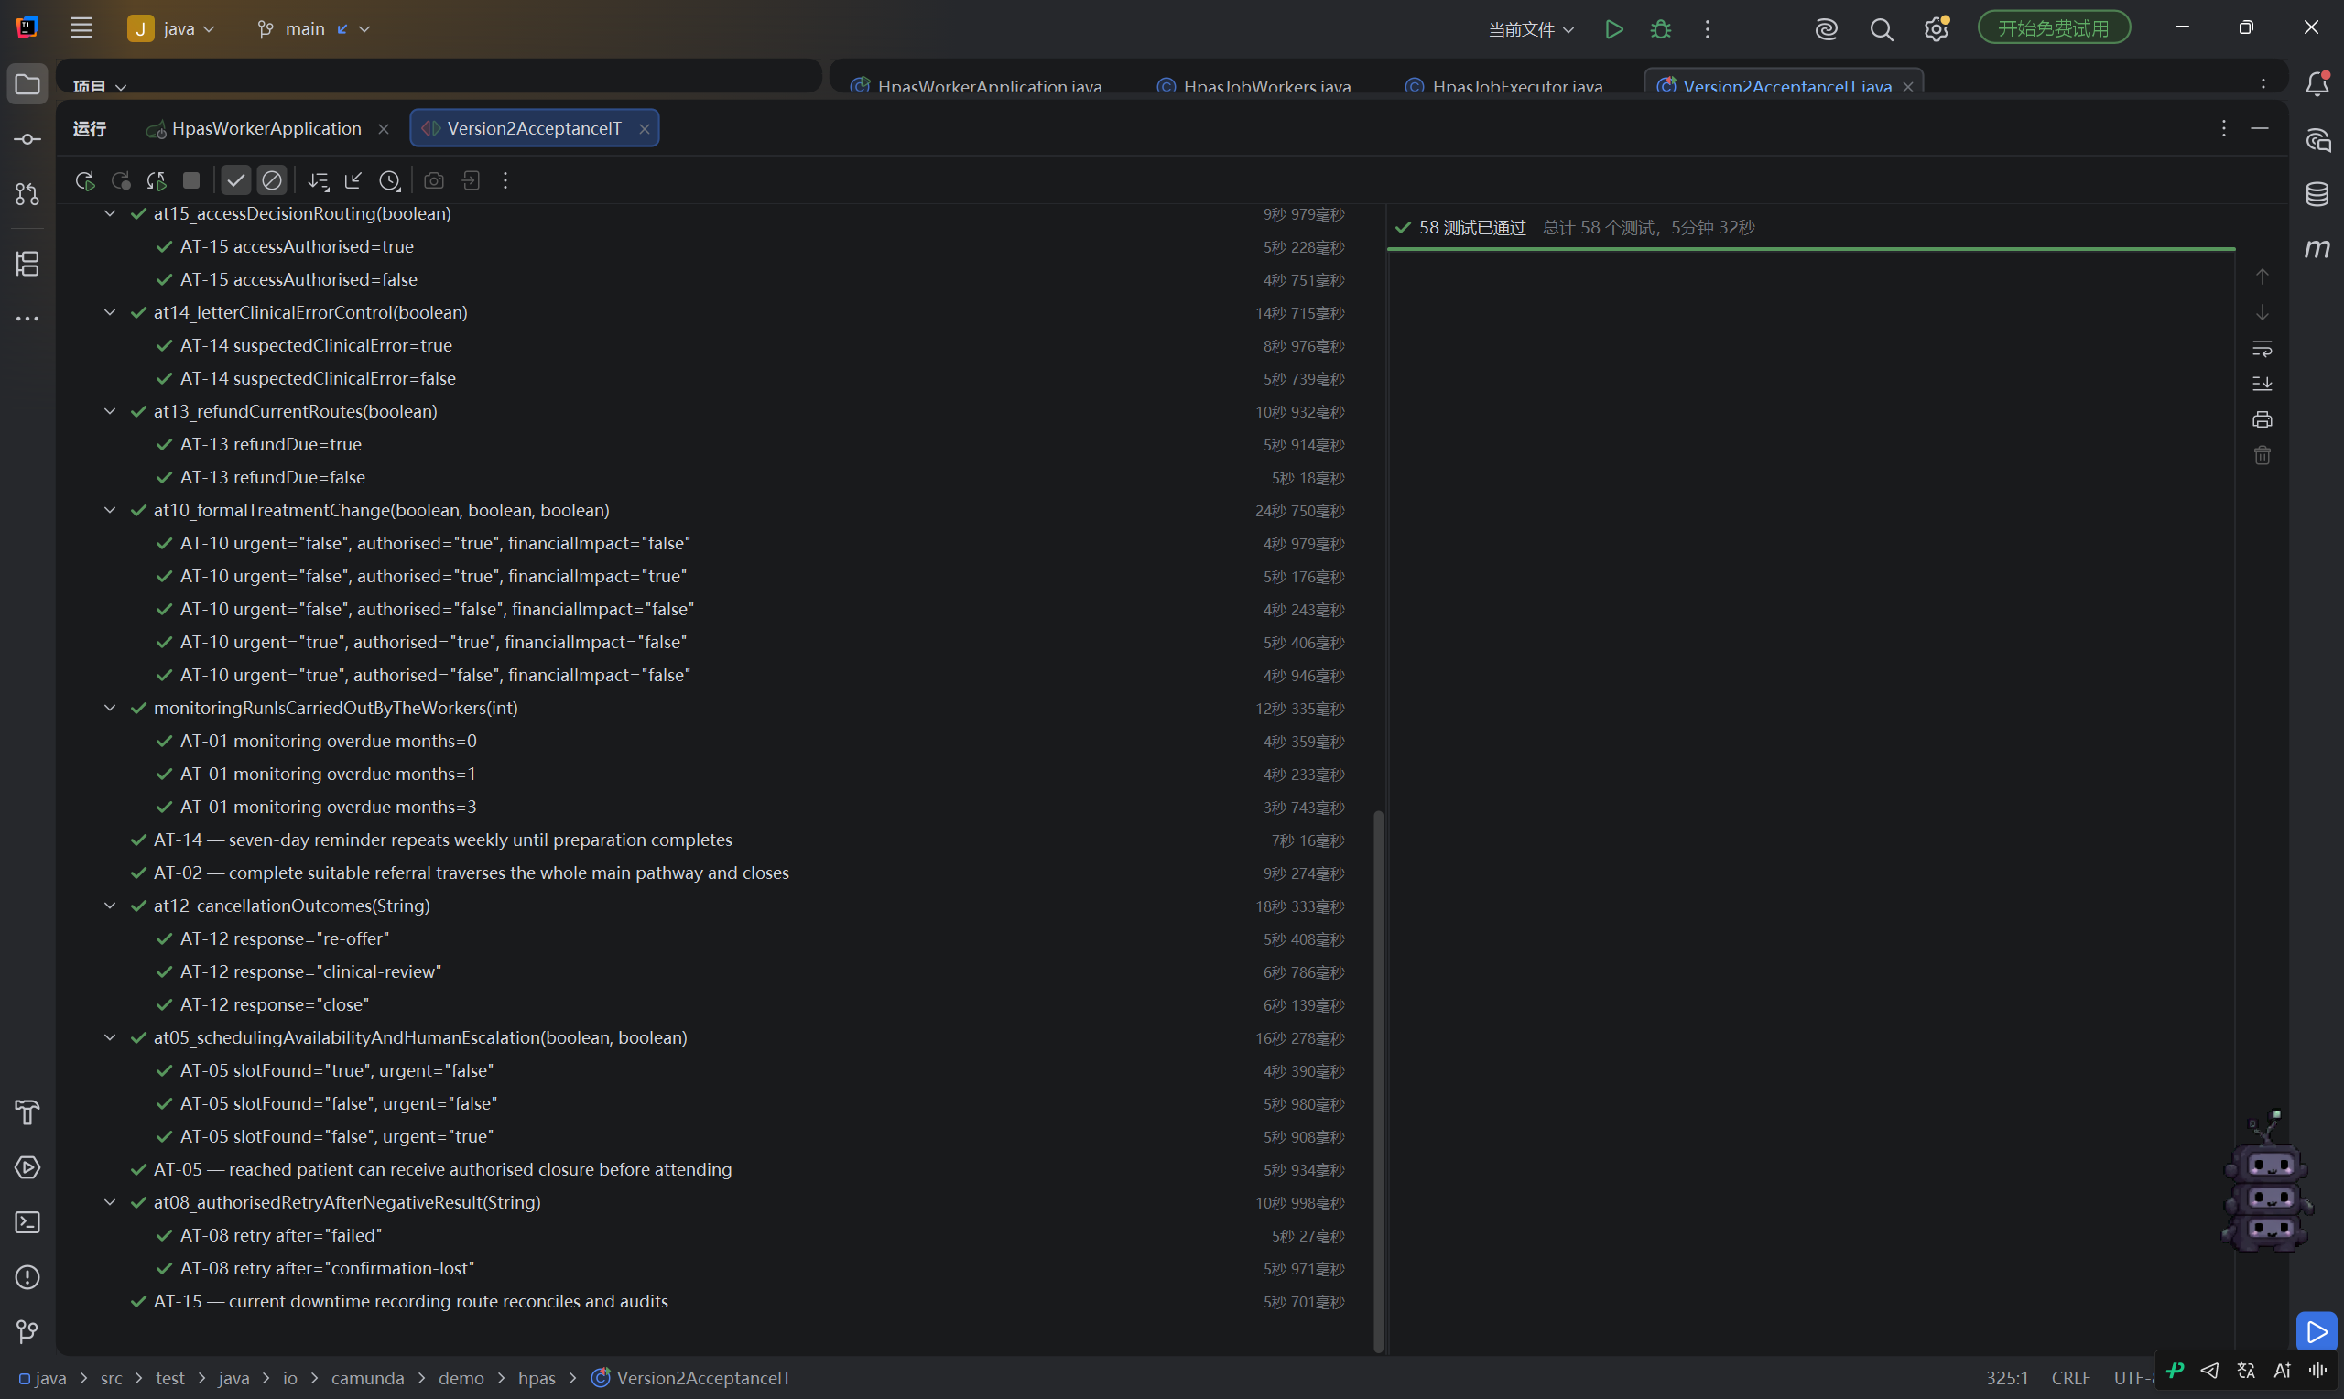
Figure 2. Parameterized decision, exception and timing scenarios within the same 58-test run; this is additional detail, not a second independent run.

5 Remaining work and overall assessment

What still needs improvement
The redesign should retain the controls already established in Version 1. The immediate priorities are to align candidate groups with actual account memberships, add completion-level validation to the 37 redesigned tasks, and declare explicit deployment binding for their forms. These changes should be checked through both Tasklist and the API, including unauthorized accounts and invalid submissions.
The original acceptance tests also identify business-rule gaps. Important examples are explicit refund authorization, checking existing charges before another payment request, appointment-change identity and date rules, financial review before implementing affected treatment changes, recurring weekly reminders and incident-specific restoration. These remain proposed fixes, not completed improvements. [4]
A particularly useful negative test supplies refundAuthorised=false together with a finance approver name. The current Version 2 Worker still accepts the refund conditions because it checks the name and refundDue rather than explicit authorization. This shows why valid-looking data and actual permission must be checked separately.

Overall assessment
We have made the prototype clearer, more executable and easier to verify. Version 1 provides a substantial response to the teacher's role and validation feedback. Version 2 improves process organization, task-specific interaction and external integration. Testing strengthens the project further by identifying where the redesign has not preserved the original controls.
Our next step is to combine these strengths and rerun the unchanged acceptance criteria against a fixed deployment. The evidence supports the improvements described here, while full role isolation, input protection and business acceptance still require the remaining fixes and runtime verification.

Selected evidence
The links below are pinned to the reviewed repository commit. Fresh test totals are from the isolated runs performed on 19 October 2026; historical figures come from the repository records.
[1] Version 1 role configuration and input validation
[2] Version 2 architecture and implementation
[3] Server-side form validator
[4] Version 2 acceptance results and outstanding criteria
[5] SP05 integration changes and execution evidence
[6] Historical full-process tests and treatment-change repair
[7] User-provided Version2AcceptanceIT execution screenshots, 20 October 2026. Figures 1 and 2 show the same run; source revision and complete assertion details are not visible.

