How We Improved the Hospital Patient Pathway
  - Changes across the two versions and what we learned from testing

1 What we worked on
The teacher asked us to focus on two things: "Implement Camunda-based roles" and "Add user-input validation." These points helped us look more closely at who should handle each task and what should happen when someone submits incorrect information. We also changed the process layout and used tests to check how it behaved.
Looking at the two versions, Version 1 already has role settings and fairly detailed input checks. Version 2 makes the process easier to follow and gives each hospital task its own form. It also adds an HTTP connection for checking external availability. Some of Version 1's checks are missing from the reviewed Version 2 code, so the comparison shows both progress and work we still need to finish. [1, 2]

2 What changed between the versions
Area | Version 1 | Version 2
Process organization | Integrated hospital model covering stages 1 to 17 | Main pathway with nine event subprocesses
User interaction | 70 hospital user tasks using shared forms | 37 hospital user tasks with individual forms
Roles | Candidate groups plus departmental role configuration | Candidate groups use redesigned group identifiers
Input validation | Form rules and server-side completion listeners | Form rules and selected Worker checks
External availability | Java-simulated availability response | REST Connector calling a local mock API

Version 1 shares 16 forms across its hospital tasks. Version 2 uses 37 separate forms, which makes it easier to see what information each task needs and where to change it. The lower task count comes from how we reorganized the model. It does not tell us whether hospital staff would have less work.
The changes are mainly about making the prototype easier to follow and checking information before the process moves on. We have not measured patient waiting times or hospital costs, so we cannot say that these have improved.
This comparison uses commit 1402859, reviewed on 19 October 2026. We also include the test screenshots from 20 October. They show a later run, but no commit number, so we keep that result separate from the earlier test records.

3 How we addressed the feedback

Assigning tasks through Camunda roles
For roles, we linked tasks to the hospital teams responsible for them. In Version 1, all 70 hospital user tasks have candidate groups instead of fixed demo assignees. The configuration contains 11 departmental groups and matching roles, covering teams such as consultants, secretaries, finance and booking. Authorization checks are enabled, and the task workers include these groups in their settings. [1]
For example, a consultant review goes to the consultant group, while finance handles financial decisions. Putting a task in a named lane helps someone read the diagram. Adding the candidate group gives Camunda an assignment it can use. The security tests check that the groups exist in the configuration and that each hospital task has its input validator.
These assignments still need to match real staff accounts and their permissions. Entering a staff name on a form does not prove who is using it. In the same way, approving an access request records a decision, but the account permissions must also be updated for that decision to take effect.
All 37 hospital tasks in the reviewed Version 2 code also have candidate groups. Some names changed, such as finance-team becoming finance, so the account settings need to match. The recorded browser run used one demo account across the groups. We still need to try separate staff accounts to check that each person can only access the work intended for them. [2, 5]

Checking what users enter
For input validation, Version 1 checks data both on the form and on the server. The forms mark required fields and limit choices, text lengths and numbers. HospitalFormValidator handles checks that need more context. For example, a patient's share cannot exceed the estimated cost, missing referral documents need an explanation, and a transfer needs a destination. It also checks calendar dates and positive waiting durations. [1, 3]
Each hospital task calls UserInputValidationWorker before it completes. The worker uses the task ID from the engine to choose the right checks and rejects invalid input. This matters because the hospitalFormTask value can be changed by the caller; trusting it could let someone use the wrong set of rules. The tests try invalid dates, unsuitable amounts, blank spaces, incorrect task data and choices that are not on the list.
Version 2 makes the forms more specific to each task and uses required fields and fixed options. Its workers also reject some actions, including unapproved treatment changes. However, the reviewed code does not include Version 1's general check before task completion. A required date field labelled YYYY-MM-DD, for example, can still need a check that the date actually exists. We need to bring those server checks into the redesigned forms.

4 How testing helped us improve the process

Changes to the workflow
In Version 2, we separated the main patient journey from nine event subprocesses. These handle work such as appointment changes, refunds and clinic letters. It is easier to follow the main route when these activities have their own sections. [2]
One useful example came from testing urgent treatment changes. The earlier route skipped formal authorization and reached a worker that rejected the change. We changed the route so that ordinary and retrospective changes both pass through the authorization gateway. When the case was tested again with authorization set to false, it avoided the earlier incident. [6]
We also used a REST Connector in SP05 to check external availability. Tests with a local mock service covered available capacity, capacity released later and an HTTP 503 error. The error case raised the expected incident without creating an external booking. In a separate browser run, 12 submissions across nine types of form completed without an incident. [5]

What the test results tell us
Test evidence | Result | Interpretation
20 October supplied Version 2 run | 58 of 58 passed | 100% reported process coverage; revision not shown.
19 October isolated Version 1 tests | 44 of 44 passed | Security, validation and persistence checks.
19 October isolated Version 2 tests | 14 passed, 1 failed | Missing explicit form deployment binding.
Archived Version 1 suite | 28 of 28 passed | Baseline includes six engine scenarios.
Archived Version 2 acceptance | 74 passed, 12 failed | Broader historical suite; separate from the 58-test run.

The 20 October screenshots show all 58 Version2AcceptanceIT tests passing in 5 minutes 32 seconds, with 100% reported coverage for Process_HPAS. The cases try different access decisions, refund outcomes, treatment approvals, scheduling options, cancellations and payment retries. The weekly-reminder test also passed. Both screenshots on the next page come from this run. [7]
This is a good result for those 58 tests, but the older acceptance suite contains 86 tests and checks a different set of requirements. We cannot use one total to replace the other. The isolated tests from 19 October ran without a Camunda cluster. Their one Version 2 failure was about the missing deployment-binding setting, which was absent from all 37 hospital forms in that source version. [4, 7]

Screenshots from the test run
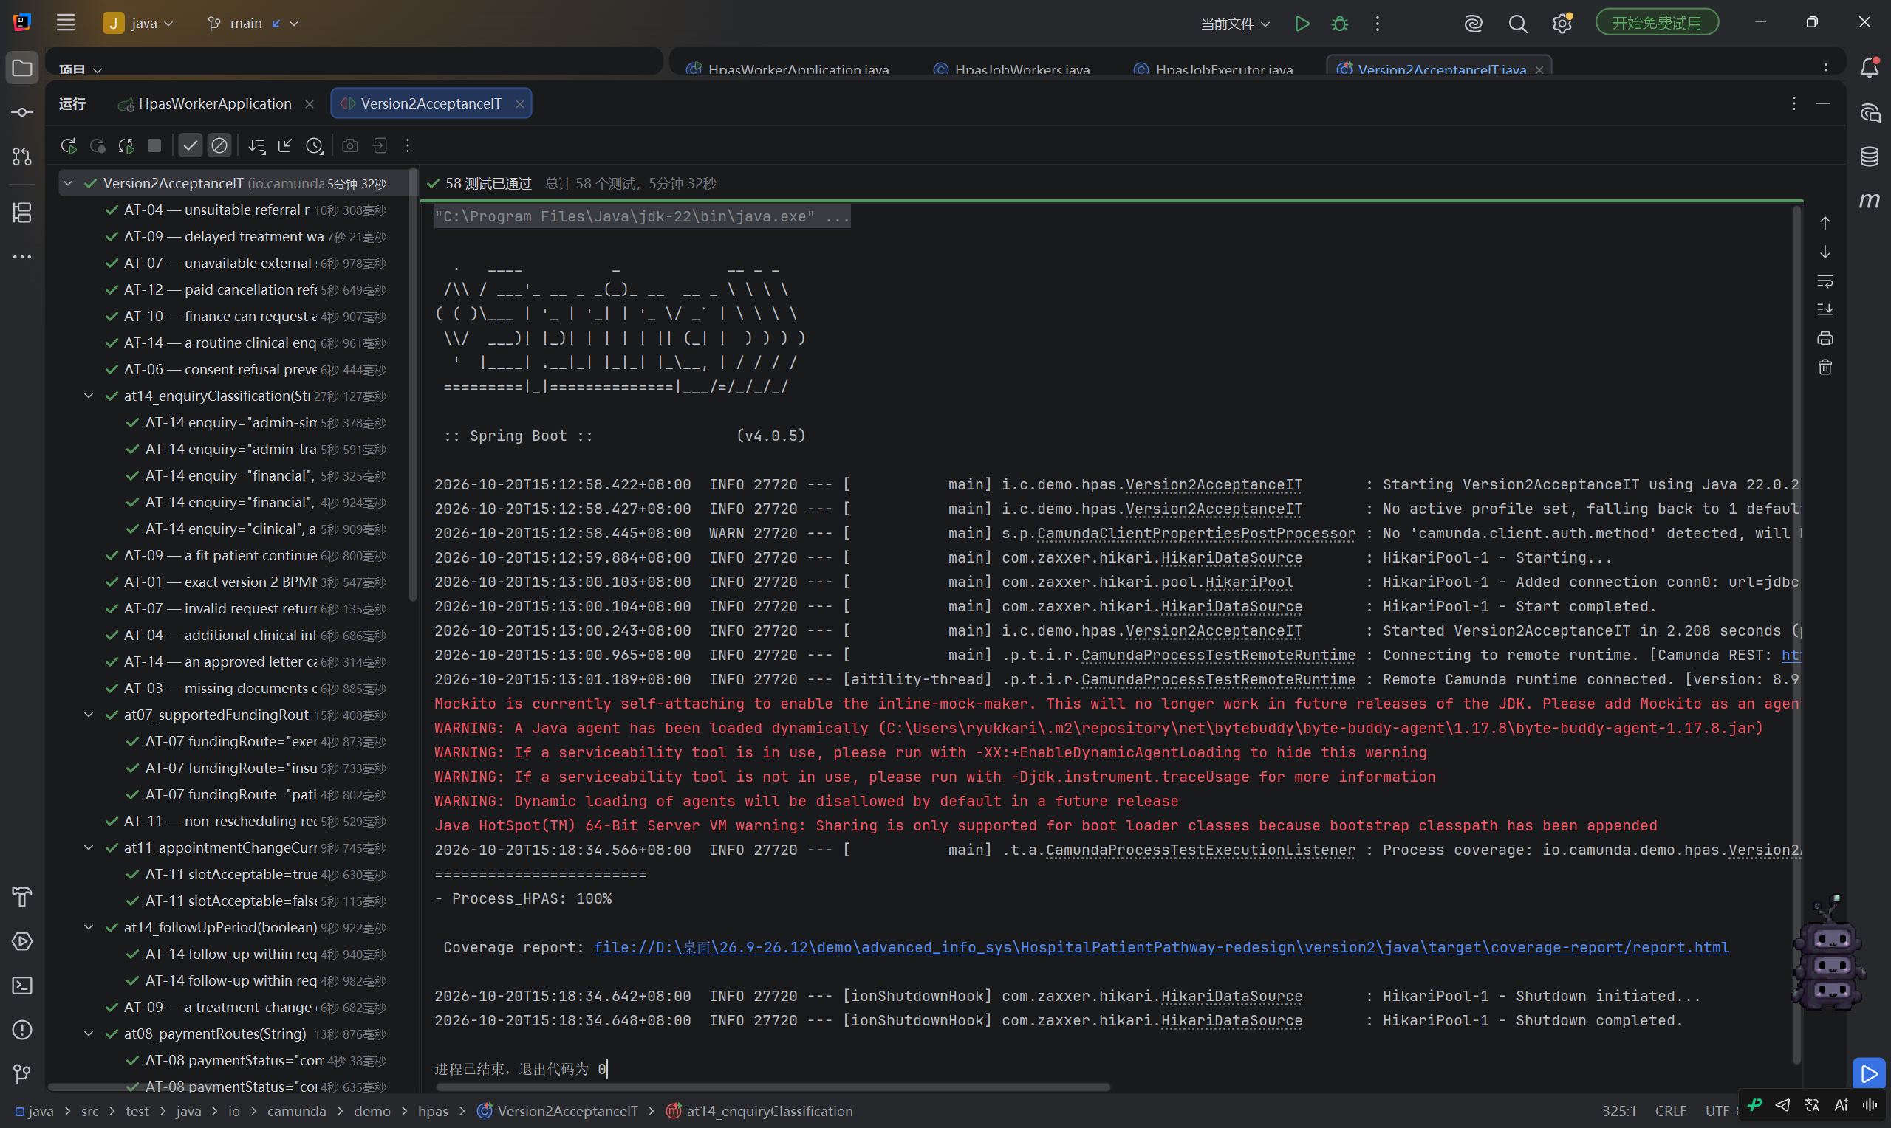
Figure 1. The 20 October run shows 58 tests passed and 100% Process_HPAS coverage. [7]
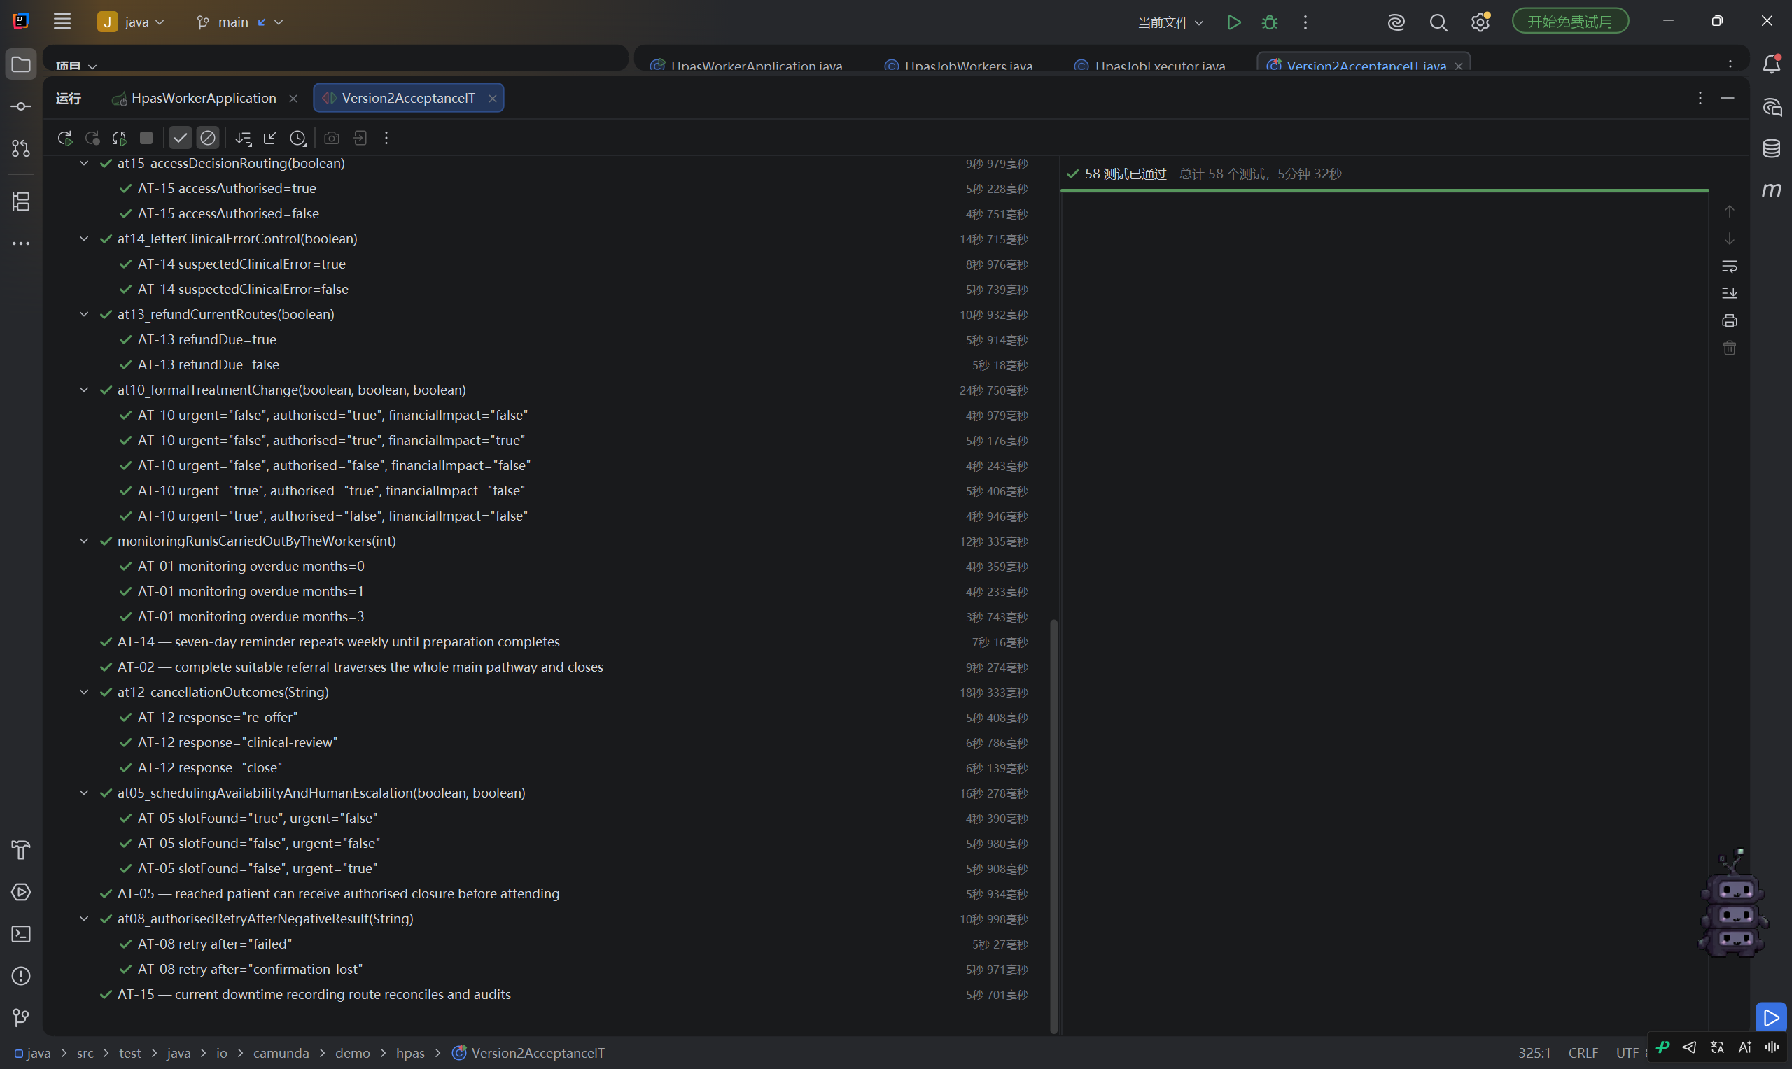
Figure 2. More cases from the same run, including the passing weekly-reminder test. [7]

5 What we still need to finish

Checks to carry into the next version
The main job now is to keep the clearer Version 2 layout while bringing over Version 1's stronger checks. We need to match candidate groups to staff accounts, add validation before tasks complete and set explicit deployment bindings for the forms. We should then try incorrect submissions and separate user accounts through both Tasklist and the API.
The older acceptance tests raised issues with refund approval, repeated charges, appointment identity and dates, financial review before treatment changes, weekly reminders and restoring a specific incident. The newer screenshots show the weekly-reminder case passing. We need to check the other findings against the exact version used for that run before saying which ones remain. [4, 7]
The refund case shows why the details of a test matter. In the code reviewed on 19 October, the worker checked refundDue and an approver's name, but not explicit refund approval. A useful test would therefore enter a name while setting refundAuthorised=false. We should also check that a payment retry does not charge twice and that reminders stop once preparation is complete.

What we learned
The comparison showed us that a cleaner process diagram can still lose checks that worked in an earlier version. Version 1 is stronger on roles and validation; Version 2 is easier to follow task by task. The 58 passing tests are encouraging, but we still need to check the original requirements against the same version before calling the work finished.
For the next run, we should save the exact source revision, BPMN and form hashes, runtime settings and test report. That will let us trace a result back to the code that produced it. We should also show which original requirements each test checks, alongside the browser tests using different staff accounts.

Sources
Links [1] to [6] refer to the commit reviewed on 19 October. The table separates tests run during that review from older results saved in the repository. Source [7] contains the later screenshots.
[1] Version 1 role configuration and input validation
[2] Version 2 architecture and implementation
[3] Server-side form validator
[4] Version 2 acceptance results and outstanding criteria
[5] SP05 integration changes and execution evidence
[6] Historical full-process tests and treatment-change repair
[7] Supplied Version2AcceptanceIT screenshots dated 20 October 2026. Both show the same 58-test run. The commit number and full test assertions are not visible.

