Lexta Business System
Staff User Guide

Draft for review
13 November 2026

Prepared for Lexta Ghana Limited by
1773 Human Resources & Marketing Services LTD

Contents
Videos
1. Getting started
What the Business System is
Signing in
Forgot your password?
Your menu depends on your role
Using it on a phone
Signing out
Good to know
2. Management overview
The tabs
Look at a period or one brand
The Overview tab
The Activity tab
A system's tab
Good to know
Common questions
3. Distributor ordering
For Lexta staff
For distributors
Good to know
Common questions
4. Field sales
For sales reps (on your phone)
For managers (admin and management)
Good to know
Common questions
5. CRM
Who can do what
Add a lead
Work a lead
Add a contact or an organisation
Website leads
Website lead managers (admin only)
Good to know
Common questions
6. Complaints
Log a complaint (phone, walk in, email or social media)
Take and work a case
Close a complaint
Reopen a complaint
Good to know
Common questions
7. Product management
Change a product
Add a product
Add or change images
Publish or hide a product
Good to know
8. Stockists (Where to Buy)
Add a stockist
Import many shops from a spreadsheet (CSV)
Hide or confirm a stockist
Good to know
9. CSR activities
Log an activity
Mark a planned activity as done
Manage programmes (admin only)
Good to know
10. Recruitment
How the Careers page feeds it
Work an application
Open, close or edit a role
Good to know
11. Live chat inbox
Answer a chat
Add an internal note
Turn a chat into a lead or a complaint
Close or reopen a chat
Good to know
12. Users and access
To get someone access (for now)
To remove someone's access
Good to know
13. Who to ask
14. Glossary

This guide shows you how to use the Lexta Business System, the staff portal behind the Lexta websites. It covers every system you can open from the menu, with steps and pictures. The pictures were taken with made up demo data (names such as "Ama Demo" and "Demo Shop Adabraka"), so your screens will show your own records.
If something in this guide does not match what you see, or a step does not work, tell your admin. The system is still being finished, so a few screens may change.

Videos
Short screen recordings of the main tasks, without sound. They are in the videos folder next to this guide and play in any browser or media player. Each one goes with the chapter shown.
Video | File | Goes with | Length
Signing in and finding your way around | 01-sign-in.mp4 | 1. Getting started | 47 seconds
CRM: a website enquiry becomes a lead | 02-crm-website-lead.mp4 | 5. CRM | 68 seconds
Complaints: log, acknowledge and resolve | 03-complaints.mp4 | 6. Complaints | 83 seconds
Recruitment: an application from Careers | 04-recruitment.mp4 | 10. Recruitment | 67 seconds
Live chat: reply to a visitor | 05-live-chat.mp4 | 11. Live chat inbox | 43 seconds
Product management: edit a product | 06-products.mp4 | 7. Product management | 29 seconds
Stockists: add a shop | 07-stockists.mp4 | 8. Stockists (Where to Buy) | 51 seconds
Distributor ordering: place and confirm an order | 08-distributor-order.mp4 | 3. Distributor ordering | 56 seconds
Field sales: record a shop visit (phone) | 09-field-sales-phone.mp4 | 4. Field sales | 33 seconds
CSR activities: log an activity with a photo | 10-csr.mp4 | 9. CSR activities | 49 seconds
Management overview: a tour | 11-dashboard.mp4 | 2. Management overview | 46 seconds

1. Getting started

What the Business System is
The Lexta Business System is one website where Lexta staff and distributors do their daily work: orders, shop visits, leads, complaints, products, stockists, CSR, recruitment and the website chat. You sign in once and see only the parts your job needs.
It works on a computer and on a phone. You do not need to install anything; you open it in your web browser (Chrome works well).
Video: Signing in and finding your way around (47 seconds).

Signing in
Logins are by invitation only. You cannot sign yourself up.
- Open the Business System. You can tap Staff login at the bottom of the Lexta website, or open the portal address your admin gave you.
- Type the Email Lexta invited you with.
- Type your Password.
- Tap Sign in.
The first time, you get an email invitation. Tap the link in it, choose a password on the Choose your password screen (at least 10 characters, typed twice), then tap Save password. You are then signed in.
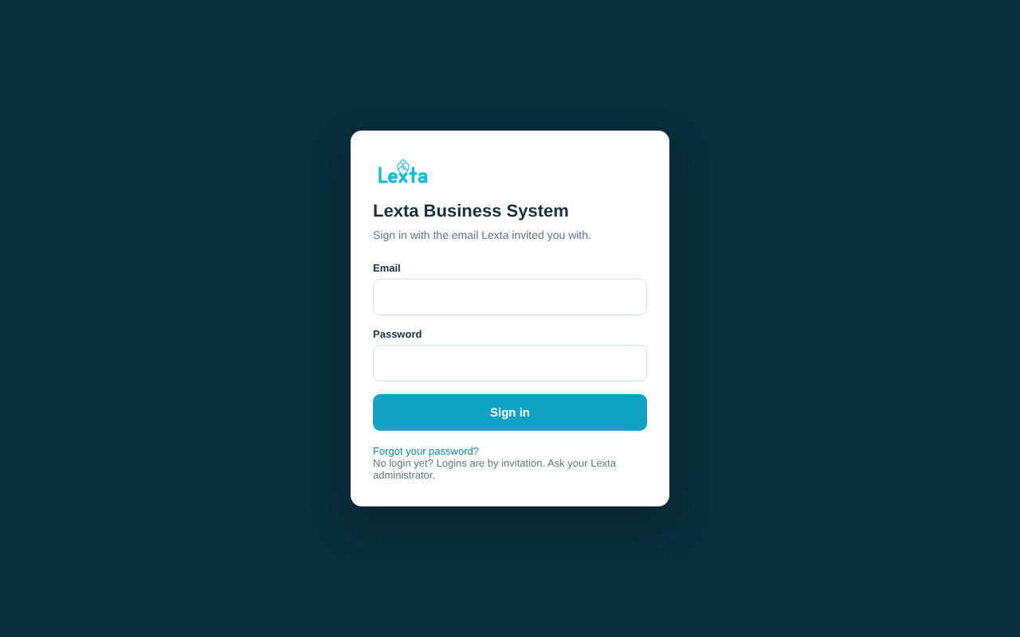
The sign in screen

Forgot your password?
- On the sign in screen, tap Forgot your password?
- Type your email and tap Send reset link.
- Open the email and tap the link. Choose a new password (at least 10 characters) and tap Save password.
The screen always says "If that email has a login, a reset link is on its way". If no email arrives after a few minutes, check your spam folder, then ask your admin. A reset link works once; if it says "That link has expired or was already used", ask for a new one.
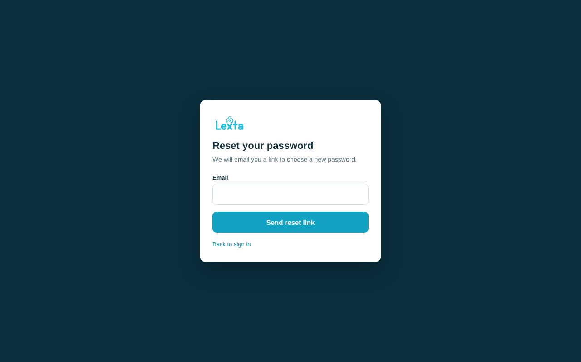
Reset your password

Your menu depends on your role
Each person has one role. Your role decides which systems appear in your menu and on your Home screen. Admin and management have no Home screen: they land on the Management overview when they sign in (see chapter 2). Your name and role show at the bottom of the menu (at the top on a phone).
System | Admin | Management | Sales rep | Customer care | Marketing | HR | Distributor
Management overview | Yes | Yes
Distributor ordering | Yes | Yes | Yes |  |  |  | Yes (own orders only)
Field sales | Yes | Yes | Yes
CRM | Yes | Yes | Yes | Yes | Yes
Complaints | Yes | Yes | Yes | Yes | Yes
Product management | Yes | Yes |  |  | Yes
Stockists (Where to Buy) | Yes | Yes | Yes | Yes | Yes
CSR activities | Yes | Yes |  |  | Yes
Recruitment | Yes | Yes |  |  |  | Yes
Live chat inbox | Yes | Yes |  | Yes
Users and access | Yes

Seeing a system does not always mean you can change everything in it. Each chapter below says who can do what.
Brands. Sales reps and marketing staff are also linked to the brands they work on (Yazz, Linzzy, Hooch). They see and change records of those brands. Admin and management see every brand. If you see "You are not linked to a brand yet", ask your admin to add your brands.
If your Home screen says "an administrator has not given you a role yet", your login works but you have no access yet. Ask your admin to set your role.
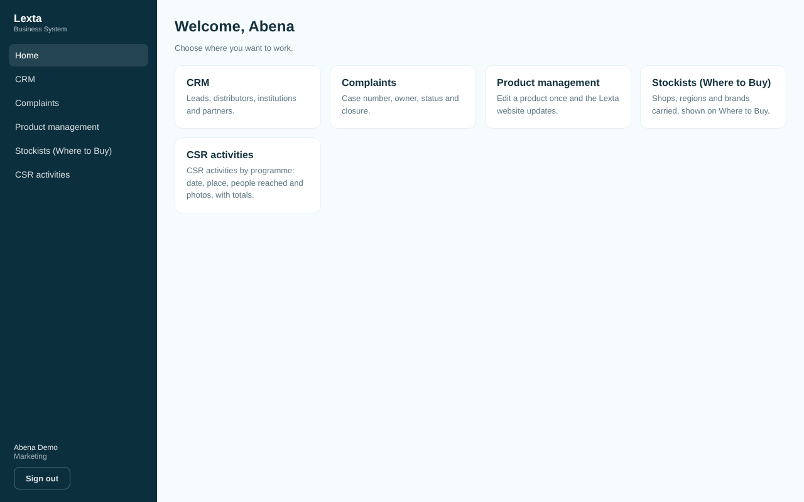
Home screen for a marketing person

Using it on a phone
The Business System fits a phone screen. On a phone the menu sits at the top of the screen as a row of buttons: swipe it sideways to see every system. Tables turn into cards you scroll down.
Field sales is made for the phone. See chapter 4.
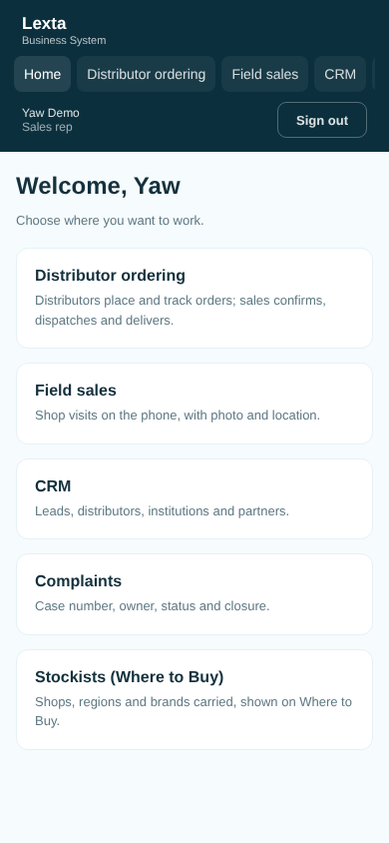
Home screen on a phone for a sales rep

Signing out
Tap Sign out under your name. Always sign out on a shared computer.

Good to know
- The system saves when you tap the button (Save, Add, Change status and so on). If you leave a page without tapping it, your changes are lost.
- Green messages mean it worked. Red messages tell you what to fix. Fields with a problem are marked.
- Most lists have Search and filters at the top. Choose your filters, then tap Apply. Tap Clear to see everything again.
- Drop down boxes (Brand, Status, Region and so on) open a list with the current choice ticked. Click an option, or use the keyboard: the arrow keys move, typing the first letters jumps to an option, Enter chooses and Escape closes without changing anything. On a phone they open the phone's own list.
- Date boxes (From, To, Date bought and so on) can be typed in, or tap the calendar icon to open a calendar. Today has a ring and the chosen day is filled in teal. Click a day, or use the keyboard: the arrow keys move by a day or a week, Page Up and Page Down by a month (with Shift, by a year), Enter chooses and Escape closes. Today picks today and Clear empties a box that can be left empty. Days you cannot choose are greyed out. On a phone they open the phone's own calendar.
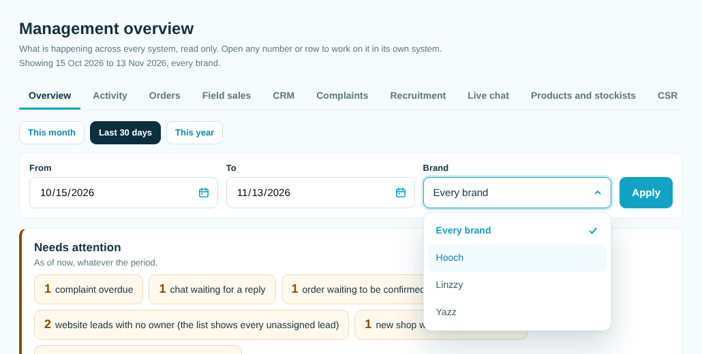
A drop down box open: the current choice is ticked
- Long lists show 50 at a time. Use Previous and Next at the bottom.
- "Delete" removes a record for good and asks you to confirm first. In most systems only admin can delete.
- Times are Ghana time.

2. Management overview
Who can use it: admin and management. Nobody else can open it, and it only shows; it never changes a record.
What it is for: one place to see what is happening across every system: the key figures and how they changed, what needs attention now, small charts over time, and everything people recorded, newest first. Tap any number or row to work on it in its own system.
Where to find it: admin and management land on it when they sign in. It is also the first item in their menu. (Its old name was Management dashboard; old links still work.)
Video: Management overview: a tour (46 seconds).
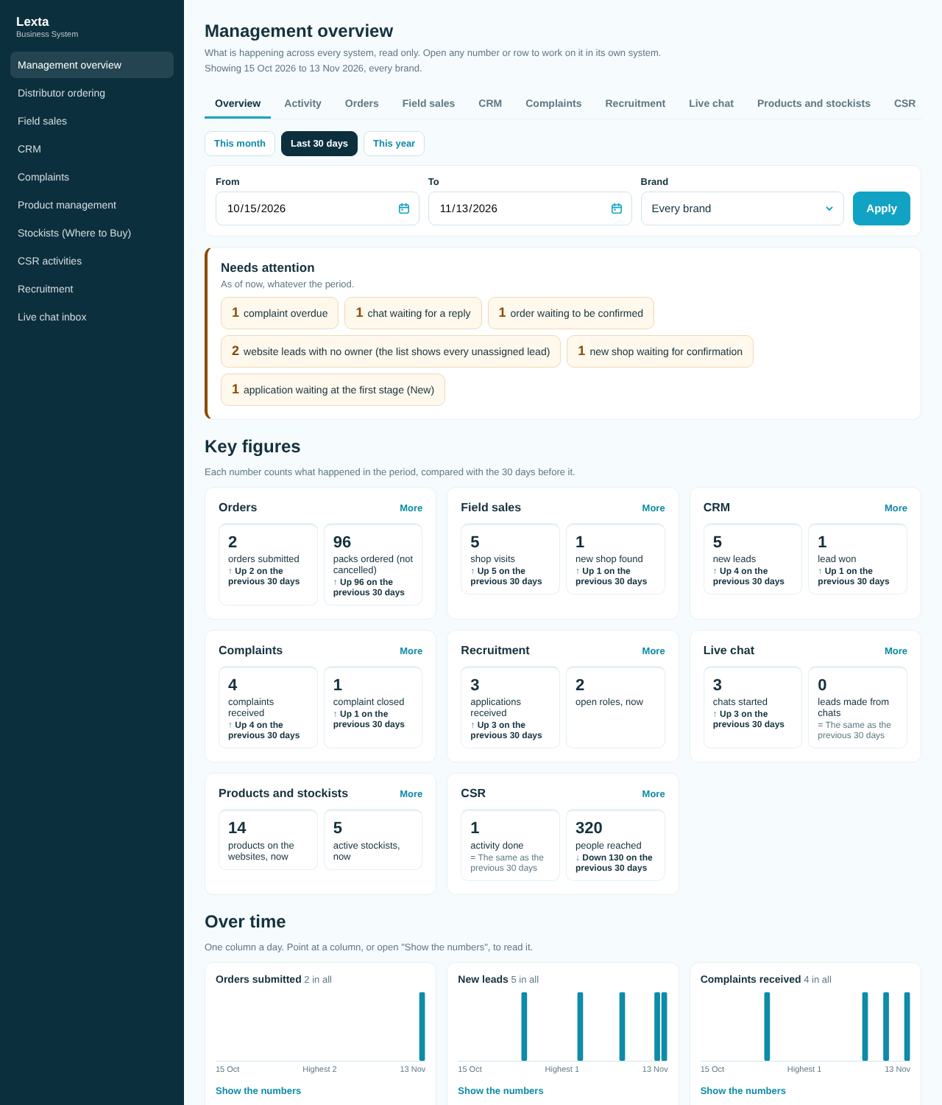
The management overview

The tabs
Along the top: Overview, Activity, then one tab for each system: Orders, Field sales, CRM, Complaints, Recruitment, Live chat, Products and stockists and CSR. The period and brand you choose stay set when you move between tabs. On a phone, swipe the tabs sideways to see them all.

Look at a period or one brand
- Tap This month, Last 30 days (the default) or This year.
- For your own dates, set From and To and tap Apply.
- To look at one brand, choose it under Brand and tap Apply. Tap Clear to go back to the last 30 days and every brand.

The Overview tab
- Needs attention lists what is waiting right now, whatever the period: overdue complaints, chats waiting for a reply, orders waiting to be confirmed, website leads with no owner, new shops waiting for confirmation and applications still at the first stage (New). Tap one to open that list in its system. If nothing is waiting, it says "Nothing needs attention right now."
- Key figures shows two numbers for each system, with how they changed on the period of the same length just before (for example "42 new leads, Up 41 on the previous 30 days"). Tap a number to open those records in its system, or More to open that system's tab.
- Over time has four small charts: orders submitted, new leads, complaints received and shop visits. Each column is a day (a week for longer periods, a month for more than a year). Point at a column to see its number, or tap Show the numbers for a table.
- Latest activity shows the eight newest things recorded. Tap See all activity for the rest.

The Activity tab
Everything recorded across the systems, newest first: new leads (with their source) and stage changes, complaints received and every status change (closed and resolved included), applications received and moved on, chats started and closed, orders submitted and every status change, shop visits, new shops found and confirmed, CSR activities logged, and products and stockists added or changed.
- Choose a System and, if you like, a Person, then tap Show. Tap All activity to clear them.
- Each row says what happened, when (Ghana time), who did it and the brand. Tap a row to open the record in its own system.
- The first 30 rows show. Tap Load more for the next 30.
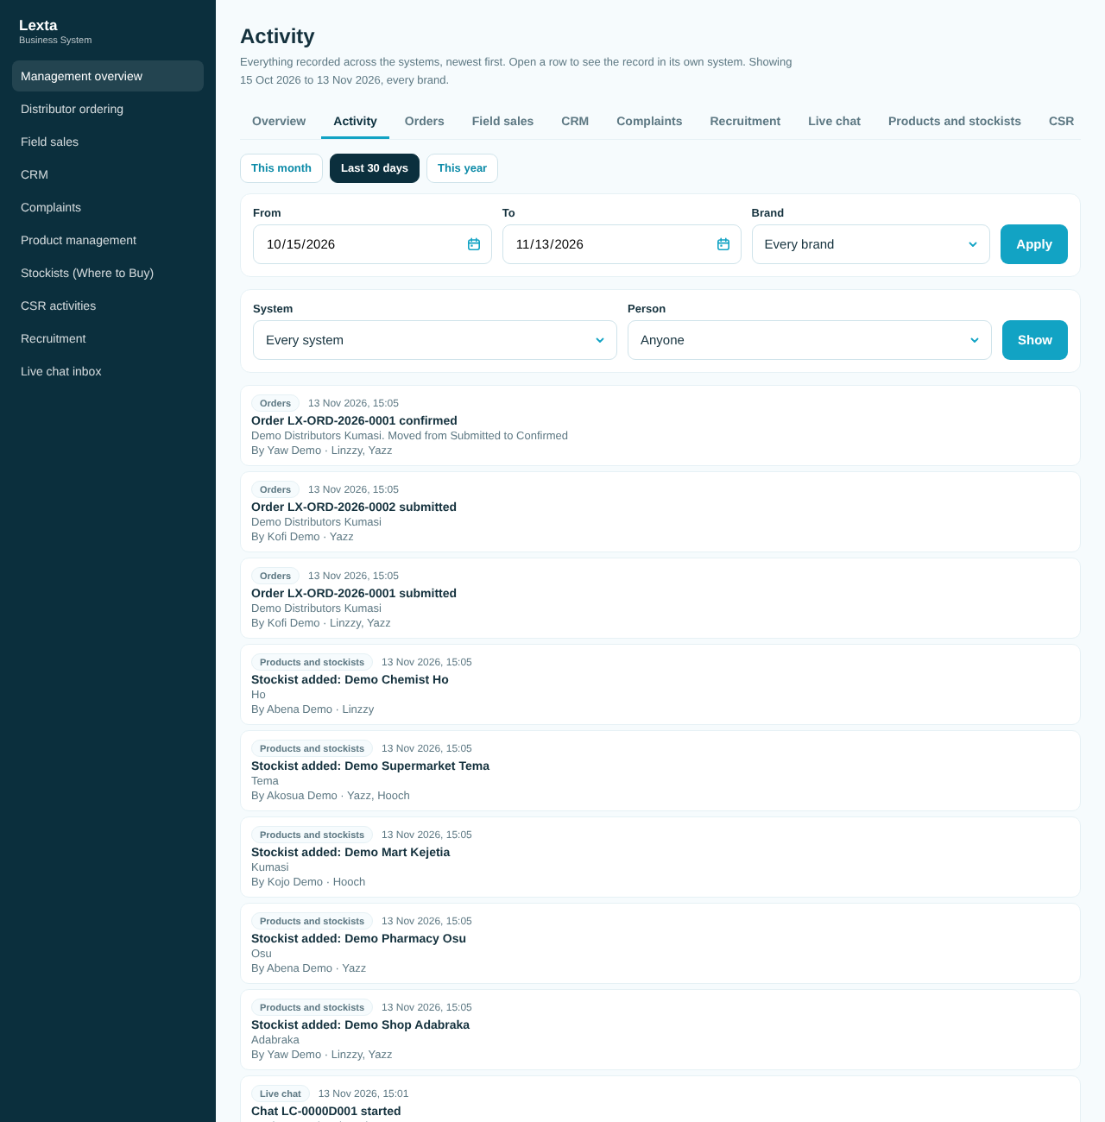
The activity feed

A system's tab
Each system's tab shows its figures (with the change on the period before), breakdowns such as complaints by severity, a chart for orders, field sales, CRM and complaints, and the ten latest records of the period. Tap a record to open it, or use the link at the top right of the list (for example All complaints) to open the full list in that system, where you can search, filter and export.
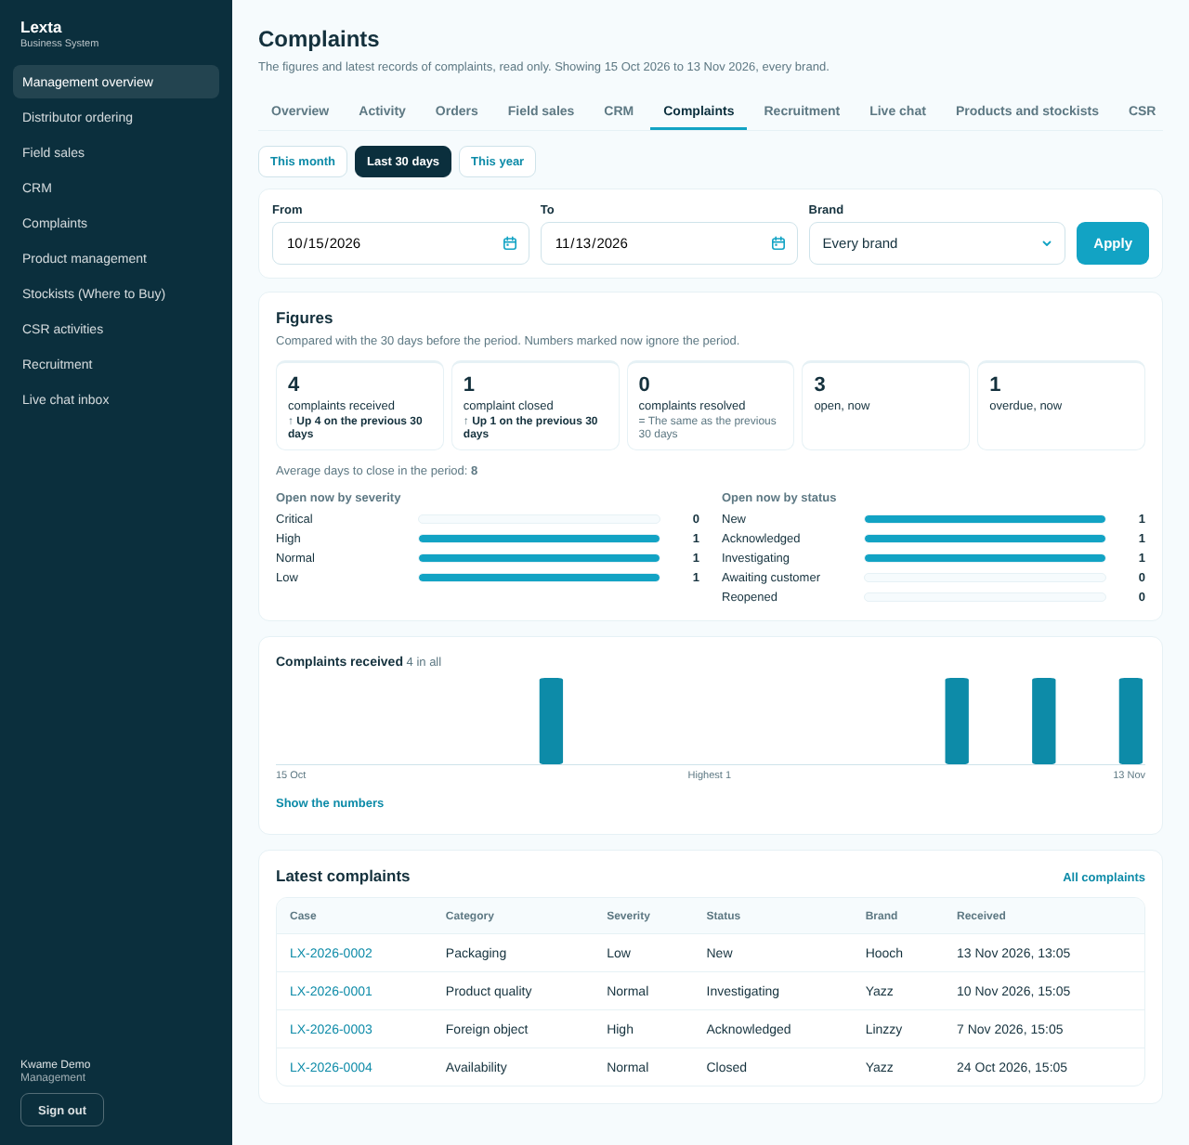
A system's tab: complaints
On the CRM tab, the latest leads that came from the website forms or the website chat show as "Website enquiry", "Partner enquiry", "Newsletter sign up" or "Live chat lead" with their reference, the same as on the Activity tab. Leads your team typed in keep their own title. Tap a lead to see who it is from.
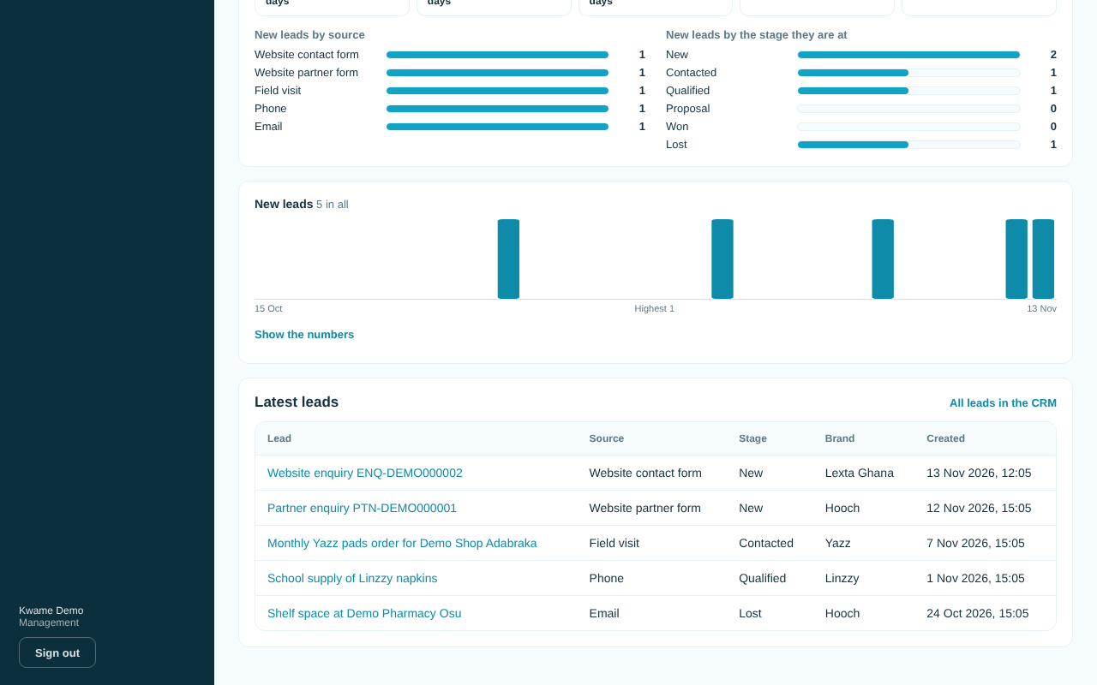
The CRM tab's latest leads

Good to know
- Numbers marked "now" are as they are at this moment. The others count what happened in the period you chose.
- "Up" and "Down" compare with the same number of days just before your period. For This month on the 13th, that is the 13 days before the 1st.
- Orders carry no prices yet, so order size is shown as order lines and packs.
- Recruitment is not split by brand. With a brand chosen, recruitment figures still count every application, and the Activity tab leaves out records with no brand (recruitment, corporate CSR programmes and leads with no brand).
- With a brand chosen, live chat counts that brand but the inbox still shows every chat. The website leads link opens every unassigned lead, not only website ones.
- Products and stockists keep no history, so the Activity tab shows only the latest change to each one. A shop added on a field visit shows once, as a new shop found.
- Leads from the website forms and the website chat show as "Website enquiry", "Partner enquiry", "Newsletter sign up" or "Live chat lead" with their reference, not by their title, because those titles hold the visitor's name. This is the same on the Activity tab and in the CRM tab's latest leads. Tap the row to see the lead.
- Some rows name no one: a website lead or an application, for example, has no staff member behind it.
- CSR totals only count activities marked done.

Common questions
Everything shows 0. Nothing has been recorded for that period yet. Try This year.
Can I change a record from here? No. The overview only shows. Tap the record to open it in its own system and change it there.
Can I download the overview? Not from the overview. Several systems have their own Export CSV button (orders, field sales, recruitment).

3. Distributor ordering
Who can use it: admin, management and sales reps (the staff side); distributors (their own orders only).
What it is for: distributors place orders in the portal and follow them. Lexta staff confirm, dispatch and mark them delivered. The distributor sees each step.
Video: Distributor ordering: place and confirm an order (56 seconds).
An order goes: Draft (only the distributor sees it), Submitted, Confirmed, Dispatched, Delivered. It can also be Cancelled.

For Lexta staff
Sales reps see the orders for the brands they work on. Admin and management see all orders.
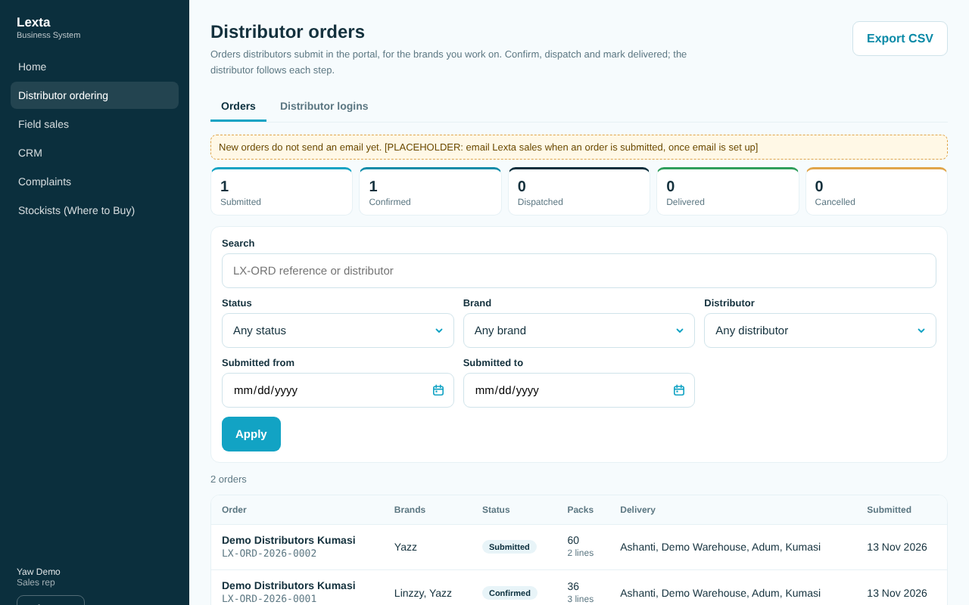
The orders inbox

Work a new order
- Open Distributor ordering. The boxes at the top count orders by status; tap Submitted to see orders waiting for you.
- Tap the distributor's name to open the order.
- Check the products, packs and Delivery details.
- Under Status, tap Confirm order. You can add a Note for the distributor (for example "On the Tuesday truck").
- Tap the Confirm order button below the note to save.
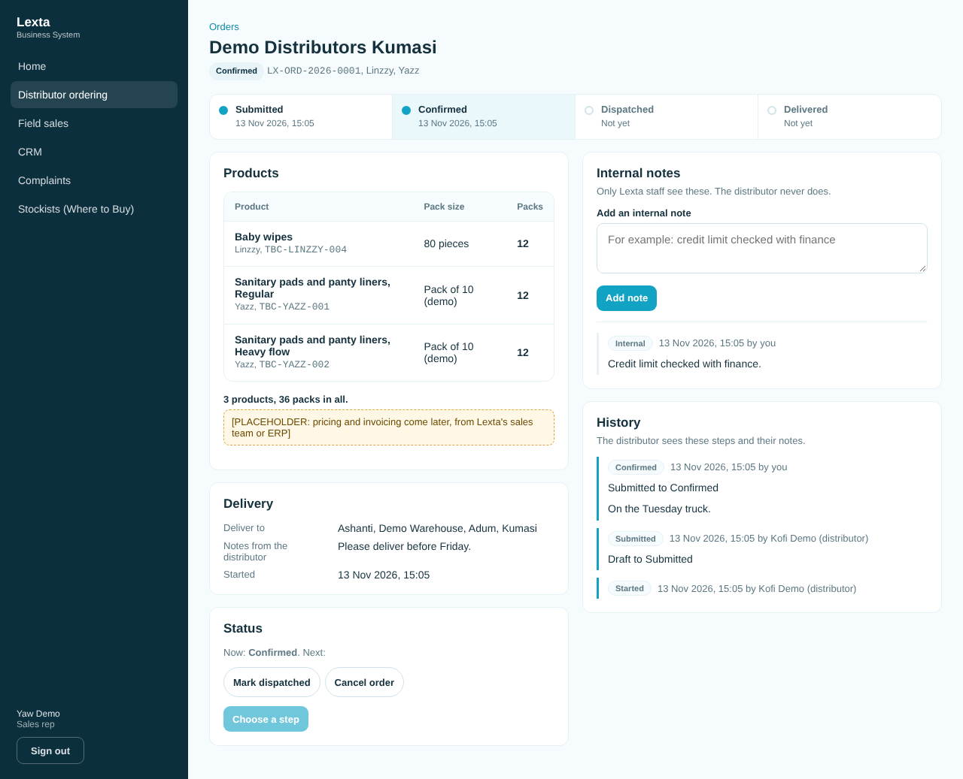
An order, staff view

Dispatch and deliver
- Open the order.
- Under Status, tap Mark dispatched, add a note if you like, and tap the button to save.
- When it arrives, open it again, tap Mark delivered and save.

Cancel an order
- Open the order. Under Status, tap Cancel order.
- Type the Reason for cancelling. This is required, and the distributor sees it.
- Tap Cancel order to save.
A submitted or confirmed order can be cancelled. A dispatched order can only move to delivered.

Add an internal note
- Open the order. Under Internal notes, type your note.
- Tap Add note. Only Lexta staff see internal notes; the distributor never does.

Link a distributor login to its company
A distributor can only order once their login is linked to their company (an organisation in the CRM). The organisation's brands decide what they can order.
- Open Distributor ordering, then the Distributor logins tab.
- Find the person marked Not linked.
- Choose their organisation under Organisation for ... and tap Link.
- To stop a login seeing orders, tap Unlink and confirm.
If the company is not in the list, add it in the CRM first (see chapter 5) with the brands it carries. New distributor logins are created by your admin; ask your admin.
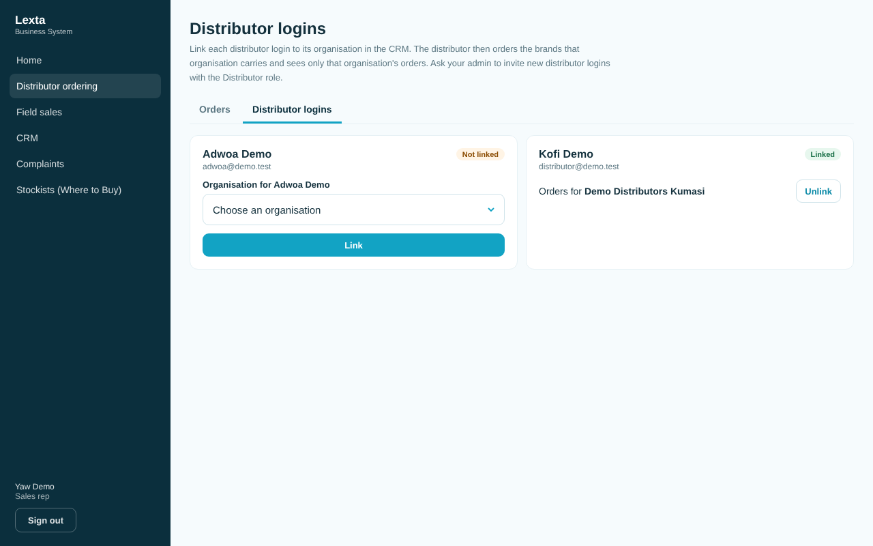
Distributor logins

Export orders
Set the filters you want and tap Export CSV. The file opens in Excel.

For distributors
Your menu shows My orders, New order and Catalogue only.
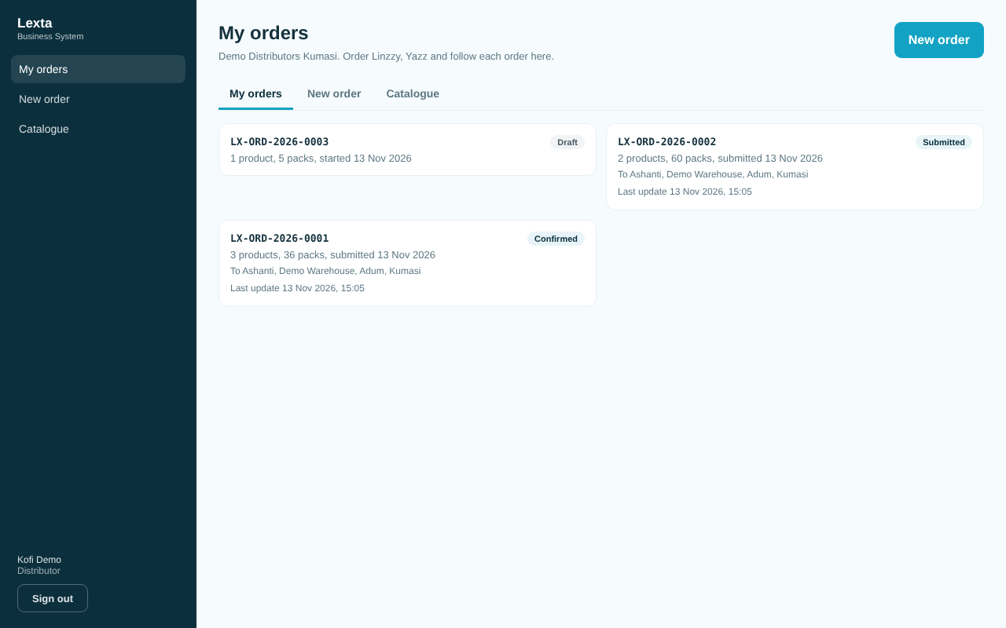
My orders, distributor view

Place an order
- Tap New order.
- Find products by brand or with Find a product.
- For each product, set the number of packs with + and -, or type the number.
- Tap Review order at the bottom.
- Check the list. Under Delivery, choose a Region or type a Delivery address (at least one is needed). Add Notes for Lexta if you like.
- Tap Submit order. Or tap Save as draft to finish later.
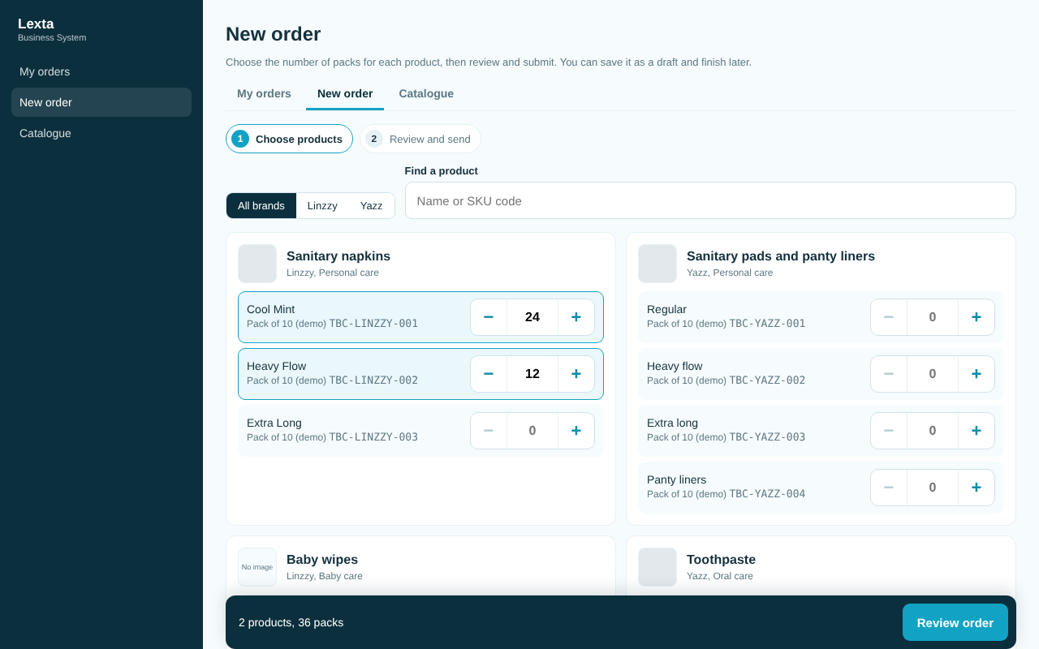
Choosing products
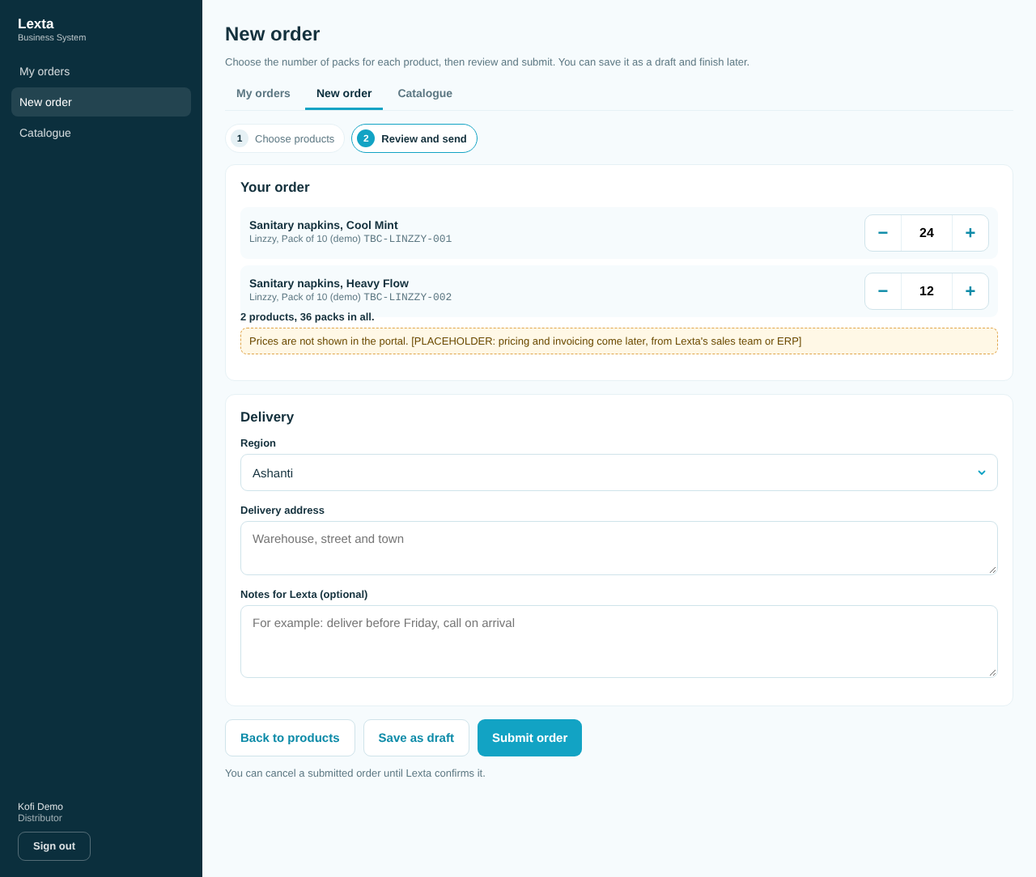
Review and send

Follow or change an order
- Tap My orders and tap an order. The tracker shows each step with its date and time.
- A draft can be changed with Edit draft, sent with Submit order or dropped with Drop draft.
- A submitted order can be cancelled with Cancel order until Lexta confirms it. After that, call your Lexta sales contact.

Good to know
- Quantities are whole packs, at most 100,000 a line and 200 lines an order.
- Prices are not shown in the portal yet. Pricing and invoicing come later.
- No email is sent when an order is submitted yet. Staff should check the inbox for Submitted orders. Ask your admin when email alerts will start.
- If a product is no longer available, it is removed from a draft when you save it.
- Only admin can delete an order, and only for orders made by mistake. Cancel it instead.

Common questions
The distributor says "Not linked yet". Link their login on the Distributor logins tab.
The distributor sees "No products to order yet". Their organisation's brands have no published products with pack sizes. Check the organisation's brands in the CRM, and the products in Product management.

4. Field sales
Who can use it: sales reps (on their phones), admin and management.
What it is for: log every shop visit with the shop, a photo, what happened, notes and your location. Managers see every visit.
Video: Field sales: record a shop visit (phone) (33 seconds).

For sales reps (on your phone)
Your Field sales screen shows a big Start visit button, your visits today, and the My history tab.
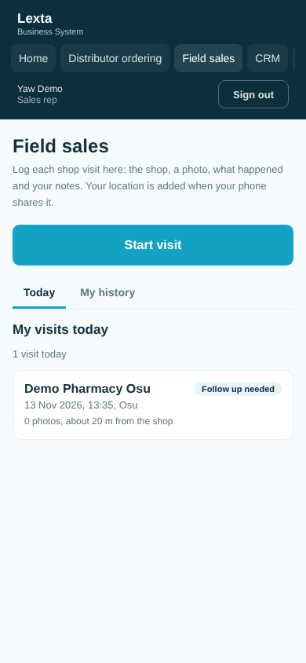
Field sales today, on a phone

Log a shop visit
- When you reach the shop, open Field sales and tap Start visit.
- Allow location when your phone asks. You see "Location captured" with how accurate it is.
- Under Which shop are you at? the shops of your brands are listed, nearest first. Tap your shop, or type its name or town in Find a shop.
- Under Photos, tap Take a photo for the shelf or shop front, or Choose from phone. Photos are optional.
- Under What happened?, tap the outcome (for example Order taken). Add Notes if you like: who you spoke to, what they need, when to come back.
- If the shop is in the CRM, you can tick Also log this visit on the CRM timeline.
- Optional: open Quick stock check and mark each product On shelf or Not on shelf, with the number of facings.
- Tap Save visit. Wait for Visit saved, then tap Start another visit or My visits today.
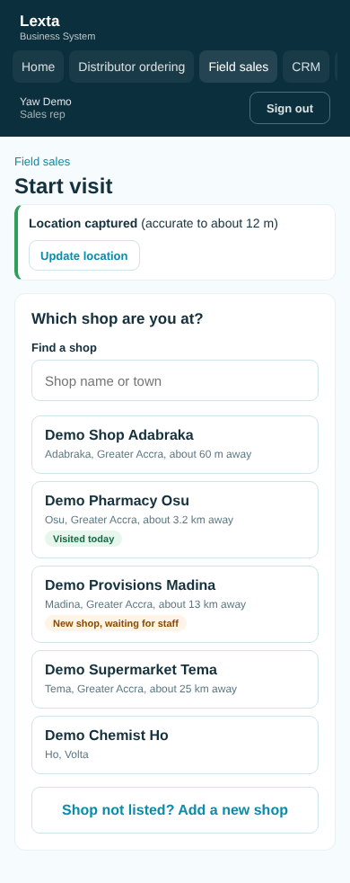
Pick the shop
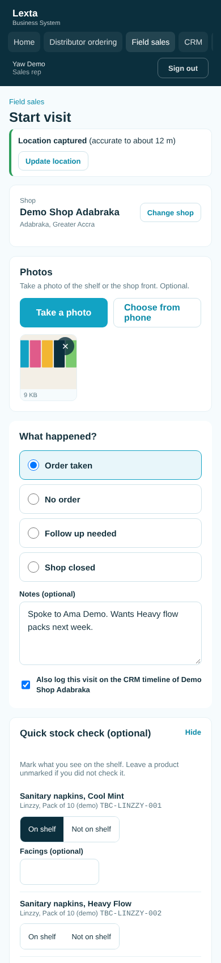
The visit form
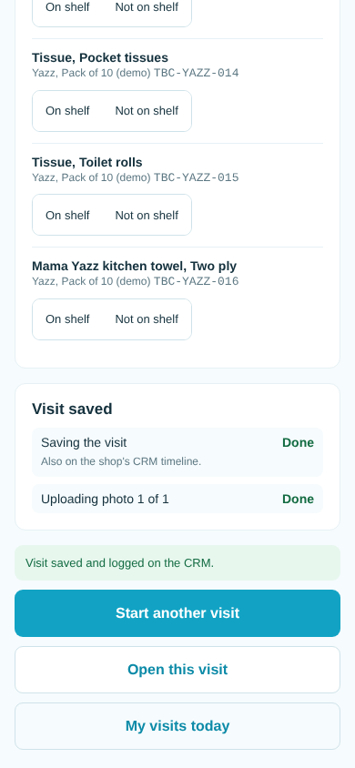
Visit saved

Add a new shop
- On Which shop are you at?, tap Shop not listed? Add a new shop.
- Fill in the Shop name, Type of shop, region, town and the Brands the shop sells. Address and phone are optional.
- Finish the visit as usual and tap Save visit.
New shops do not appear on the website's Where to Buy until admin or marketing check them and switch them on in Stockists.

Change a visit
- Open My history and tap the visit.
- Under Change this visit, change the outcome, notes, stock check or photos and save.
You can change your own visit for 24 hours after you made it.

For managers (admin and management)
- Open Field sales. The All visits tab lists every visit.
- Filter by rep, region, brand, outcome or dates and tap Apply.
- Tap a shop name to open the visit with its photos, stock check and location. Open in OpenStreetMap shows where it was logged.
- Tap Export CSV to download the list.
Managers can also log visits with Log a visit. Admin can change the outcome list on the Outcomes tab (add, switch off or delete), change any visit and delete visits.
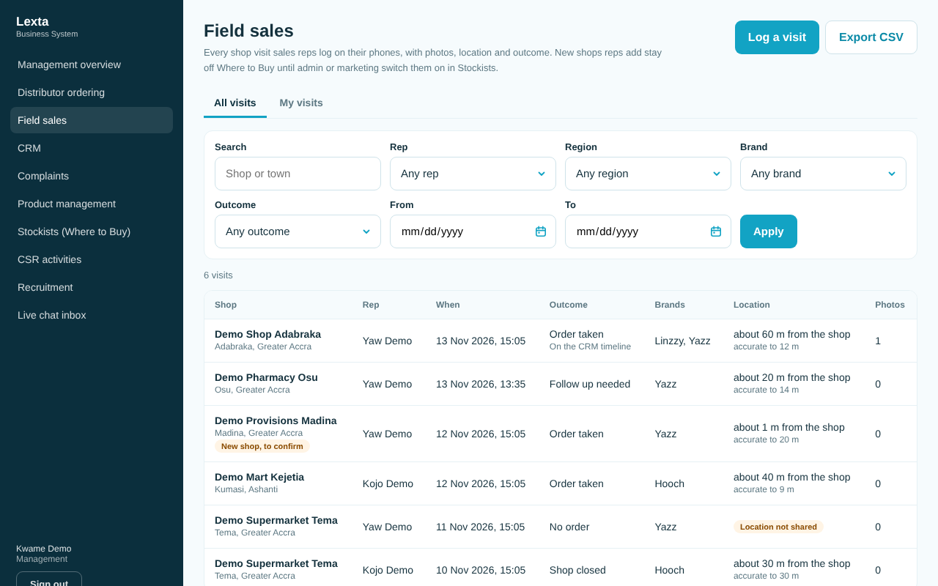
All visits, manager view

Good to know
- A visit has at most 10 photos, each up to 5 MB (JPG, PNG or WebP).
- If you refuse location or it cannot be found, you can still log the visit; it is marked "Location not shared" or "Location not available".
- The list shows how far you were from the shop (for example "about 60 m from the shop").
- Bad network? The phone keeps trying ("Connection problem. Trying again"). Press Try again if asked. A visit is never saved twice.
- If photos fail with "Photo uploads are not set up yet", the visit itself is saved. Ask your admin.
- If you see "Your session has ended", tap Sign in (it opens in a new tab, so nothing is lost), sign in, come back and press Try again.
- Only admin and sales reps can add new shops.

Common questions
No shops are listed. You are not linked to a brand yet, or no shops of your brands are listed. Ask your admin to add your brands; add the shop as a new shop.
I picked the wrong shop. Before saving, tap Change shop. The shop of a saved visit cannot be changed: ask your admin to delete the visit, then log it again.

5. CRM
Who can use it: admin, management, sales reps, marketing and customer care.
What it is for: one shared list of leads (possible sales), contacts (people) and organisations (distributors, retailers, institutions, partners, media, suppliers), each with a timeline of calls, visits and notes.
Video: CRM: a website enquiry becomes a lead (68 seconds).
Leads move through stages: New, Contacted, Qualified, Proposal, Won or Lost.
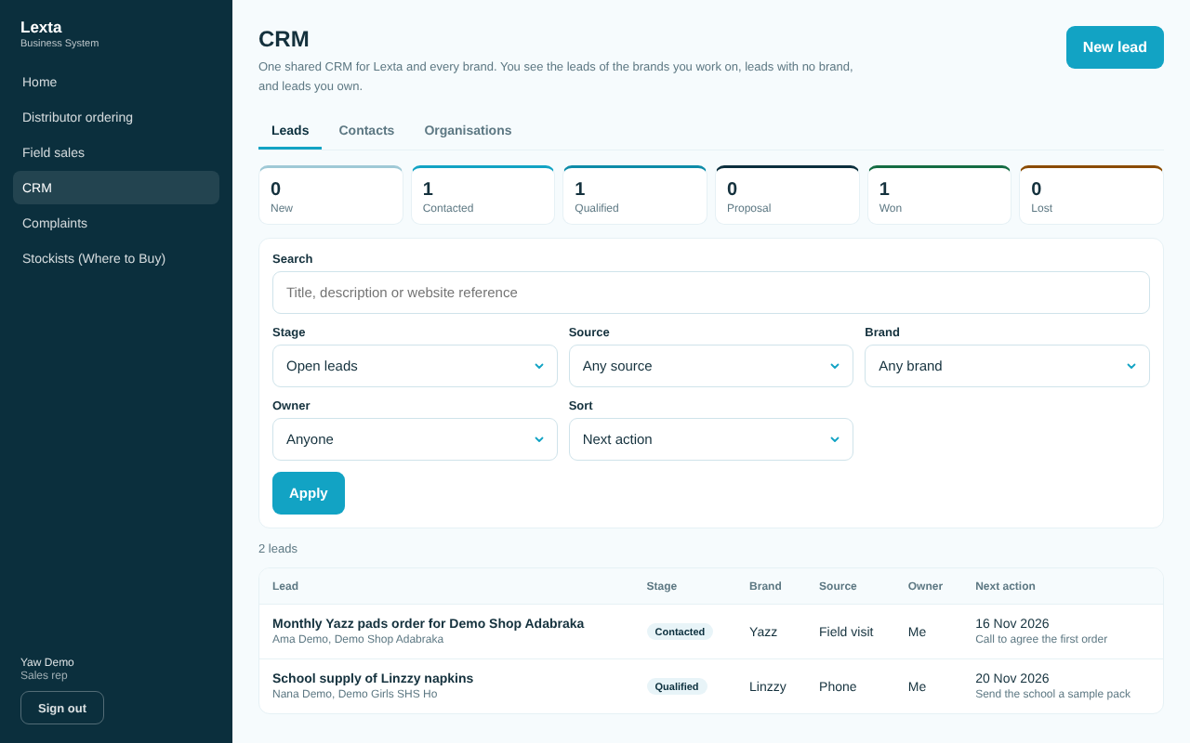
The leads list

Who can do what
- Admin and management: everything, including choosing the owner of any record.
- Sales reps and marketing: see and work records of their brands, records with no brand, and records they own. They can take an unowned lead with Assign to me.
- Customer care: add contacts, leads (at stage New) and timeline entries. They cannot change existing records.
- Only admin deletes records.

Add a lead
- Open CRM. On the Leads tab, tap New lead.
- Type a Title (for example "200 cartons a month for a Kumasi wholesaler").
- Choose the Contact and/or Organisation (at least one), the Brand and the Source.
- Add the estimated monthly volume, a description and the Next action with a date if you know them.
- Tap Add lead.

Work a lead
- Open the lead from the list.
- To log what happened, choose the Type (call, meeting, visit, email or note), write What happened, and tap Add to timeline.
- To move it on, choose the new stage under Stage and tap Change stage. For Lost, give the reason.
- Update the Next action in the form and tap Save changes.
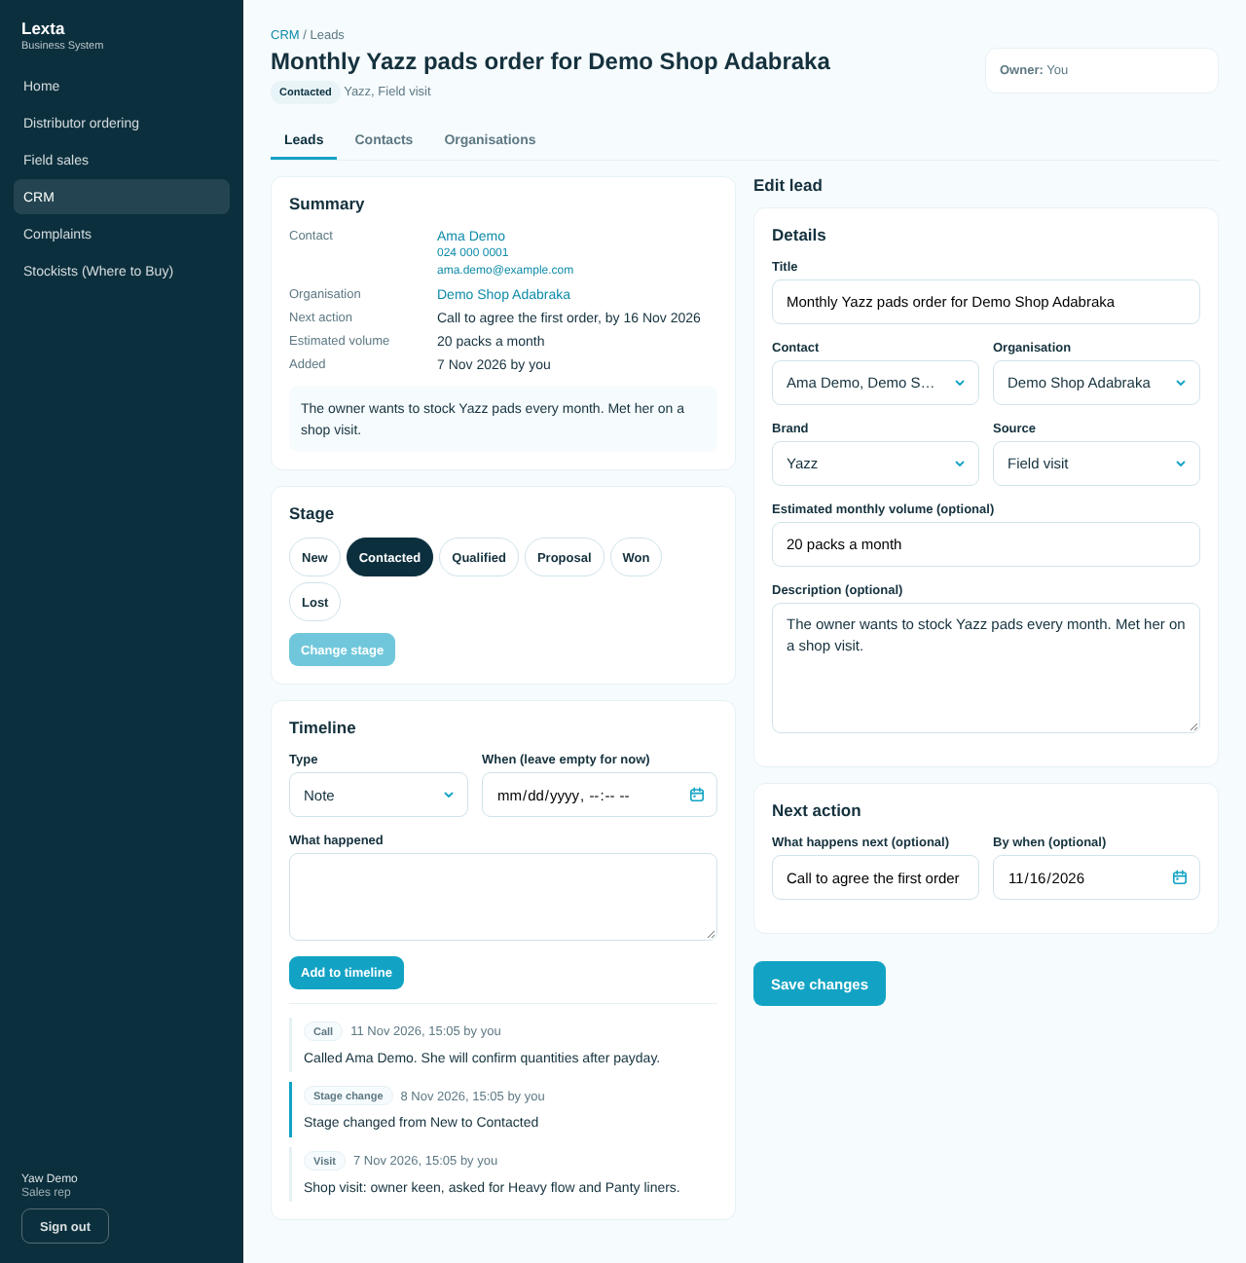
A lead with its timeline

Add a contact or an organisation
- Open the Contacts or Organisations tab.
- Tap New contact or New organisation.
- Fill in the details and save. For an organisation, tick its Brands of interest.
Customer care cannot add organisations.

Website leads
Messages from the website forms land in the CRM by themselves:
- Contact Us (every reason except Consumer care) makes a lead and a contact.
- Partner With Us makes a lead, a contact and an organisation.
- The newsletter sign up adds a contact with marketing consent.
- Contact Us, Consumer care goes to Complaints instead (see chapter 6).

Website lead managers (admin only)
Admin chooses who gets new website leads.
- Open CRM and tap Website lead managers.
- Choose a Default manager: they get every new website lead unless the brand has its own manager.
- Under Manager per brand, choose a manager for a brand, or leave Use default.
- Tap Save managers. Recent changes shows who changed what.
A sales rep or marketer can only manage a brand they work on. If nobody is chosen, website leads stay unassigned; the management overview shows how many.
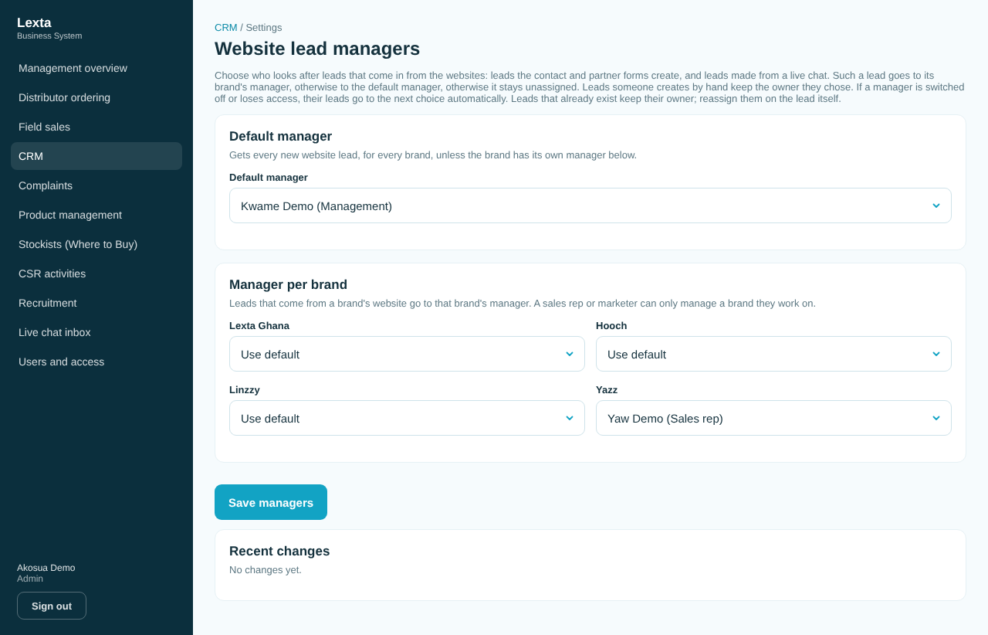
Website lead managers

Good to know
- The lead list shows open leads by default. Choose All stages under Stage to see won and lost ones too.
- Use Owner: Unassigned to find leads nobody has taken.
- Estimated volume is quantities only, never prices.
- An organisation with leads cannot be deleted until its leads are moved or deleted.

Common questions
I cannot change the brand of a lead. Sales reps and marketing must own the lead first: tap Assign to me. This only works on a lead nobody owns; if a colleague owns it, ask them or a manager.
I cannot see a lead a colleague mentioned. It is for a brand you do not work on. Ask its owner or a manager.

6. Complaints
Who can use it: admin and customer care work complaints. Management can read all complaints, assign owners and add notes. Sales reps and marketing can read the complaints of their brands and add notes, calls and emails.
What it is for: every consumer complaint gets a case number (for example LX-2026-0001), an owner, a severity with target times, a status and a timeline until it is closed.
Video: Complaints: log, acknowledge and resolve (83 seconds).
Status goes: New, Acknowledged, Investigating, Awaiting customer, then Resolved and Closed. A closed case can be Reopened.
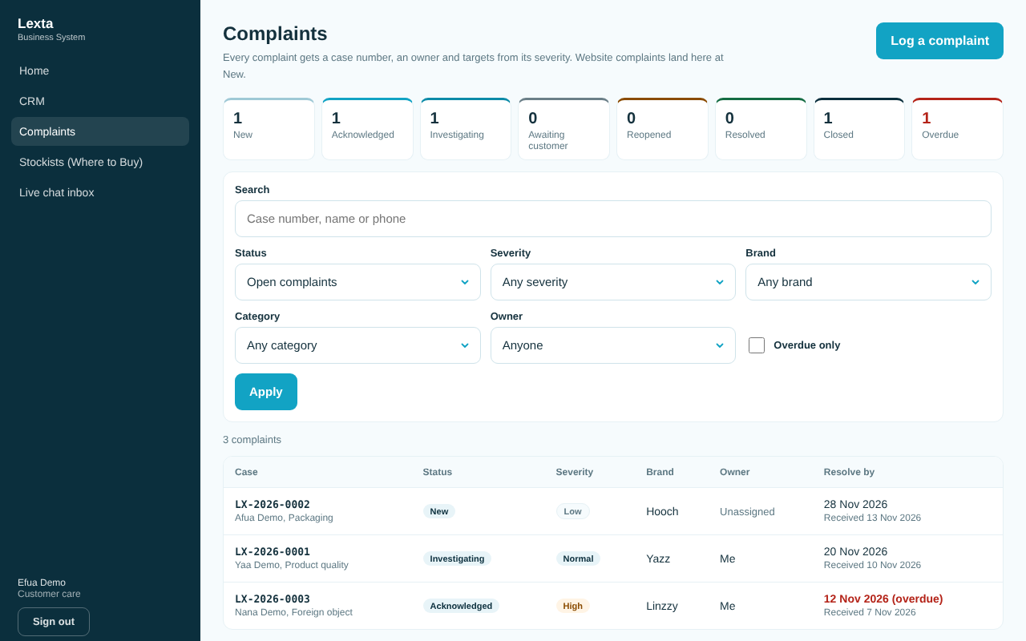
The complaints list

Log a complaint (phone, walk in, email or social media)
- Open Complaints and tap Log a complaint.
- Under Find the customer, type their name, phone or email and tap Find. Tap Use if they are already in the CRM. If not, type their name and a phone or email; they are added to the CRM.
- Choose How it came in, What it is about and the Severity. Type What the customer said.
- Choose the Brand (use Lexta Ghana for anything not about one brand). Add the product, pack size, batch number, date bought and where it was bought if you know them.
- Choose the Owner (or leave it for now) and tap Log complaint. The case number appears.
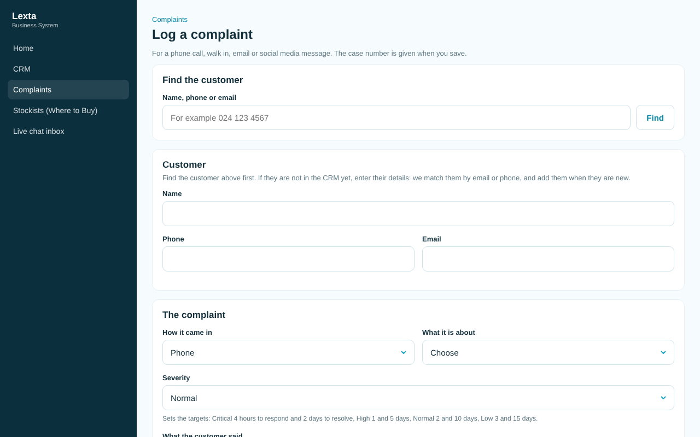
Log a complaint

Take and work a case
- Open the case. If it has no owner, tap Assign to me (customer care) or choose an owner (admin and management).
- Under Status, tap the next status (for example Acknowledged) and tap Change status.
- Log every call, email and note: choose the Type, write What happened, tap Add to timeline.
- Add photos of the product, batch code or receipt under Files: choose the file and tap Upload.
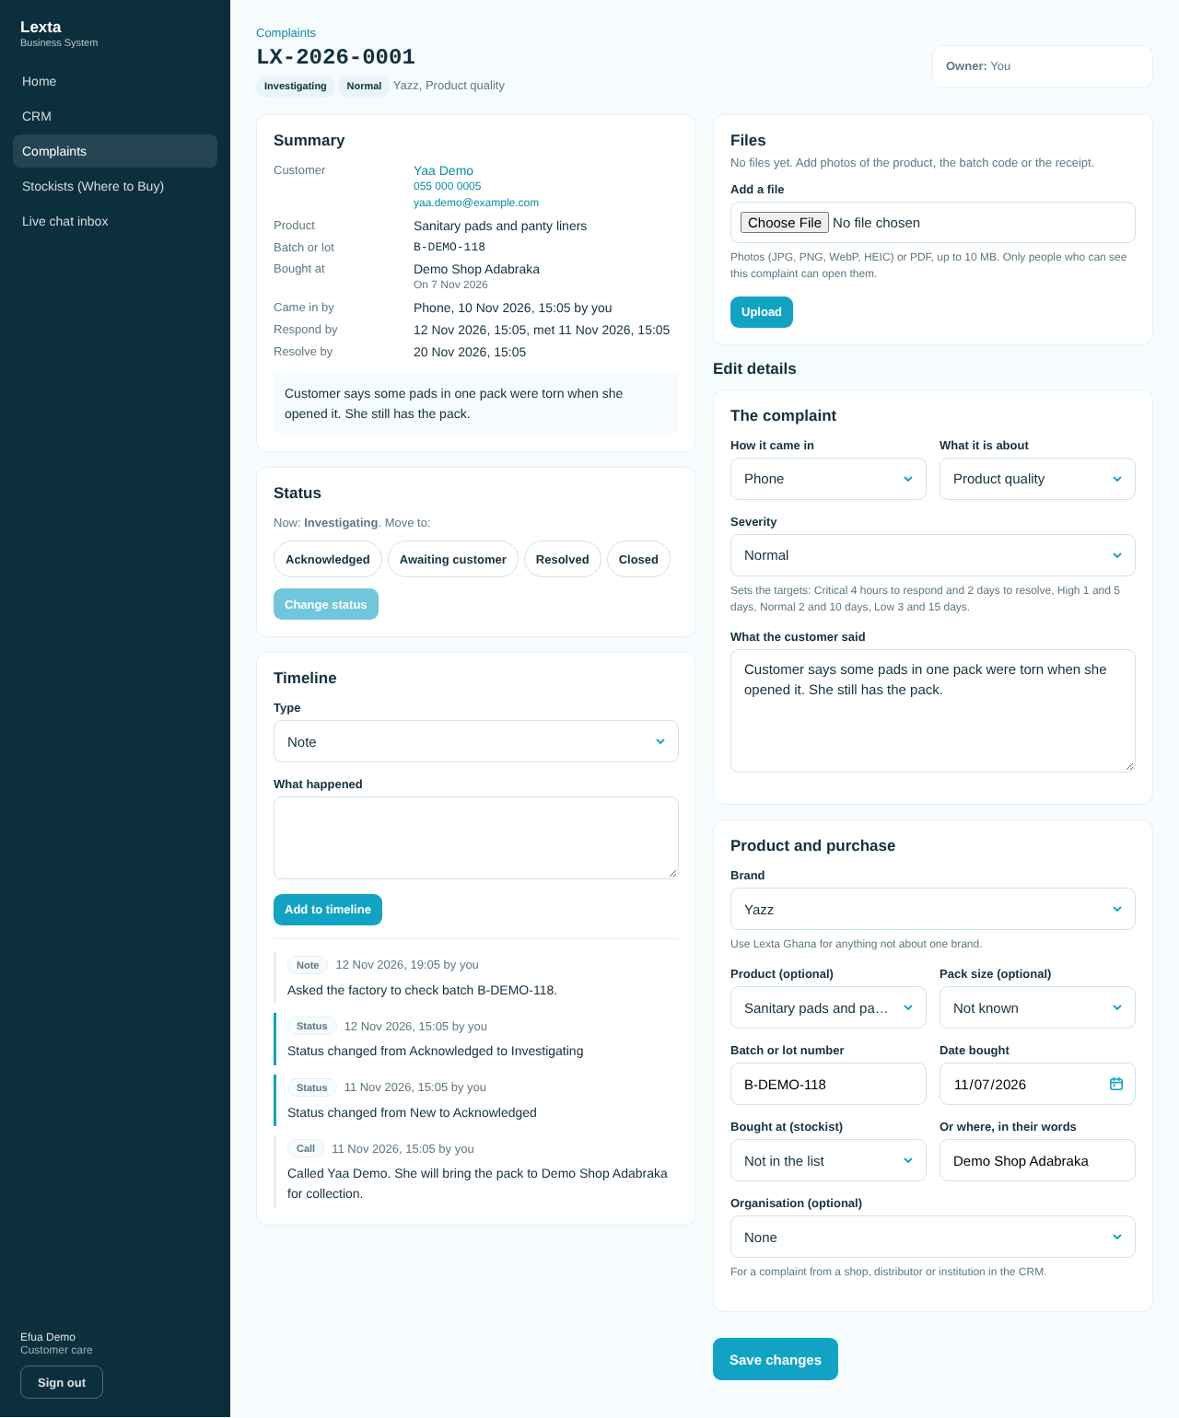
A complaint with its timeline

Close a complaint
- Open the case. Under Status, tap Resolved.
- Write How it was resolved and the Root cause, then tap Change status.
- When the customer is satisfied, tap Closed and Change status.
You can also close straight away; closing needs How it was resolved.

Reopen a complaint
- Open the closed case. Under Status, tap Reopened.
- Write Why reopen it and tap Change status.

Good to know
- Severity sets the targets: Critical 4 hours to respond and 2 days to resolve; High 1 day and 5 days; Normal 2 and 10 days; Low 3 and 15 days. Late cases are marked Overdue.
- A health or safety concern or a foreign object is always at least High.
- Website complaints (Contact Us, reason Consumer care) arrive at New with no owner.
- Files: photos (JPG, PNG, WebP, HEIC) or PDF, up to 10 MB each. Only people who can see the complaint can open them.
- A closed case is read only. You can still add notes, calls and emails. Reopen it to change details, owner or files.
- Only admin deletes a complaint, and only one logged by mistake.

Common questions
I am a sales rep. Can I log a complaint? No. Pass the customer's details to customer care, or add a note to an existing complaint.
The owner list does not show my colleague. Only active admin and customer care people can own complaints.

7. Product management
Who can use it: admin and marketing (change); management (read only).
What it is for: one place for every product, its pack sizes (SKUs) and images. Edit a product once and the Lexta website shows the change (the brand sites will too, once they are built).
Video: Product management: edit a product (29 seconds).
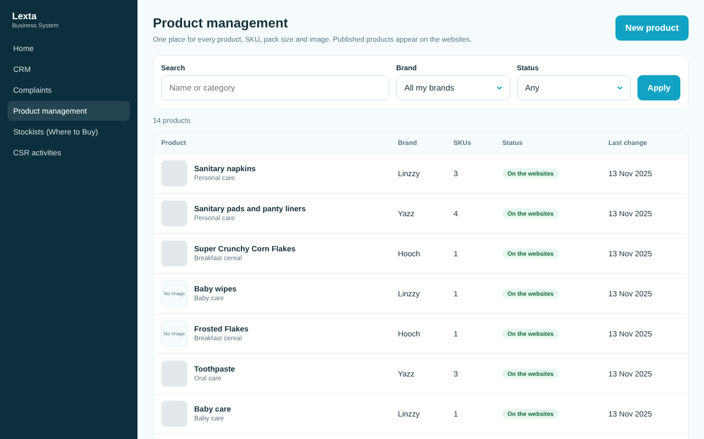
The product list

Change a product
- Open Product management and tap the product.
- Change the details: name, category, descriptions, display order, key features, how to use, ingredients.
- Under SKUs and pack sizes, change or Add a SKU (SKU code, variant, pack size, barcode). Untick Active to stop a pack size being ordered.
- Tap Save changes. The message "Saved. The websites will show the change shortly" confirms it.
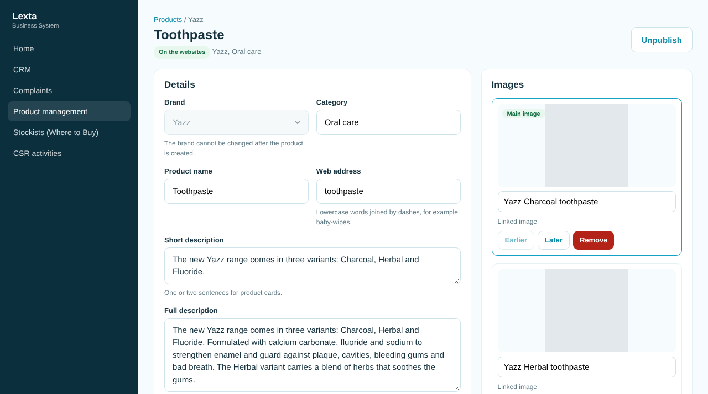
Editing a product

Add a product
- Tap New product.
- Choose the Brand (it cannot be changed later), type the name and details, and add the SKUs.
- Tap Create product.
- Add images on the next screen (see below), then publish.

Add or change images
- Open the product and go to Images.
- Choose Upload a file (JPG, PNG, WebP or AVIF, up to 5 MB) or Use a link.
- Write the Alt text: a short description of what the image shows. It is required.
- Tap Add image. Use Make main, Earlier, Later and Remove to arrange them.

Publish or hide a product
- Open the product and tap Publish to show it on the websites, or Unpublish to hide it.
- Unpublished products stay as drafts that only staff see.

Good to know
- Only put information Lexta has approved in Approved information. The websites show it exactly as written.
- You only see the brands you are linked to. If you see "No brands assigned yet", ask your admin.
- Published products also feed the distributor catalogue and the field sales stock check.
- Some pack sizes still say "[PLACEHOLDER: pack size from Lexta]". Replace them with the real pack sizes.
- Deleting a product removes it from the system and the websites for good. Unpublish it instead if you only want to hide it.

8. Stockists (Where to Buy)
Who can use it: admin, sales reps and marketing (add and change); management and customer care (read only).
What it is for: the list of shops, supermarkets, pharmacies, markets and distributors that sell Yazz, Linzzy and Hooch. Active stockists show on the website's Where to Buy.
Video: Stockists: add a shop (51 seconds).
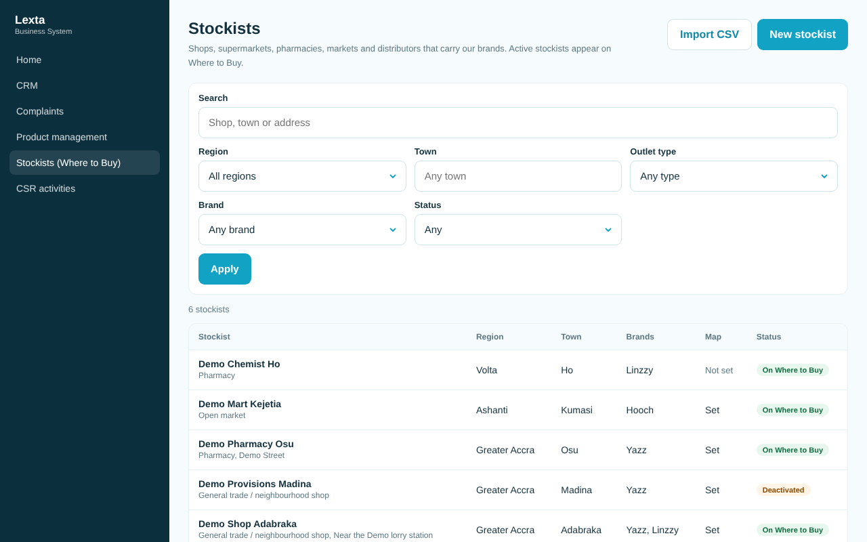
The stockist list

Add a stockist
- Open Stockists (Where to Buy) and tap New stockist.
- Type the Shop name, choose the Outlet type and Region, and type the Town.
- Add phone, address or landmark and opening hours if you have them.
- For the map position, stand at the shop entrance and tap Use my location, or type the latitude and longitude from Google Maps.
- Tick the Brands carried.
- Tap Add stockist. It shows on Where to Buy while it is active.
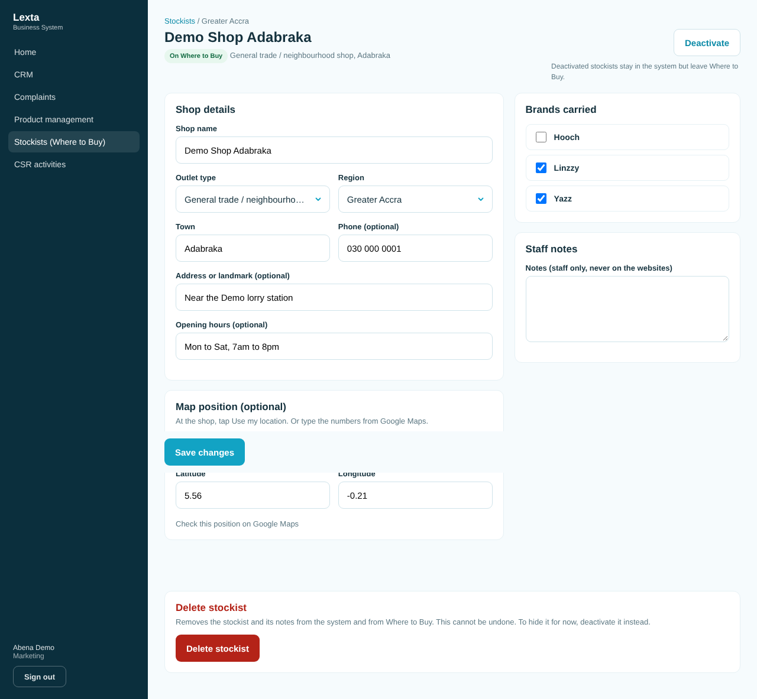
Editing a stockist

Import many shops from a spreadsheet (CSV)
- Save your spreadsheet as CSV with this first line: name,outlet_type,region,town,address,phone,latitude,longitude,brands
- Open Stockists and tap Import CSV.
- Choose the file, or paste the text.
- Tap Check rows. Rows with problems are listed with what to fix.
- Fix the file and check again, or tap Import ... valid rows to load the good rows now.
Rules for the file: outlet_type is supermarket, pharmacy, open market, general trade, distributor or other; region is one of Ghana's 16 regions (or Liberia (Monrovia)); separate brands with a semicolon (for example Yazz; Hooch). At most 2,000 shops and 1 MB a file.
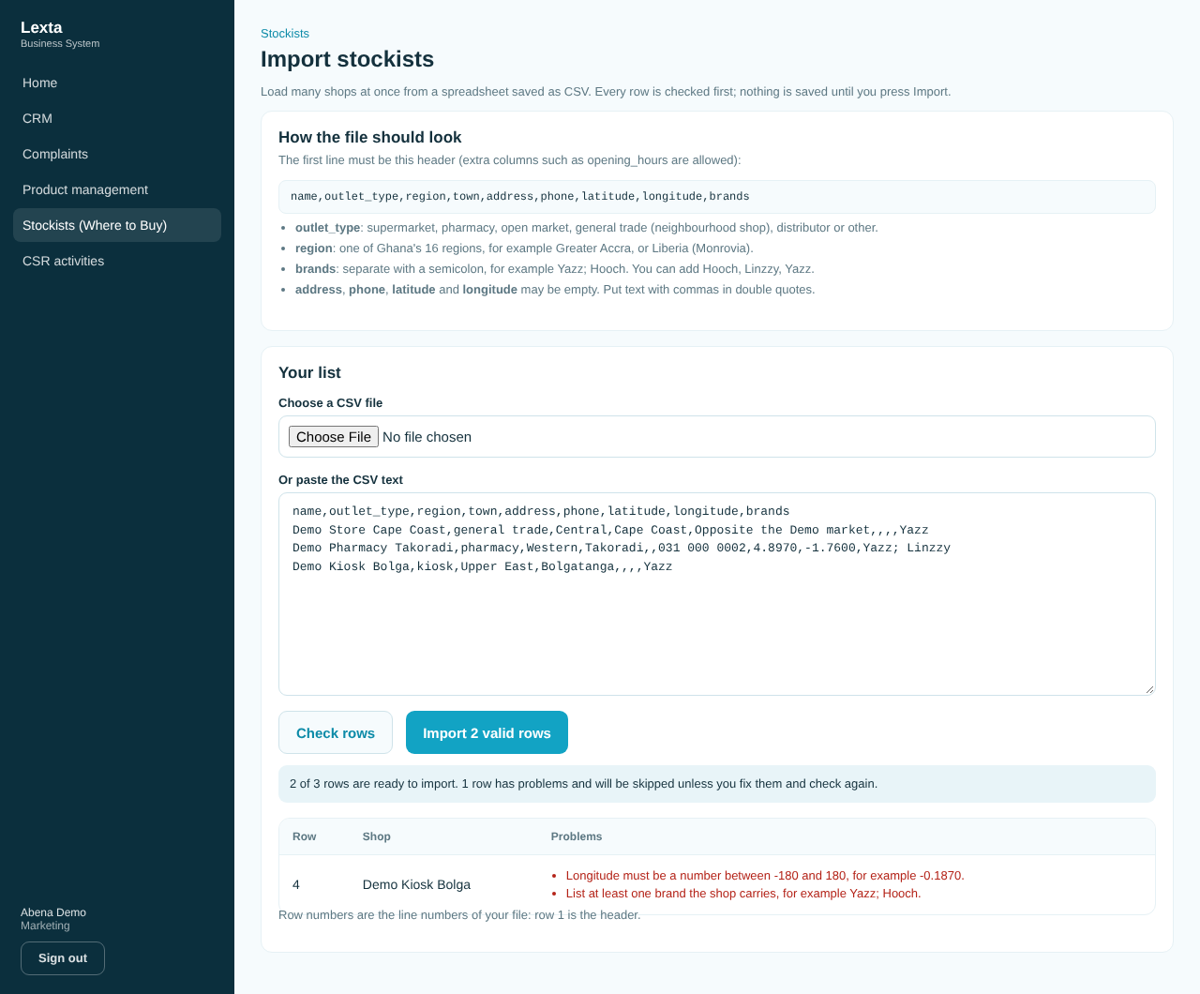
Checking an import

Hide or confirm a stockist
- Open the stockist.
- Tap Deactivate to take it off Where to Buy (it stays in the system), or Reactivate to show it again.
New shops added by sales reps in Field sales start deactivated. Filter Status: Deactivated to find them, check them, then tap Reactivate. Only admin or marketing can switch these new shops on.

Good to know
- Sales reps and marketing can change a stockist only if every brand it carries is one of theirs. On a shop that carries other brands too, they can add or remove their own brands only (Save my brands).
- Staff notes are never shown on the websites.
- Deleting removes the stockist for good. Deactivate it instead to hide it.

9. CSR activities
Who can use it: admin and marketing (log and change); management (read only).
What it is for: record every CSR activity: the programme, date, place, people reached, partners, notes and photos, with totals per programme.
Video: CSR activities: log an activity with a photo (49 seconds).
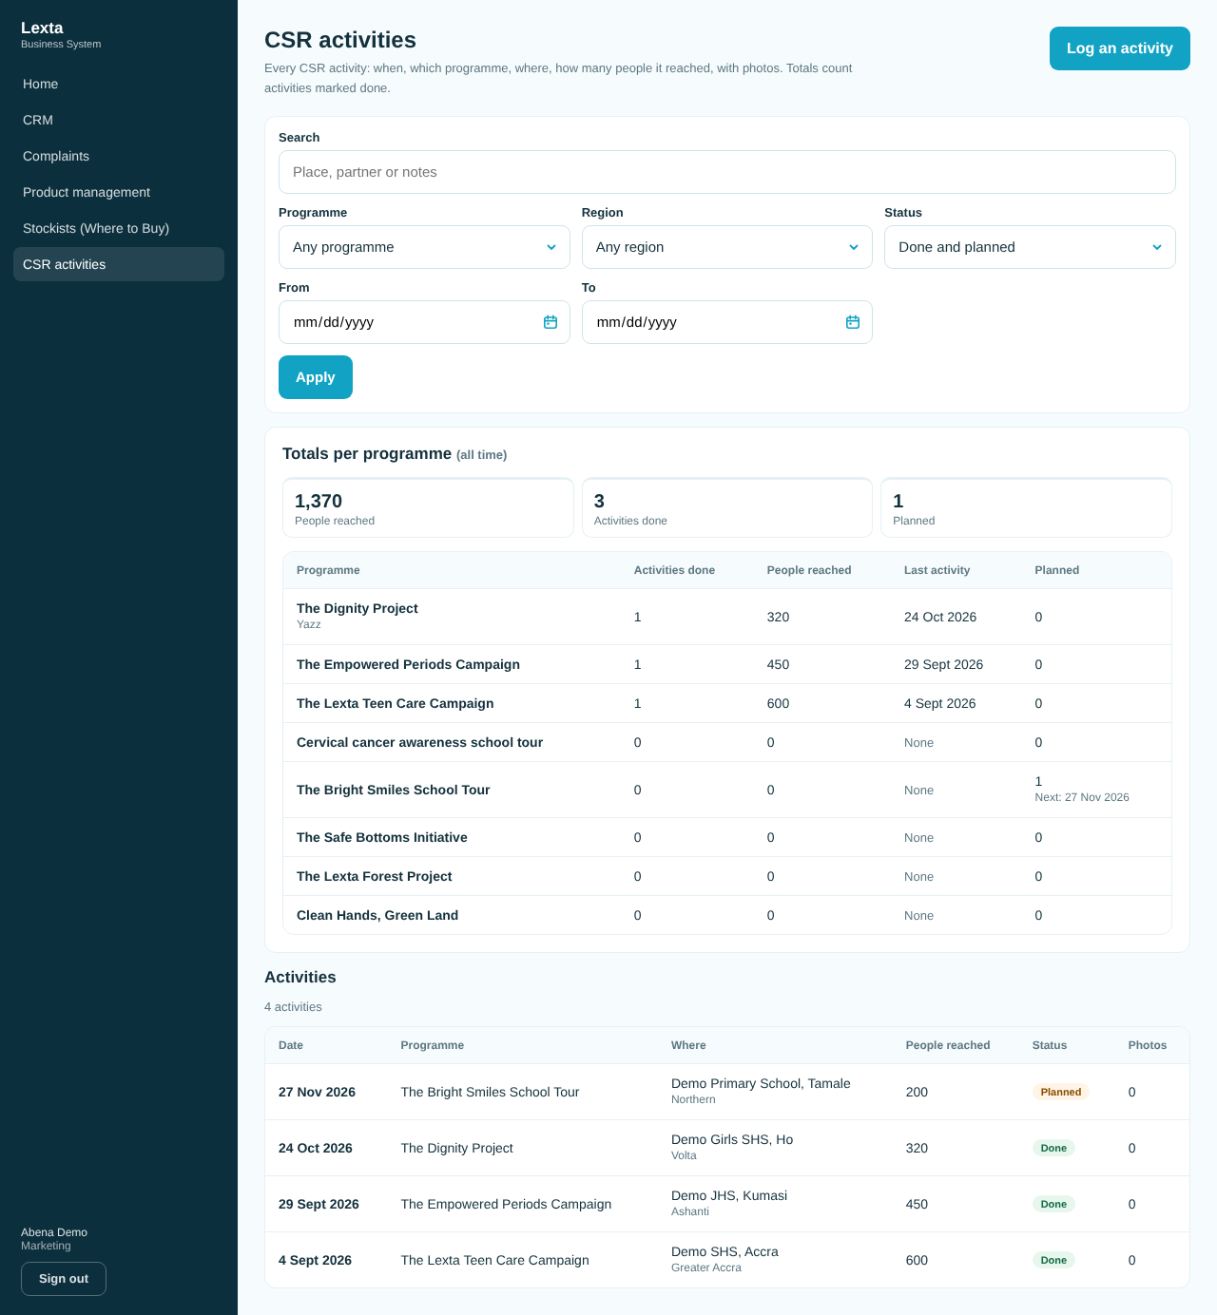
CSR activities and totals

Log an activity
- Open CSR activities and tap Log an activity.
- Choose the Programme and Date, and tick Done or Planned.
- Choose the Region and type the Town or place (for example the school's name).
- Type the People reached (for a planned activity, the number you expect). Add partners and notes if you like.
- Tap Save activity.
- On the next screen, add photos: Take a photo or Choose photos.
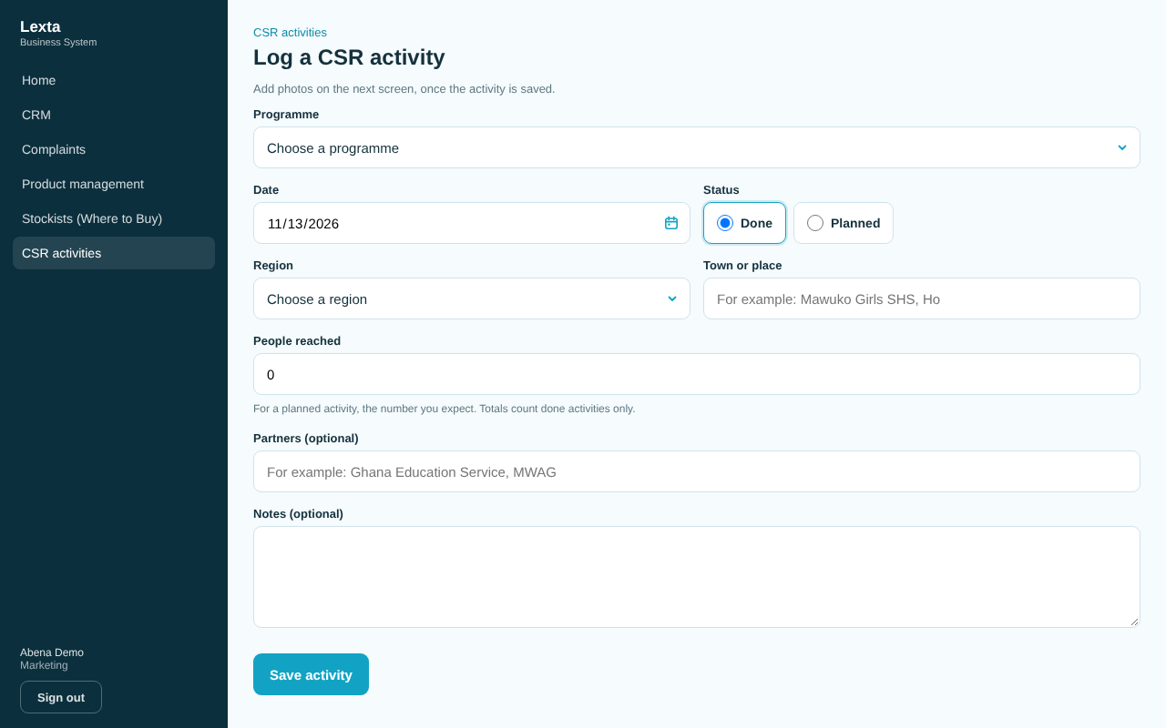
Log a CSR activity

Mark a planned activity as done
- Open the activity from the list.
- Under Change this activity, tick Done, correct the people reached and save.

Manage programmes (admin only)
- Open the Programmes tab.
- Add a programme with Add programme, or edit, Switch off or delete one.
- Programmes copied from the website are marked "From the website, check and edit". Check them and tap Save as checked.

Good to know
- Totals count activities marked Done only. Planned ones show as "Next" in the totals table.
- Up to 20 photos an activity, each up to 5 MB (JPG, PNG or WebP). Large photos are made smaller before they are sent.
- If photos fail with "Photo uploads are not set up yet", the activity is saved. Ask your admin.
- Marketing can log activities for programmes with no brand or of a brand they work on.
- A programme with activities cannot be deleted; switch it off. Only admin deletes activities.

10. Recruitment
Who can use it: admin, management and HR.
What it is for: the job roles shown on the Careers page of the Lexta website, and the applications that come from it, each with the CV, a stage and an owner.
Video: Recruitment: an application from Careers (67 seconds).

How the Careers page feeds it
- HR creates a role and sets it to Open. It shows on the Careers page from its opening date to the end of its closing date.
- A visitor applies on the Careers page with their CV (PDF or Word, up to 4 MB).
- The application lands in Recruitment at stage New, with a reference like LX-APP-2026-0001.
Stages: New, Screening, Shortlisted, Interview, Offer, Hired, Rejected, Withdrawn.
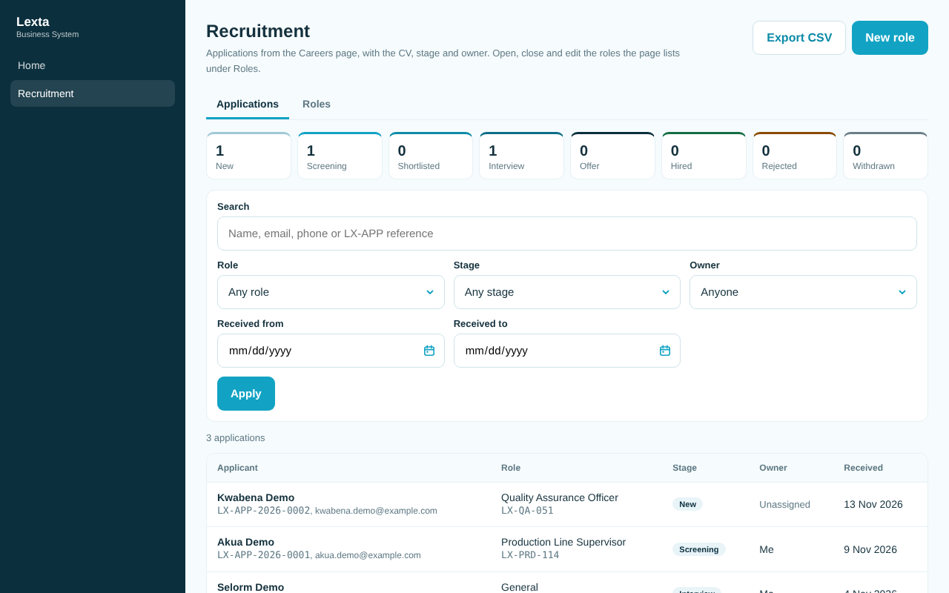
Applications

Work an application
- Open Recruitment and tap the applicant's name.
- Tap Download CV to read the CV. It downloads with your own login; there is no link to share.
- Set the Owner and tap Set owner.
- Under Stage, choose the next stage, add a note if you like, and tap Change stage.
- Add to the history with Add note (for example "called, interview booked for Monday 10am"). Keep longer notes in Staff notes and tap Save notes.
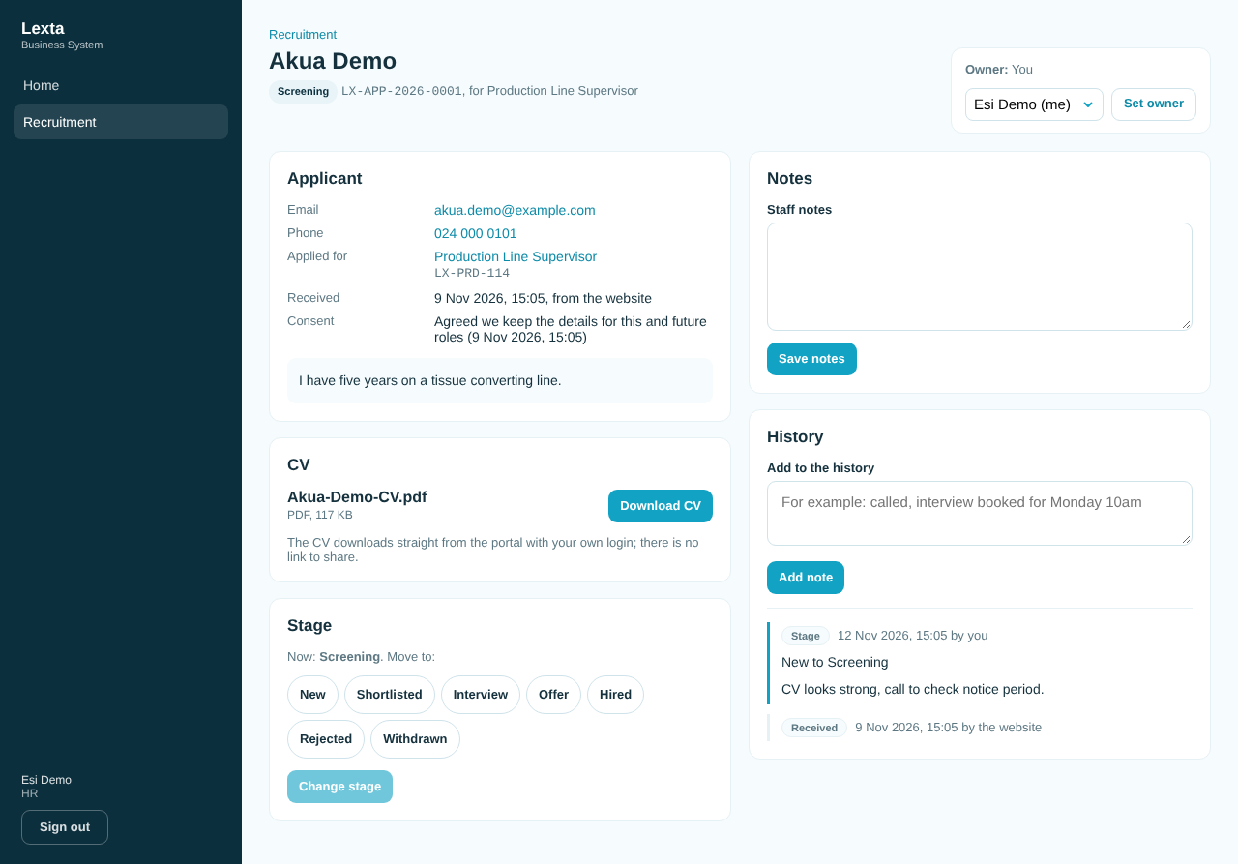
An application

Open, close or edit a role
- Open the Roles tab and tap a role, or tap New role.
- Fill in the reference, title, department, location, type, level, summary, duties and requirements (one per line, up to 20).
- Set the Opening date and Closing date. Tick Show "Closing soon" if you want that label.
- Tap Create role or Save role.
- Use Open role, Close role, Reopen role or Back to draft to change its status.
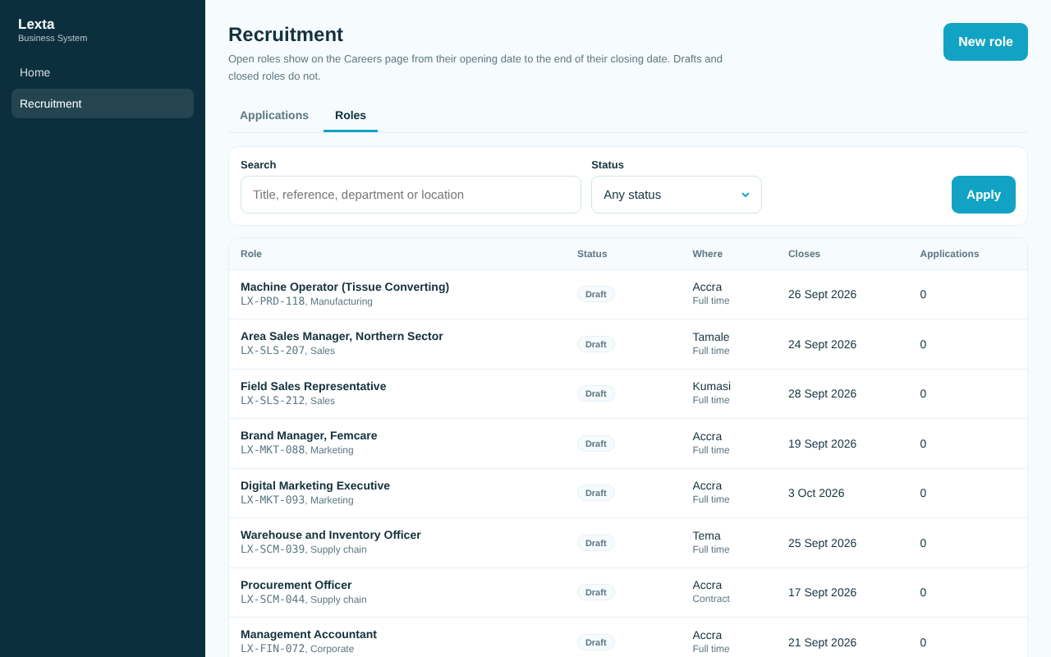
Roles

Good to know
- The 12 roles from the old Careers page are there as drafts. Check them, set dates and open the ones Lexta is hiring for.
- A role with applications cannot be deleted; close it.
- Export CSV downloads the application list with your filters.
- Only admin deletes an application (for example when the applicant asks for their data to be erased).
- Unclaimed CV uploads are CVs from applications that were never sent. Tap Remove unclaimed uploads now and then.

11. Live chat inbox
Who can use it: admin, management and customer care.
What it is for: answer website visitors who use the chat on the website, all in one inbox. Every answer comes from a person; there is no chatbot. Today the chat is on the Lexta website; the brand sites will use the same inbox when they are built.
Video: Live chat: reply to a visitor (43 seconds).
Chat status: Open (the visitor is waiting for you), Waiting for visitor (you replied), Closed.
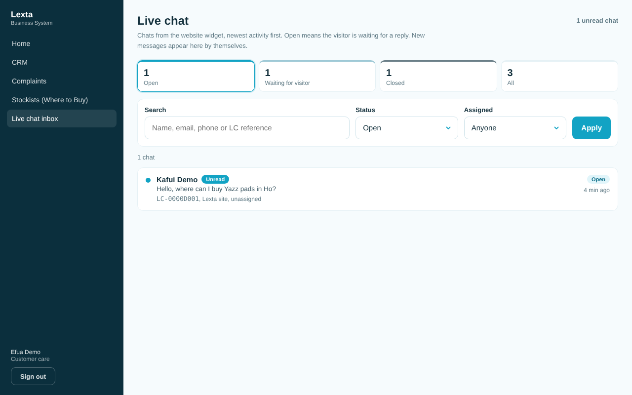
The chat inbox

Answer a chat
- Open Live chat inbox. New and unread chats are marked. The inbox updates by itself every few seconds.
- Tap the chat.
- Tap Assign to me so colleagues know you have it.
- Type in Reply to the visitor and tap Send reply (or press Enter; Shift and Enter makes a new line).
The visitor sees your first name only.
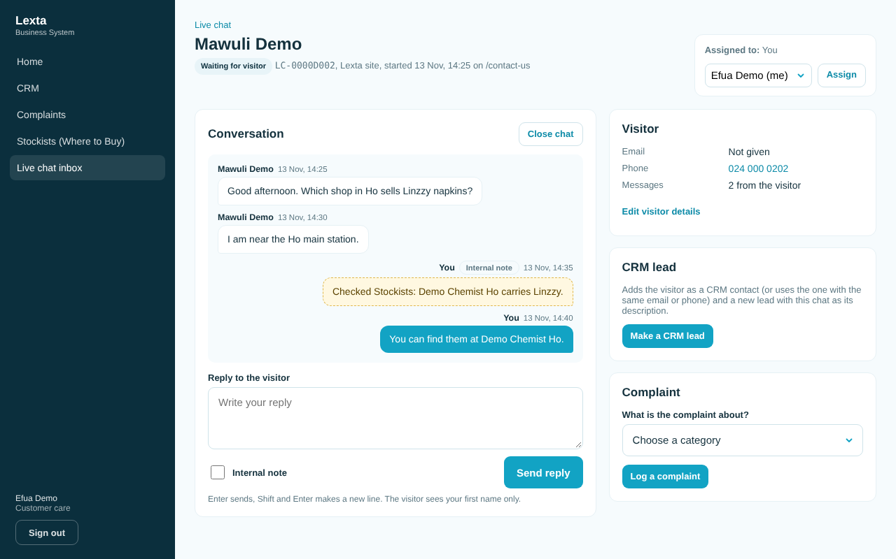
A conversation

Add an internal note
- Tick Internal note under the reply box.
- Type the note and tap Add note. The visitor never sees it.

Turn a chat into a lead or a complaint
- To make a CRM lead, tap Make a CRM lead. The visitor is added as a contact and the chat becomes the lead's description.
- To log a complaint, add the visitor's email or phone first (Edit visitor details), choose What is the complaint about? and tap Log a complaint.
Management can make leads but not complaints; assign the chat to customer care instead.

Close or reopen a chat
- Tap Close chat when it is finished.
- Tap Reopen chat to reply again. If the visitor writes again, the chat opens by itself.

Good to know
- Outside office hours the website tells visitors the team is away and to leave a message. The office hours shown on the website are not set yet; ask your admin.
- Only admin can delete a chat (for example when the visitor asks for their data to be erased).
- Sales reps, marketing and HR do not see the chat inbox.

12. Users and access
Who can use it: admin only.
What it is for: inviting people, setting their role and the brands they work on, and switching logins off.
Today: the Users and access screen in the portal still says "Being built". Until it is ready, new logins, roles and brand links are set up for you by the admin team behind the system.
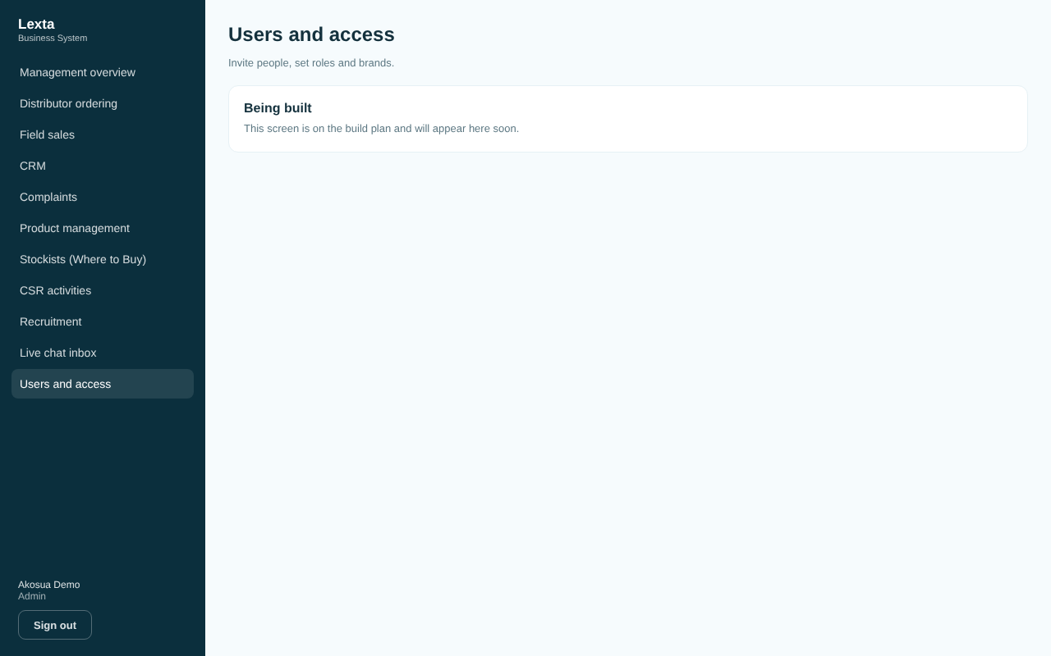
Users and access is still being built

To get someone access (for now)
- Send your admin the person's full name, work email, role (admin, management, sales rep, customer care, marketing, HR or distributor) and, for sales reps and marketing, their brands.
- The person gets an invitation email and chooses a password (see Signing in).
- For a distributor, link the new login to its company on the Distributor logins tab (see chapter 3).

To remove someone's access
Ask your admin to switch off their login. When someone leaves, their records stay; their name shows as "Former team member".

Good to know
- A person has one role. Admin and management see every brand; other roles see the brands they are linked to.
- A login with no role sees "No access yet".
[PLACEHOLDER: steps and screenshot for the Users and access screen, once it is built]

13. Who to ask
Question | Ask
I cannot sign in, or I need a login, role or brand | Your Lexta admin
Something on a screen looks wrong or a button does not work | Your Lexta admin, who passes it to the IT team
Photo uploads say "not set up yet" | Your Lexta admin
A distributor cannot order | Their Lexta sales contact (to link the login)
Product information or pack sizes | Marketing
A complaint from a customer | Customer care
Jobs and applications | HR

[PLACEHOLDER: names, phone numbers and emails of Lexta's admin and IT contacts]

14. Glossary
Word | Meaning
Admin | The role that can do everything, including deletes and settings
Brand | Yazz, Linzzy or Hooch (Lexta Ghana is the company brand)
Case number | A complaint's number, for example LX-2026-0001
CRM | The shared list of leads, contacts and organisations
CSV | A spreadsheet file format Excel can open and save
Draft | Saved but not sent or not shown on the websites yet
Facings | How many packs of a product face the customer on the shelf
Internal note | A note only Lexta staff see
Lead | A possible sale or partnership being followed up
Organisation | A company or institution in the CRM, for example a distributor
Outcome | What happened on a shop visit, for example Order taken
Owner | The person responsible for a lead, complaint, application or chat
Publish | Show a product on the websites
Role | Your job type in the system; it decides what you see
SKU | One pack size or variant of a product, with its own code
Stockist | A shop or outlet that sells Lexta brands, shown on Where to Buy
Timeline | The list of everything that happened on a record, newest first
Where to Buy | The shop finder on the websites

