## 1、MJava的语法规则

Goal-> MainClass { ClassDeclaration } EOF

MainClass->**"class"** Identifier **"{"** **"public"** **"static"** **"void"** **"main"** **"("** **"String"** **"["** **"]"** Identifier **")"** **"{"** Statement **"}"** **"}"**

ClassDeclaration->**"class"** Identifier [ **"extends"** Identifier ] **"{"** { VarDeclaration } { MethodDeclaration } **"}"**

VarDeclaration ->Type Identifier **";"**

MethodDeclaration->**"public"** Type Identifier **"("** [ Type Identifier { **","** Type Identifier } ] **")"** **"{"** { VarDeclaration } { Statement } **"return"** Expression **";"** **"}"**

Type->**"int"** **"["** **"]"**|**"boolean"**|**"int"**| Identifier

Statement->**"{"** { Statement } **"}"**|**"if"** **"("** Expression **")"** Statement **"else"** Statement |**"while"** **"("** Expression **")"** Statement |**"System.out.println"** **"("** Expression **")"** **";"**| Identifier **"="** Expression **";"**| Identifier **"["** Expression **"]"** **"="** Expression **";"**

Expression-> Expression ( "&&" | "<" | "+" | "-" | "*" ) Expression | Expression **"["** Expression **"]"**| Expression **"."** **"length"**| Expression **"."** Identifier **"("** [ Expression { **","** Expression } ] **")"**| IntegerLiteral |**"true"**|**"false"**| Identifier |**"this"**|**"new"** **"int"** **"["** Expression **"]"**|**"new"** Identifier "(" ")"| **"!"** Expression |**"("** Expression **")"**

## 2、语法分析程序实现步骤

### 2.1、消除左递归

MJava主要的递归出现在Expression产生式中

1、改写产生式

Expression-> Expression ( "&&" | "<" | "+" | "-" | "*" ) Expression

|Expression **"["** Expression **"]"**

|Expression **"."** **"length"**

|Expression **"."** Identifier **"("** [ Expression { **","** Expression } ] **")"**

|IntegerLiteral

|**"true"**

|**"false"**

| Identifier

|**"this"**

|**"new"** **"int"** **"["** Expression **"]"**

|**"new"** Identifier "(" ")"

| **"!"** Expression

|**"("** Expression **")"**

2、多项直接左递归消除

Expression->

IntegerLiteral **A**

|**"true" A**

|**"false" A**

| Identifier **A**

|**"this" A**

|**"new"** **"int"** **"["** **Expression** **"]" A**

|**"new"** Identifier "(" ")" **A**

| **"!"** **Expression** **A**

|**"("** **Expression** **")" A**

A->

( "&&" | "<" | "+" | "-" | "*" ) **Expression A**

| **"["** **Expression** **"]"** **A**

| **"."** **"length"** **A**

| **"."** Identifier **"("** [ **Expression** { **","** **Expression** } ] **")" A**

| ε

3、重写新的文法G‘[Goal]

Goal-> MainClass { ClassDeclaration } EOF

MainClass->**"class"** Identifier **"{"** **"public"** **"static"** **"void"** **"main"** **"("** **"String"** **"["** **"]"** Identifier **")"** **"{"** Statement **"}"** **"}"**

ClassDeclaration->**"class"** Identifier [ **"extends"** Identifier ] **"{"** { VarDeclaration } { MethodDeclaration } **"}"**

VarDeclaration ->Type Identifier **";"**

MethodDeclaration->**"public"** Type Identifier **"("** [ Type Identifier { **","** Type Identifier } ] **")"** **"{"** { VarDeclaration } { Statement } **"return"** Expression **";"** **"}"**

Type->**"int"** **"["** **"]"**|**"boolean"**|**"int"**| Identifier

Statement->**"{"** { Statement } **"}"**|**"if"** **"("** Expression **")"** Statement **"else"** Statement |**"while"** **"("** Expression **")"** Statement |**"System.out.println"** **"("** Expression **")"** **";"**| Identifier **"="** Expression **";"**| Identifier **"["** Expression **"]"** **"="** Expression **";"**

Expression->

IntegerLiteral **A** |**"true" A** |**"false" A** | Identifier **A** |**"this" A** |**"new"** **"int"** **"["** **Expression** **"]" A** |**"new"** Identifier "(" ")" **A** | **"!"** **Expression** **A** |**"("** **Expression** **")" A**

A->

( "&&" | "<" | "+" | "-" | "*" ) **Expression A** | **"["** **Expression** **"]"** **A** | **"."** **"length"** **A** | **"."** Identifier **"("** [ **Expression** { **","** **Expression** } ] **")" A** | ε

## 2.2抽象语法树

Goal-> MainClass { ClassDeclaration } EOF

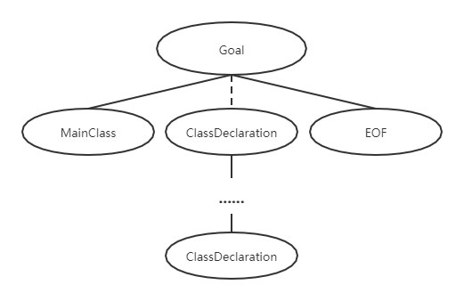

MainClass->**"class"** Identifier **"{"** **"public"** **"static"** **"void"** **"main"** **"("** **"String"** **"["** **"]"** Identifier **")"** **"{"** Statement **"}"** **"}"**

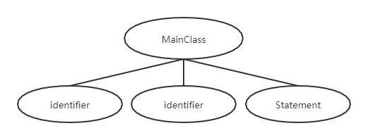

ClassDeclaration->

**"class"** Identifier [ **"extends"** Identifier ] **"{"** { VarDeclaration } { MethodDeclaration } **"}"**

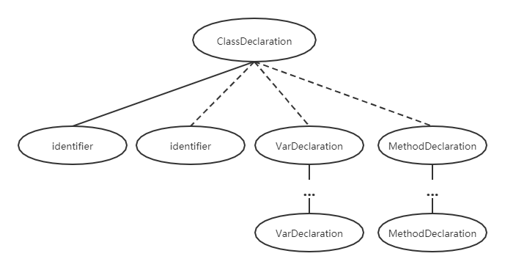

VarDeclaration ->Type Identifier **";"**

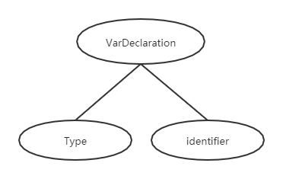

MethodDeclaration->**"public"** Type Identifier **"("** [ Type Identifier { **","** Type Identifier } ] **")"** **"{"** { VarDeclaration } { Statement } **"return"** Expression **";"** **"}"**

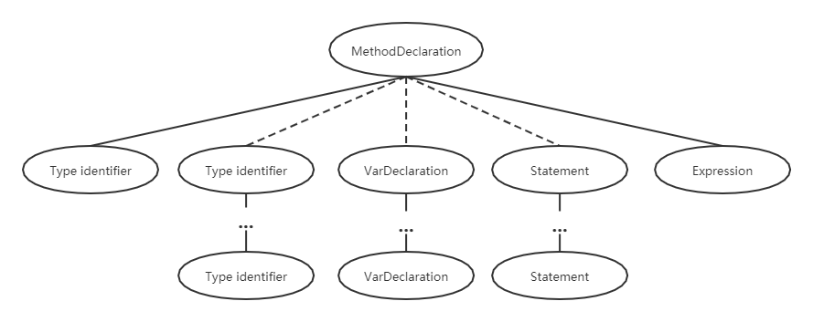

Type->**"int"** **"["** **"]"**|**"boolean"**|**"int"**| Identifier

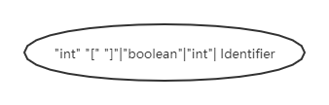

Statement->StatementSeries|if_Statement|While_Statement|Print_Statement|VarAssign_Statement|ArrayAssign_Statement

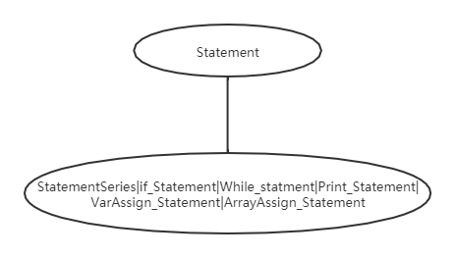

StatementSeries->**"{"** { Statement } **"}"**

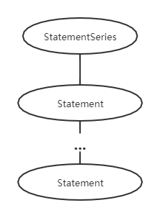

If_Satement->**"if"** **"("** Expression **")"** Statement **"else"** Statement

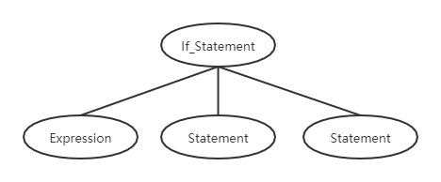

While_Satement->**"while"** **"("** Expression **")"** Statement

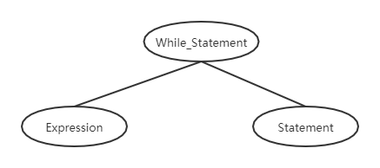

Print_Statement->**"System.out.println"** **"("** Expression **")"** **";"**

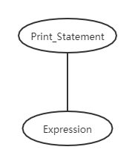

VarAssign_Statement->identifier **"="** Expression **";"**

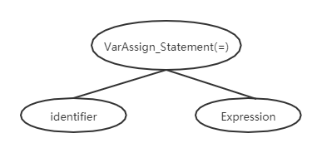

ArrayAssign_Statement->identifier **"["** Expression **"]"** **"="** Expression **";**

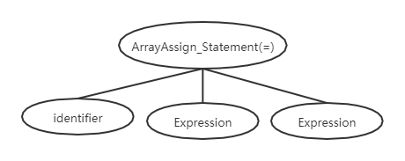

Expression->

int_Expression | true_Expression | false_Expression | identifier_Expression | this_Expression | newArray_Expression | new_Expression | not_Expression | brace_Expression

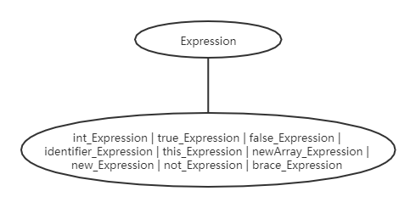

int_Expression ->IntegerLiteral **A**

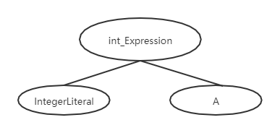

true_Expression **->"true" A**

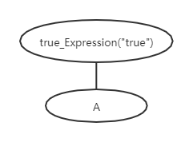

false_Expression **->"false" A**

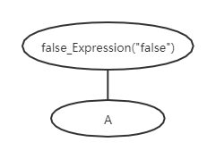

identifier_Expression ->Identifier **A**

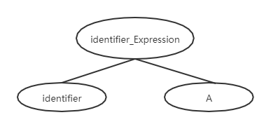

this_Expression **->"this" A**

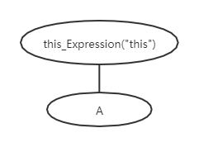

newArray_Expression **->"new"** **"int"** **"["** **Expression** **"]" A**

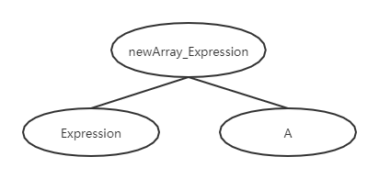

new_Expression **->"new"** Identifier "(" ")" **A**

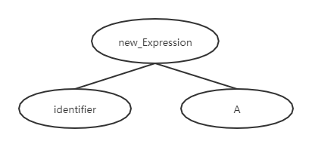

not_Expression **->"!"** **Expression** **A**

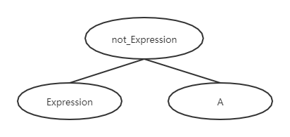

brace_Expression ->**"("** **Expression** **")" A**

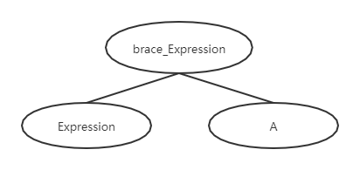

A->op_A | experssion_A | length_A | method_A | null_A

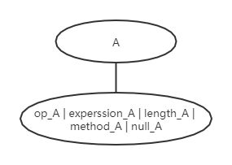

Op_A ->( "&&" | "<" | "+" | "-" | "*" ) **Expression A**

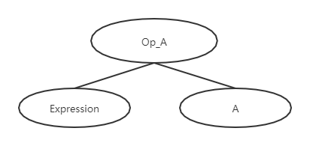

Experssion_A ->**"["** **Expression** **"]"** **A**

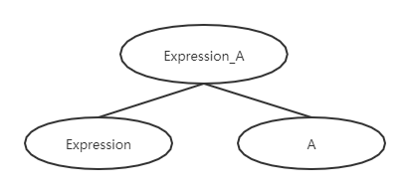

Length_A ->**"."** **"length"** **A**

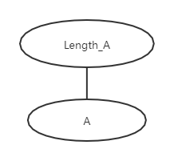

Method_A->**"."** Identifier **"("** [ **Expression** { **","** **Expression** } ] **")" A**

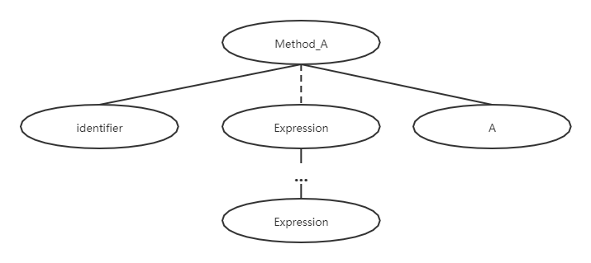

Null_A->ε

