# 1.Js和jq中遍历数组和对象的方法

## 遍历数组:

### Js中遍历数组:

#### for循环遍历数组 :

*var* arr = [1,2,3,4,5];

for(*var* index = 0; arr.length>; index++){

*console*.log(arr[index]);

}

#### For in 遍历数组

*var* arr = [1,2,3,4,5];

for(*var* v in arr){

*console*.log(arr[v]);

}

v是数组里面的下标 arr[v] 是每一项

### Jq中遍历数组

Jq中遍历数组有四种方法

#### $.each(arr,function(i,items){}); 方法遍历数组

*var* arr = ["1","2","3","4","5"];

$.each(arr,*function*(*index*,*items*){

*console*.log(index)

})

Arr是需要遍历的数组,index是数组的下标,items是数组里面的每一项

#### **$(arr).each(function(index,items){});方法遍历数组**

*var* arr = ["1","2","3","4","5"];

$(arr).each(*function*(*index*,*items*){

*console*.log(index);

*console*.log(items)

})

用法基本和上面一致

#### $.map(arr.function(items,index){});方法遍历数组

*var* arr = ["1","2","3","4","5","6","7"];

*var* x = $.map(arr,*function*(*items*,*index*){

*console*.log(items);

*console*.log(index)

return items+1;

})

*console*.log(x)

#### $(arr).map(function(index,items){});方法遍历数组

*var* arr = ["1","2","3","4","5","6","7"];

$(arr).map(*function*(*index*,*items*){

*console*.log(index);

*console*.log(items);

})

#### 两者的区别：

map()方法主要用来遍历操作数组和对象，each()主要用于遍历jquery对象。

each()返回的是原来的数组，并不会新创建一个数组。

map()方法会返回一个新的数组。如果在没有必要的情况下使用map，则有可能造成内存浪费。

## 遍历对象

### Js中遍历对象(for in 用法)

*var* obj={name:"xiaoming",age:20,addr:"xiaominglu"};

for(*var* key in obj) {

*console*.log(key)

*console*.log(obj[key])

}

#### Jq中的遍历对象

*var* obj={name:"xiaoming",age:20,addr:"xiaominglu"};

*console*.log("jquery.each遍历对象1");

$.each(obj, *function* (*index*, *item*) {

*console*.log(index + "--" + item);

});

*console*.log("jquery.map遍历对象1，注意这里回调函数中第一个参数是元素，第二个是索引");

$.map(obj, *function* (*item*, *index*) {

*console*.log(index + "--" + item);

});

# 2.图解Js event对象offsetX, clientX, pageX, screenX, layerX, 的区别

#### 测试代码如下:

<!DOCTYPE HTML>

<html lang="zh-cn">

<head>

<meta charset="utf-8" />

<title>Javascript</title>

<style>

body {

*margin*: 0;

*padding*: 0;

*background*: #ccc;

*font-size*: 12px;

*overflow*: auto

}

.main {

*width*: 500px;

*height*: 330px;

*position*: relative;

*margin*: 250px auto 0;

*background-color*: #eee;

}

.box {

*position*: absolute;

*width*: 220px;

*height*: 180px;

*background-color*: orange;

*top*: 80px;

*left*: 80px;

}

</style>

</head>

<body style="height:1600px;">

<div class="main">

<div class="box" id="box"></div>

</div>

<script>

*var* oBox = document.getElementById('box');

window.onload = *function* () {

oBox.onmousedown = *function* (*ev*) {

ev = ev || window.event;

*console*.log(ev.offsetX, ev.offsetY);

*console*.log(ev.clientX, ev.clientY);

*console*.log(ev.pageX, ev.pageY);

*console*.log(ev.screenX, ev.screenY);

*console*.log(ev.layerX, ev.layerY);

*console*.log(ev.x, ev.y);

}

}

</script>

</body>

</html>

#### 图解如下:

图解 event.offsetX，event.clientX，event.pageX，event.screenX属性

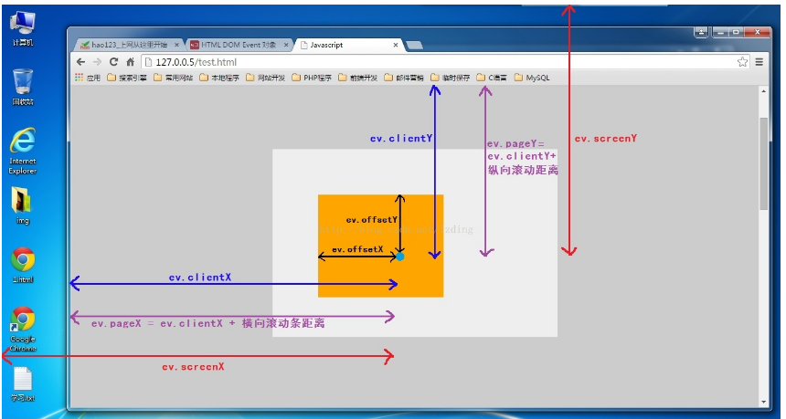

图解 event.layerX，event.layerY 属性

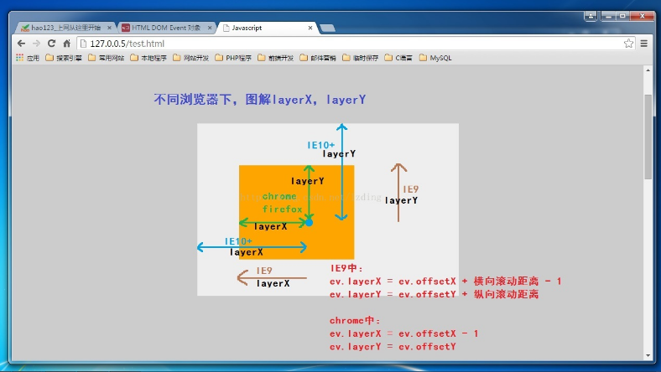

#### 图解 event.x，event.y 属性

