按照均值方差标准化后的实验记录

1.

模型配置：

Depth = 7

N_estimators (num) = 200

损失函数: exponential

数据配置：

14个特征上直接进行, 测试集用cycle层面预测, 然后转换为unit层面，转换方式为直接平均.

20631 20631 13096 100

(165.54009938878824, 16554.009938878822)

(4.181233021532802, 33.427424733986165, 0.63169052069917275, 0.09191733614299608, 0.43944675904708064)

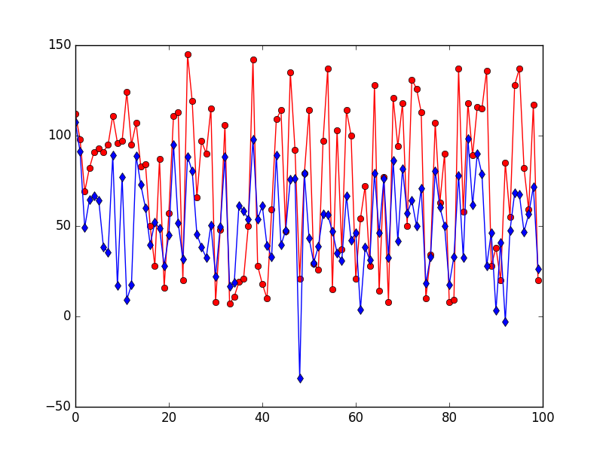

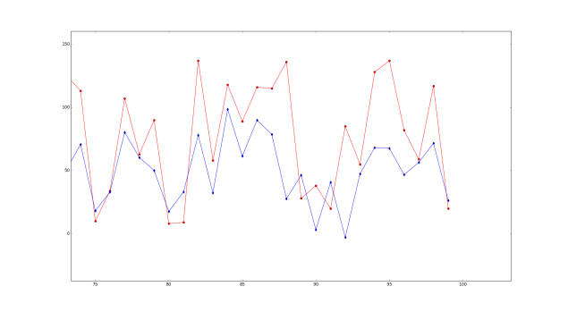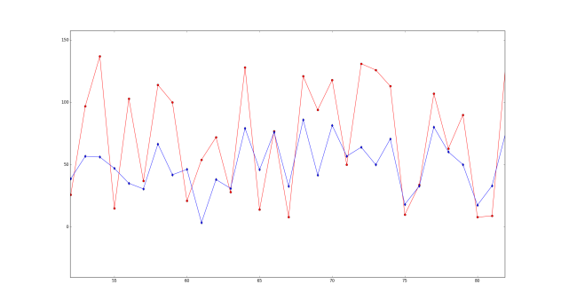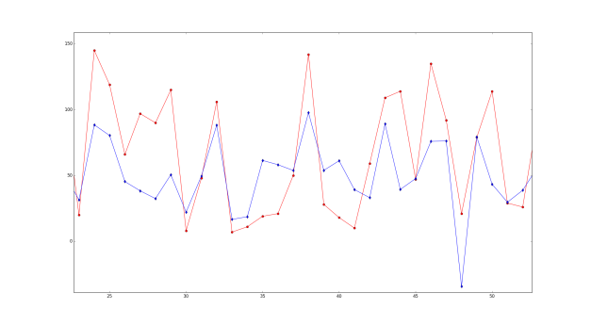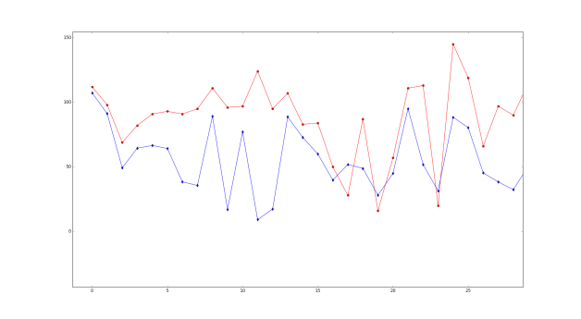

2. 在上面的实验中将损失函数改为square，其他条件相同

(213.53151324695224, 21353.151324695224)

(4.426121561988511, 35.465013124543063, 0.60260480994209331, 0.08327593772644104, 0.44034301169428958)

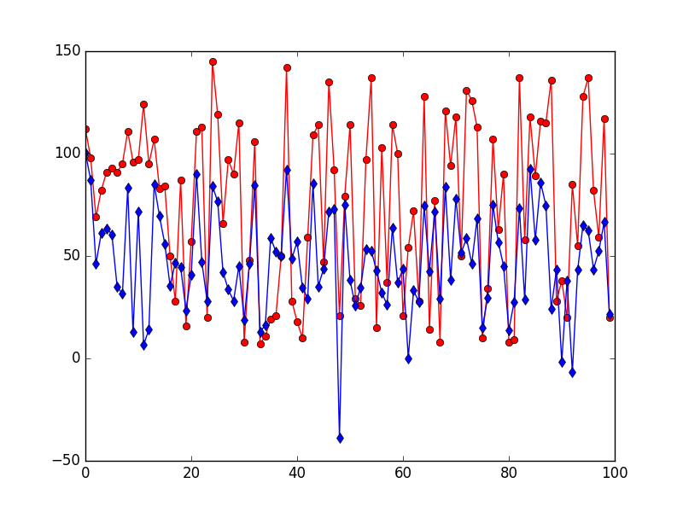

3. 将损失函数更换为linear,其他条件保持相同

(171.34550313505372, 17134.550313505373)

(4.203527196086077, 33.631345081669267, 0.63137294313494052, 0.09116065036140979, 0.43865048332533385)

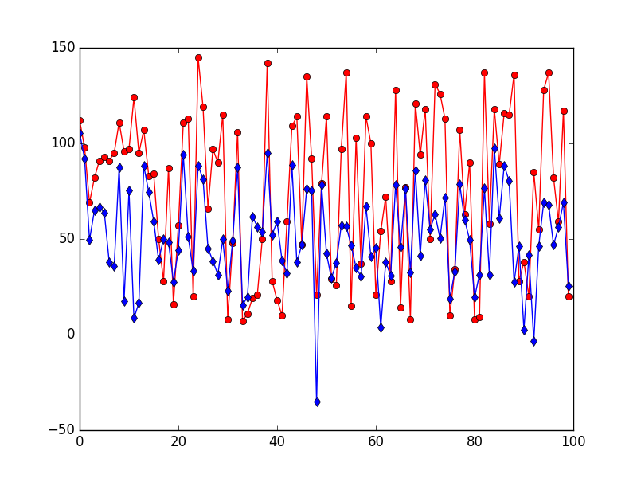

4 . 参数搜索[50,65]×[3,11]

损失: exponential

[(50, 3), (50, 4), (50, 5), (50, 6), (50, 7), (50, 8), (50, 9), (50, 10), (50, 11), (55, 3), (55, 4), (55, 5), (55, 6), (55, 7), (55, 8), (55, 9), (55, 10), (55, 11), (60, 3), (60, 4), (60, 5), (60, 6), (60, 7), (60, 8), (60, 9), (60, 10), (60, 11), (65, 3), (65, 4), (65, 5), (65, 6), (65, 7), (65, 8), (65, 9), (65, 10), (65, 11)]

[[3.6153137504153428, 29.582311900848321, 0.82860737938267048, 0.14184895513595755, 0.45864836429290934], [3.659524055814681, 29.833849931071196, 0.77283402094444409, 0.12818088190985227, 0.44417737156119308], [3.872322705896681, 30.848685443931966, 0.6578920927633698, 0.10090099113761948, 0.42391330235099445], [4.199554605010423, 33.336301393450825, 0.61222358377459984, 0.08789157915284561, 0.4302933456945589], [4.437014053426992, 35.331705384202046, 0.58431364703467281, 0.08025819962950892, 0.42971294128641269], [4.640719902382825, 37.136993705134664, 0.56955216325753522, 0.07589769423701051, 0.4298883120984196], [4.776259018816422, 38.318996644713522, 0.56530105017043519, 0.07310206336646091, 0.42814514238390511], [4.976366878843455, 40.203890653076961, 0.57840016482710033, 0.07267213441095696, 0.43544030670688449], [5.138167881496899, 41.704675171630406, 0.59200682646423541, 0.0728242798284929, 0.44252660440927283], [3.5872535216142984, 29.335944295455175, 0.8312064874617523, 0.14284116359272805, 0.45463871096178765], [3.635399666941171, 29.678920713410047, 0.78509639877695203, 0.13118802159106724, 0.44578363195054982], [3.8589613347944125, 30.875620193440696, 0.67368699323246728, 0.10412250877914284, 0.42995451770060356], [4.14004995938109, 32.923205753458291, 0.62478857885851158, 0.090970405750186, 0.43242768410751442], [4.378804093256326, 34.858808791354392, 0.58865341314078845, 0.08164707807492803, 0.42864411671597547], [4.603784953619185, 36.794081882857249, 0.56857618127907572, 0.07609542037154157, 0.4274287720868466], [4.743491244019439, 38.022495442593311, 0.56390464027879261, 0.07322448558343912, 0.42641281253119123], [4.950567514783832, 39.973243657329142, 0.57664256550278559, 0.07265626887878181, 0.43343194622276182], [5.100702891677996, 41.350776526939136, 0.58812204660443346, 0.07261782298905621, 0.43991210239008727], [3.5755268045859427, 29.354963824476862, 0.8551218725935672, 0.14852252890248635, 0.45909530845962343], [3.6004541315936796, 29.396894450247117, 0.78995600957018008, 0.13261986914248397, 0.4418697594295411], [3.844519567477493, 30.859466272744953, 0.68667270478735887, 0.10692581158784932, 0.43376200979538437], [4.112834844980623, 32.83223680062175, 0.63785957720765529, 0.09349740481240473, 0.43625473919855273], [4.359323813130263, 34.697518946454323, 0.59387540568119568, 0.08310901683984355, 0.43110272067471433], [4.567569001805782, 36.504629284106059, 0.57040572072453255, 0.07671927747578955, 0.42598578930825015], [4.718404636610327, 37.791190001208662, 0.56375152692962227, 0.07341614378933835, 0.42463309715974618], [4.911538143149224, 39.596977041218139, 0.57473592790788819, 0.07280276959273675, 0.43197346233164435], [5.066299537673172, 41.021388241589349, 0.58561296798902407, 0.07263606896854564, 0.43746001784402677], [3.5540734583373457, 29.199774159481009, 0.86409449264383253, 0.15075075936133228, 0.45696910813045155], [3.6103507775547694, 29.446704850440252, 0.79358810790990475, 0.13354659051677034, 0.44583069352934002], [3.8240657030233796, 30.861960217812555, 0.70734659755508678, 0.11135837296824205, 0.43950312345846998], [4.087476128095651, 32.665675418748258, 0.64252240150351314, 0.09491980508466659, 0.43646495519588091], [4.3387229658261335, 34.525603936660325, 0.59381142956010458, 0.08322288016750429, 0.4291488000182121], [4.545996042933381, 36.351526404945851, 0.57314160584395324, 0.07737238998195797, 0.42559727671127157], [4.720423109781489, 37.808389889464621, 0.56358346328243558, 0.07352226788782418, 0.42525882359425471], [4.881778659899395, 39.333192114204941, 0.57286980696049905, 0.07282475158121643, 0.43017078927175856], [5.038245899959614, 40.739511692204985, 0.58207602393876101, 0.07250023821295787, 0.43621123384799232]]

[(7693.130327695836, 76.93130327695836), (8138.507276436706, 81.38507276436707), (11492.229077765836, 114.92229077765836), (18576.08884953283, 185.7608884953283), (23144.095672384134, 231.44095672384134), (29018.627297747156, 290.18627297747156), (34888.23246655034, 348.8823246655034), (42656.66805944913, 426.56668059449134), (50904.951285161274, 509.04951285161275), (7558.298949496482, 75.58298949496482), (7822.511504648068, 78.22511504648068), (11078.557636672864, 110.78557636672863), (16822.26787211872, 168.22267872118718), (21472.605950884183, 214.72605950884181), (28126.63149288682, 281.2663149288682), (33552.07088206114, 335.5207088206114), (42125.16409517346, 421.2516409517346), (48770.335167445824, 487.70335167445825), (7496.848858400094, 74.96848858400094), (7498.707454860738, 74.98707454860738), (10837.047326436312, 108.37047326436311), (16182.808156961115, 161.82808156961116), (21143.034989472984, 211.43034989472983), (26870.960782007918, 268.70960782007916), (32460.13137048263, 324.60131370482634), (40608.50273690575, 406.0850273690575), (47447.74867826491, 474.47748678264907), (7364.13655607279, 73.6413655607279), (7599.967843495896, 75.99967843495897), (10362.365363077091, 103.62365363077092), (15297.250161308773, 152.97250161308773), (20512.522881847322, 205.12522881847323), (26404.563958932198, 264.045639589322), (32288.030765809446, 322.88030765809447), (39104.15650514059, 391.04156505140594), (45904.4394614878, 459.04439461487794)]

1. **[70,95]*[3,11]**

[(70, 3), (70, 4), (70, 5), (70, 6), (70, 7), (70, 8), (70, 9), (70, 10), (70, 11), (75, 3), (75, 4), (75, 5), (75, 6), (75, 7), (75, 8), (75, 9), (75, 10), (75, 11), (80, 3), (80, 4), (80, 5), (80, 6), (80, 7), (80, 8), (80, 9), (80, 10), (80, 11), (85, 3), (85, 4), (85, 5), (85, 6), (85, 7), (85, 8), (85, 9), (85, 10), (85, 11), (90, 3), (90, 4), (90, 5), (90, 6), (90, 7), (90, 8), (90, 9), (90, 10), (90, 11), (95, 3), (95, 4), (95, 5), (95, 6), (95, 7), (95, 8), (95, 9), (95, 10), (95, 11)]

[[3.5504872345038057, 29.258709977275871, 0.87857080719655156, 0.154103244973456, 0.4596614578994106], [3.5927608880677218, 29.352649143291693, 0.80550073420957513, 0.13650613624075913, 0.44656808276919635], [3.818272696079043, 30.906779990784763, 0.71774298657949431, 0.1134724951896336, 0.44335507931022289], [4.066114424407676, 32.49598052657668, 0.64838946610323756, 0.09635850723976552, 0.43807808156673667], [4.30254366159443, 34.204479771617713, 0.59710336412011178, 0.08427136232422842, 0.42927410541637734], [4.535336738694961, 36.249681139737184, 0.57162421440190259, 0.07723491421147796, 0.42427112355942376], [4.691875843656723, 37.56904148771055, 0.56250154280481435, 0.07366523805913594, 0.42306123113201999], [4.867734802098639, 39.190718511655277, 0.57178287965680707, 0.07281417831876508, 0.43015271401756794], [5.026241376415444, 40.608391113276468, 0.58081260558598979, 0.07248161869137522, 0.43537586482983315], [3.5336446222665203, 29.123027304499889, 0.89185813677736181, 0.15756234194825397, 0.45839177294486433], [3.5918786410266295, 29.356786587093112, 0.8124637496944257, 0.13810933317785584, 0.44889861821455046], [3.792856623030648, 30.766935980734875, 0.72651706232954327, 0.11555949336608809, 0.44378650892004878], [4.049982084948729, 32.460775119967764, 0.6597562993808036, 0.09873914833668365, 0.44207776034721447], [4.2805921277177275, 34.042417590567723, 0.60126439199029325, 0.08513362751980288, 0.42952811027248972], [4.542342077021943, 36.313793760489148, 0.57253216821679997, 0.07734757383778877, 0.42539034233011419], [4.683599861032057, 37.496608604378736, 0.56201934655301211, 0.07353359922169156, 0.42235804595774762], [4.847806391792434, 39.005632083647981, 0.56989449787202251, 0.07277519545333816, 0.42805213753162241], [5.005176239589914, 40.386379071360082, 0.5773574641799345, 0.07236729670569739, 0.43353484893489624], [3.519684518060231, 29.032139211071208, 0.90384787041259518, 0.1605544659119152, 0.45705694313478429], [3.5804404814094357, 29.293468478498863, 0.81334086807012929, 0.13826721555934005, 0.44676278923111212], [3.771809855492604, 30.638324919951859, 0.73085212299944402, 0.11669984060684581, 0.44221903500120696], [4.040103559946657, 32.383874214932888, 0.66328910085061477, 0.09970308315618145, 0.44324826535025741], [4.261628510628006, 33.92969473414837, 0.60864894961553606, 0.08683009361476765, 0.43241186347982896], [4.517460540488932, 36.067928190203872, 0.57295357165211369, 0.07769518244764638, 0.42458235775516107], [4.664262543376294, 37.337153866437745, 0.56270570949308263, 0.07377327909549124, 0.42169738091333053], [4.829981034817645, 38.834299377993936, 0.56810846373988233, 0.07278897187785857, 0.42620265233172316], [5.001972448728497, 40.390747366722763, 0.57825963164928895, 0.07237098658891467, 0.43254447745713576], [3.5104750236715545, 28.993949638732012, 0.92033934669444861, 0.16444803141492892, 0.4567746850088269], [3.5657571706198854, 29.190116483180642, 0.82102997625073881, 0.14028395918297007, 0.44648364650725181], [3.77163084937583, 30.610081007017012, 0.7332140174143652, 0.11749766003601306, 0.4435127180248124], [4.02811296300079, 32.333135096106638, 0.6698228775765136, 0.10111931384603412, 0.44552714965600781], [4.258671667012587, 33.952909053135798, 0.61262570354490753, 0.08751221259920078, 0.43445610935119872], [4.500511694228224, 35.91459884147546, 0.57357796283734175, 0.07794672903246705, 0.42456558853933513], [4.635223625554229, 37.082896446935067, 0.56298648268885576, 0.07411885379293928, 0.42056816225772531], [4.82654908497811, 38.815502581576574, 0.56851885586514328, 0.07290648098035236, 0.4261604657215331], [4.987272266012718, 40.232782175864372, 0.57653957362844821, 0.0724404872117586, 0.43262383261884774], [3.5043127820073035, 28.958533403705324, 0.92650787085041986, 0.16587153248177253, 0.45546648162397874], [3.567560504823435, 29.191452319749654, 0.82106060578984041, 0.14030992181728988, 0.44704630889451769], [3.765747934336145, 30.618624107562471, 0.74132731584108602, 0.11944599440793702, 0.44651120205071126], [4.022679368622425, 32.310796578568613, 0.67153378255659169, 0.1015276230625408, 0.44535756761790735], [4.235707778191088, 33.777500737672483, 0.61498364940087247, 0.08815318430612777, 0.43333174197618574], [4.4780808192191905, 35.709373286151504, 0.57580942584997086, 0.07854774931714721, 0.42482451840314983], [4.631706996347414, 37.06262224082235, 0.56351939310717469, 0.07419033501544461, 0.42097467076916462], [4.809324087274586, 38.641202531264881, 0.56818629510563889, 0.07293615782821132, 0.42466721012545106], [4.968139980115828, 40.055397700920999, 0.57525828454224148, 0.07250730566944212, 0.43058122798605447], [3.5002175025443614, 28.940821941358127, 0.94088187405914925, 0.16927794010929106, 0.45503740037396734], [3.5572966158759374, 29.130547333659369, 0.82632819922173739, 0.141672382072784, 0.44629295176106776], [3.757786706161416, 30.561862818157536, 0.74060584722185552, 0.11927430557636999, 0.44525809540530958], [4.002967825966986, 32.19925195233305, 0.67644733640028731, 0.10271317064847076, 0.44495413654244664], [4.217390818547101, 33.642959299411856, 0.61761655842994645, 0.08888642262754974, 0.43304463259090675], [4.463932521000976, 35.577539965904151, 0.57563894863487197, 0.07868063098561696, 0.42382869143703705], [4.628973365647714, 37.039568578231581, 0.56346951108479504, 0.07421660372038398, 0.4206906325300358], [4.801923814018827, 38.577954783034123, 0.56805659571721323, 0.07295782532877942, 0.42396961489502827], [4.961369639932753, 39.992007809155446, 0.57462755139242983, 0.07246174539434276, 0.42997823518130596]]

[(7279.153374299882, 72.79153374299882), (7421.710682402928, 74.21710682402927), (10255.191191963926, 102.55191191963927), (14670.253650130422, 146.70253650130422), (19717.832563852586, 197.17832563852585), (25968.504393347583, 259.6850439334758), (31557.06147217309, 315.57061472173086), (38378.17777785875, 383.78177777858747), (45221.27880501079, 452.2127880501079), (7238.196642741434, 72.38196642741434), (7472.550336737915, 74.72550336737915), (9763.771168960677, 97.63771168960676), (14259.96945470417, 142.5996945470417), (19088.246641208403, 190.88246641208403), (26182.35422562175, 261.82354225621754), (31324.864923928908, 313.2486492392891), (37463.95615780389, 374.6395615780389), (43997.416759774904, 439.97416759774904), (7186.116426933617, 71.86116426933617), (7299.581288196966, 72.99581288196966), (9393.522677146915, 93.93522677146915), (14111.755598069036, 141.11755598069035), (18627.15282569228, 186.2715282569228), (25377.376181987252, 253.77376181987253), (30733.077438449873, 307.33077438449874), (36501.16377531829, 365.01163775318287), (43974.98580028287, 439.7498580028287), (7229.060098590401, 72.290600985904), (7102.57613235847, 71.0257613235847), (9409.684116578106, 94.09684116578106), (13783.02295814151, 137.8302295814151), (18392.26361918375, 183.92263619183748), (24924.65573966239, 249.2465573966239), (29402.3375935683, 294.023375935683), (36255.005650017665, 362.55005650017665), (43233.63228103409, 432.33632281034096), (7218.104126150169, 72.18104126150169), (7147.663062870079, 71.47663062870079), (9320.686063569276, 93.20686063569275), (13668.689977690889, 136.6868997769089), (17767.39773348693, 177.6739773348693), (24417.01524448457, 244.1701524448457), (29478.61689850697, 294.7861689850697), (35597.822878329986, 355.97822878329987), (42341.93766405866, 423.4193766405866), (7341.466383303225, 73.41466383303225), (7025.118666719588, 70.25118666719588), (9232.51477699295, 92.3251477699295), (13286.618516847779, 132.86618516847778), (17291.04446706514, 172.9104446706514), (24046.9743857111, 240.46974385711098), (29242.291648825623, 292.42291648825625), (35345.24076966366, 353.45240769663656), (42002.31324507323, 420.0231324507323)]

1. **[100,120]*[3,10]**

[(100, 2), (100, 3), **(100, 4)**, (100, 5), (100, 6), (100, 7), (100, 8), (100, 9), (103, 2), (103, 3), (103, 4), (103, 5), (103, 6), (103, 7), (103, 8), (103, 9), (106, 2), (106, 3), **(106, 4)**, (106, 5), (106, 6), (106, 7), (106, 8), (106, 9), (109, 2), (109, 3), (109, 4), (109, 5), (109, 6), (109, 7), (109, 8), (109, 9), (112, 2), (112, 3), (112, 4), (112, 5), (112, 6), (112, 7), (112, 8), (112, 9), (115, 2), (115, 3), (115, 4), (115, 5), (115, 6), (115, 7), (115, 8), (115, 9), (118, 2), (118, 3), (118, 4), (118, 5), (118, 6), (118, 7), (118, 8), (118, 9)]

[[3.5218527152335906, 29.462934075199264, 1.0614011404817709, 0.1952437924077425, 0.41323590019910617], [3.492058085890352, 28.895464934245233, 0.94614635673441394, 0.17054031493927846, 0.45234768292801653], [3.5389384114165563, 28.974399197698084, 0.83039123549247318, 0.14283079755365244, 0.44396430831413858], [3.7352154587109925, 30.406236473934015, 0.74279286800741173, 0.11991897646328972, 0.44283078851942037], [3.989890343004932, 32.044485040647622, 0.67157559292813473, 0.10184036613371833, 0.44119943185930866], [4.2203312697542055, 33.664450518489531, 0.61660771989160423, 0.08862740463356834, 0.43300355972062365], [4.458340137058398, 35.530718946556433, 0.57532394516909524, 0.0787403460208231, 0.42435287725003568], [4.62651687395499, 37.028453961103466, 0.56323169707082532, 0.07426808384003661, 0.41968640237426735], [3.5304452088866496, 29.533065769414591, 1.0670293335637628, 0.19652753163860304, 0.4149926820541161], [3.488859919354671, 28.842163314638839, 0.94353659640310938, 0.16991125010179647, 0.45113958193964521], [3.533475605506305, 28.918918068199147, 0.83121190422197133, 0.1431040972832684, 0.44316004819806631], [3.7336295900970384, 30.377392941434437, 0.7429790795354887, 0.12003011916099236, 0.44266650025745802], [3.97353275769612, 31.92533022229166, 0.67281598087216965, 0.102175443645595, 0.44064476510901474], [4.229277895277631, 33.762124436673965, 0.61735806249435954, 0.08862987863668752, 0.43405108381029889], [4.448431558318539, 35.442544733195732, 0.57411782456340399, 0.07864483161098082, 0.42201079623116622], [4.627158103826343, 37.029828929301154, 0.56340292600366315, 0.07429745229192458, 0.42046362543813587], [3.5442781072207903, 29.657731221642578, 1.0762933527546432, 0.19832675282118406, 0.41225108130142984], [3.4960615394479566, 28.889017586663208, 0.94461136169561744, 0.17023863029696662, 0.45379227619566942], [3.528113666642974, 28.900947018704379, 0.83606244730070434, 0.14421418353793983, 0.44341300490608848], [3.737358343303462, 30.415818818900512, 0.74527269002642749, 0.12052898738655958, 0.44473040419867294], [3.973214668667394, 31.945418011954033, 0.67622663703748098, 0.1029400285005225, 0.44243567765366398], [4.235156836463139, 33.829465906821525, 0.61983166260936995, 0.08906013014232485, 0.43605271107325438], [4.451314291336092, 35.474030810449918, 0.57601065145068597, 0.07895220179200618, 0.42386795838225666], [4.62633334613309, 37.022428449158113, 0.56358415538272399, 0.07438822978078369, 0.42070811953154508], [3.562379376317969, 29.864297558300599, 1.0870486850663481, 0.200269068840224, 0.41121191651713296], [3.504360417040539, 28.958191191109353, 0.94515571238137097, 0.17028521765119436, 0.45664500971565969], [3.5383627461763814, 29.004568302601712, 0.83752576677746826, 0.14445256143607416, 0.44572652315850758], [3.730219944242836, 30.375619883508833, 0.7463390680768528, 0.12079910658948625, 0.44356186549684495], [3.9710319574753483, 31.929798003471305, 0.67632048330800953, 0.10296769058304783, 0.44215763612331604], [4.233389771676959, 33.823323541120466, 0.62179087191106608, 0.08946516658861105, 0.43733537687049839], [4.428175311107881, 35.292885614156773, 0.57783257993807613, 0.07932764760817992, 0.42345944095186372], [4.622515031053864, 36.982981345523598, 0.56409451056425186, 0.07442424444916244, 0.42097366870179598], [3.5738226670379323, 29.928920276816601, 1.0925539120610721, 0.20133068325890333, 0.41144710272583152], [3.503629444421439, 28.966557676958999, 0.95139659578248581, 0.17164627203488259, 0.45666646602561412], [3.537188303454032, 28.982783509743598, 0.83925436869148495, 0.1449601712172753, 0.44614059390101279], [3.720868316564548, 30.311335678340988, 0.74949895130792787, 0.12172173949809856, 0.44387224496096367], [3.963645530951853, 31.872651374181281, 0.67665306179055607, 0.1030895774156376, 0.44126816940200508], [4.230251754739829, 33.766607053696227, 0.61822652915378673, 0.08890194439360709, 0.43485838701672341], [4.424246448549569, 35.259736965285612, 0.57750008915989659, 0.07928265437425039, 0.42243642030987205], [4.618971456640555, 36.957081835964274, 0.56451702130216252, 0.07451943227465958, 0.42112860528083185], [3.5811175285014274, 29.972740045720386, 1.0963453507089451, 0.2022289789426019, 0.41281310155568507], [3.500850729735294, 28.945557872613445, 0.95595346913007573, 0.17272388780704656, 0.4556554260318294], [3.534661804372356, 28.977476688965179, 0.84111481361674423, 0.1454028266739771, 0.44610702818734649], [3.728305681578843, 30.352875787637327, 0.74743829882553314, 0.12113577991223283, 0.44416385076805454], [3.969324070346591, 31.919748482310812, 0.67705625797959257, 0.10316723025796584, 0.44253031237230644], [4.2346960436997385, 33.790163381393484, 0.61731839481827078, 0.08869413541847916, 0.43498884336165522], [4.425436568482539, 35.275835894916256, 0.57879984177858412, 0.07940192887804334, 0.42333347220859707], [4.614044585322092, 36.899750787537634, 0.56398886393080216, 0.07462843145940916, 0.42135542027925144], [3.6099506028122157, 30.259277773213743, 1.1127883013469098, 0.20549636727181955, 0.41186735397887564], [3.5115604410896877, 29.023748903380145, 0.95622642338209529, 0.1727000055770206, 0.45955879768542462], [3.529336905707476, 28.953014324864345, 0.84426027737279097, 0.14617123124947895, 0.4459168056254631], [3.724047145076855, 30.344735145858056, 0.74971726204320022, 0.12166877805356499, 0.44413716954908689], [3.956837990792572, 31.85386163581126, 0.68030127301270371, 0.10389897152581332, 0.44225640246259645], [4.2307259590472235, 33.765208063096729, 0.61666281268914203, 0.08860530110012378, 0.43372625373097229], [4.42124106944826, 35.232585085337561, 0.57918703780538916, 0.07950339368623872, 0.42377279600022477], [4.608137309068783, 36.852215725896237, 0.5642257902378478, 0.07470049285885193, 0.42118997202918207]]

[(10173.501935369395, 101.73501935369396), (7373.488438747017, 73.73488438747017), (6934.288282517606, 69.34288282517606), (8939.721208866256, 89.39721208866257), (13062.810505048874, 130.62810505048873), (17424.164183410772, 174.24164183410772), (23754.298524278798, 237.54298524278798), (28854.549866195714, 288.54549866195714), (10416.96490623113, 104.1696490623113), (7367.906322196349, 73.67906322196349), (6885.414421351589, 68.8541442135159), (8958.302304606324, 89.58302304606325), (12767.50887733058, 127.6750887733058), (17585.199112910526, 175.85199112910527), (23512.32896187238, 235.1232896187238), (28710.591583997386, 287.1059158399739), (10872.10150904031, 108.72101509040311), (7426.143811528839, 74.2614381152884), (6818.659715123521, 68.1865971512352), (9023.875293440557, 90.23875293440557), (12745.33262075572, 127.4533262075572), (17722.160550690358, 177.2216055069036), (23640.10782818903, 236.4010782818903), (28872.576866267413, 288.7257686626741), (11486.703277451212, 114.86703277451211), (7487.243300789025, 74.87243300789025), (6863.733021569304, 68.63733021569304), (8894.21341591251, 88.9421341591251), (12729.31730801122, 127.2931730801122), (17707.197987482, 177.07197987482), (22928.975560224713, 229.28975560224714), (28683.8102746387, 286.838102746387), (11729.887022912902, 117.29887022912902), (7476.725692925496, 74.76725692925497), (6874.56540759022, 68.74565407590221), (8758.66185914295, 87.5866185914295), (12569.39395641795, 125.69393956417952), (17706.688182043123, 177.06688182043123), (22828.58917016793, 228.28589170167928), (28688.055667711425, 286.88055667711427), (11954.989643607316, 119.54989643607315), (7522.466897580605, 75.22466897580605), (6845.1352720862305, 68.4513527208623), (8895.312435835995, 88.95312435835994), (12656.850083812995, 126.56850083812995), (17821.76111713281, 178.2176111713281), (22906.889872324235, 229.06889872324234), (28577.067366219933, 285.77067366219933), (13021.247602556945, 130.21247602556946), (7585.94887235824, 75.8594887235824), (6793.779486936892, 67.93779486936891), (8781.994227483505, 87.81994227483504), (12356.446485853183, 123.56446485853184), (17615.44437895541, 176.1544437895541), (22777.526766398158, 227.77526766398157), (28268.979149062932, 282.6897914906293)]

**7. [120,147]*[4,6]**

[(120, 4), (120, 5), (120, 6), (123, 4), (123, 5), (123, 6), (126, 4), (126, 5), (126, 6), (129, 4), (129, 5), (129, 6), (132, 4), (132, 5), (132, 6), (135, 4), (135, 5), (135, 6), (138, 4), (138, 5), (138, 6), (141, 4), (141, 5), (141, 6), (144, 4), (144, 5), (144, 6), (147, 4), (147, 5), (147, 6)]

[[3.5204472346332576, 28.87968064613489, 0.84409470895195216, 0.14619318142471407, 0.44399048213610615], [3.7203586299513645, 30.321579379279914, 0.75068195349781208, 0.121848740986268, 0.44399685997105753], [3.958594996886886, 31.888802240857288, 0.68263109699339897, 0.10437353223728447, 0.44351108925379212], [3.5178065342335816, 28.854792499661801, 0.84436770160620855, 0.146309206293443, 0.44347761127305507], [3.721710926156868, 30.313919317735142, 0.7511873197816944, 0.12206121158408939, 0.44462711609007621], [3.955419420426818, 31.883992909941412, 0.68559492964791702, 0.10498378156392282, 0.44450745088608901], [3.510937995859386, 28.80029465359361, 0.84979834993734504, 0.14770358798787614, 0.44362799371032002], [3.72165580595316, 30.321650620542854, 0.75266062602940875, 0.12236754271894487, 0.44534558261536994], [3.954263077400882, 31.899999386309425, 0.6873570383380625, 0.10528551721812032, 0.44513408062837156], [3.5112788073536, 28.7981952811685, 0.8513070196728546, 0.14805355892115493, 0.4441964418855372], [3.727990533379598, 30.36688214353752, 0.75313532478138778, 0.12241681775199613, 0.44652999441484809], [3.9646002784535157, 31.968307209284102, 0.68626246891627973, 0.10495443598761657, 0.44585178399582925], [3.511092505982708, 28.81637364598766, 0.85104789732333797, 0.14789811780320988, 0.44405159071845268], [3.721085966197403, 30.348723927579375, 0.75626497598847864, 0.12315620172515819, 0.44638276344143835], [3.9687018471295277, 32.023822334952065, 0.68697289183020882, 0.10495368821259463, 0.44662465184783862], [3.5176008232542997, 28.874603617373836, 0.85082958601606928, 0.14778425695210726, 0.44548524657474664], [3.7209631193780943, 30.363952601197607, 0.75743967767916065, 0.12337804213097403, 0.44684273513138617], [3.9651929849048027, 31.970500618277313, 0.68291333250071329, 0.10410204262619338, 0.44429668352984653], [3.5147376003832305, 28.868423168069459, 0.8537639397353991, 0.14846964165260532, 0.44556373028617757], [3.719764160204814, 30.361931789107146, 0.7593739631219073, 0.12383493913387751, 0.44742130850224604], [3.9583133283430403, 31.952295846016369, 0.68722370586360937, 0.1050958347758819, 0.44537859637009081], [3.507356201427149, 28.830584231652225, 0.85543834892636939, 0.14883609969576653, 0.44429692256923314], [3.712971131153816, 30.306652021299172, 0.75933038764941119, 0.12385355639262904, 0.446499813176511], [3.9556125605492007, 31.910115856332123, 0.68654515676146755, 0.10500859821686705, 0.44510706554934309], [3.508348810943043, 28.840104500993117, 0.85333200319487246, 0.1483673793346933, 0.44394241613055829], [3.7184667739084114, 30.350707786444609, 0.7601287696848128, 0.12399597253174754, 0.44762333549866795], [3.95424817775519, 31.907401973490092, 0.68838384638847439, 0.1054776404015989, 0.44593605858985297], [3.513179065756729, 28.875611114263524, 0.85238861909936903, 0.1480481446732981, 0.4449428404246405], [3.7156628538809486, 30.331567427756781, 0.76040341264736522, 0.12412987368163982, 0.44726378264784594], [3.9528876060834954, 31.886973673020957, 0.68765885352188894, 0.10535914107778925, 0.44540600993467139]]

[(6732.75932328023, 67.3275932328023), (8749.521681899405, 87.49521681899405), (12340.036275984845, 123.40036275984845), (6762.289876483414, 67.62289876483415), (8802.07259092519, 88.02072590925191), (12250.500453382376, 122.50500453382375), (6777.262131250904, 67.77262131250903), (8798.387759673662, 87.98387759673662), (12196.35246008655, 121.9635246008655), (6815.048696374807, 68.15048696374807), (8870.571965941432, 88.70571965941431), (12437.525438872943, 124.37525438872943), (6793.039216763482, 67.93039216763482), (8726.98477317726, 87.2698477317726), (12448.432940779458, 124.48432940779458), (6821.10651420364, 68.21106514203639), (8728.119539836, 87.28119539836), (12445.996261204844, 124.45996261204844), (6764.769709236325, 67.64769709236325), (8702.692334216554, 87.02692334216553), (12286.247831484523, 122.86247831484523), (6674.530030878799, 66.74530030878799), (8591.118730529179, 85.91118730529179), (12287.367911208728, 122.87367911208729), (6676.517748110115, 66.76517748110115), (8623.250253795582, 86.23250253795582), (12265.10174458412, 122.6510174458412), (6771.003982850713, 67.71003982850713), (8590.563095920537, 85.90563095920537), (12243.807479247855, 122.43807479247855)]

1. **[150,250]*[4,5]**

[(150, 4), (150, 5), (153, 4), (153, 5), (156, 4), (156, 5), (159, 4), (159, 5), (162, 4), (162, 5), (165, 4), (165, 5), (168, 4), (168, 5), (171, 4), (171, 5), (174, 4), (174, 5), (177, 4), (177, 5), (180, 4), (180, 5), (183, 4), (183, 5), (186, 4), (186, 5), (189, 4), (189, 5), (192, 4), (192, 5), (195, 4), (195, 5), (198, 4), (198, 5), (201, 4), (201, 5), (204, 4), (204, 5), (207, 4), (207, 5), (210, 4), (210, 5), (213, 4), (213, 5), (216, 4), (216, 5), (219, 4), (219, 5), (222, 4), (222, 5), (225, 4), (225, 5), (228, 4), (228, 5), (231, 4), (231, 5), (234, 4), (234, 5), (237, 4), (237, 5), (240, 4), (240, 5), (243, 4), (243, 5), (246, 4), (246, 5), (249, 4), (249, 5)]

[[3.5199740044837937, 28.916076689035471, 0.85064734055026447, 0.14758359486437733, 0.44612462830279098], [3.718219494701409, 30.355654989962396, 0.76157862715550995, 0.12440214568157282, 0.44846347943194942], [3.521666022271134, 28.942959731997206, 0.85231064403025569, 0.147944276661454, 0.44689643152624114], [3.7143112342828646, 30.324597356037337, 0.7615673064819698, 0.12440718629898334, 0.4479669409441146], [3.528152302568474, 28.992782232083201, 0.85091312187885226, 0.1475408597432254, 0.4480397127393082], [3.7058678915370598, 30.25922138999827, 0.76229336366112421, 0.12468150085354868, 0.44665541742458259], [3.5217105864542924, 28.985430351088194, 0.85566585733657163, 0.14856688044100064, 0.44765020844104109], [3.699791941918769, 30.21833796461064, 0.76420788038303289, 0.12519793034623103, 0.44642543485264541], [3.5270157893483596, 29.016038169391081, 0.85321779986498225, 0.14803999029609863, 0.44823843966423049], [3.7005433320973706, 30.190415952174341, 0.75876939896495144, 0.12392387630502981, 0.44458277592076556], [3.522704929749846, 28.982746063292996, 0.85429678235350759, 0.14835925238092817, 0.44758323484769214], [3.697656178895966, 30.165415847464704, 0.75914343527314299, 0.12404520204581936, 0.44431732164758175], [3.5152746677640563, 28.90591247500674, 0.85466595370828957, 0.1486102774634947, 0.44605295549696855], [3.7030621245173303, 30.206036147156748, 0.75927215384748703, 0.12405496121625083, 0.44524341925961908], [3.504061461787282, 28.813775246984889, 0.85694474932915721, 0.1492081082130061, 0.44408665135748737], [3.6942659000158384, 30.13568177135609, 0.76057811656616525, 0.12445315688137334, 0.44444445351033213], [3.5006187690040202, 28.798402724822349, 0.8576071290878976, 0.14933591543847774, 0.44340705527635016], [3.6982016235031336, 30.179605595961206, 0.76133140407742883, 0.12455005417235668, 0.4452184243463071], [3.4987898308950696, 28.787865220211231, 0.85831393856813387, 0.14953017431476082, 0.44310991220445117], [3.696319400030947, 30.179902364701956, 0.76222687199644834, 0.12469173922365993, 0.44524014912826315], [3.502940595950986, 28.833281078630311, 0.85879100760283844, 0.1496149855873571, 0.44413793948072466], [3.69625699143319, 30.17922349732601, 0.76337783337316911, 0.12499379914396924, 0.44553001190452834], [3.495530839938821, 28.774126583672786, 0.86107670012806581, 0.15021231913066055, 0.44289122406788439], [3.6951442306612625, 30.157880953748521, 0.76404548996084853, 0.1251986207939823, 0.44583855417076057], [3.503045022880684, 28.819667280431801, 0.85869744438635398, 0.14958167101426256, 0.44421144253403733], [3.6883334319558174, 30.09620807395746, 0.76439967026996369, 0.12538674597112856, 0.44492187579075404], [3.5046902376278593, 28.832602213340195, 0.85819128549058743, 0.14941773660130436, 0.44444488685087669], [3.6916635087727587, 30.121984966674596, 0.76375958581391745, 0.12518134960918847, 0.44514174272716067], [3.502530256256591, 28.819044408618907, 0.85739068165121413, 0.1492214437216001, 0.4437409412508605], [3.690829766506539, 30.125446575953074, 0.76393892242087491, 0.12520831974925115, 0.44498308499990236], [3.501593369887296, 28.804522951552247, 0.85745444413335348, 0.14924309927753648, 0.44362005927070425], [3.6933056897823557, 30.144923353490817, 0.76433824223978986, 0.12528142372480083, 0.44571242154637225], [3.505058426027308, 28.838744934244001, 0.85689456948565634, 0.14909127099907227, 0.44425240894747997], [3.6857417042097804, 30.069825257200087, 0.76397885813013067, 0.12536061216795902, 0.44439131262146758], [3.500668276102622, 28.808265968282669, 0.86005199120289644, 0.14990307111845275, 0.44389856076360568], [3.6856389930592894, 30.064526340368417, 0.76398725761782227, 0.12537367150724602, 0.4445309746098306], [3.5044408490200243, 28.837788339386631, 0.85697262132136298, 0.14907873224154797, 0.44415838614180825], [3.683114063696101, 30.045379467937675, 0.76545596250231485, 0.12578796065589962, 0.44510099604968778], [3.5092207692449606, 28.872448224811027, 0.85597364876868087, 0.14878917680765247, 0.44499527349690426], [3.6845280906098195, 30.05015742133898, 0.76405524899759936, 0.12539366771283703, 0.44465104857117765], [3.4941225182489415, 28.76483015409438, 0.85988663877006322, 0.1497771135271583, 0.44249877215496403], [3.675257265311788, 29.992781516931995, 0.76744713134105891, 0.12626840012826798, 0.44447498179971179], [3.490989387781992, 28.735614041923029, 0.86127330198473895, 0.15015340730489335, 0.44199513003639124], [3.670223532727564, 29.962922192396942, 0.76933807595886294, 0.12677553522302418, 0.44425079231559272], [3.4895432232235377, 28.720864943765982, 0.86113959220260894, 0.15015276011678577, 0.44153960936872938], [3.675599621758959, 29.989683897443783, 0.76647184068253482, 0.12608845218569012, 0.44396401882988024], [3.4935802396392397, 28.77192788629408, 0.86265309290664627, 0.15040173663822937, 0.44285111081767303], [3.671023679421836, 29.947965885357657, 0.76677882515782958, 0.1262277761190372, 0.44347436575885679], [3.496397536269939, 28.785469221026929, 0.86276935488106854, 0.15044426158443436, 0.4436557702256877], [3.674703965080518, 29.987854442323265, 0.76721347585117894, 0.12621581500175655, 0.44407782867958689], [3.4958850616044885, 28.780925625648202, 0.86413773674792493, 0.1507624238616197, 0.44383509152170042], [3.6758673652542937, 29.999596479466646, 0.7669796090406118, 0.12615102591887084, 0.44412476022811698], [3.489606956406829, 28.735544016370838, 0.86583330356215571, 0.15121024348938955, 0.44265970460359982], [3.6772553428975874, 30.008633207025049, 0.76652471772042108, 0.12601282806403943, 0.44405111760086424], [3.4834830335315043, 28.674140104873469, 0.86530859525219583, 0.15114724754502074, 0.44111146663770928], [3.680636233623553, 30.039450437399232, 0.76709116129984423, 0.1261460164914076, 0.44486530524007373], [3.4882808231683624, 28.724791630004425, 0.86523638264988412, 0.15108980058661642, 0.44219673521354941], [3.6796695885613273, 30.017888246998936, 0.76574511050672511, 0.12591189752500262, 0.44418745808220994], [3.488515111871079, 28.725167478801289, 0.86528038109014349, 0.15106596226062505, 0.44234751824146357], [3.6829531840393996, 30.056742926977481, 0.7665368738279642, 0.12605842394966818, 0.44489250418064097], [3.487840479635036, 28.715152909652232, 0.86591467481965878, 0.15127006497602433, 0.44226498579636286], [3.6784959041176695, 30.019913359022596, 0.76658595054130496, 0.1261028466403683, 0.44416519892743378], [3.488424143404563, 28.730831471124294, 0.86526119253966127, 0.1510825628980068, 0.44226959231438112], [3.6753514709015374, 29.990682342055472, 0.76613016057014216, 0.12601995285010426, 0.44356551518599985], [3.4933269731142467, 28.776664910258237, 0.86455173789007067, 0.1508489295759779, 0.44326751029961919], [3.6817365592667155, 30.05416578282016, 0.76699344894990784, 0.12613170322915898, 0.44478060796072483], [3.4973050866345305, 28.808476718126443, 0.86457375350441734, 0.15082247676115407, 0.44421550576227031], [3.6885439924891745, 30.107460862341068, 0.76577104570872967, 0.12570156105899172, 0.4457547994464709]]

[(6846.1825131499845, 68.46182513149985), (8610.316939434719, 86.10316939434719), (6850.229701109525, 68.50229701109525), (8554.504718225355, 85.54504718225354), (6908.873580677126, 69.08873580677125), (8468.469171690178, 84.68469171690178), (6845.61175717857, 68.4561175717857), (8384.952082261621, 83.84952082261621), (6909.228633394481, 69.09228633394481), (8479.207662059554, 84.79207662059554), (6860.021673349356, 68.60021673349357), (8418.68895330868, 84.1868895330868), (6818.846831829691, 68.18846831829691), (8488.981145348826, 84.88981145348825), (6748.557593078237, 67.48557593078237), (8407.831800418078, 84.07831800418079), (6737.755256386273, 67.37755256386272), (8416.316428229242, 84.16316428229241), (6691.053910865594, 66.91053910865594), (8438.119764072693, 84.38119764072694), (6703.36930041299, 67.0336930041299), (8444.67771980741, 84.4467771980741), (6659.737824636646, 66.59737824636646), (8431.894069872955, 84.31894069872955), (6730.667032838317, 67.30667032838318), (8329.002112240794, 83.29002112240795), (6733.858356967041, 67.3385835696704), (8357.423751586948, 83.57423751586948), (6695.902815770392, 66.95902815770393), (8331.559512213815, 83.31559512213815), (6685.4448377901435, 66.85444837790143), (8363.332631466907, 83.63332631466906), (6686.42390403876, 66.8642390403876), (8287.381446878713, 82.87381446878713), (6661.0220297861315, 66.61022029786132), (8297.07851957553, 82.97078519575531), (6736.232003708974, 67.36232003708975), (8256.876980185909, 82.56876980185909), (6758.968475184427, 67.58968475184427), (8304.181772378211, 83.04181772378212), (6635.978835769445, 66.35978835769446), (8168.49624057496, 81.6849624057496), (6594.634297369374, 65.94634297369373), (8107.096480803029, 81.0709648080303), (6581.723232385313, 65.81723232385313), (8196.911490151522, 81.96911490151523), (6613.257754907214, 66.13257754907214), (8188.4705317426615, 81.88470531742661), (6672.193551189039, 66.7219355118904), (8211.453070409116, 82.11453070409115), (6668.570071570453, 66.68570071570453), (8252.465494049968, 82.52465494049967), (6628.941688210636, 66.28941688210637), (8271.133858608377, 82.71133858608377), (6632.389384431021, 66.32389384431022), (8307.697622167982, 83.07697622167981), (6634.039849374508, 66.34039849374508), (8315.96767074137, 83.1596767074137), (6636.789707232276, 66.36789707232276), (8369.049364455877, 83.69049364455877), (6641.104037827685, 66.41104037827685), (8295.511293825479, 82.95511293825479), (6620.920208135103, 66.20920208135104), (8274.926256742845, 82.74926256742845), (6636.726095011871, 66.3672609501187), (8349.312816009431, 83.49312816009432), (6673.553683974149, 66.73553683974148), (8475.770396535996, 84.75770396535997)]